#Load the dataset and read it on Jupyter

from pandas.io.json import json_normalize

import json

import pandas as pd

dataset = pd.read_csv("shop_visits.csv")

dataset

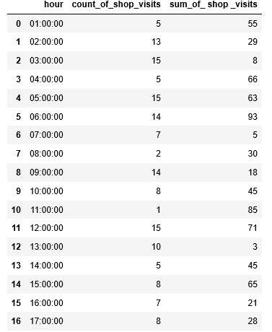

#Get the summary of the data

df = pd.DataFrame(dataset)

print(df)

print(df.describe())

