SQL Development

Name of student

Name of professor

University

Course

Date

1. Create the database:
2. For this exercise we use the Dbeaver DBMS;

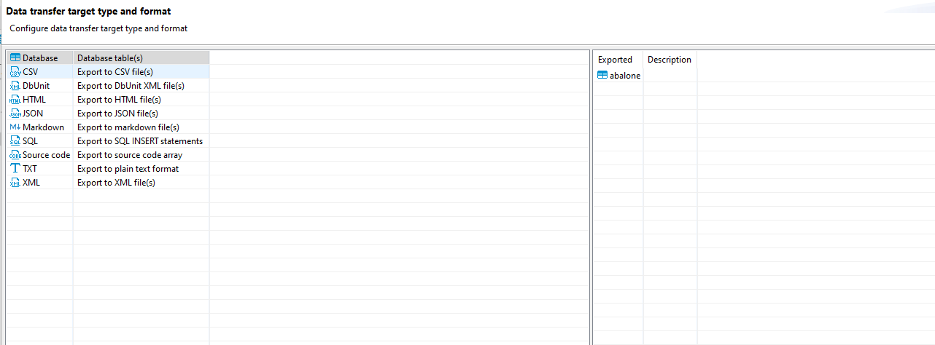

1. Show imported results

select \* from abalone;

