Data analysis and visualizations

Name of student

Name of professor

University

Course

Date

This analysis was based on the county of ten counts of baskets that were filled with fruits and then the concentration of vitamins and minerals selected from this selection of baskets. The also step of this task involves the prediction of the potential random fruit baskets. The analysis is done on Python and Jupyter Notebook

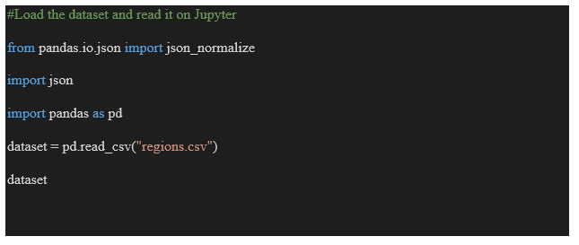

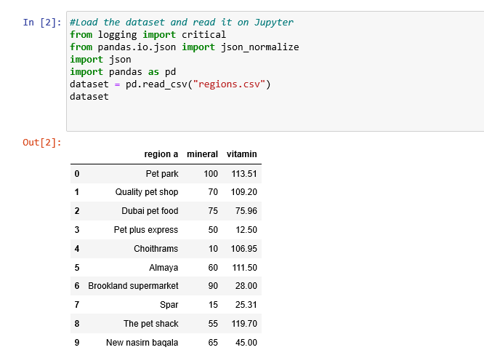

Getting a summary of the dataset looks like below:

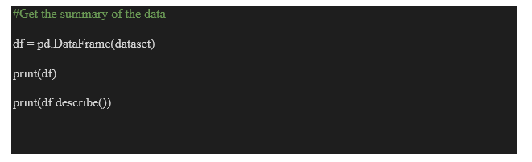

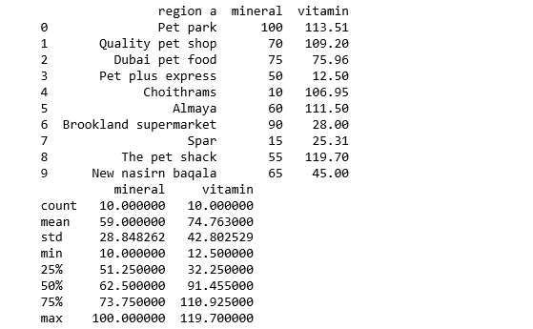

Dataset summary.

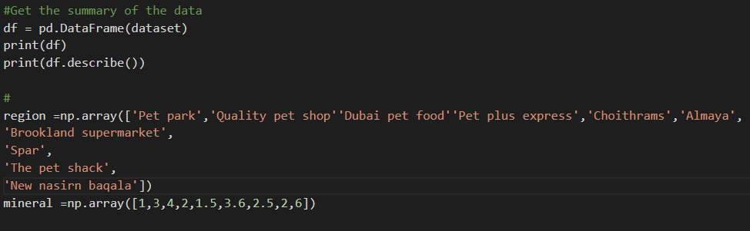

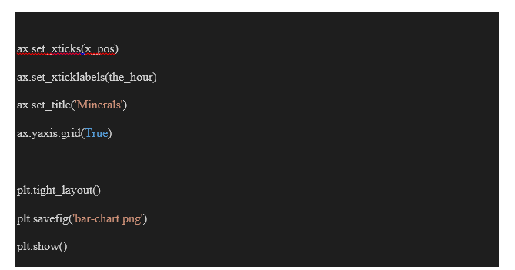

The below analysis shows a movement of the vitamins and minerals at a constant rate within the regions.

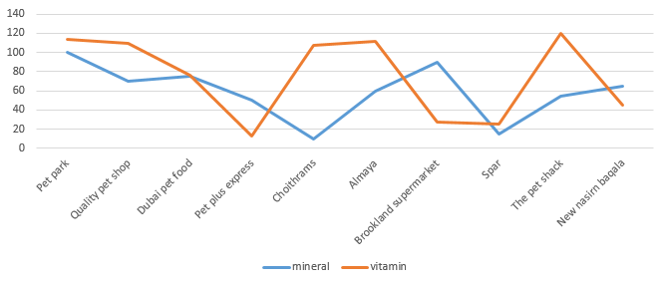

In the next step, an analysis was done to predict the potential vitamin content in random sample of the 2.4 samples and then the resulting output shown below. This indicates a negative correlation covariance between these two data variables. Meaning that the change in a basket does not change the vitamin content or the mineral content of the

