STUDENT NAME:

COLLEGE NUMBER:

PROFESSOR NAME:

This is an exercise based on Tableau open visualisation software. The dataset used in this application is derived from the sample sales dataset that is openly allocated and availed within Tableau software program.

The dataset is composed of 9995 instances of datasets. Upon loading the dataset in the tableau application, it looks like as below:

**Aims and objectives of the task:**

* Replicate the required assignments and tasks by changing regions from South to West regions
* Create visualisations from the West regions
* Create a story and dashboard from the provided dataset
* Be able to tell a story based on the sales regions of this dataset.

The following steps were followed:

**Step one:**

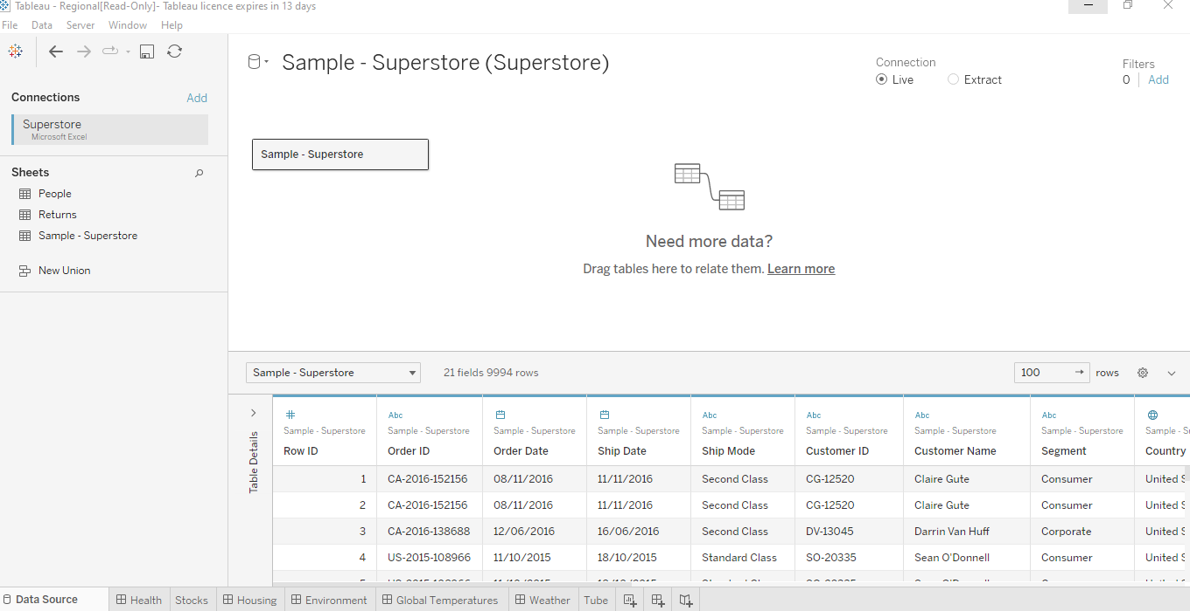

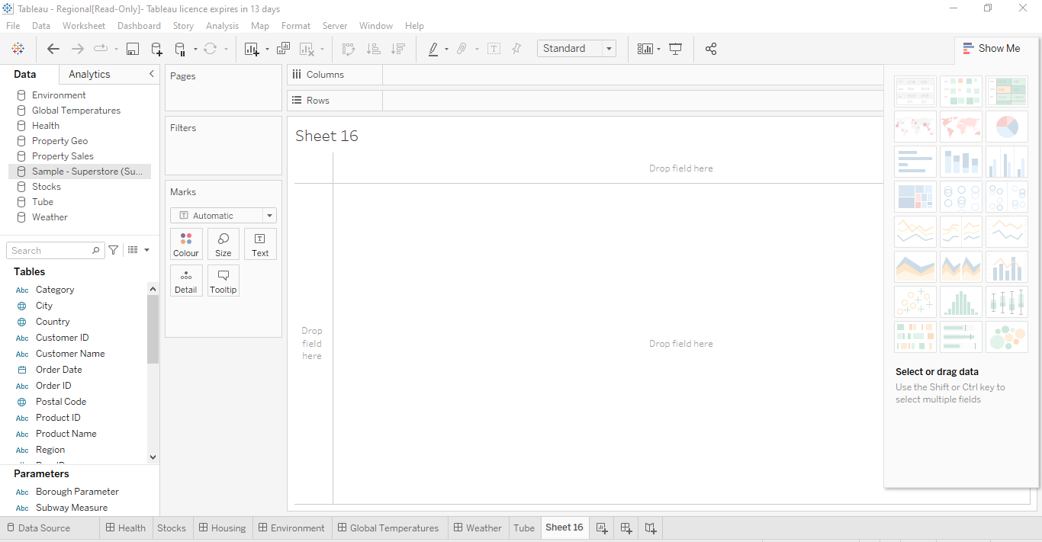

-Opening up the tableau window shows the layout pane needed for the data analysis program running from each window and on the far right, the various visualisations that one can chose from when visualising the data

**Step two**

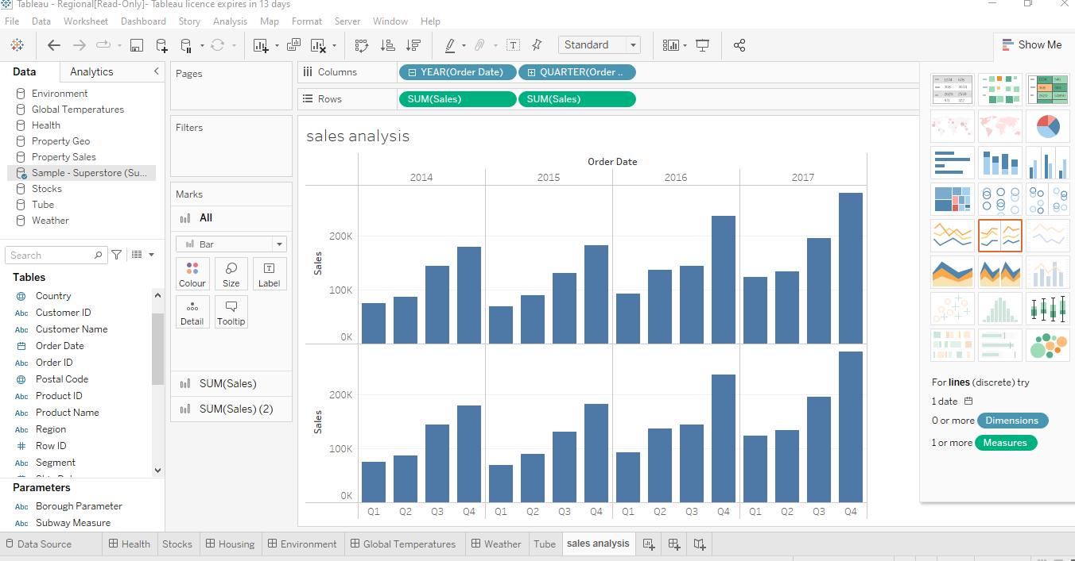

-Loading the data displays a summary of some of the column variables available to the user, these can be put as a summary on each column. Summary shows the distributions of these datasets across each category of sales

**Step three**

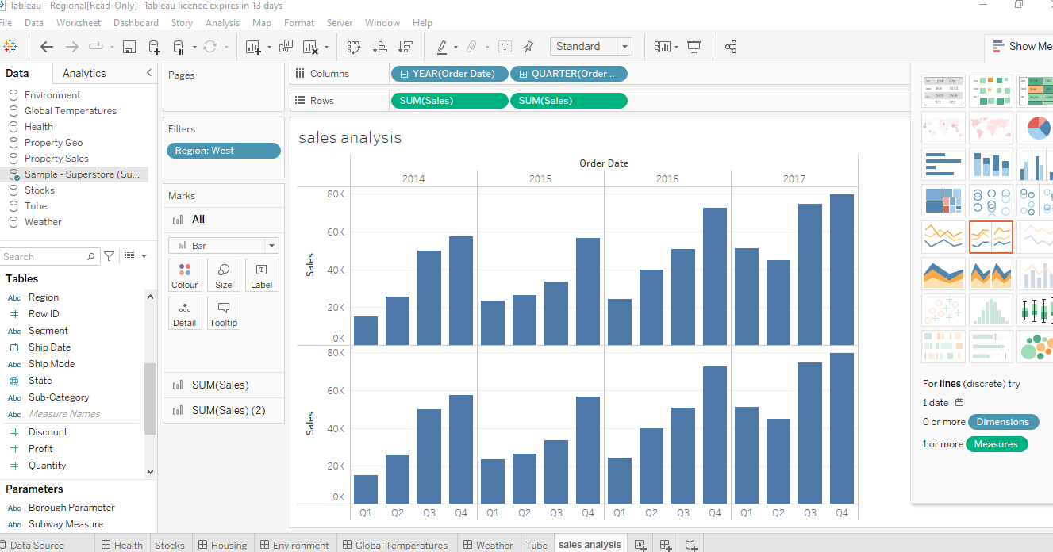

-Further presentation of this dataset as seen from the Region West indicates the distribution of the sales from the West region.

**Step four**

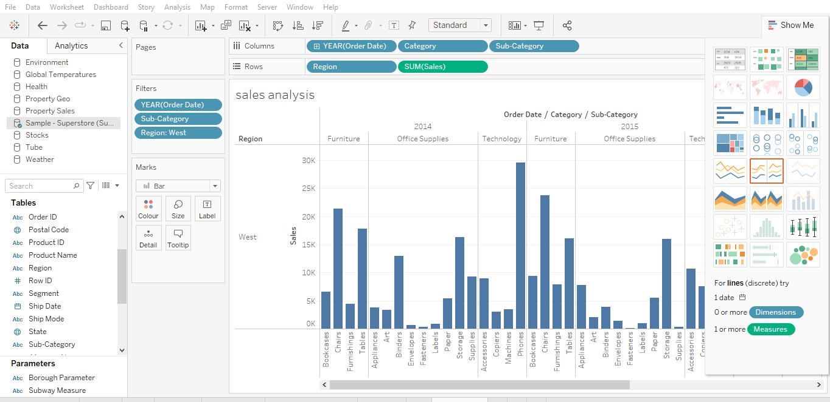

The above is the presentation as seen from the sub-categories and West Regions grouped by their order date and count of orders in the bar chart

**Step five**

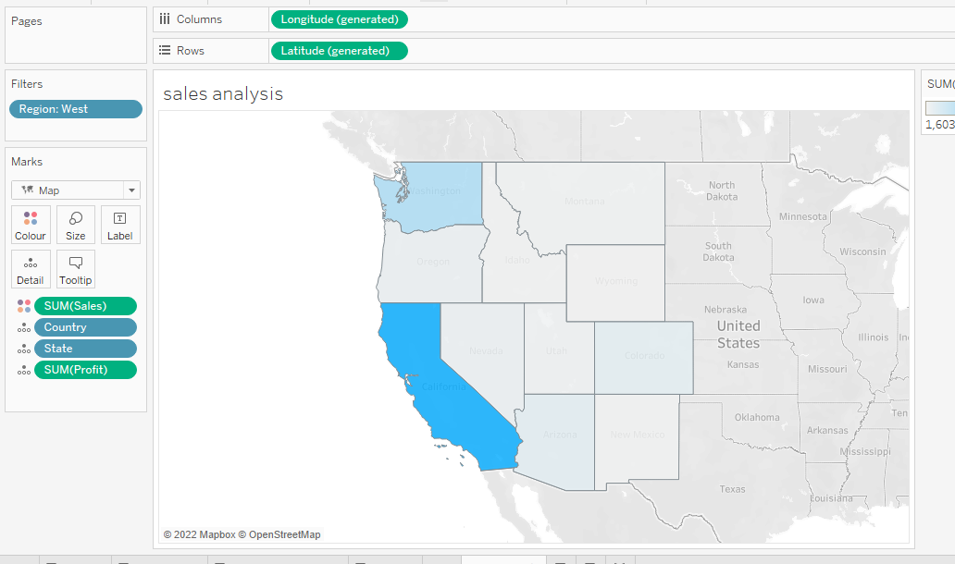

The sum of sales as seen from the Western states, largest sales seems to be dominated by the south West states.

**Step six**

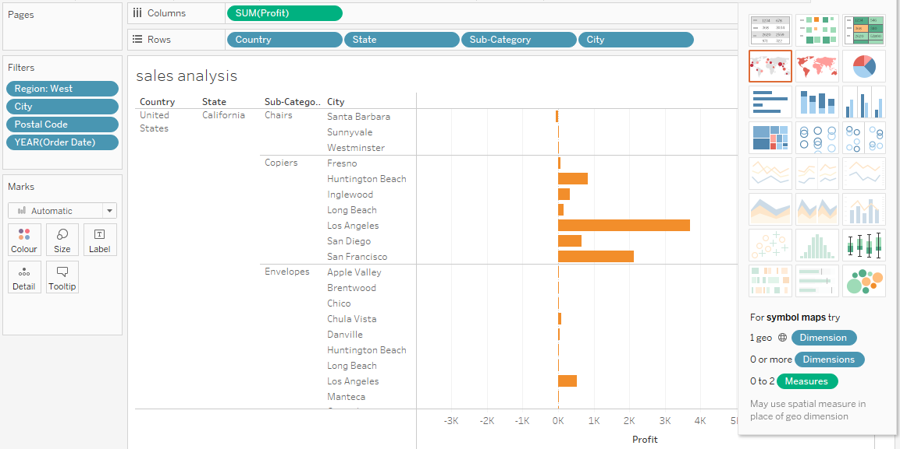

This step shows a summary of the total profit distribution within the country, state, sub-category and city within the within the West region together with their cities and postal code.

**Step seven**

US west Dashboard

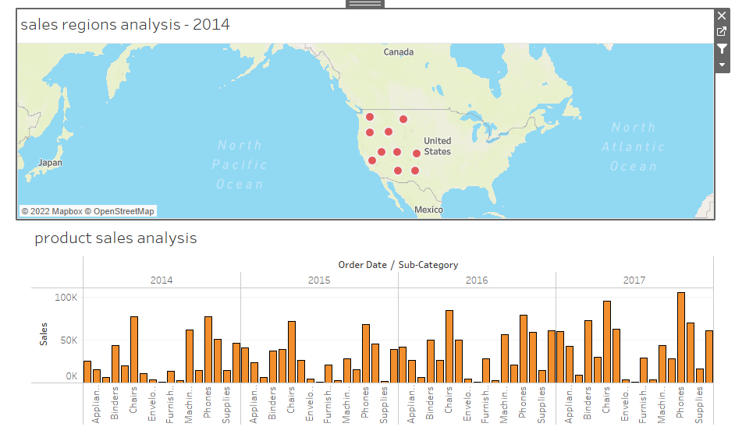

In this dashboard, we have illustrated the geographical map distribution of the sales from the Western regions in the top map and then product sales across the years with each varying sales of the sub-categories in a bar chart presentation.

**Step eight:**

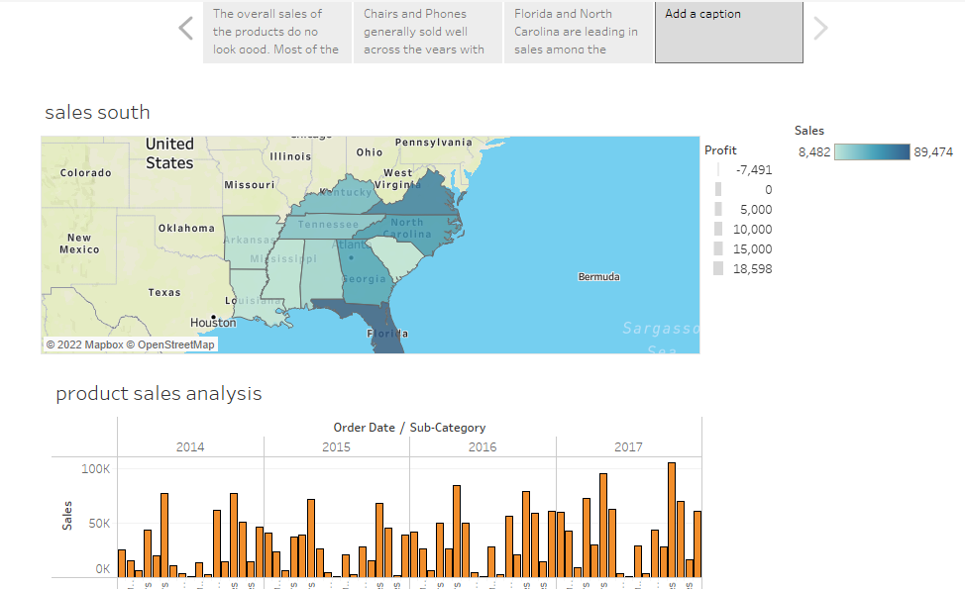

The above dashboard story indicates what’s happening across the data, the story captions have highlighted overall sales as not being satisfactory with the chairs and phones overall selling well across the years. Further, Florida and North Carolina are leading in sales among the other states in the South.