Student Name

College Number

Professor Name

System analysis and design are critical components when designing organisational technological requirements. Feasibility studies are a core part in trying to understand and implement such initiatives. The systems analysts usually draw a complete illustration and conceptual frameworks on some of these requirements. A simple requirement would look like below:

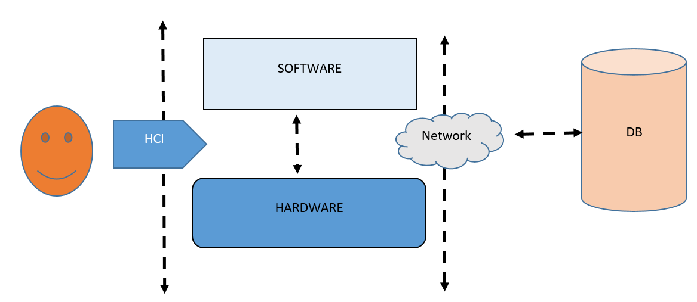

As part of the organizational requirement, there three levels of requrements for the roles identified in this partuclar task. These reoles are separed and subdivided into four reuremnts, they include:

* Human comuter ntecations (HCI)
* Software requiremnts
* Hradware requirements
* Network requirements
* Secuirty requirements

Certified Public accounts CPA

The CPA cum the organisational auditor handles the organisation sensitive audit and tax reports.

**Hardware requirements:**

For this particular requirement. This office shall require the following hardware materials;