Student Name

College Number

Department Name

Professor Name

Certified Public Accountant (CPA)

The CPA is a senior position at a tax preparation company. The CPA will not only be handling sensitive customer data from personal tax returns, but also preparing tax returns for corporate clients. The CPA is also responsible for the personal tax returns filled out by the tax and data-entry specialist employee.

Tax Specialist

The tax specialist has the dual role of entering data and verifying that tax returns are correct. This position involves customer interaction in gathering data for minimizing taxes owed or maximizing tax refunds.

Data-Entry Specialist

This position requires data entry for personal tax returns for customers who walk in the door. Although the data-entry specialist works with sensitive customer data, they do not have access to the tax returns once the returns are submitted to the tax specialist for review.

James Otis Tax Associates requires the following hardware components to complete daily business effectively:

* 8plus GigaBytes of RAM
* 256GB SSD which can acquire files quickly than a HDD.
* Multiple USB ports.
* Intel Core i5/i7 processors or a Ryzen 5/Ryzen 7 processor. The Processor picked has enough cores to satisfy all of the employees' demands for faster and effective completion of work.
* Multiple monitors or a huge single 4K monitor which enables the staff to work for long hours at a workstation with little eye strain
* A backup external hard disk
* Video Card- 4GB Nvidia Geforce Graphics Card, A video card's goal is to assist the CPU run more effectively by handling the visual component of the processing capacity. Since majority of today's programs are visually driven, a video card may help practically any software run faster.
* Power Supply- RMx Series™ RM1000x — 1000 Watt 80 PLUS® Gold Certified Fully Modular PSU ,Corsair RMx series power supplies give you extremely tight voltage control, quiet operation, Gold-certified efficiency, and a fully modular cable set. Built with all Japanese 105°C capacitors, they’re a great choice for high performance PCs where reliability is essential.
* Printer- Canon I-SENSYS LBD223dw A4 Mono Laser Printer, The purpose of an All- in-One printer is that someone can print, scan, copy, and fax all on one machine at their desk. This will save plenty of time not having to walk to multiple machines to do the work that someone needs to do.

The following are peripherals needed

* Wireless keyboard and mouse
* Network printer
* Scanner
* Fax machine
* 2nd Monitor

For all three positions to be able to fulfil their work functions efficiently and professionally, the aforementioned set of hardware will be required. Your staff will be able to multitask and run multiple apps at fast speeds with my CPU and RAM suggestions, without having to worry about their laptops lagging. The decision to have two monitors per laptop is in line with the earlier claim of multitasking efficiently in order to finish jobs and support clients in a professional and timely manner. Since your employees will be typing up tax data and reports every day at work, the mouse and keyboard you choose should be comfortable for them. Having an All-in-One printer at each employee's desk eliminates office walking and allows employees to print and duplicate customer forms without leaving their workstation. They'd also be able to scan documents onto their computers and fax documents from the comfort of their own desk.

James Otis Tax Associates requires the following Software Programs to complete daily business effectively:

* Latest Operating System, Microsoft Windows 11 which has performance-improving features ad Better multi-monitor functionality
* They will need office automation products like cloud-based accounting software such as Intuit’s QuickBooks online & QuickBooks online accountant which does the heavy lifting so you can spend your time on other important business tasks.
* They will require security software such as Microsoft Defender or premium antivirus software such as Kaspersky.

Security Measures put in place in James Otis Tax Associates includes:

* Encrypted File Storage
* High Level Filename Obfuscation
* Brute Force Login Protection
* SQL Injection Protection
* Strong Password Policies
* State-of-the-Art Firewall
* Encrypted "Cross Server" Backups
* Detailed Audit Trails and Reporting
* Operating System Hardening and Patch Management

**Network Requirements:**

The network is a star topology. A wireless router will connect all wired devices, such as a multifunction device. They will be a fusion of star/Wi-Fi infrastructure; we will be able to use devices that can move around, such as a laptop, while providing a secure connection. I will set up a VPN to allow a specific user, such as a (CPA), to obtain data while away from the workplace. Each day, a Local area network will automatically backup data to the cloud server. This safeguard will maintain the privacy of confidential material because physical devices can sustain damage during use, leading to data loss.

Though establishing a VPN and domain server will be critical for ensuring secure access to the network. To ensure the security of customer data, I will issue IP addresses to each computer. We can ensure that no devices can connect to a network by mapping IP addresses. A firewall and network bandwidth will be used to keep track of security on the network. The bandwidth will be tracked by analysing user requirements and enabling for improved network performance. It will ensure that the network is free of suspicious activities and domains that could compromise security.

I highly recommend purchasing a CAT-6 ethernet cable to ensure better performance and future upgrades; the transmission speed is much faster than the typical CAT-5, which only has rates of 10/100 Mbps. I also propose an ISP-based fiber optic, such as FIOS; the difference between fiber optic and conventional internet is that the speed in fiber isn't shared with other users like it is with cable. We can use VOIP to save money by eliminating the need for a traditional landline.

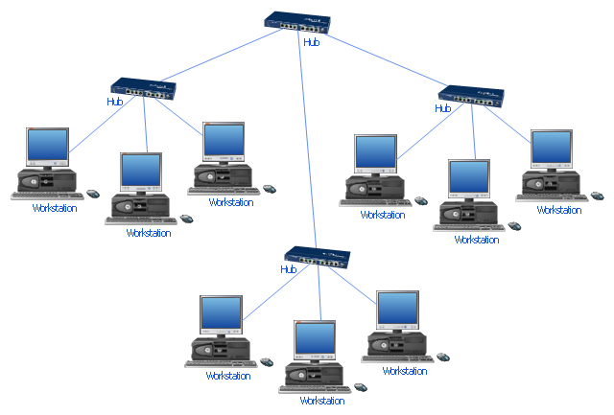

The workstations includes the CPA, Data entry specialist and Tax Specialist