**NAME**

**COLLEGE NUMBER**

**Designing a power quality improvement conditioner using neural networks**

**Introduction**

The set of electrical attributes that allow an electrical system to work properly without considerable performance loss is referred to as power quality. The phrase custom power is used for distribution systems in the same way it is used for flexible ac transmission systems. Custom power improves the quality and dependability of power given to clients, this in turn improves the quality of power transmission systems I terms of quality and reliability.

Harmonic currents available, the existing poor power factors, the supply voltage changes, and other factors all contribute to poor power quality Vadirajacharya G et al (2011). Thus, need for high-quality electric power has risen dramatically in recent years. As a result of their significance for both utilities and customers, power quality issues have gotten a lot of attention lately. Voltage sags, swells, brief interruptions, under voltages, over voltages, and noise are all examples of voltage sags and swells. As one of the eminent power related issues today affecting it’s the quality of power available.

A voltage dip is a brief event in which the R.M.S. voltage magnitude decreases. Despite its brief duration, a small deviation from the nominal voltage can cause serious disruptions. According to Timothy (1995), a voltage dip is caused by a fault in the utility system, a fault within the customer's facility, or a large increase in load current, such as starting a motor or energizing a transformer.

As known, unified power quality conditioner (UPQC) is regarded as one of the most effective custom power devices for compensating in the side of load and consequently source as well. It is made up of shunt and series converters that are linked back to back to a common dc link. It can carry out both DSTATCOM and DSTATCOM functions Zouidi (2011).

**Control Methods for the Upqc System**

UPQC is made up of three main components: the series active power filters, the given shunt active power filters and then finally energy storage capacitors. The DC-link energy storage capacitors connect the shunt active power filters.

Ahmet (2011), series APF connected to the grid and load via a coupling transformer is primarily used to adjust the load voltage amplitude and compensate for power supply voltage sag In the controlled voltage source mode. To compensate for load currents, an ASF that is connected to the load is used.

The energy of voltage sag is defined as

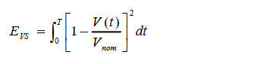

**The (ANN ) Artificial Neural Networks**

Artificial Neural Networks (ANNs) are electronic models based on the brain's neural structure. The brain learns primarily through experience. It is natural proof that small energy-efficient packages can solve problems that are beyond the scope of current computers.

This brain modeling also implies a less technical approach to machine solution development. The artificial neural network (ANN) is made up of artificial neurons that are linked together. It is essentially a collection of suitably interconnected nonlinear elements of very simple form that can learn. Following that is a one-layer network with R input elements and S neurons. The weight matrix W connects each element of the input vector p to each neuron input in this network. The *ith* neuron has a summer that collects its weighted information.

**Creating a typical artificial neural network**

When a network has been structured for a specific application, it is ready to be trained. The initial weights are chosen at random to begin this process. The training, or learning, process then begins. There are two training approaches: 'SUPERVISED' and 'UNSUPERVISED.' Supervised training entails a mechanism for providing the desired output to the network, either by manually "grading" the network's performance or by providing the desired outputs with the inputs.

Unsupervised training requires the network to make sense of the inputs without the assistance of a human. The vast majority of networks use supervised training. Unsupervised training is used to perform some initial input characterization. Training can also be divided into types based on how the training pairs are presented to the network.

**Upqc Design with Matlab Simulation**

A 3-phase electrical system is used to validate the operating performance of the proposed UPQC, and a neural network controller with a reference signal generation method is designed for UPQC, and its performance is compared to that of an artificial neural network-based controller, which is simulated using MATLAB software.

**Neural network design**

The control scheme's goal is to keep the voltage magnitude constant at a point where a fault is connected. The controller input is an error signal derived from the reference voltage, and the terminal voltage rms value is measured. Such errors are handled by NN also known as neural network-based controllers, the output of which is the angle, which is fed into the PWM signal.

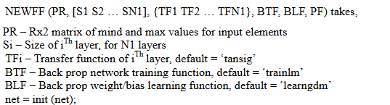

Weights and biases must be initialized before training a feed forward network. The command init is used to generate the initial weights and biases. This function accepts a network object as input and outputs a network object.

**Input training**

According to how the inputs are applied to the network, there are two types of training procedures. They are 'incremental training,' which applies each training pair one by one, and 'batch training,' which applies the entire set of training pairs at once.

They have the following syntax.

*train = net (net, p, t);*

**Modeling**

Simulates a network with the sim function.

Sim accepts a connection p and a network object net, and gets back the network outputs 'k'. *sim*

**

**Generation of Reference Signals**

The Parks transformation is used to generate reference voltages for series converter control and reference currents for shunt converter control. The source current is given as follows:



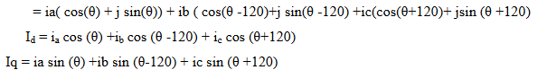

**Conclusion**

This research project is concerned primarily with the analysis and resolution of power quality issues using an active power line conditioner (UPQC). The study's findings provide useful insight into the behavior of converter used for active power filter that are connected to distribution lines. The most commonly used controllers for improving power quality are neural network control systems and neural net network-based controllers. The performance of a neural network controller with a reference signal generation method for a unified power quality conditioner (UPQC) is compared to that of an artificial neural network-based controller. The UPQC system now includes new functionality for quickly extracting reference signals directly for load current and supply voltage with a small number of mathematical operands.

We utilized MATLAB/SIMULINK that has cutting-edge graphic capabilities, to handle out all elements of modeling process and comprehensive numerical simulations on the test system. The simulation results show that the UPQC with neural net controller compensates for 75% of voltage sag during a fault condition. UPQC, on the other hand, uses an artificial neural network-based controller to compensate for 95% of voltage sag.

**Future Work Scope**

To account for both source and load core issues, the proposed UPQC model employs neural networks and ANN controllers. The work can be further extended to accommodate for the overall drop in the system utilizing combined NEURO-FUZZY control (Adaptive neuro fuzzy controller).

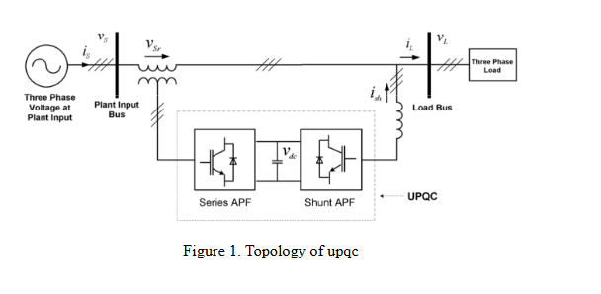

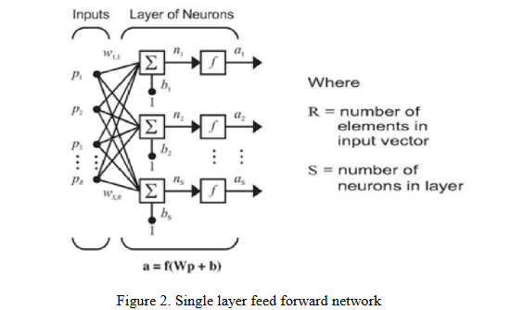

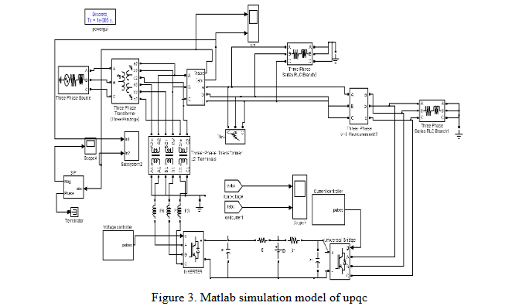

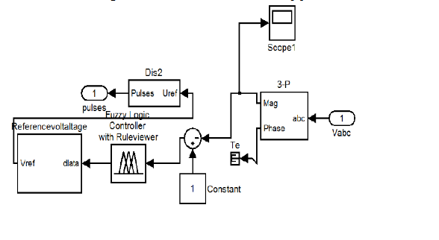

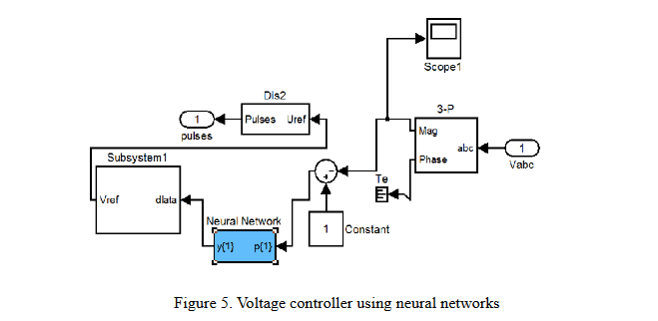

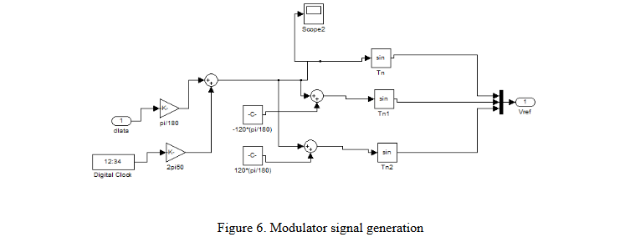

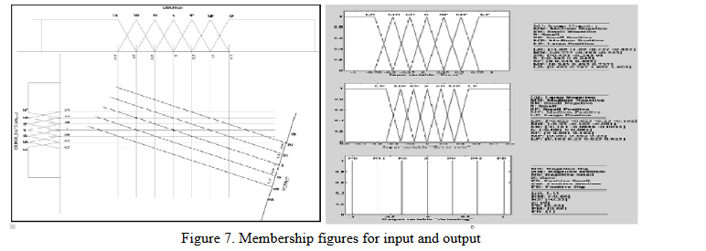

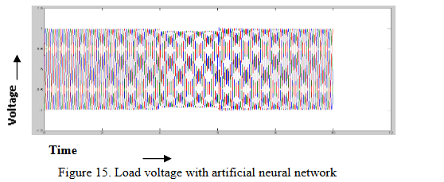

Load current with an artificial neural network. Circuit Parameters for UPQC

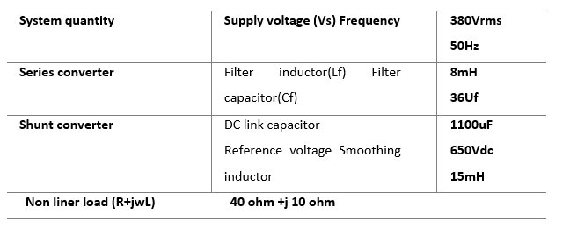

**Voltage Profile Comparison between Fuzzy Logic and Neural Network Controllers**

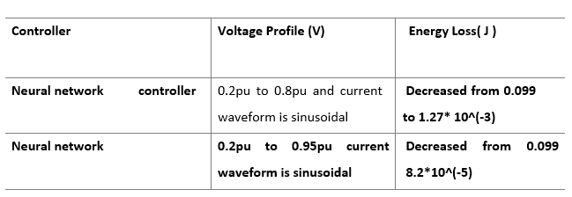

According to the above table, the voltage profile is increased from 0.2 to 0.8pu using a fuzzy logic controller and from 0.2 to 0.95 using a neural network. When compared to neural network controller, ANN controller provides better voltage profile, which is the main requirement in power system operation.

**REFERENCES**

Vadirajacharya G. Kinhal, Promod Agarwal, and Hari Oam Gupta (2011)*, Senior Member, IEEE “*Performance Investigation of Neural-Network- Based Unified Power-Quality Conditioner” ieee transactions on power delivery, vol.26.

Ahmet Teke, Lütfü Saribulut, and Mehmet Tümay (2011) “A Novel Reference Signal Generation Method for Power- Quality Improvement of Unified Power-Quality Conditioner” ieee transactions on power delivery.

A. Zouidi, F. Fnaiech, and K. AL-Haddad (2006), “Neural network controlled three-phase three-wire shunt active power filter,” in *Proc. IEEE ISIE*, Montreal, QC, Canada, Jul. 9–12,pp. 5–10.

L. H. Tey, P. L. So, and Y. C. Chu (2004), “Unified power quality conditioner for improving power quality using ANN with hysteresis control,” in *Proc. Int. Conf. Power System Technology*, pp. 1441–1446.

Ruiye Liu, Ning Xia, Xiaonan Wang” The Research on Fuzzy-PID Control in Unified Power Quality Conditioner”.

Timothy Ross J. (1995), “Neural network with Engineering Applications”, McGraw-Hillbook Company; University of Mexico.

HUANG Min, ZHA Xiao-ming, CHEN Yun-ping (2002), The controller of fuzzy changing structure of parallel power quality conditioner[J]. Power System Technology,26(7):11-14.