Student name

College number

Functional requirements define the behaviour of the software product. The behaviour of the software product is entirely dependent on the features and objectives each of the assigned components of the software modules. These modules include buttons, event actions, form inputs and validations, role based access parameters, routing and code functions.

In this technology product, the phone number inputs only accepts numerical values as inputs, where there is any other value entered other than the numerical, an error is thrown and captured by the user. There are certain routes that are only accessed based on the specific roles of the currently logged in user. For instance, a user can only view their dashboard page of they are logged in otherwise they won’t view the page.

During registration, the username filed should not be left empty. Where a user tries to submit the details and the username field is empty, the page throws an error and shows the user that the field has to be field. Further, re-registrations of existing email will equally throw errors and the user will have to re-enter fresh email address.

The non-functional requirements include reliability, scalability, availability, maintainability and serviceability. Reliability refers to the ability of the software program to deliver even during the low down times. Availability refers to the ability of the software product to be available on demand and request at any given time. Maintainability refers to the ability to maintain the software product whenever there are loop holes in the system. Scalability as a non-functional requirement refers to the ability to graduate the software product from one level to another. The other requirements is the ability to add servicing capabilities to the software products. Regular services may include integrations, feature changes or code merges.

Business process model

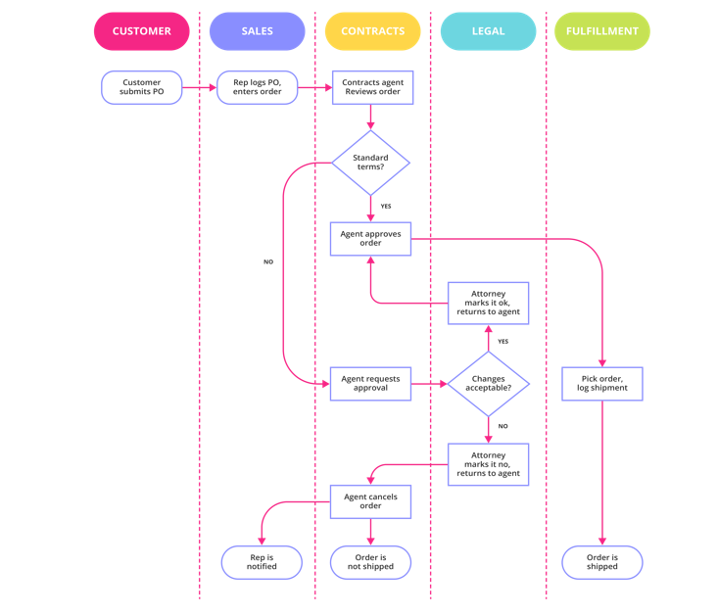

References

*A catalogue of functional software requirement patterns for the domain of content management systems*. (2013, March 18). ACM Digital Library. https://dl.acm.org/doi/abs/10.1145/2480362.2480598