**Python arithmetic functions**

Name of student

Name of professor

University

Course

Date

##Calculating the total area of a cube

length = int(input("Enter  the length of the Cube:.."))

area = 6*length*length

print(length)

print("The area of the cube is", + area)

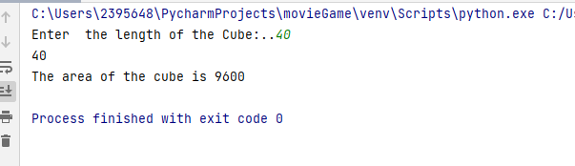

#Volume of a sphere

sphere_section = 0.75

pi = 3.142

sphereRadius = int(input("Enter the radius of the sphere to calculate: .."))

sphereVolume = sphere_section*pi*sphereRadius

print("The volume of the sphere is", +sphereVolume)

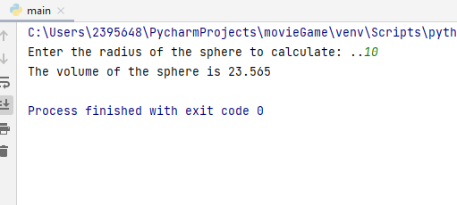

#Geolocation calculator

import math

k1 = [6, 0]

k2 = [8, 12]

geoDistance = math.sqrt( ((k1[0]-k2[0])**2)+((k1[1]-k2[1])**2) )

print("The distance between X and Y is ", + geoDistance)

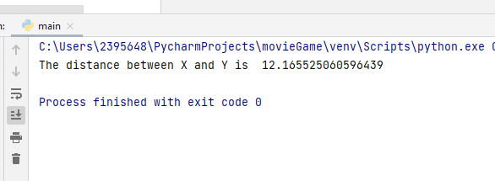

# Degree / Farenheit conversion

fromCelsius = int(input("Enter the degree celcius to convert to Farenheit: .."))

toFahrenheit = (fromCelsius * 1.8) + 32

print(fromCelsius,"Celcius"

