Database Modelling and design

Name of student

Name of professor

University

Course

Date

Install Docker

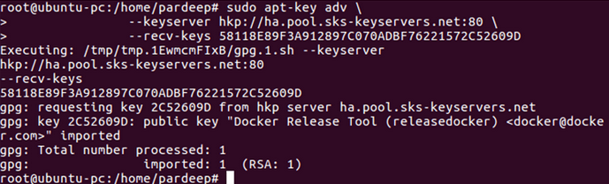

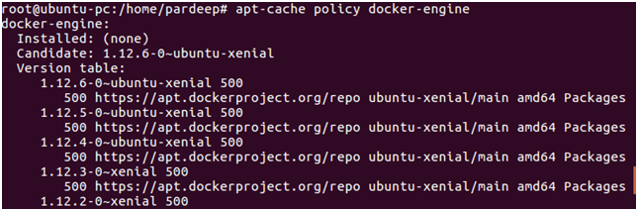

Install the docker engine

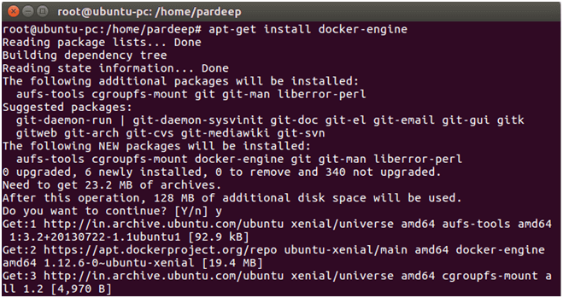

Installing egg ll

sudo apt-get install apache2

sudo apt-get install mysql-server

sudo apt-get install php5 libapache2-mod-php5 php5-mysqlnd

sudo apt-get install phpmyadmin

sudo a2enmod rewrite

Task 1

<script>alert(‘XSS’)</script>

