Data visualizations

Name of student

Name of professor

University

Course

Date

**Introduction**

In this exercise, we are going to visualize how Covid 19 has affected flight delays in the US. The visualization software we are going to use is Tableau software. The visualizations are map oriented. In order to achieve this, the dataset utilized the coordinates of the airports, their trend in departures and arrivals.

**Data collection.**

The data was collected from the US Flight department of transportation at [flight delays and cancellations](https://www.kaggle.com/usdot/flight-delays?select=flights.csv). Since some of the data is displayed on some other columns, the data was joined across the tables and to have a single tabular view of the data. Upon loading the data;

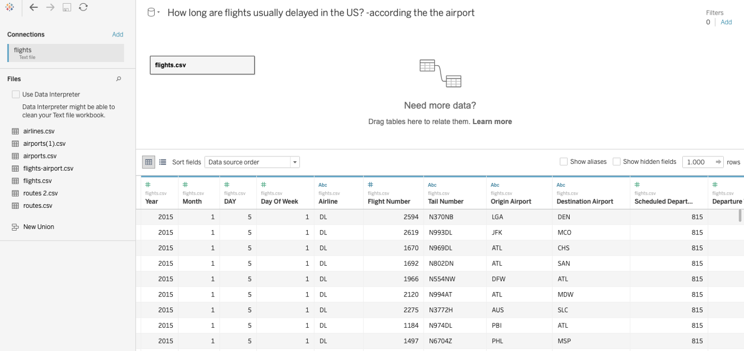

The next step is to create a join between the flights and the airports dataset as shown below on tableau;

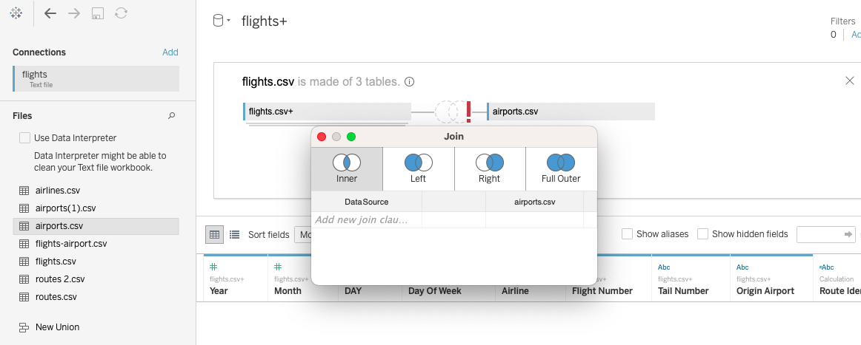

A simple route location looks as below:

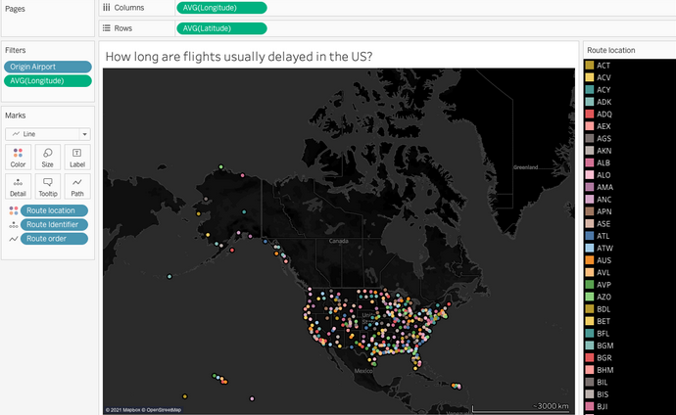

Then we try to find the route identifier from the sample shown below;

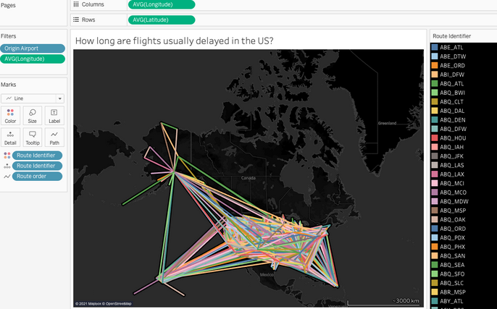

So the maps above shows the routes of the different planes across the year and the concentration of each route per airline. We can further filter out these flight routes by states and visualize the intensity if their interactivity.

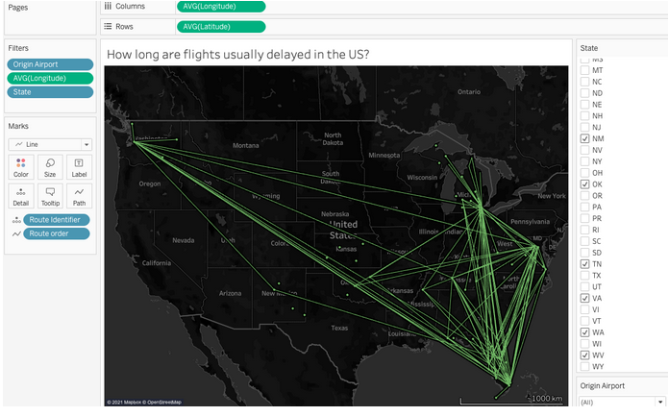

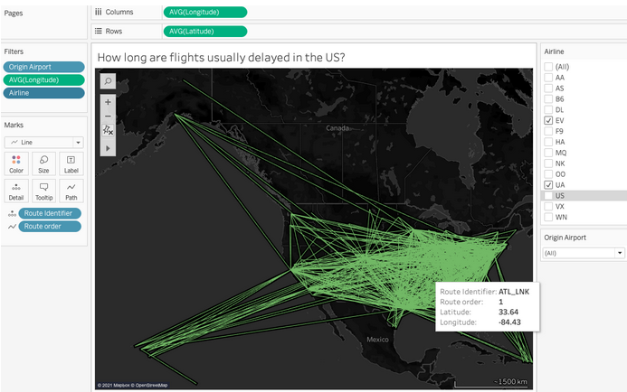

In this exercise, we have visualized the US flight data and destinations for the various states, further, on maps, we have established the concentration cancellations and delays routes for the different airlines.