**NAME**

**COLLEGE NUMBER**

**Impacts of Big Data on Business Intelligence**

**Abstract**

Historically, organisation s have relied on decision support tools to get reliable data needed for accurate decision making purposes in the various cross functional sectors. Source of big data include point of sales applications, intelligent systems, smart intelligent systems, and autonomous application gave been used in the previous past to generate massive data for decision support. Overtime, developments have been done that focus on making decisions faster and much easier as focus is drawn to the need to relay information instantly by top management. These developments have focused on designing new information systems that aim to leverage on specific organization performance and deliverables. While this is not true, it’s crucial to understand that at the centre of all these is big data. This is data that is fast moving voluminous, fast moving and contains a given amount of veracity i.e. has truthfulness as an element. To examine this further, we consider the situations below:

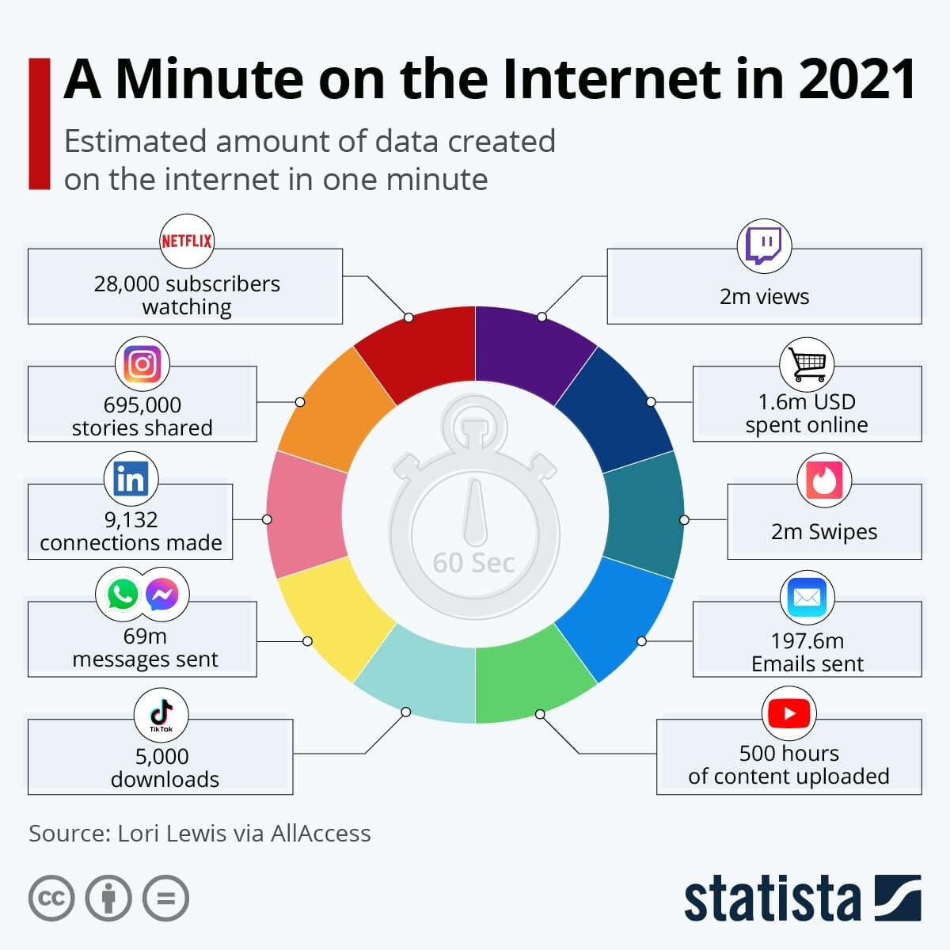

According to statistica.com, in 1 minute, a lot seems to happen, millions and millions of data get generated. This is what might be defined as big data. As we live in situation and age and time when too much information is being produced. The following questions continue to cross our minds?

1. What kind of data is this?
2. Where does this data come from?
3. How big is this data?
4. How do we handle it?

Sources of big data include social media applications where millions of posts, comments and page views are created every hour. Several blogs are generated continuously with large amounts of posts and page views. This sounds interesting for the sales and marketing departments. Such great insights and analytics given can be leveraged by the organisation owning this data so that it can be turned into meaningful and profitable funnel. Though this has to be done in an averment that obeys and adheres to the data protection laws across different entities. After harnessing the full power and potential of big data, one of the tools that can be put in place is the business intelligence tool.

BI systems are designed by corporation and engineers to have quick insights at the click of a button. Different cross functional departments have to be incorporated together on a single interface where upon which the data pipeline draw the data, the data moves into the BI system, where already there are algorithms and formulae that automatically work on this data and present the data to the user. Also, during the data manipulation state in the BI application, models can be made to forecast and predict the final outputs in the dataset. Such models include, logistic regressions, linear regression models, KNN, Random forests and the ARIMA models. So where does this leave the big data and BI. Big data can be used to power up BI systems in a massive way, die to be ability to generate continuous and voluminous data for the BI systems. With a strong and large BI application, the data can then be modelled to help predict outputs and models that users can interactively make sense of.