STUDENT NAME

REG NUMBER

TOPIC: HOW HARDWARE ENGINEERING WORKS

Introduction

History of computers

The history of computers can be traced back as we try to study the devices of the past. Some of these devises include printers, teletypes, transistors and the slide rules. These tools relied on physical mechanical and hand written calculations to come up with solutions, their users at this time could have thought of them as being easier to use, not being fully aware of some of the drastic changes that would later happen in the industry.

Also, at this time, we had no satellites or colour TVs. Abaci came in handy whenever mathematically operations were needed to be done and counting of numbers involved looking at the abacus and deducing logic behind the number beads and spaces between.

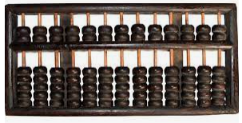

Later on, calculation s would be done on mathematical calculators that cost $ 395 at the time. As technology advanced, the T130 slide rule was replaced by the scientific calculators. Charles Babbage is known as the father of Mechanical computing, he developed the first mechanical computer that accepted input and output interactions paving way for Joseph Marie who built the prototype engine, the first machine that could calculate algorithms from punch cards in June 1883.

Further, Herman Hollerith invented the mechanized binary code computer that that was based on semiautomatic data; being the very fast computer to be used in the use census calculations reducing the census time from 8 years to 6 years. His inventions would later be used on pay checks, saving bonds and inventory. Another Computer, the German Enigma machine was used by the German government for crypting information during World War 1. The British government at around the same time went, invented the Colossus machine that was used for cryptanalysis of sensitive information sent by the German government, this computer would later save approximately 14,000,000 British lives.

The US government then built the ENIAC computer that was used by the military to program artillery during the war. This computer was the first digital computer at the time. With a possible jail time looming over his head from engaging in unfair competition practises in the CTR machines, Tom Watson Senior invented the IBM punch card machines before his son Tom Watson Junior invented the IBM 1401 series that had bigger memory of 14MB.

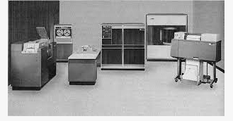

Later the IBM 1620 CADET was invented to apply scientific programming, supporting languages like FOTRAN and COBOL. The IBM series introduced the IBM 360 that had floppy disks under the influence of Allan Shugart. Then during the space exploration of the Apollo 11, there was need to have on board a portable and lighter computer, at this point, interacted core processors were invented that made all space recordings and calculations possible.

The Xerox Alto was the first operating system with a graphical user interface before IBM incorporated Compaq BIOS chips into their PCcs. In 1979, Apple built its first computer also known as the LISA /Macintosh with a graphical user interface.

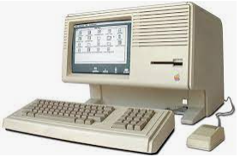

Disruptive technologies:

A case of augmented reality

The world today runs on a digital community. A lot has changed and we don’t have to see each other physically so as to engage, such is the case of augmented reality. AR was invented by Ivan Sutherland in the 1970s at the University of Utah. His remarkable contribution to the field of computer graphics opened a can of endless possibilities of what we could just do with AR. AR is a term used in computer science to refer to the creation of perceive realistic imaginary environments that make the normal user have the impression that they were actually experiencing the same.

For instance, by use of AR, we can simulate a possible aircraft scenarios of a pilot who is flying a plane or jet in a given environment, this gives the participants what would be the realistic expected scenarios at the actual scene.AR has been applied in Medical science to simulate the human physiology and its interactions with surgeries, drugs and accidents, in aviation to simulate flight behaviour while in the air, in gaming industry to create movies and games in high definitions and finally in entertainments to watch movies in 3D environment.

Positively, AR has made us realise and experience things even without being there. The fact that a pilot can train in an almost realistic environment even without being there means that they know what to expect before they aboard. It has also reduced costs and expenses that would be incurred had we not discovered possible threats before simulation. AR has increased product quality, we are now more than ever before able to detect leakage, holes and bugs in the products that we produce, this is done through simulation of the final product, where case sceneries are not satisfactory then we revert and correct.

As a downside, AR creates a virtual reality of something that may not exist, emotional, this may be draining, since psychologically one may feel so attached to particular seen that was never there in reality.

REFERENCES

Foley, James D., et al. Introduction to computer graphics. Vol. 55. Reading: Addison-Wesley, 1994.

Campbell-Kelly, Martin, et al. Computer: A history of the information machine. Routledge, 2018.

Williams, Brian K., Stacey C. Sawyer, and Sarah E. Hutchinson. Using information technology: A practical introduction to computers & communications. McGraw-Hill Companies, PO Box 182604, Columbus, OH 43272, 1999.

Clements, Alan. Principles of computer hardware. Oxford University Press, 2006.