**NAME**

**COLLEGE NUMBER**

1. **The cardinality (number of rows) of the table**

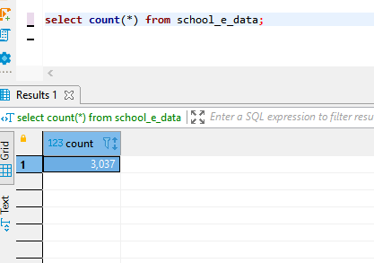

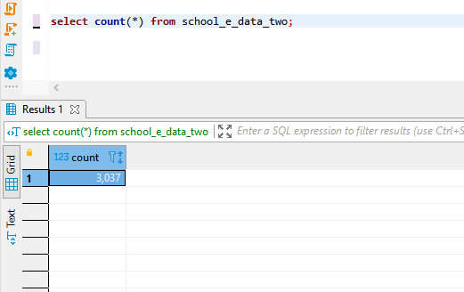

**Whether all rows are unique**

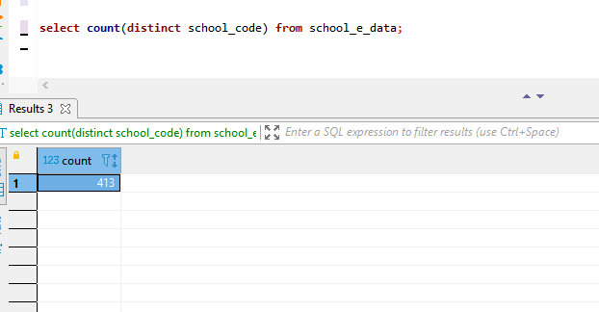

**What column(s) would be good potential keys (for this part, list any columns or   
combination of columns which you believe would be unique for the school)**

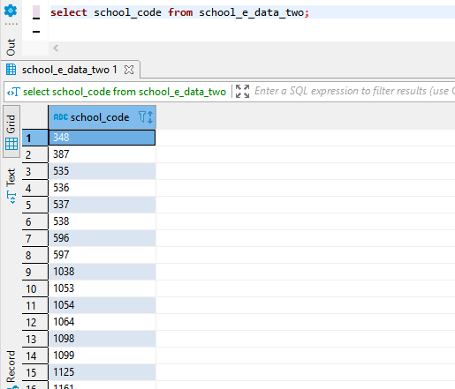

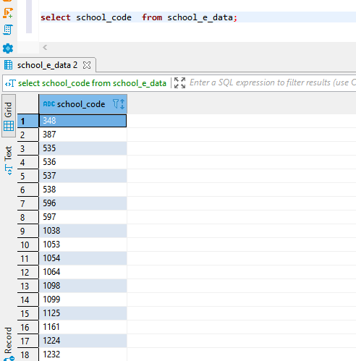

**How many post-secondary institutions are listed in the provided data?**

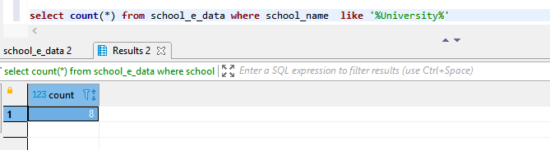

**What is the address, postal code, and school code of each post-secondary institution?**

**How many students participated in Calgary Home Education in 2018-2019 compared to   
2020-2021?**

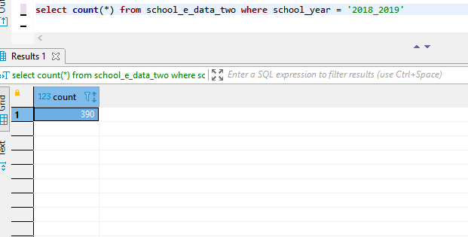

**How many students participated in Calgary Home Education in 2018-2019 compared to   
2020-2021?**

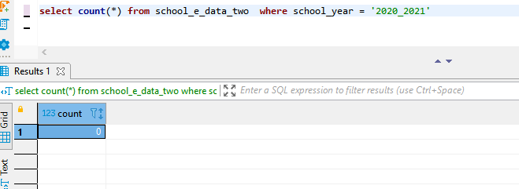

**How many schools provide ECS (Early Childhood Services) in the provided data?**

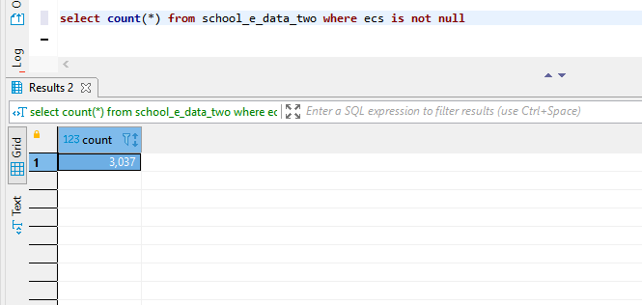

**What is the address and postal code of every elementary school in provided data?**

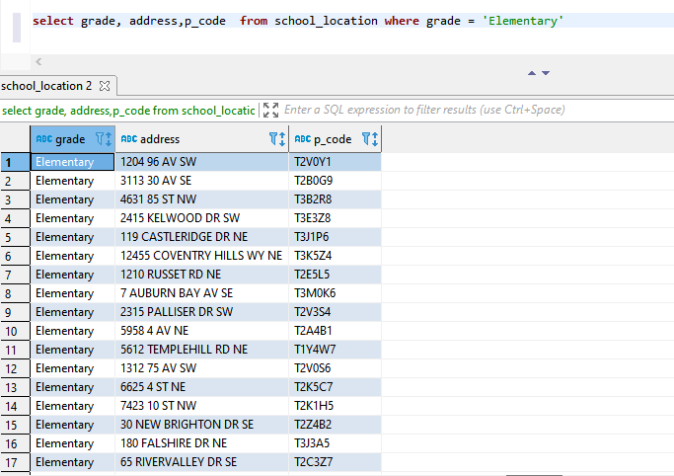

**For each grade, list the mean and median number of students for the 2014-2015 and   
2019-2020 school years**

select  median(grade_1),median(grade_2),median(grade_3),median(grade_4),median(grade_5),median(grade_6),median(grade_8),

median(grade_8),median(grade_9),median(grade_10),median(grade_11),median(grade_12),

avg(grade_1),avg(grade_2),avg(grade_3),avg(grade_4),avg(grade_5),avg(grade_6),avg(grade_8),avg(grade_8),avg(grade_9),

avg(grade_10),avg(grade_11),avg(grade_12)

from school_e_data

where school_year ='2014_2015' and school_year = '2019-2020'

group by grade1_grade_2,grade_3,grade_4,grade_5,grade_6,grade_8,grade_8,grade_9,grade_10,grade_11,grade_12