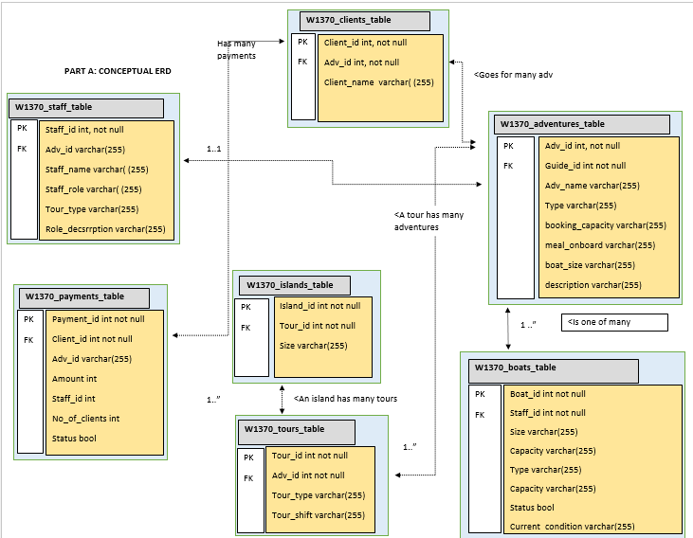

2. **Data dictionary**

|  |  |  |  |  |  |  |  |  |  |  |  |  |  |  |  |  |  |  |  |  |  |
| --- | --- | --- | --- | --- | --- | --- | --- | --- | --- | --- | --- | --- | --- | --- | --- | --- | --- | --- | --- | --- | --- |
| |  |  | | --- | --- | | Entity name | Brief description | | Adventure | Stores all adventures acttivties during tours | | Staff | All staff that assit in Archipelago | | Boat | Are used within sea tours | | Payment | Are made when clients access the tours | | Tours | Are activities that clients engage in | | Island | Are visisted during marine tours | | Clients | Are the target market for adventures and tuors | |  |  | |  |  | |  |

|  |  |  |
| --- | --- | --- |
| General entity | Specialized entity | Brief description |
| Adventure | Adventure ID | Uniquely identifies every adventure |
| Staff | Staff ID | Uniquely identifies every staff |
| Boat | Boat ID | Uniquley identifies every boat |
| Payment | Payment ID | Unquely identifies every payment made |
| Tours | Tour ID | Uniquely identifies every tour made |
| Island | Island ID | Uniquely identifies every Island |
| Client | Client ID | Uniquely identifies every custormer |
|  |  |  |

**3.**

|  |  |  |  |  |  |
| --- | --- | --- | --- | --- | --- |
| Entity name | Multiplicity | Relationship | Multiplicity | Entity name | Brief justifications |
| Staff | One to many | Can attend to many adventures | Many to one | Adventure | -staff can be assigned many adventures  -Adventure can have one staff  -Staff can monitor a tour |
| Client | One to many | Can pay for many adventures | Many to one | payments |  |
| Tours | One to many | A tour can have many adventures | Many to one | Adventures |  |
| Boat | Many to one | Boat can have many clients | One to many | Clients |  |
| Adventures | Many to many | Many adventures can have many clients | Many to many | Clients |  |