**Traditional Chinese Medicine**

**Personas:**

Integrated managements systems rely on the extensive use of data and the respective user groups to manage and handle user requests and data streams. The different data communications happen upon levels and layers.

Below is the integrated architecture system management profile:

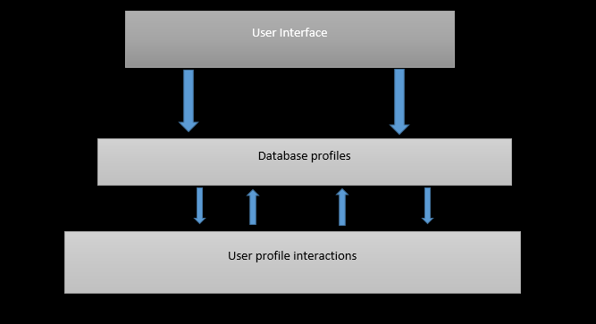

All data is passed to the database profiles which can then be picked and posted to the different API ends points to which users interact and create, updated, delete and read records.

**The process:**

When a user come to the website, their first process is to create an account or login to the system whereby which after, they can proceed to create appointments with the available doctor and then schedules are done for one on one meetings with the patient. The doctor proceeds to get the latest appointments assigned to him and accepts the appointment and shares feedback and comments concerning the appointment. The system admin then proceeds to monitor the overall system performance and ensure every component communicates efficiently without any downtimes. In cases where the patient is not able to use the system well, they can be helped by the data secretary to create accounts and book appointments.

In light of this particular activity, the Traditional Chinese Medicine web application will consume three different types of personas as follows:

1. Doctor
2. Patient
3. Data secretary
4. System Admin

Doctor:

The doctor is the primary consultant within the application. He/she will be responsible for answering and advising on the necessary and relevant issues raised by the patients.

**Case:**

**Jonathan Bayes**

Gender: Male

Role: Psychology and Nutritional Expert

Location: Guangzhou China

Age: 55

Motivations:

-Success

-Assertions

-Resilience

Goals:

-To help sleep deprived personas achieve better metal state

-To discover the relationship between quality sleep and fasting

-To train and help other healthcare professionals master the human mind

Background

Jonathan has been a medical practitioner focusing on mental health and social wellbeing for the last 15 years. Most of which have been spent in Northern China and 2 years in Singapore and South Korea. He holds a master’s degree in Physiology and Psychology from the University of Beijing. Bayes has been studying and offering rational Chinese therapeutics and treatment techniques to patients across the Asian race in the last 2 years, this is part of his doctorate research study that he carried out for his PhD study.

Challenges/Pain point

Currently, he is looking for funds to expand his research around the use of traditional Chinese medicine across different countries and races.

Data Secretary:

Acts as the secondary data entry person on behalf of the patient.

**Case:**

**Joseph Ribbsonn Juan**

Role: Data Secretary

Location: Hong Kong China

Age: 29

Gender: Male

Motivations:

-Clean data

-Clean energy computer science and majored in information systems and data management. He is patient about data modelling and predictive analytics. Prior to joining the Chinese Traditional Medicine, he had been building models around healthy food among men in Eastern China.

Challenges/Pain point

He is currently trying to collate big data streams across Eastern China for his project in healthy food among men.

**Case:**

**Hellena Po**

Patient:

Role: Chief Chef

Location: Beijing China

Age: 34

Gender Female

Motivations:

-Healthy foods

-Smart diet

-Weight management

Goals:

-To help the hospitality industry provide nutritionally healthy foods

-To discover lightweight non weight gaining starch in children

-To help the food industry achieve low glycogen content in children diets

Background

Po holds a diploma in Hotel Management and catering from the Institute of Gungan China. She currently works in Hilton Hotel in Beijing as the Chief. She is also the chairperson of Beijing food association. She loves to play tennis during her free time.

Challenges/Pain

Po is currently trying to learn swimming, to which she has already taken swimming lessons every weekend

Process

**Motivation:**

This project was arrived at after careful consideration of the fact that healthcare matters and needs currently hold a bigger percentage of the global concern. Individuals are seeking daily solutions to their health problems, some of which may not be immediately known to them. To be precise, psychological and mental awareness issue are the rising concern issues among patients in the world and as such the need to come up with a platform that will link the Chinese community and other global citizens into achieving a more realistic and healthier lifestyle. The three motivations are:

* Immediate solution to these problems
* The rising need of help by patients in this category
* The growing number of lifestyle and psychological therapists

Numerous brainstorming process led to the realisation that a web application would be one of the key solutions to bridging the gap between the patient and the doctor. Such a website can easily be accessed by patients across the globe and appointments and meetings can be done both physically and online. In order to achieve this, user friendly designs and mock ups of the finally delivery were drawn and outlined of what would be the expected outcome of the website. In light of these, building the website would be match easier considering the laid down road map and models.

During the development of the website; interactive logos of the website measuring about 20*40 pixels were inserted in the website and followed by the navigation links of these items that include the Home, About, Contact and Patient page. After the navigation bar, I built the banner that contained the banner image together with a hero text prompting the user to a call to action to our services on the website.

Below the banner I put card boxes in columns of 3 fitting into the website, showing the different services that we offer. Each service had a patient call to action to execute a given action. Finally is the footer page that had background image dark and fort colour of dark. Here I list some of the navigation quick links titles like contact, address and appointments, all fitting in three columns arranged horizontally along the footer of the website.