**AI Assisted Problem Solving Using Python**

NAME : MANNE EVANCY

HT.NO : 2503B05116

DATE : 27-10-2025

Program Name: M.Tech (CSE)

**Lab 1: Environment Setup – GitHub Copilot and VS Code Integration**

**Task Description#1**● Install and configure GitHub Copilot in VS Code.

**Expected Output#1**● Install and configure GitHub Copilot in VS Code.

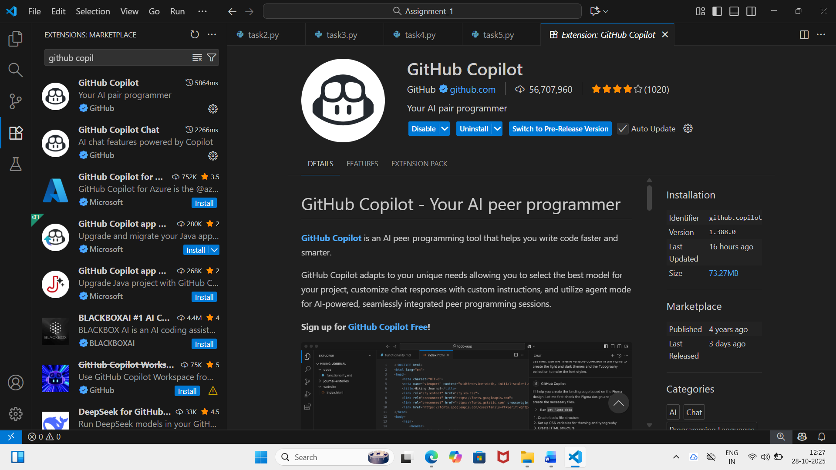

**Task Description#2**

● Use Copilot to generate a is_prime() Python function.

**Expected Output#2**  
● Function to check primality with correct logic.

**Prompt_1:**

Create a function named is_prime() to check primality.

**Prompt_2:**

Now, update this code where the user can take the input from keyboard.

**CODE:**

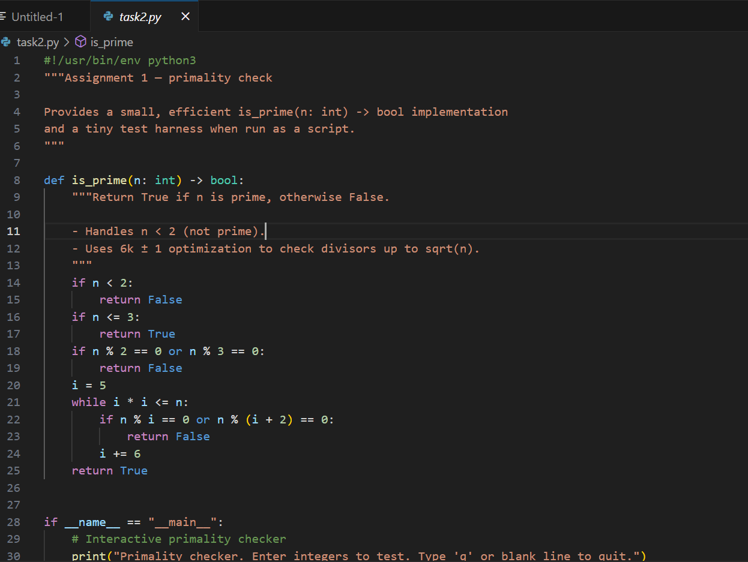

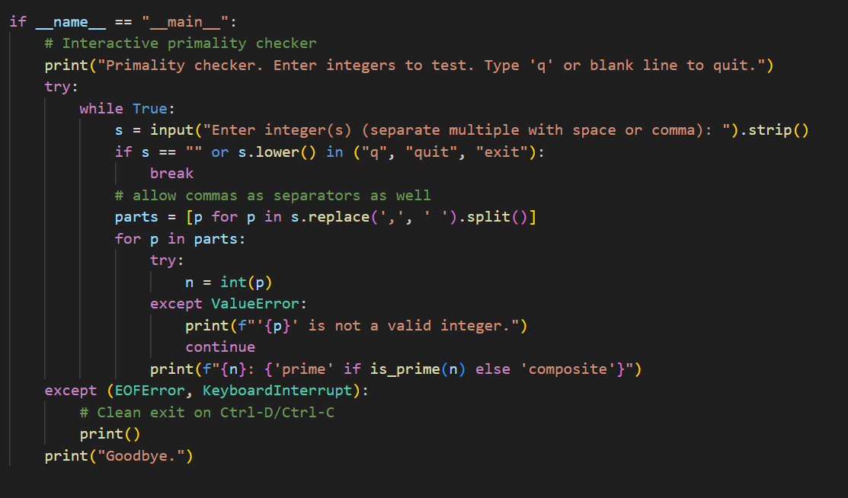

**OUTPUT:**

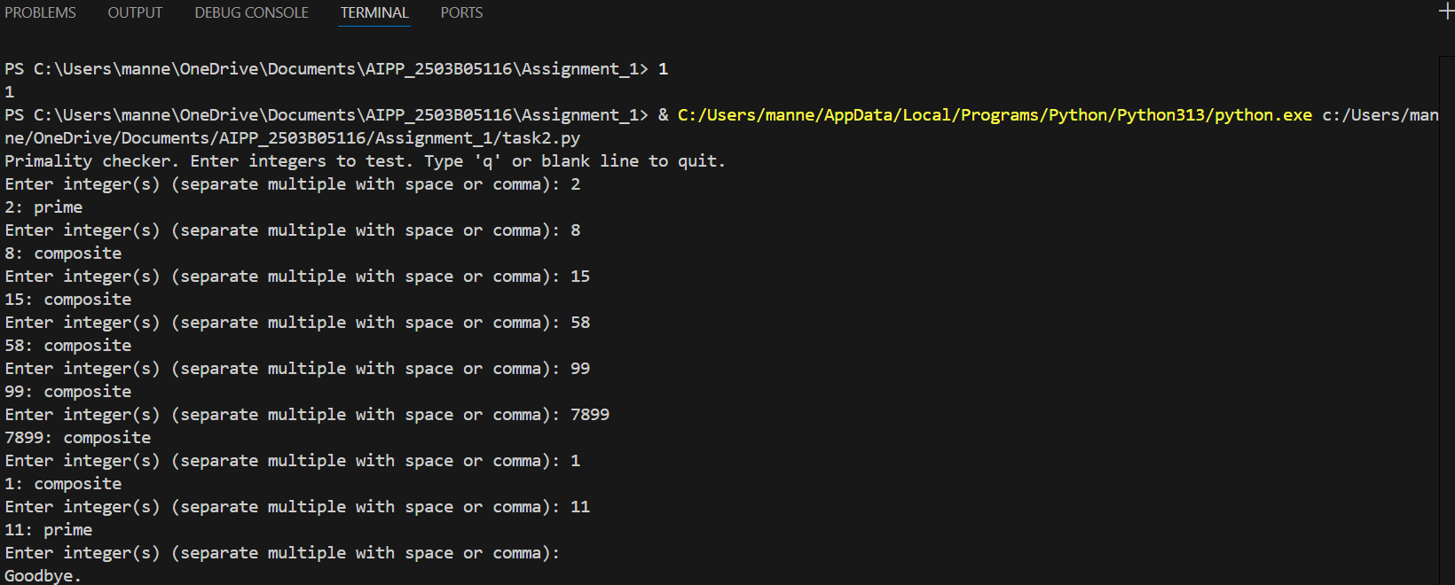

**Task Description#3**   
● Write a comment like # Function to reverse a string and use Copilot to generate the  
function.

**Expected Output#3**

● Auto-completed reverse function

**Prompt_1:**

Create a function to reverse a string and provide the auto completed reverse function output.

**CODE:**

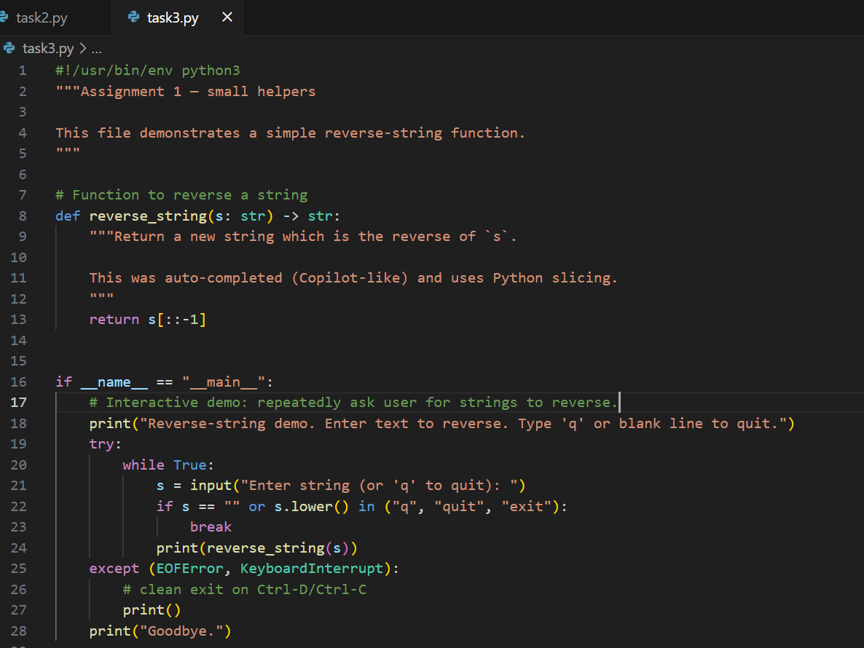

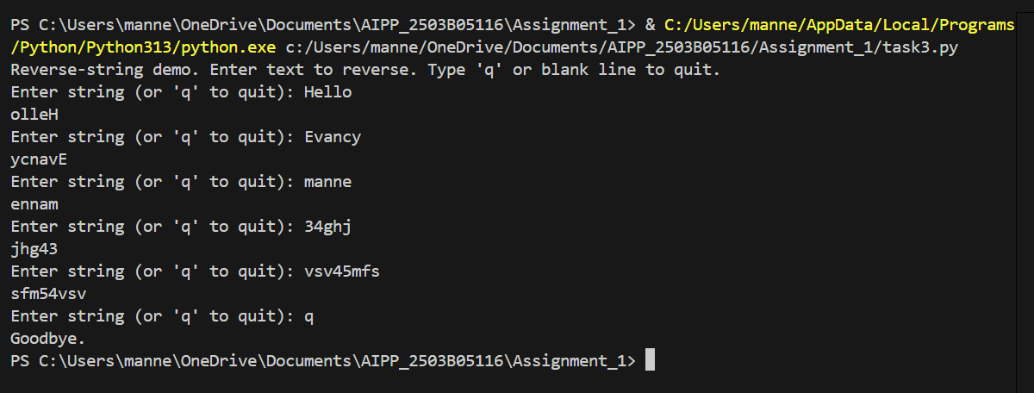OUTPUT:

**Task Description#4**  
● Generate both recursive and iterative versions of a factorial function using comments..  
**Expected Output#4**  
● Two working factorial implementations

**Prompt_1:**

Generate both recursive and iterative versions of a factorial function where the output needs to return two working factorial implementations.

**CODE:**

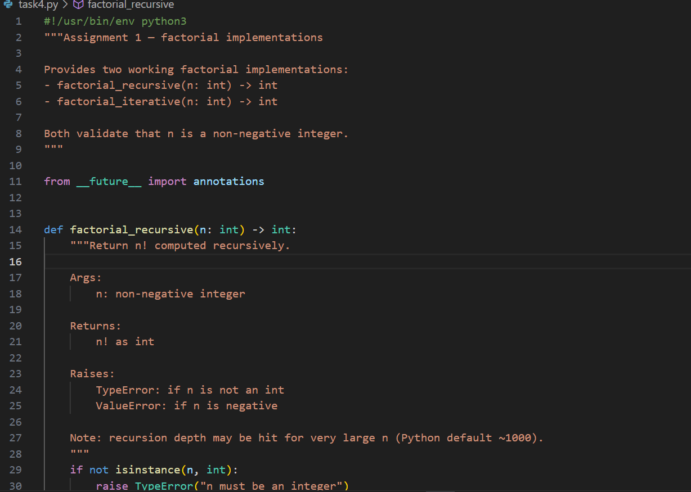

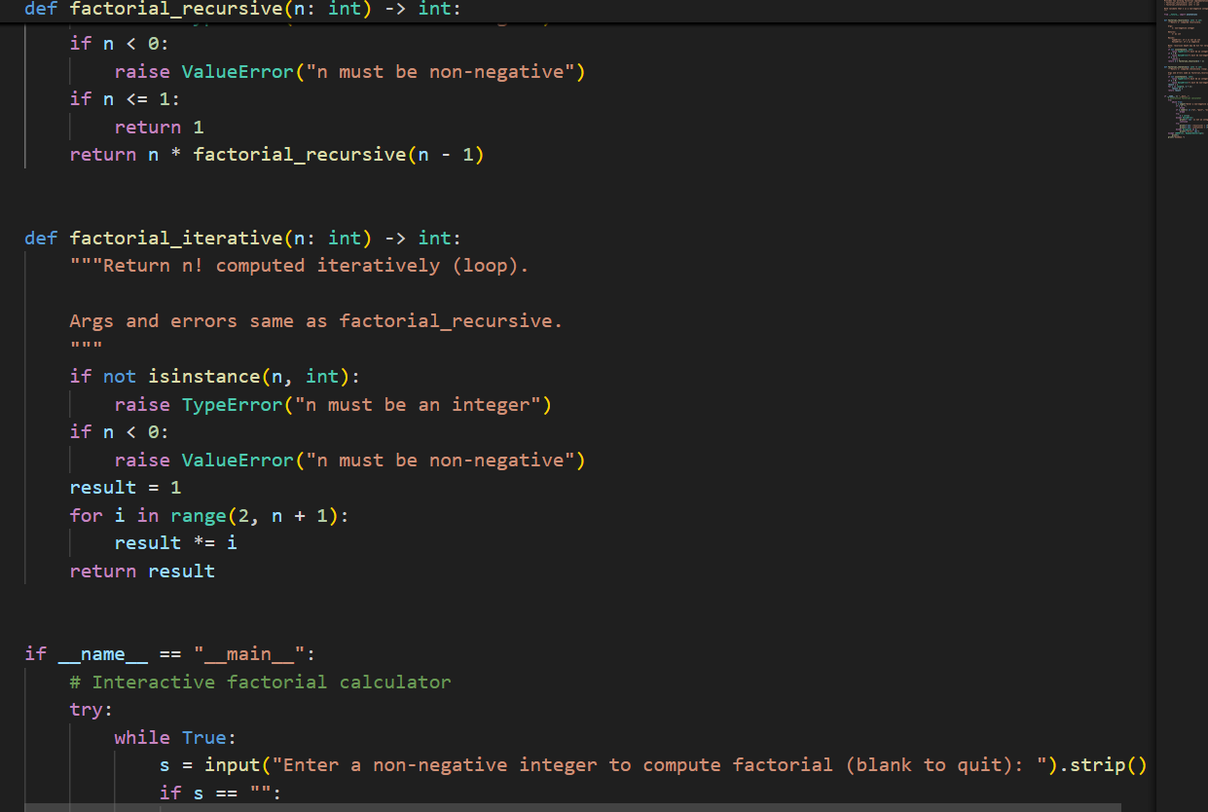

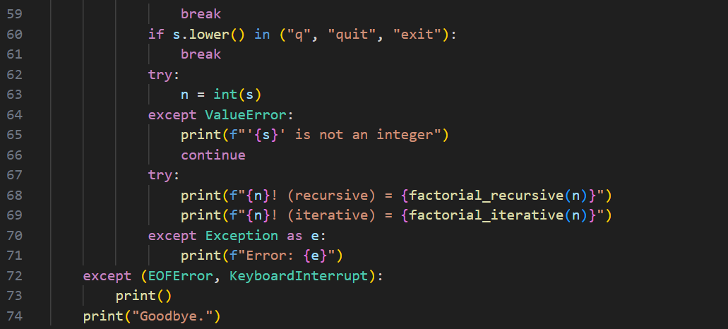

**OUTPUT:**

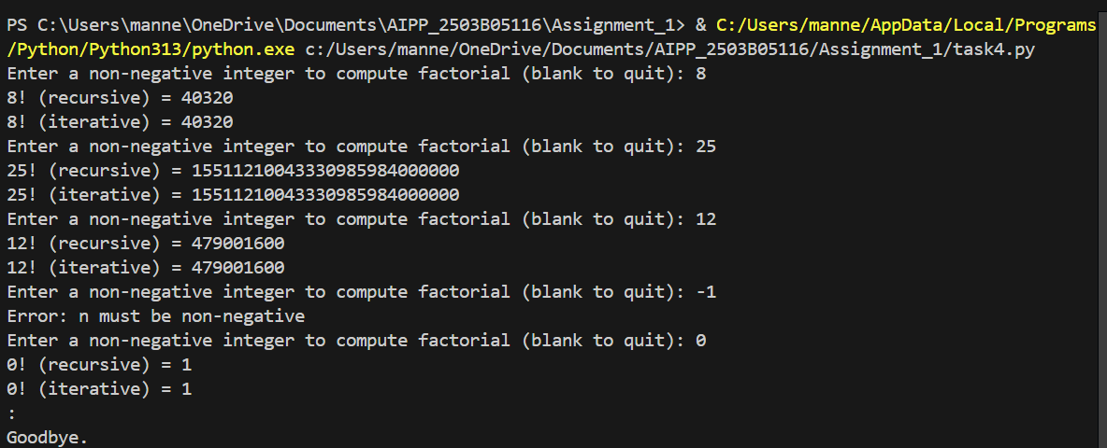

**Task Description#5**  
● Use Copilot to find the largest number in a list. Assess code quality and efficiency.  
**Expected Output#5**  
● A valid function with your review

**Prompt_1:**

Create a function to find the largest number in a list where the list need to be taken from keyboard.

**CODE:**

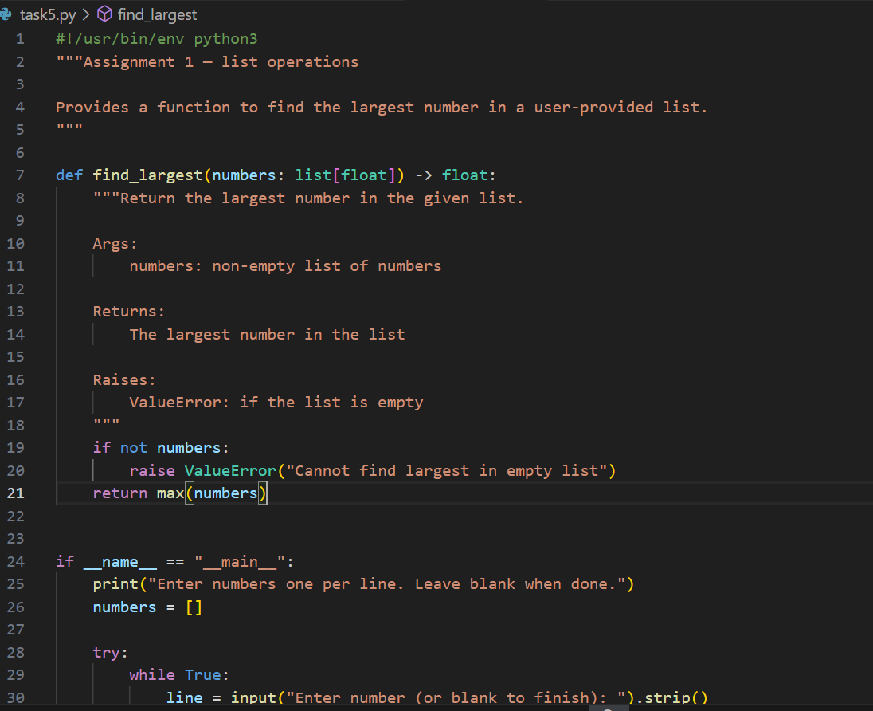

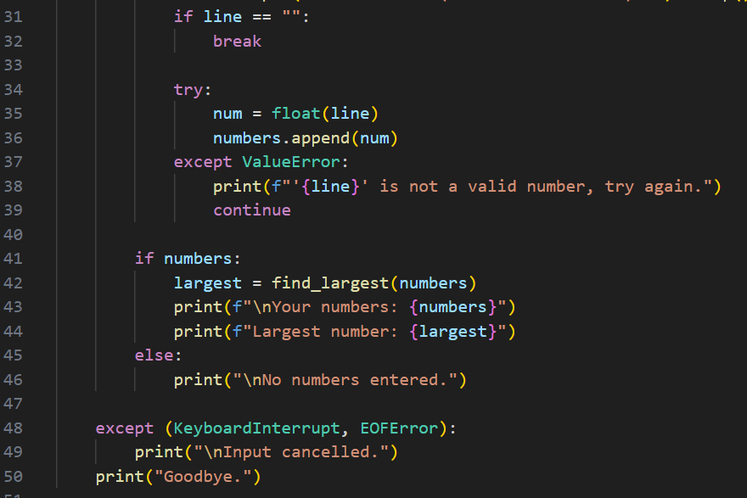

**OUTPUT:**

