**AI Assisted Problem Solving Using Python**

NAME : MANNE EVANCY

HT.NO : 2503B05116

DATE : 28-10-2025

Program Name: M.Tech (CSE)

**Lab 2: Exploring Additional AI Coding Tools – Gemini (Colab) and Cursor AI**

**Task Description#1**● Use Google Gemini in Colab to write a function that reads a CSV file and calculates  
mean, min, max. **Expected Output#1**●Functional code with output and screenshot

**Prompt_1:**

Write a function that reads a CSV file and calculates mean, min, max. Create the CSV file.

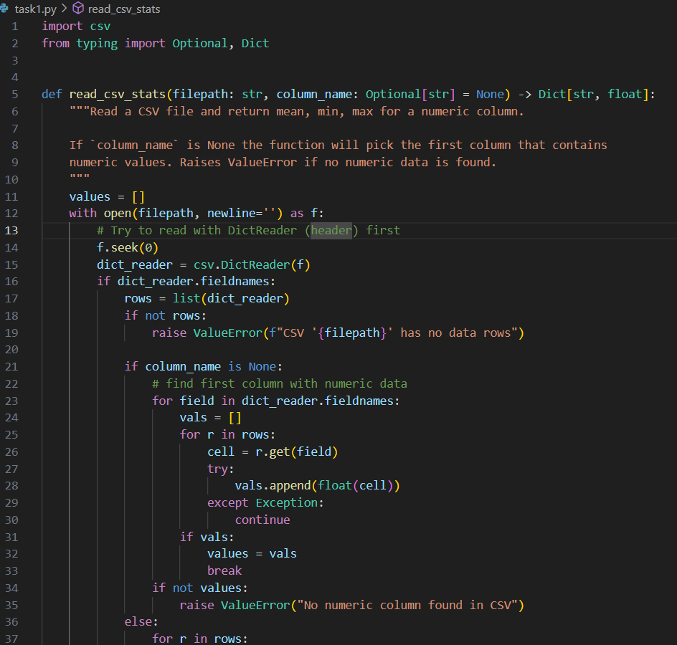**CODE:**

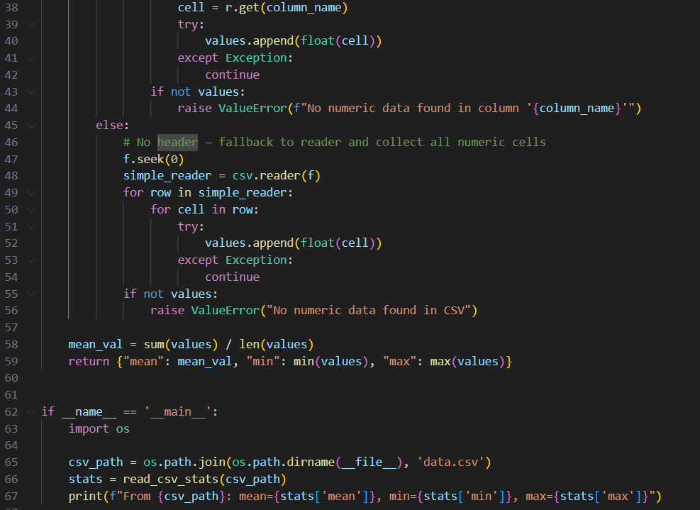

**OUTPUT:**



**Task Description#2**● Compare Gemini and Copilot outputs for a palindrome check function. **Expected Output#2**● Side-by-side comparison and observations

**Prompt_1:** Generate the code to check whether the given string is palindrome or not.

**CODE:**

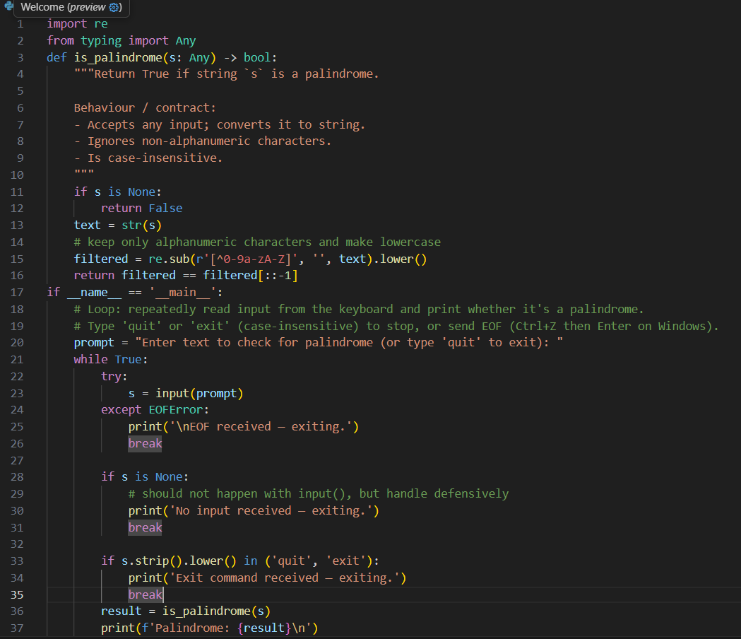

**OUTPUT:**

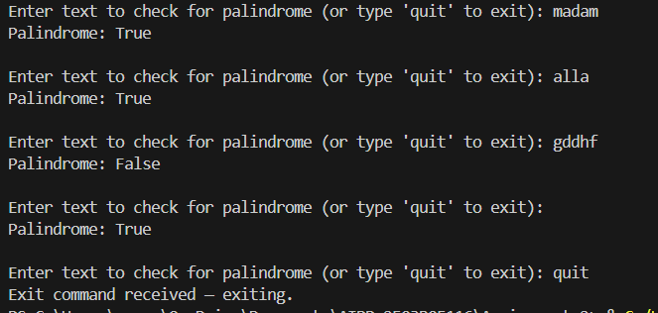

**Task Description#3**● Ask Gemini to explain a Python function (to calculate area of various shapes) line by  
line.. **Expected Output#3**● Detailed explanation with code snippet

**Prompt :** Create a python function to calculate area of various shapes

**CODE:**

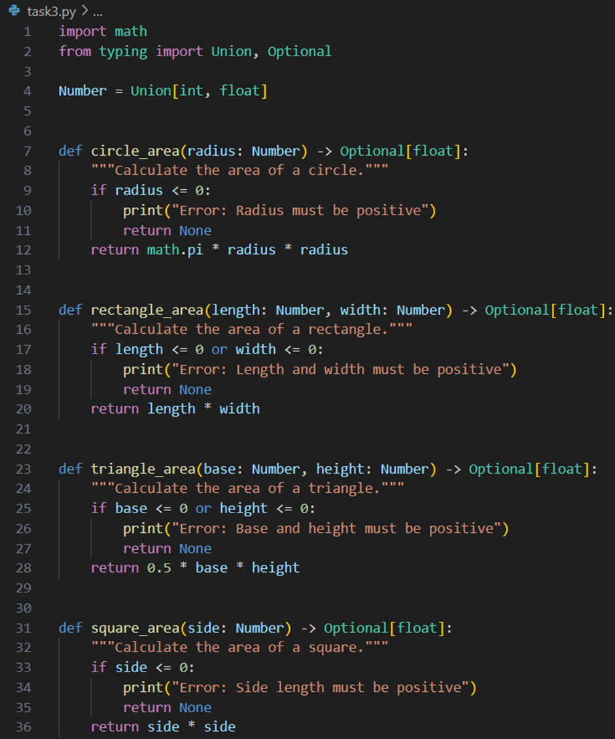

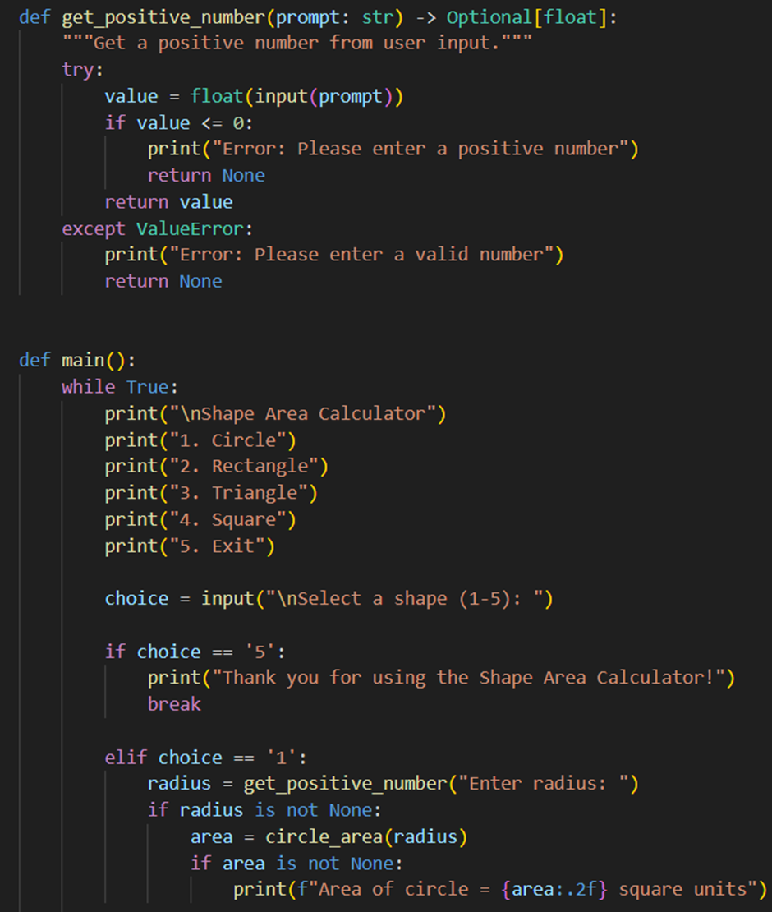

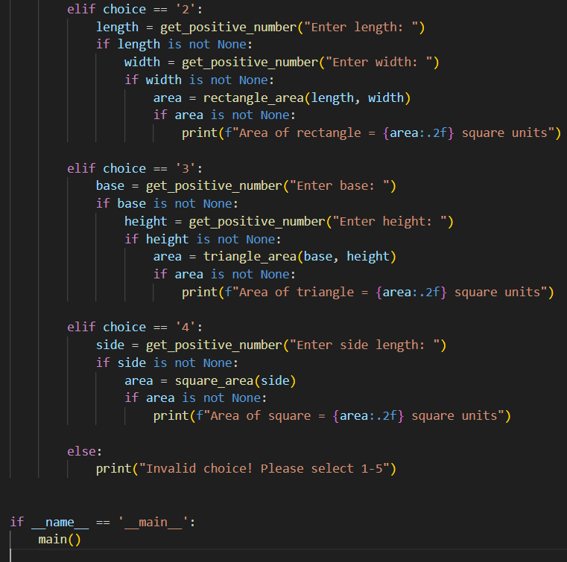

**OUTPUT:**

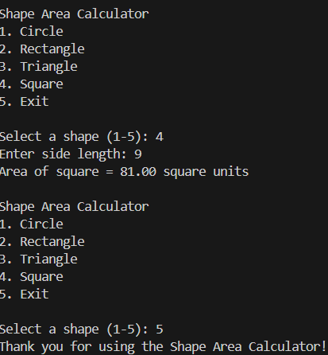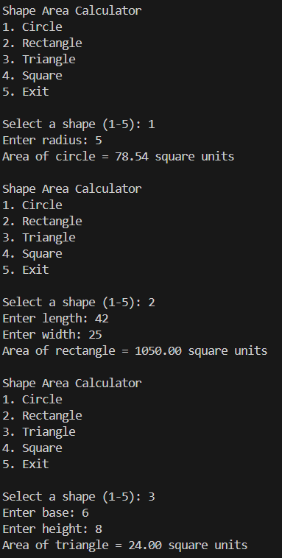

**Task Description#4**● Install and configure Cursor AI. Use it to generate a Python function (e.g., sum of  
squares). **Expected Output#4**● Screenshots of working environments with few prompts to generate python code

**Prompt :** Generate a python function to calaculate sum of squares

CODE :

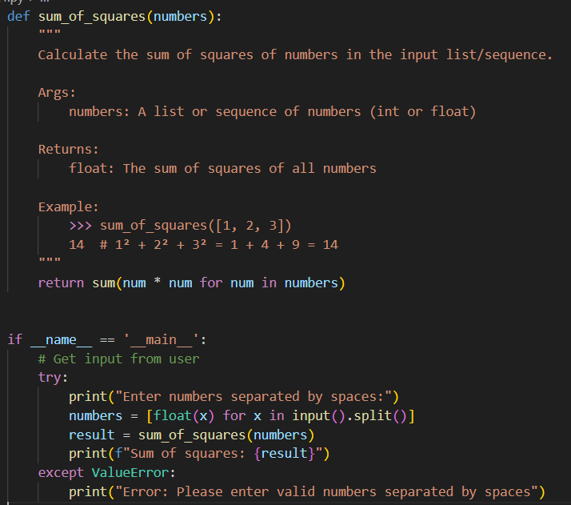

**OUTPUT:**

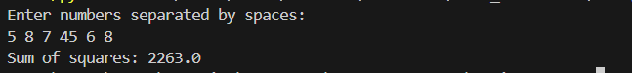

**Task Description#5**● Student need to write code to calculate sum of odd numbers and even numbers in the  
list **Expected Output#5**● Refactored code written by student with improved logic

**Prompt:** Generate the python code to calculate sum of odd numbers and even numbers in the list

**CODE :**

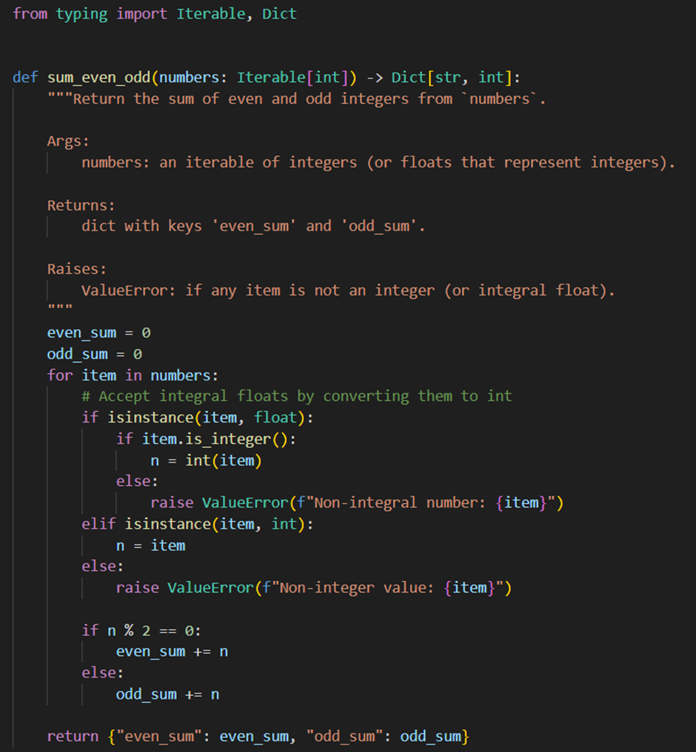

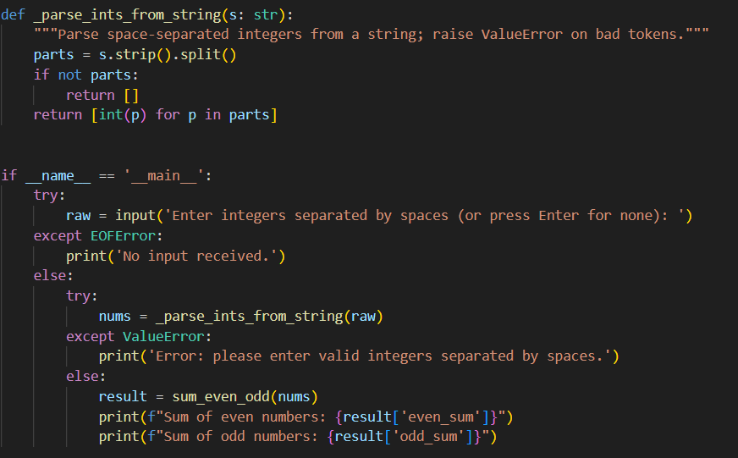

**OUTPUT:**

