**AI Assisted Problem Solving Using Python**

NAME : MANNE EVANCY

HT.NO : 2503B05116

Program Name: M.Tech (CSE)

**Lab 3 : Application for TGNPDCL**

**Objective:**

Build an application using Python program for TGNPDCL, to generate the bill based on energy consumption and type of customer with the help of AI tools. Build a python application as per below instructions  
• Read all the required data like PU,CU and Type of customer  
• Calculate bill amount based on number of units consumed, type of customer and other charges  
• Finally print the values of EC(Energy Charges),FC(Fixed Charges),CC(Customer Char-ges),ED(Electricity Duty Charges),bill as per expected output

**Requirements:**  
• VS Code with Github Copilot and/or Google Colab with Gemini  
• Students should bring power bill from their home  
Deliverables:  
• Print energy bill for given inputs and verify with bill taken by students

**Prompt:**

Generate a python program for TGNPDCL, to create a bill based on energy consumption and type of customer. Read all the required data like PU,CU and Type of customer , Calculate bill amount based on number of units consumed, type of customer and other charges. Finally print the values of EC(Energy Charges),FC(Fixed Charges),CC(Customer Charges),ED(Electricity Duty Charges) and Total Bill.

**CODE:**

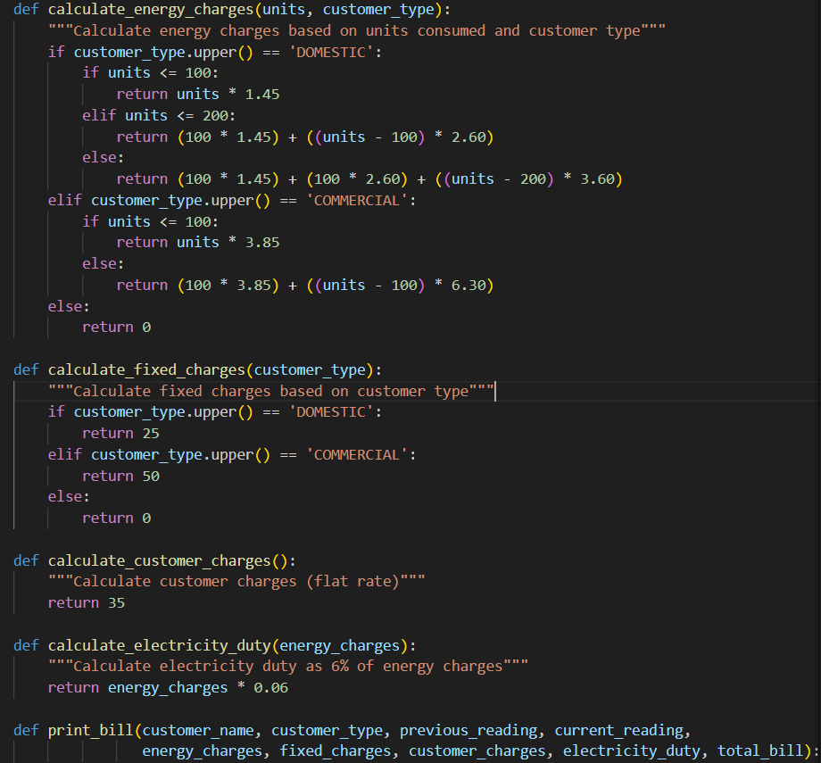

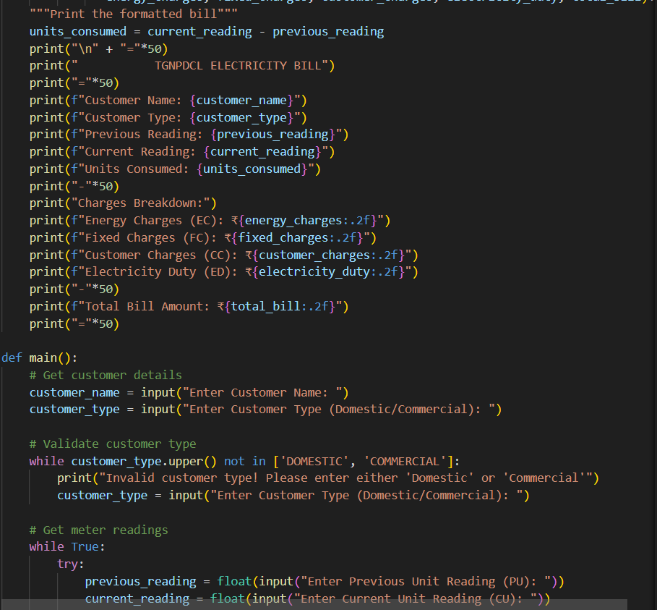

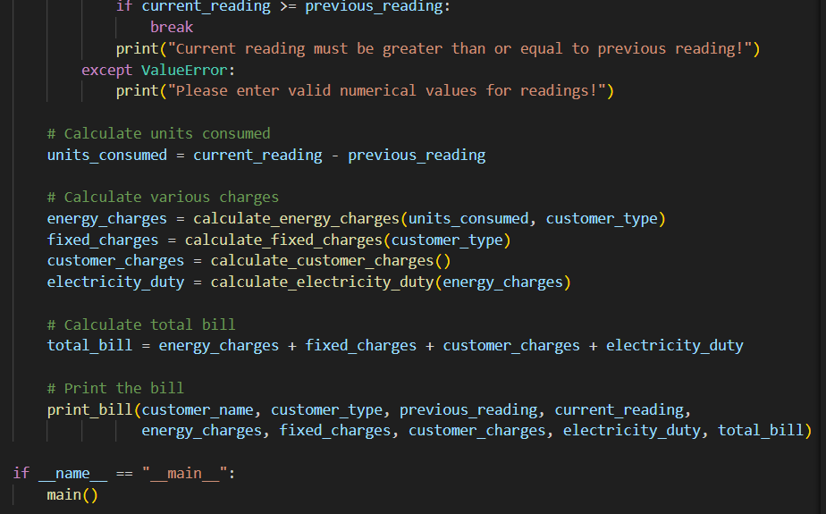

**OUTPUT:**

