AI Assisted Problem Solving Using Python
Name: Manne Evancy
Mtech – 1st Year
HTNO: 2503B05116
Lab 9: Documentation Generation: Automatic documentation and code comments
Task Description-1 Basic Docstring Generation
· Write python function to return sum of even and odd numbers in the given list.
· Incorporate manual docstring in code with Google Style
· Use an AI-assisted tool (e.g., Copilot, Cursor AI) to generate a docstring describing the function.
· Compare the AI-generated docstring with your manually written one.
Expected Outcome-1: Students understand how AI can produce function-level documentation.
Prompt: Generate the python function to return sum of even and odd numbers in the given list.

CODE_1(MANUAL):
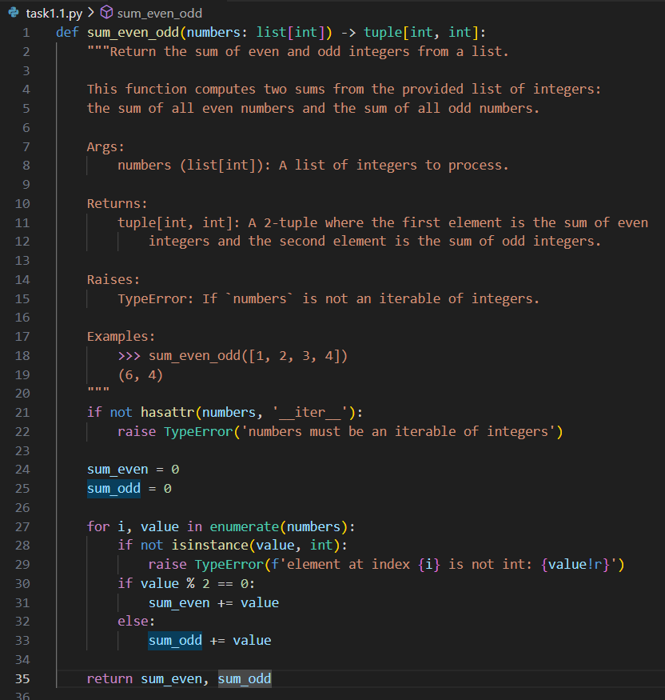

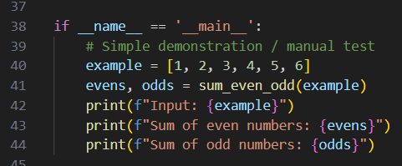
CODE_2:
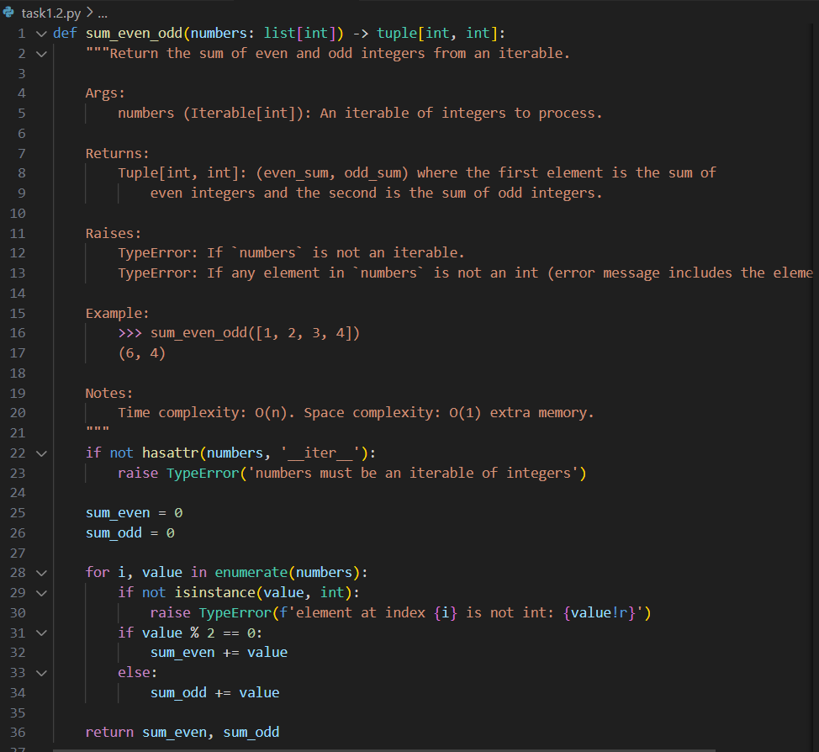
OUTPUT_1:
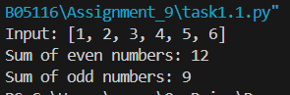
Comparison: Manual vs. AI-Generated Docstring
The manually written docstring used list[int] as the parameter type and provided a verbose description. The AI-generated docstring improved upon it by:
(1) using a more general Iterable[int] type, which matches the actual implementation that accepts any iterable;
(2) separating the two TypeError cases (not iterable vs. element not int) for clarity;
(3) adding complexity notes (O(n) time, O(1) space) for efficiency reference; and
(4) using slightly more concise wording while maintaining all key information. The combined version blends both strengths: accurate type annotations, clear error cases, helpful complexity notes, and readable structure—making it more precise and practical than either version alone.
Task Description-2 Automatic Inline Comments
· Write python program for sru_student class with attributes like name, roll no., hostel_status and fee_update method and display_details method.
· Write comments manually for each line/code block
· Ask an AI tool to add inline comments explaining each line/step.
· Compare the AI-generated comments with your manually written one.
Expected Output-2: Students critically analyze AI-generated code comments.

Code-1:
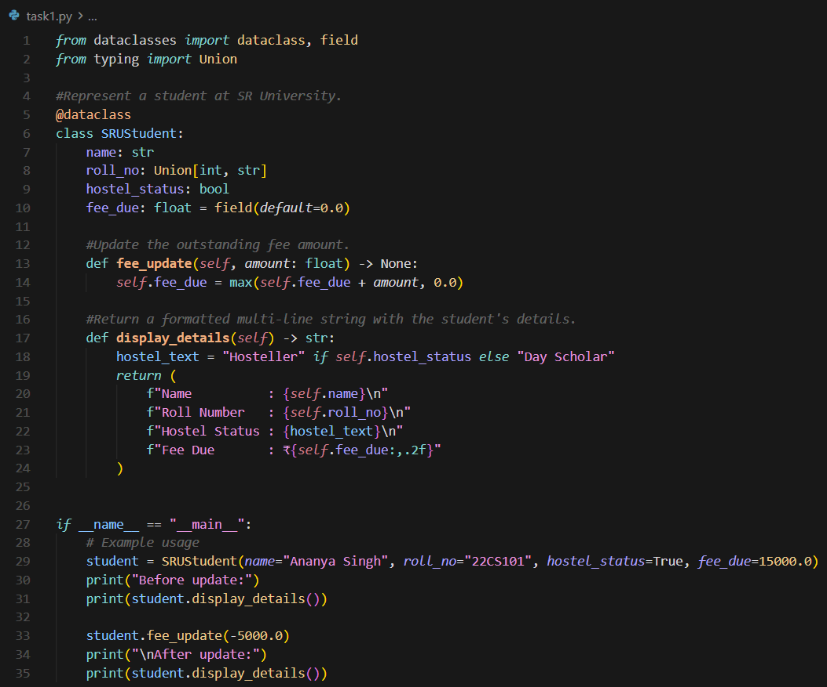
Code-2
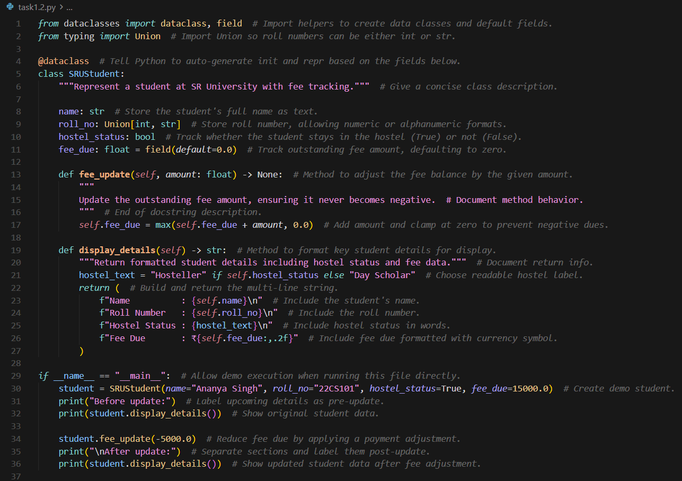
OUTPUT:
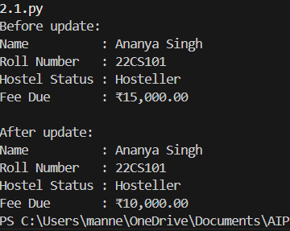
Explanation:
Manual comments employs minimal, structural comments placed only above class and method definitions with no inline explanations or docstrings, assuming readers have deep domain knowledge. In contrast, AI generated comments uses comprehensive, line-by-line comments that explain not just what the code does but why—including import purposes, decorator functions, field constraints, method behavior with docstrings, and inline logic explanations.
Task Description-3
· Write a Python script with 3–4 functions (e.g., calculator: add, subtract, multiply, divide).
· Incorporate manual docstring in code with NumPy Style
· Use AI assistance to generate a module-level docstring + individual function docstrings.
· Compare the AI-generated docstring with your manually written one.
Expected Output-3: Students learn structured documentation for multi-function scripts
Code-1:
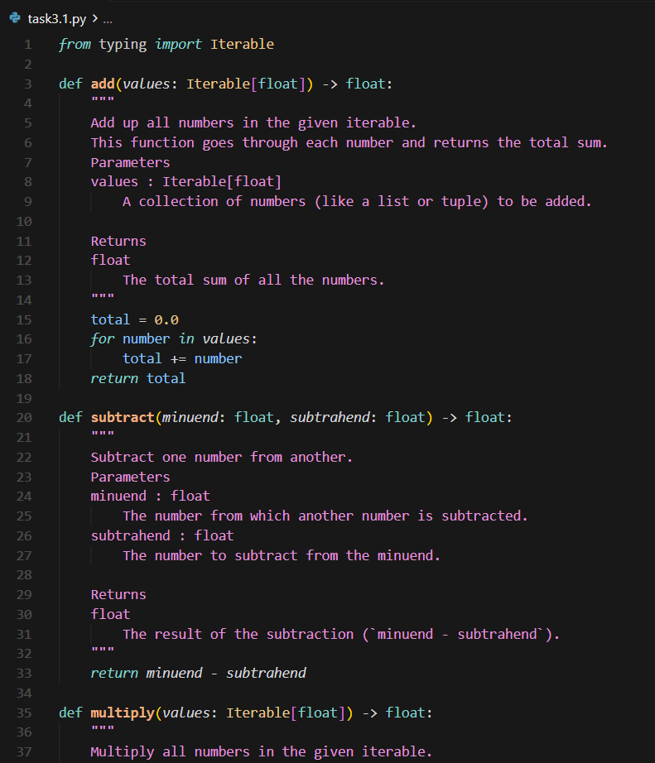
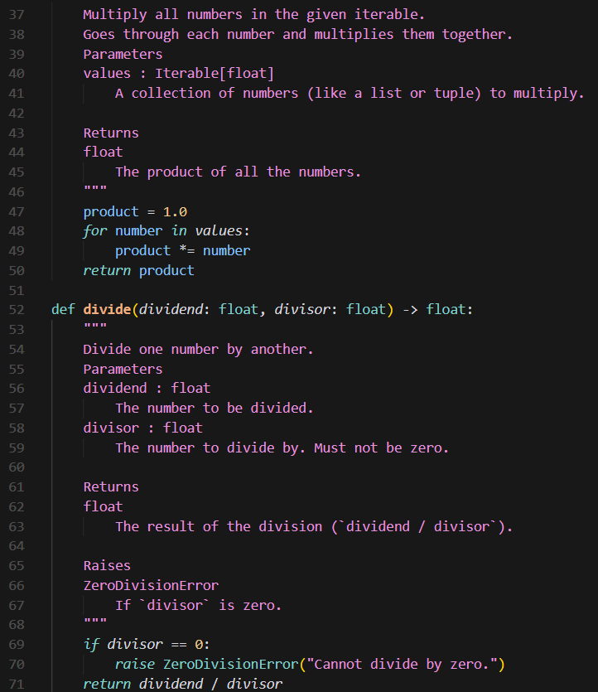
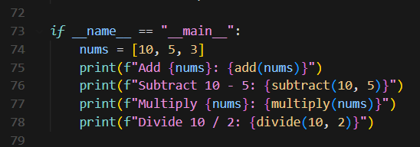

Code-2:
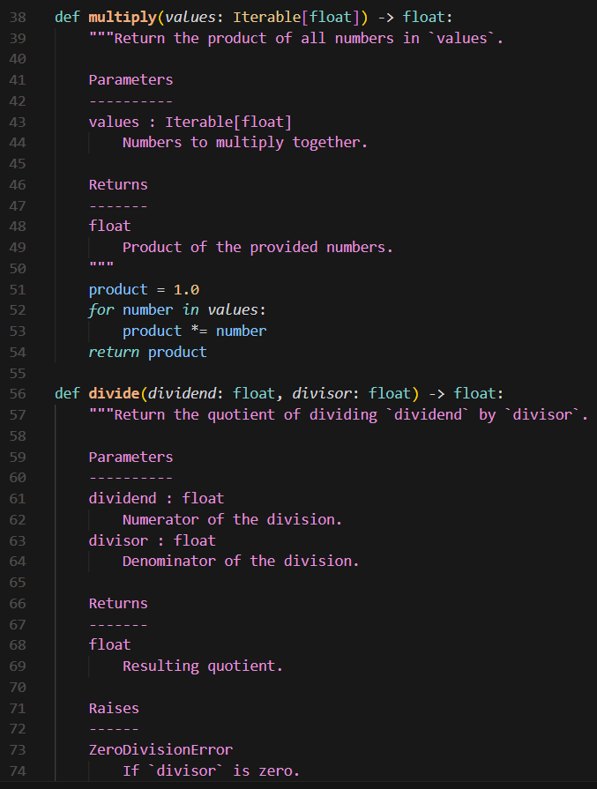
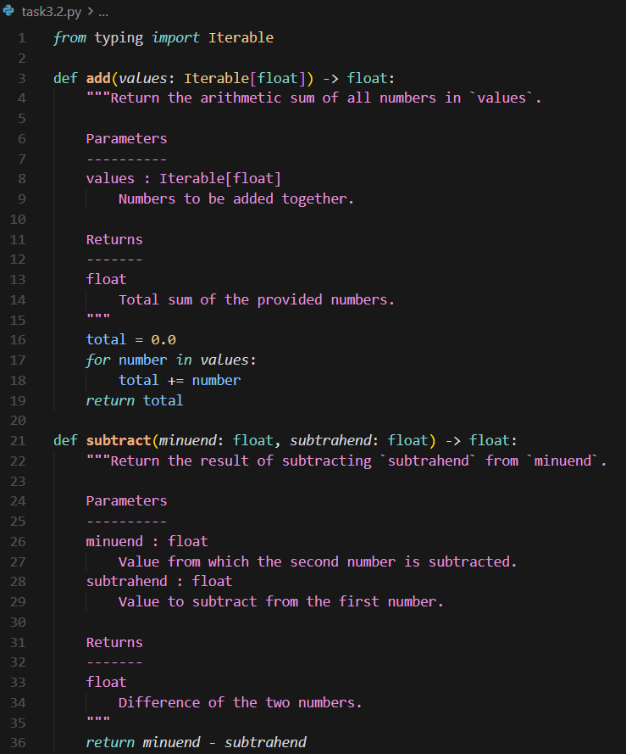

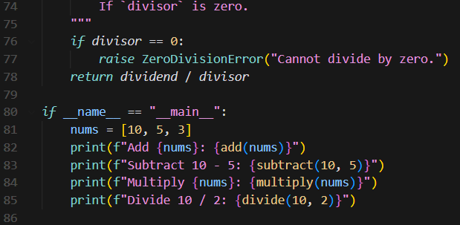
OUTPUT:
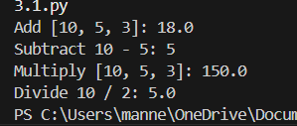
EXPLANATION:
Manual comments uses verbose, narrative NumPy-style docstrings with conversational explanations while AI generated comments uses polished, concise NumPy-style docstrings with one-line summaries and proper dashed section separators (Parameters, Returns, Raises). Manual comments are more beginner-friendly but less formal; AI Generated comments are more professional, consistent, and scannable. Both follow NumPy conventions, but AI is cleaner format with minimal, technical descriptions and proper formatting is superior for maintenance and readability.

Push documentation whole workspace as .md file in GitHub Repository

