AI Assisted Problem Solving Using Python

NAME : MANNE EVANCY
HT.NO : 2503B05116
Program Name: M.Tech (CSE)
Lab 6: AI-Based Code Completion – Classes, Loops, and Conditionals

Task Description#1 (Classes)
• Use AI to complete a Student class with attributes and a method.
• Check output
• Analyze the code generated by AI tool
Expected Output#1
• Class with constructor and display_details() method
Prompt: Create a student class with attritubes , constructor and display_details() method
CODE:
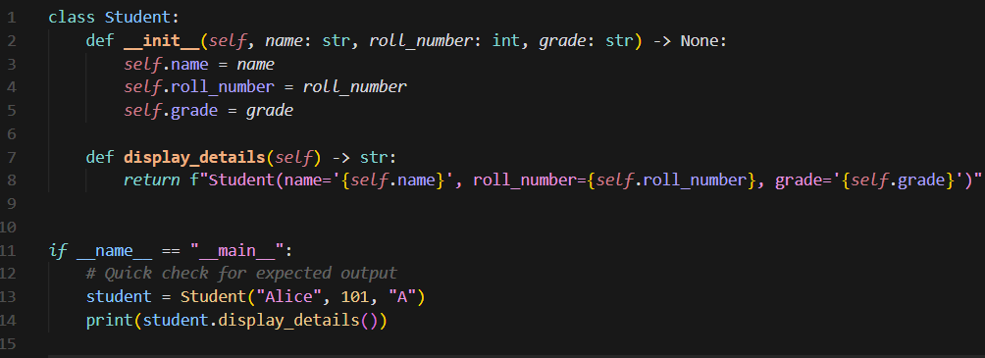
OUTPUT:

Task Description#2 (Loops)
• Prompt AI to complete a function that prints the first 10 multiples of a number using a
loop.
• Analyze the generated code
• Ask AI to generate code using other controlled looping
Expected Output#2
• Correct loop-based implementation
Prompt_1:
Complete a function that prints the first 10 multiples of a number using a loop.
Prompt_2:
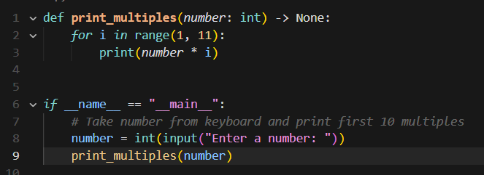
Generate the code using other controlled looping
CODE_1:

OUTPUT_1:
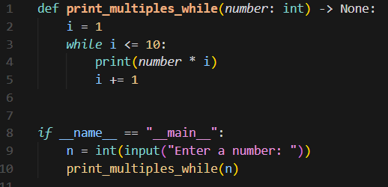
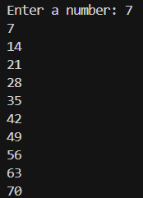
CODE-2:

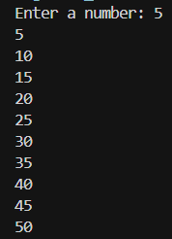
OUTPUT-2:

Task Description-3 (Conditional Statements)
· Ask AI to write nested if-elif-else conditionals to classify age groups.
· Analyze the generated code
· Ask AI to generate code using other conditional statements
Expected Output-3
· Age classification function with appropriate conditions and with explanation
Prompt:
Write nested if-elif-else conditionals to classify age groups.
CODE:
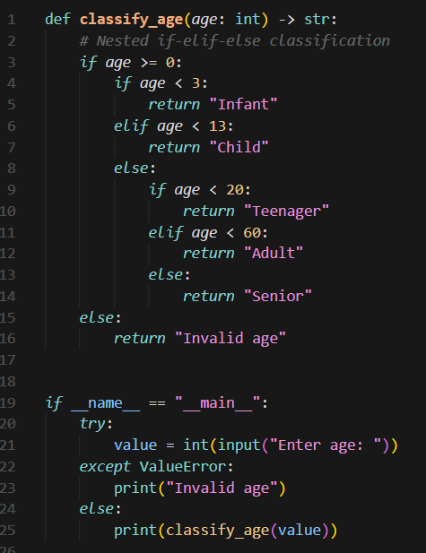
OUTPUT:

Prompt_2:
Using other looping statement

CODE_2:

OUTPUT_2:
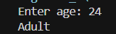
Task Description#4 (For and While loops)
• Generate a sum_to_n() function to calculate sum of first n numbers
• Analyze the generated code
• Get suggestions from AI with other controlled looping
Expected Output#4
• Python code with explanation

Prompt:
Generate a sum_to_n() function to calculate sum of first n numbers using 2 different looping statements.

CODE:
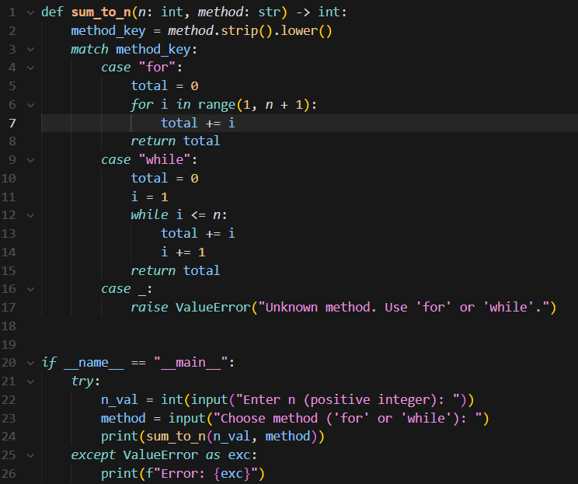
OUTPUT:
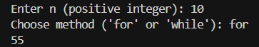
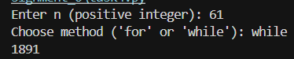
Task Description#5 (Class)
• Use AI to build a BankAccount class with deposit, withdraw, and balance methods.
• Analyze the generated code
• Add comments and explain code
Expected Output#5
• Python code with explanation
Prompt:
Build a BankAccount class with deposit, withdraw, and balance methods.

CODE:
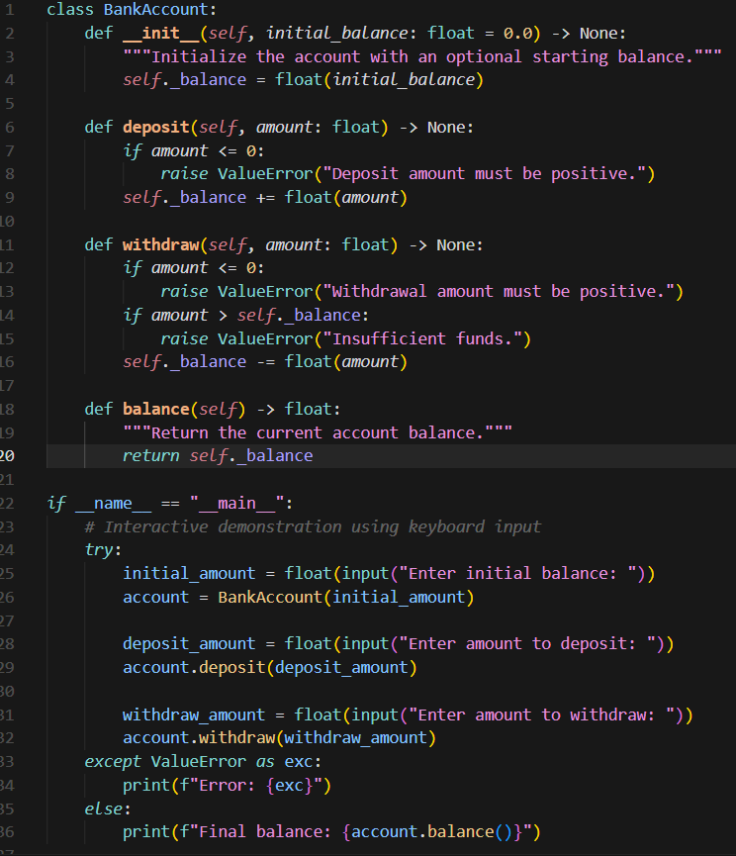
OUTPUT:
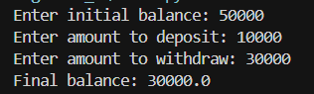
Explanation:
Simple bank account model supporting deposits, withdrawals, and balance inquiry.

