AI Assisted Problem Solving Using Python

NAME : MANNE EVANCY
HT.NO : 2503B05116
Program Name: M.Tech (CSE)
Lab 7: AI-Error Debugging with AI: Systematic approaches to finding and fixing bugs
Task Description#1
● Paste a function with a missing colon (add(a, b)), and let AI fix the syntax error.
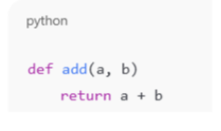
Expected Output#1
● Corrected function with syntax fix
Prompt:
Correct the code
CODE:
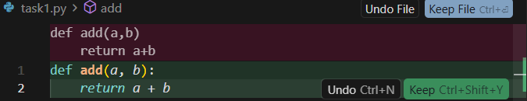
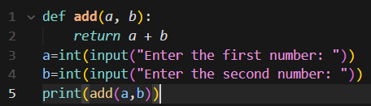
Output:
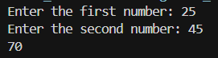

Task Description#2 (Loops)
● Identify and fix a logic error in a loop that causes infinite iteration.
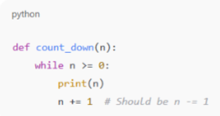
Expected Output#2
● AI fixes increment/decrement error
Prompt:
Fix the logic error in a loop

Corrected Code:
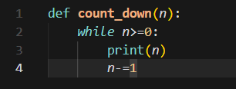
Task Description#3
● Debug a runtime error caused by division by zero. Let AI insert try-except.
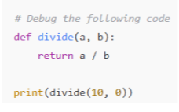
Expected Output#3
● Corrected function with safe error handling
Prompt:
Debug the error
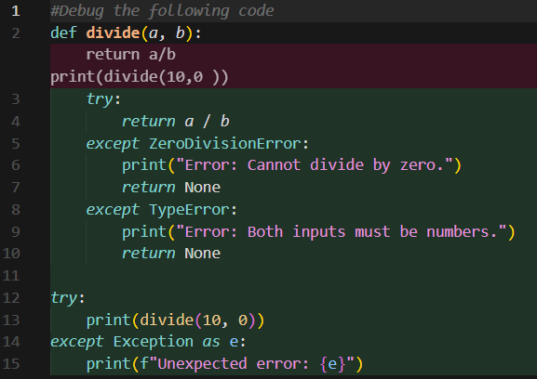
Corrected Code:
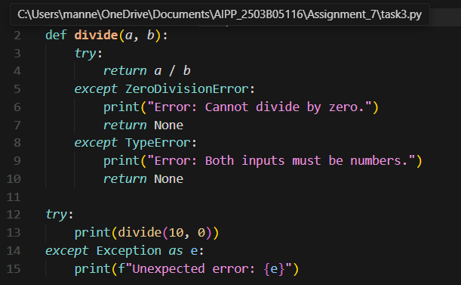
Task Description#4
● Provide a faulty class definition (missing self in parameters). Let AI fix it
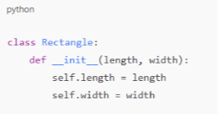
Expected Output#4
● Correct __init__() method and explanation
Prompt: Correct the code fault
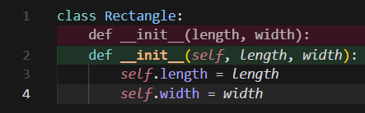
Corrected Code:
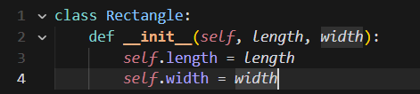
Explanation:
In Python, every instance method must take the instance itself as the first argument (conventionally named self). Without it, Python would treat length as the instance and push the real length into width, leaving no slot for the actual width argument—leading to a TypeError when constructing Rectangle(length, width). With self in place, the constructor correctly assigns self.length and self.width.
Task Description#5
● Access an invalid list index and use AI to resolve the Index Error.
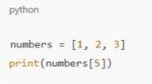
Expected Output#5
● AI suggests checking length or using safe access logic
Prompt:
Resolve the Error
CODE:
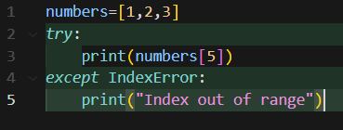
AI suggested a safe access logic to resolve the Index Error.

