AIPP LAB 18
Name: Manne Evancy
Hall Ticket No.: 2503B05116

Completed this Assignment using VS – Gemini Al Integration.
Task 1:
Translate a Simple Program (Python → JavaScript)
CODE:
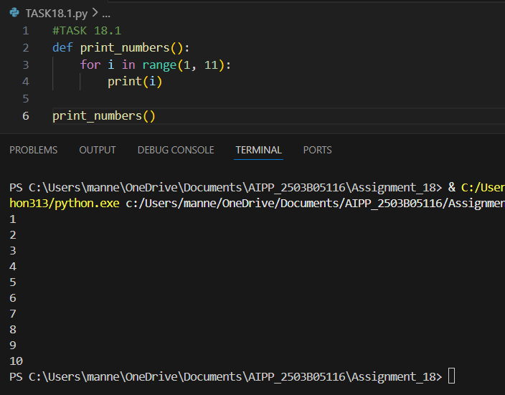

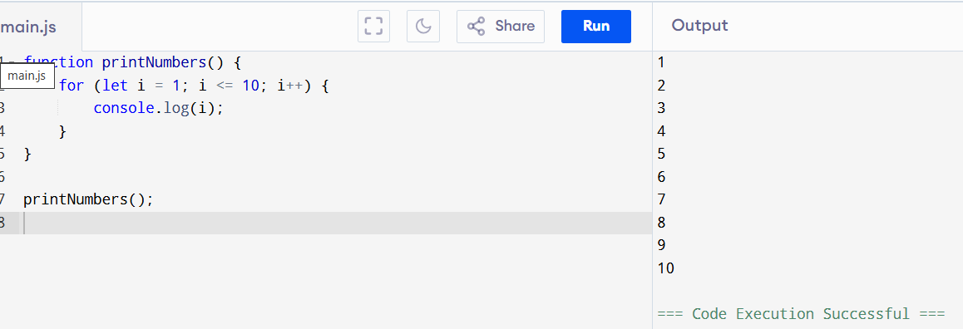
Task 2:
Convert Conditional Statements (Java → Python)
CODE:
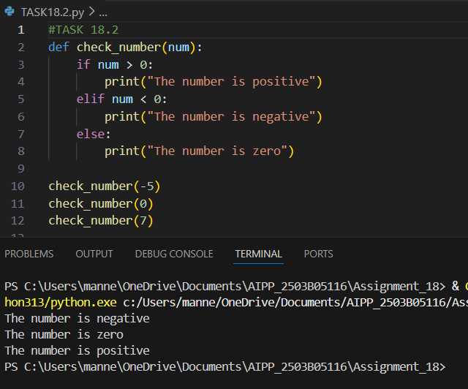

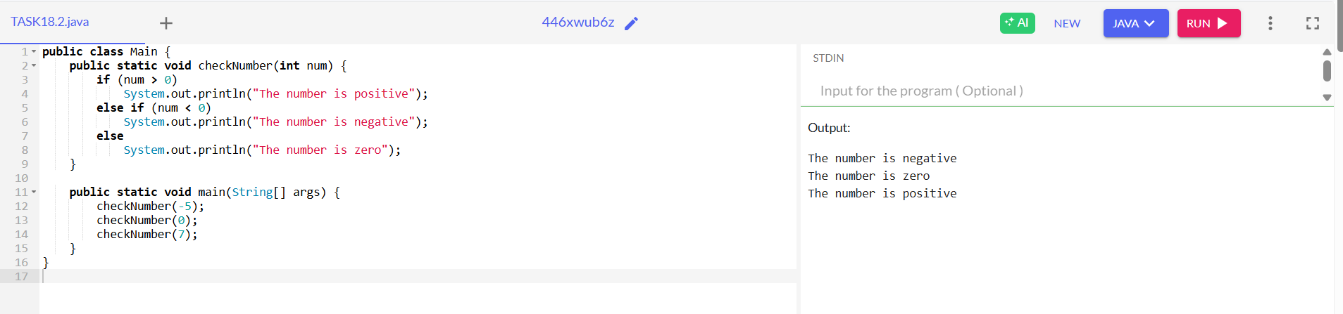

Task 3:
Translate Recursive Function (Python → C++)

CODE:
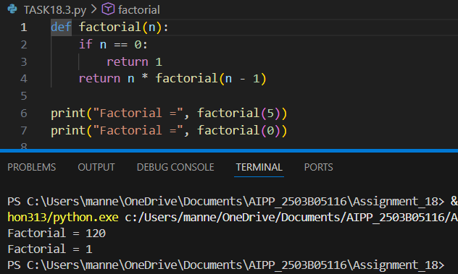

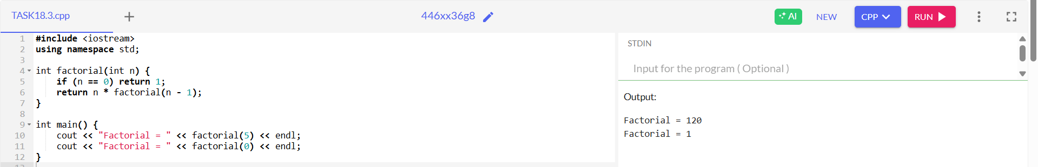
Task 4:
Data Structures with Functions (JavaScript → Python)
CODE:
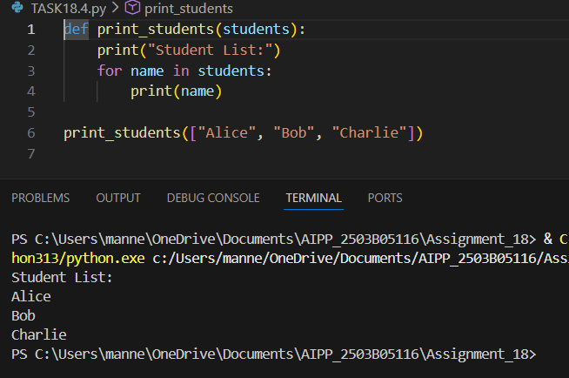
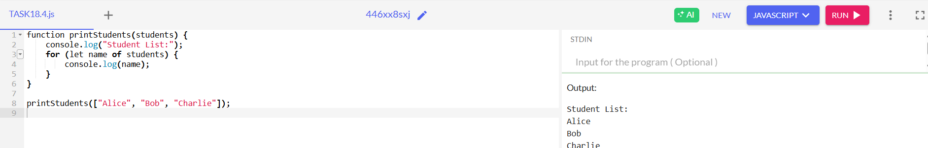
Task 5:
Class & Object Translation (Python → Java)
CODE:
