Name : MANNE EVANCY
HT.No: 2503B05116
Set No.: Set 1

Q1. Write a Python function to calculate the factorial of a number. Use a coding assistant and document how you refine your prompt to ensure the function handles negative input and zeros.
(Each question carries 5 marks)
Prompt: “Generate a Python function to calculate the factorial of a number.”
This returned a basic function, but it did not handle negative numbers and only checked for zero.
Modified Prompt (to improve the output):
“Write a Python function to calculate the factorial of a number. The function must handle zero correctly and must show an error message for negative input.”
By adding specific conditions to my prompt, I ensured that the output would handle all edge cases.
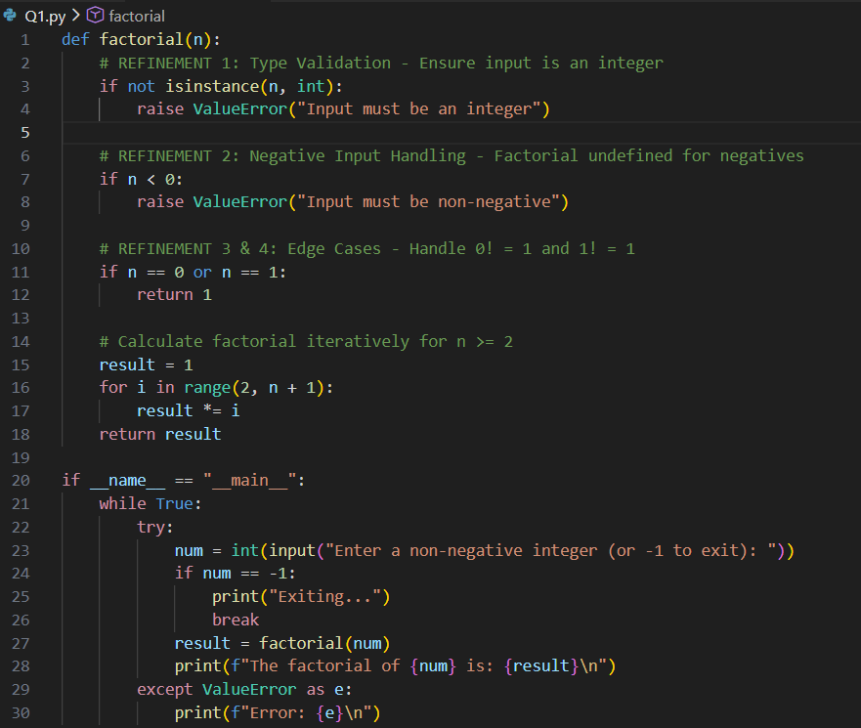
I improved my prompt by clearly mentioning edge cases (zero and negative numbers) so the AI assistant could generate a more accurate and safe function.
CODE:
.

OUTPUT:
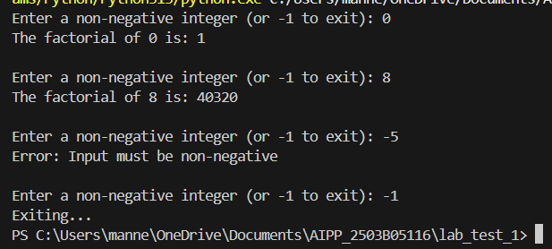

Q2. Given a list of student marks, compute the mean and list all students above the mean. Demonstrate zero-shot, one-shot, and few-shot prompts to guide an AI tool to solve this. Summarize the differences in approach.
(Each question carries 5 marks)

Zero-Shot Prompt: “Write Python code that takes a list of marks from the keyboard, calculates the mean, and prints all marks above the mean.”
Here,
- The AI generated correct code, but it had no guidance on handling variations, like different input formats or thinking step-by-step.
- It worked because the task is simple, but for more complex or edge-case scenarios, it might miss details (e.g., empty input, negative marks).
- No examples → AI relied purely on general knowledge, which may be incomplete for edge cases.
- Output is straightforward but less robust.
One-Shot Prompt:
“Example: For input [80 70], the mean is 75 and marks above mean are [80]. Now write code to do the same for any list of marks entered from the keyboard.”
- By giving one concrete example, the AI sees the pattern:
  - Convert input to integers.
  - Calculate the mean.
  - Select marks above the mean.
- AI now maps the general instruction to a specific example, reducing ambiguity.
- AI output is more predictable and aligned with your expectations.
- Less likely to miss a key step in simple scenarios.
- Only one example → may not generalize to very different input formats or tricky edge cases.
Few-Shot Prompt:
“Example 1: Input [80 70] → mean=75, above mean=[80]
Example 2: Input [60 90 70] → mean≈73.33, above mean=[90]
Write code to do the same for any list of marks entered from the keyboard.”
- Multiple examples reinforce the pattern and give AI confidence in the steps:
  - Input parsing.
  - Mean calculation.
  - Filtering above mean.
- AI is now more likely to handle variations in input values correctly.
- Stronger guidance → output is robust, accurate, and matches expectations.
- Better for tasks that require pattern recognition or repeated logic.
CODE:
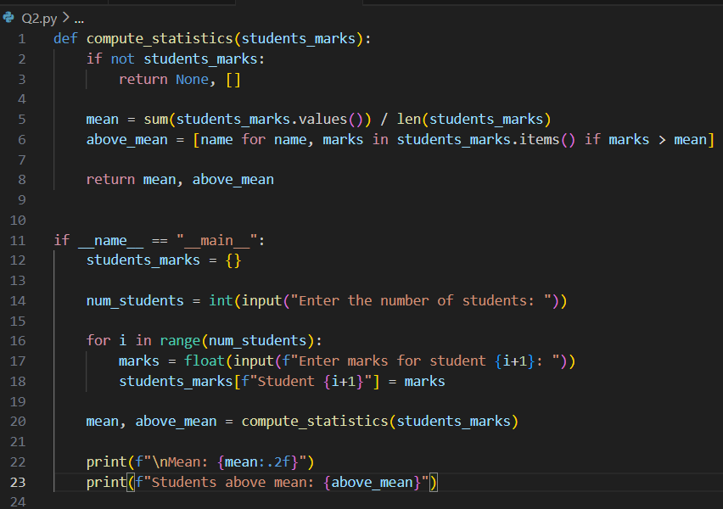
OUTPUT:
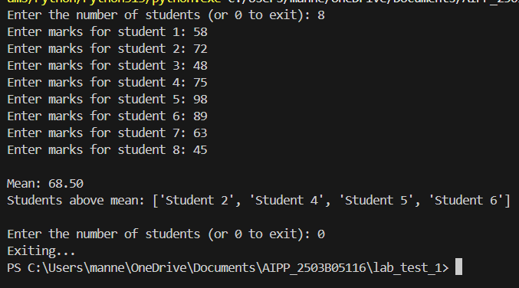
SUMMARY:
- Initial (zero-shot) prompts give a simple solution but may lack precision.
- Refined prompts (one-shot/few-shot) guide AI by showing patterns, which ensures the generated code matches the expected behavior.
- Adding examples reduces ambiguity and improves reliability, especially for tasks with input variations or step-wise logic.

