TRUF: Smart Turf Booking and Player Matching App
Book the Turf. Complete Your Squad. Play Without the Hassle.
A PROJECT REPORT
Submitted by
S EVANDLE BENNI | – | 241701015
PRAVEEN KESAHAVAN | – | 241701043

In fulfilment for the course
GE23627 – DESIGN THINKING AND INNOVATION
for the degree of
BACHELOR OF ENGINEERING IN
COMPUTER SCIENCE AND DESIGN

RAJALAKSHMI ENGINEERING COLLEGE
THANDALAM, CHENNAI
NOVEMBER 2026
RAJALAKSHMI ENGINEERING COLLEGE
THANDALAM, CHENNAI
BONAFIDE CERTIFICATE
Certified that this Report titled “TRUF: SMART TURF BOOKING AND PLAYER MATCHING APP” is the bonafide work of S EVANDLE BENNI (241701015) and PRAVEEN KESAHAVAN (241701043), who carried out the work under my supervision. Certified further that to the best of my knowledge, the work reported herein does not form part of any other thesis or dissertation on the basis of which a degree or award was conferred on an earlier occasion on these or any other candidates.
Certified further that the project contributes to SDG 3, SDG 8 and SDG 9, with a primary focus on SDG 3 – Good Health and Well-being, by making it easier for people to organise and take part in regular sports activity, while also supporting local sports venues through better slot utilisation and accessible digital innovation.

SIGNATURE OF HOD | SIGNATURE OF SUPERVISOR
Dr. S. Vinodh Kumar  Professor, The Head of the Department  Computer Science and Design  Rajalakshmi Engineering College  Chennai – 602105 | Dr.P.Revathy  Professor  Computer Science and Design  Rajalakshmi Engineering College  Chennai – 602105

ABSTRACT
Organising a casual football or cricket match is surprisingly difficult. Information about turfs, prices and availability is scattered across phone calls and different websites, players confirm and cancel through crowded WhatsApp groups, and the cost of the ground is often divided unevenly. When players drop out shortly before kick-off, the team is left incomplete and the booked slot may be wasted. TRUF: Smart Turf Booking and Player Matching App addresses these challenges through a single mobile-oriented platform that combines turf booking with substitute player matching.
TRUF allows users to search turfs by sport, location and time slot, view turf details, reserve an available slot, track the number of confirmed players, and search for substitutes when the squad is incomplete. A substitute request can be sent to an available player and, once accepted, the player is added to the match squad. The platform also proposes transparent cost sharing among team members and booking and match status updates, and it helps turf owners fill slots that would otherwise remain empty because of cancellations. The design follows a design-thinking approach based on three user personas: the college team captain, the individual player and the turf owner.
The report presents the problem analysis, objectives, proposed system, user personas, core features, the substitute-matching workflow, navigation flow, wireframes and mockups, the proposed system architecture and technology stack, the data schema, the implementation plan, the test plan and the future scope. The current work demonstrates the concept as a front-end prototype; live availability, online payment, notifications and automated location-based matching require a backend and database and are identified as future enhancements. No claims of real-world user adoption or measured performance are made in this report.
ACKNOWLEDGEMENT
Initially, we thank the Almighty for being with us through every walk of our lives and showering His blessings throughout the endeavour to complete this report. Our sincere thanks to our Chairman Mr. S. Meganathan, B.E., F.I.E., our Vice Chairman Mr. Abhay Shankar Meganathan, B.E., M.S., and our respected Chairperson Dr. (Mrs.) Thangam Meganathan, Ph.D., for providing us with the requisite infrastructure and facilities at their esteemed institution.
Our sincere thanks to Dr. S. N. Murugesan, M.E., Ph.D., our beloved Principal, for his kind support and the facilities provided to complete our project work successfully. We express our sincere thanks to Dr. S. Vinodh Kumar, Ph.D., Professor and Head of the Department of Computer Science and Design, for his valuable guidance and encouragement throughout the project. We convey our heartfelt gratitude to our internal project guide, [Internal Guide Name], [Designation], Department of Computer Science and Design, for continuous guidance, constructive suggestions and valuable support during the development of our project. We also thank the faculty members, our families and friends for their encouragement and support.
PRAVEEN KEASHAVAN ([Roll No.])
EVANDLE BENNI ([Roll No.])
TABLE OF CONTENTS
CHAPTER 1 INTRODUCTION 1
CHAPTER 2 LITERATURE SURVEY 7
CHAPTER 3 SYSTEM DESIGN 11
CHAPTER 4 DESIGN AND PROTOTYPE IMPLEMENTATION 24
CHAPTER 5 SOFTWARE IMPLEMENTATION 31
CHAPTER 6 METHODOLOGY AND ALGORITHMS 36
CHAPTER 7 TESTING AND RESULTS 40
CHAPTER 8 CONCLUSION AND FUTURE SCOPE 44
REFERENCES 46
LIST OF FIGURES
Figure 3.1 Overall system architecture of TRUF 13
Figure 3.2 Overall system flow diagram 14
Figure 3.3 Use case diagram of TRUF 15
Figure 3.4 Activity diagram for the turf booking workflow 16
Figure 3.5 Activity diagram for the substitute matching workflow 17
Figure 3.6 Sequence diagram for a substitute request 18
Figure 3.7 Entity relationship diagram of TRUF 23
Figure 3.8 App workflow and navigation flow of TRUF 19
Figure 4.1 Wireframe of the Home Screen 25
Figure 4.2 Wireframe of the Turf Listing Screen 26
Figure 4.3 Wireframe of the Player Matching Screen 27
Figure 4.4 Wireframe of the Booking Confirmation Screen 28
Figure 4.5 Mockups of the main TRUF screens 29
Figure 5.1 State transitions of booking and substitute request status 33
LIST OF TABLES
Table 1.1 Existing Methods versus Proposed TRUF Methods 4
Table 1.2 Mapping of Identified Problems to TRUF Features 4
Table 2.1 Comparative Analysis of Existing Sports Booking and Coordination Approaches 9
Table 3.1 User Personas and Their Needs 12
Table 3.2 Use Cases of TRUF 15
Table 3.3 Main Data Entities of TRUF 20
Table 3.4 Data Dictionary of the User and Turf Entities 21
Table 3.5 Data Dictionary of the Slot and Booking Entities 21
Table 3.6 Data Dictionary of the Player Profile, Match and Substitute Request Entities 22
Table 3.7 Relationships Between Entities 22
Table 4.1 Proposed Screens of the TRUF Prototype 24
Table 4.2 Proposed Design Guidelines for the Interface 29
Table 5.1 Proposed Technology Stack of TRUF 31
Table 5.2 Booking Status Values 32
Table 5.3 Substitute Request Status Values 33
Table 5.4 Form Validation Rules 34
Table 5.5 Error Conditions and System Responses 34
Table 6.1 Mapping of Design Thinking Stages to Project Work 36
Table 7.1 Test Environment 40
Table 7.2 Functional Test Cases 40
Table 7.3 Validation and Boundary Test Cases 41
Table 7.4 Usability Test Tasks 42
Table 7.5 Traceability Between Objectives and Tests 42
LIST OF ABBREVIATIONS
S.NO | ABBREVIATION | EXPANSION
1 | API | Application Programming Interface
2 | CSS | Cascading Style Sheets
3 | CRUD | Create, Read, Update and Delete
4 | DBMS | Database Management System
5 | ER | Entity Relationship
6 | HTML | HyperText Markup Language
7 | ID | Identifier
8 | JS | JavaScript
9 | PK / FK | Primary Key / Foreign Key
10 | SDG | Sustainable Development Goal
11 | UI | User Interface
12 | USP | Unique Selling Proposition
13 | UX | User Experience

CHAPTER 1
INTRODUCTION

1.1 General
Team sports such as football and cricket are popular among college students and amateur players, yet arranging a single match involves many small tasks: finding a turf, checking whether a time slot is free, confirming the booking, making sure enough players turn up and sharing the cost. These tasks are normally handled through phone calls, separate websites and messaging groups, which makes the process time-consuming and error-prone.
TRUF: Smart Turf Booking and Player Matching App is a mobile application concept that brings two services together on one platform: turf booking and substitute player matching. Its tagline, “Book the turf. Complete your squad. Play without the hassle.”, summarises the idea. Users can reserve a sports ground, and if some teammates are unavailable they can find extra players to complete the team.
Each part of the tagline has a meaning. Book the turf means that users can find and reserve a sports ground. Complete your squad means that users can find extra players when teammates are unavailable. Play without the hassle means that users can avoid the usual difficulties of organising a match.

1.2 Background
In a typical situation, ten friends plan a football match but two of them cannot attend. The captain must search for a turf through calls or websites, then post messages in several WhatsApp groups to find two replacements, and finally collect money from everyone. Each of these steps happens in a different place. Turf owners face a related problem: when a team cancels at short notice, the slot remains empty and revenue is lost.
A design-thinking approach starts from the needs of the people involved [1], [2]. TRUF therefore considers three groups: college and amateur teams who need to organise matches quickly, individual players who want to join nearby matches that have vacant positions, and turf owners who want to manage bookings and fill unused slots.
The idea of a substitute player is central to the project. A substitute is a person who plays in place of a regular team member who cannot attend. In informal sports this role is usually filled by asking friends of friends, which depends on personal contacts and is slow when the match is only a few hours away. TRUF treats the substitute as a first-class part of the booking journey instead of an afterthought.

1.3 Problem Statement
Organising a sports match today suffers from the following problems:
- Fragmented discovery: turf details, availability and prices are spread across different places, so users spend a long time searching.
- Last-minute dropouts: players cancel shortly before the match, leaving the team incomplete.
- WhatsApp group chaos: confirmations and availability messages are scattered, making it hard to know who is actually coming.
- Uneven cost sharing: dividing the turf cost among friends is confusing, and some members forget to pay.
- Uncertain booking status: users are often unsure whether a turf is truly available or whether the booking is confirmed.
TRUF proposes to reduce these problems through a single connected platform, so that the user does not have to move between phone calls, websites and chat groups to complete one match.

1.4 Motivation
The motivation for TRUF comes from the everyday experience of student and amateur sports teams. Turf booking and player finding are closely related, because the need for substitutes usually appears only after a slot has been booked. Treating them as separate activities forces users to switch between tools at the most stressful moment.
The project also gave the team an opportunity to apply design-thinking methods, such as empathising with users, defining problems, ideating solutions and prototyping screens, to a practical everyday problem. It combines interface design, workflow design, data modelling and testing in a single application, which makes it a suitable project for the course Design Thinking and Innovation.

1.5 Objectives
The primary objective of TRUF is to simplify the organisation of sports matches by combining turf booking with substitute player matching. The specific objectives are:
- To streamline slot reservations by making turf search, slot selection and booking confirmation simple.
- To automate substitute matching by helping teams find replacement players when members are unavailable.
- To provide a transparent cost split by dividing the total turf amount among players equally or by an agreed method.
- To reduce team uncertainty by tracking who is attending and whether substitutes are confirmed.
- To maximise venue utilisation by helping turf owners fill slots that might otherwise stay empty.
As an illustration of the cost-split objective, a turf costing Rs. 2,000 shared by 10 players gives an equal share of Rs. 200 per person. This is only an example of the concept; automatic collection of payments would require a payment feature that is part of the future scope.

1.6 Scope and Limitations
The scope of this project covers problem analysis, user personas, feature definition, the substitute-matching workflow, navigation flow, wireframes and mockups, a proposed system architecture and data schema, a front-end prototype and a test plan. The prototype simulates the search, booking and substitute-request process so that the user journey can be demonstrated and evaluated.
The project has limitations. Real login, permanent booking records, live slot availability, payment processing and live matching between real users require a backend server and database, which are proposed but not part of the front-end prototype. The user personas are representative profiles created for design purposes and should not be read as the results of large-scale user research. Features listed under future scope are not claimed to be implemented in the current version.

1.7 Existing System
At present, teams use a combination of methods. Turfs are booked by phone calls or through separate websites and applications. Players are found by posting in WhatsApp groups or asking friends. Costs are calculated manually and collected through individual payments. Dedicated sports platforms such as Playo and Hudle provide venue booking and, in some cases, player discovery [6], [7], so the problem is partly addressed by existing products, as discussed in Chapter 2.

1.8 Limitations of Existing Approaches
Informal methods depend on individual effort and offer no shared view of the booking, the squad and the cost. Confirmations are scattered, last-minute changes are difficult to communicate, and there is no structured way to ask an unknown player to fill a vacancy. Separate tools for booking and coordination also mean that information must be copied repeatedly between them.
For turf owners, a cancellation close to the start time is difficult to recover from, because there is no quick way to tell interested players that a slot has opened. These weaknesses motivate a workflow in which booking status, squad status and substitute requests are visible in one place.

1.9 Proposed TRUF System
TRUF is proposed as an integrated booking and player-matching platform. A user searches for a turf, selects an available slot, reserves the booking, checks the player count, searches for substitutes if players are missing, and manages the match details. Table 1.1 compares the existing and proposed methods in concept.
Table 1.1 Existing Methods versus Proposed TRUF Methods
Existing method | Proposed TRUF method
Phone calls or separate websites | Centralised turf discovery
Searching for players in WhatsApp groups | Substitute matching feature
Manual cost calculation | Cost-splitting support
Separate coordination | Connected booking journey

Table 1.2 shows how each problem identified in Section 1.3 is addressed by a feature of TRUF. Whether availability, payment and matching run on live data depends on the implementation stage; in the prototype these behaviours are simulated.
Table 1.2 Mapping of Identified Problems to TRUF Features
Problem | TRUF feature that addresses it
Fragmented discovery | Turf Listings with search by sport, location and time slot
Last-minute dropouts | Player Matching with substitute requests
WhatsApp group chaos | Match and Booking Updates showing player confirmations in one place
Uneven cost sharing | Cost Sharing that divides the total among players
Uncertain booking status | Slot Booking with clear booking status and confirmation screen

1.10 Advantages and Applications
The main advantage of TRUF is that it does not stop at booking a turf; it also helps users complete their team by finding substitute players. This brings convenience, because separate platforms for turf and player search are no longer needed; faster coordination, because missing players can be identified and replaced quickly; better team readiness, because the squad status is visible before the match; and better slot utilisation for owners, because cancelled slots can be filled.
Potential applications include college sports clubs, amateur football and cricket teams, neighbourhood groups, corporate recreation teams and turf businesses that want to reduce empty slots.

1.11 Design Thinking Applied to TRUF
The project followed the five stages of design thinking [1], [2]. In the empathise stage, the team considered the experience of a team captain who must arrange everything, an individual player looking for a game, and a turf owner worried about empty slots. In the define stage, these experiences were turned into the five problems listed in Section 1.3. In the ideate stage, the idea of combining booking and substitute matching was developed into five core features.
In the prototype stage, wireframes and a front-end prototype were prepared so that the idea could be seen and tried. In the test stage, a test plan was prepared to check whether the prototype behaves as expected and whether users can complete the main tasks.

1.12 Sustainable Development Goals
TRUF relates to Sustainable Development Goal 3 (Good Health and Well-being) because it lowers the effort of organising sports, which encourages regular physical activity. It relates to SDG 8 (Decent Work and Economic Growth) because better slot utilisation can help small turf businesses. It relates to SDG 9 (Industry, Innovation and Infrastructure) because it applies digital technology to a local service. The contribution is indirect and has not been measured.

1.13 Organisation of the Report
Chapter 1 introduces the problem and objectives. Chapter 2 reviews related work and existing platforms. Chapter 3 presents the system design, requirements, personas, architecture, workflows and data schema. Chapter 4 describes the screens and design of the prototype. Chapter 5 describes the software implementation and technology stack. Chapter 6 explains the methodology and algorithms. Chapters 7 and 8 present testing and the conclusion.

CHAPTER 2
LITERATURE SURVEY

2.1 Introduction
This chapter reviews the design approach followed in the project, the usability principles that guide the interface, the technical ideas behind the proposed system, and the existing platforms that address sports venue booking and player discovery. The survey provides the foundation for identifying where TRUF fits among existing solutions.

2.2 Design Thinking
Design thinking describes a human-centred way of solving problems through empathy, problem definition, ideation, prototyping and testing [1], [2]. Brown argues that innovation should balance what people need, what is technically feasible and what is viable as a business [1]. TRUF follows this view: personas capture user needs, the proposed features address each identified problem, and the prototype allows ideas to be tried before a full system is developed.
The Stanford d.school process guide describes empathy and prototyping as the stages that keep a project grounded in real needs [2]. Prototypes are intentionally simple so that they can be changed quickly. This is the reason TRUF begins with a front-end prototype and leaves the backend for a later stage.

2.3 Usability and User Experience
Usability guidelines are important for a booking application. Nielsen's usability heuristics highlight visibility of system status, error prevention, consistency and a match between the system and real-world language [3]. These ideas are relevant to TRUF, for example in showing booking status clearly, preventing the selection of unavailable slots and validating incomplete forms.
Norman's discussion of everyday design stresses that users form a mental model of how a system works and that good design makes the possible actions visible [10]. In TRUF this suggests labelling the next step clearly at each screen, such as “Find substitutes” when the squad is short.
Garrett's layered model of user experience, from strategy and scope to structure, skeleton and surface, supports the move from requirements to wireframes and visual mockups [4]. The same order is followed in Chapters 3 and 4.

2.4 Mobile-First and Responsive Design
Booking a turf is often done on a phone, frequently while talking to friends. Mobile-first design starts the design from the small screen and then extends it to larger screens [9], [12]. Responsive web design uses flexible layouts and media queries so that the same page adapts to different screen widths [9]. TRUF adopts a single-column, card-based layout for mobile screens, which is described in Chapter 4.

2.5 Database Design
Relational database design represents a system as entities with attributes and relationships [5]. Each entity has a primary key, and relationships are expressed through foreign keys. Normalising the tables avoids repeating the same information in several places. For TRUF, the entities User, Turf, Slot, Booking, Player Profile, Match and Substitute Request form the conceptual schema presented in Chapter 3.

2.6 Client-Server Architecture
Web and mobile applications commonly separate the client, which presents information and collects input, from the server, which holds the business rules and the stored data [11]. This separation allows the interface and the server logic to change independently and allows many clients to share the same data. The three-layer view of TRUF (frontend, backend and database) is an application of this principle.

2.7 Matching and Filtering Approaches
Finding a suitable substitute can be seen as filtering a set of player profiles by conditions such as sport, availability and location. A rule-based filter is simple, transparent and easy to explain to users, and it can be implemented with an ordinary database query. More advanced recommendation methods could rank candidates by past reliability or skill level, but they need much more data. TRUF therefore proposes rule-based matching first and lists advanced matching as future scope.

2.8 Group Coordination and Cost Sharing
Group activities depend on everyone knowing the plan and their own responsibility. In informal groups, this information is carried in chat messages, which are easily buried. A shared status view, listing who has confirmed and who has paid, reduces the need to ask repeatedly. For costs, the simplest fair rule is an equal split, but groups sometimes prefer an agreed unequal split, for example when some players join only for part of the match. The cost-sharing feature of TRUF is designed around this simple rule with room for agreed amounts.

2.9 Existing Sports Booking and Player Discovery Platforms
Playo is an Indian sports community application that lets users discover and book venues for many sports, find players and groups based on sport and skill, and join or host games [6]. Hudle is a sports platform that allows users to search for venues, choose time slots and book, and it also offers a partner application for venue owners to manage slots, bookings and payments [7]. Both products show that digital venue booking and player discovery are established ideas.
Informal coordination through phone calls and WhatsApp groups remains very common among student teams because it requires no new application, although it offers no shared booking, squad or cost view.

2.10 Comparative Analysis
Table 2.1 compares the approaches at a conceptual level, based on their publicly described capabilities. Features of commercial products change over time and should be re-verified before being quoted.
Table 2.1 Comparative Analysis of Existing Sports Booking and Coordination Approaches
Approach | Primary function | Key characteristics
Phone calls and separate websites | Turf booking | Manual enquiry; availability and price must be checked turf by turf; no squad support
WhatsApp groups | Player coordination | Free and familiar; confirmations scattered; no booking or cost tracking
Playo [6] | Venue booking and player community | Venue discovery and booking, finding players and groups, hosting games
Hudle [7] | Venue booking and venue management | Venue and slot booking for users; partner app for owners to manage bookings
TRUF (proposed) | Booking combined with substitute matching | Slot booking, squad tracking, substitute requests for incomplete teams, cost sharing, status updates

The comparison shows that TRUF does not claim to introduce booking or player discovery for the first time. Its intended contribution is a workflow centred on the incomplete squad: after a slot is booked, the application tracks how many players are confirmed and lets the captain request substitutes for the specific match, so that booking, squad status and cost sharing are handled together.

2.11 Research Gap
Existing platforms already provide venue booking and player discovery, but a team captain who has just lost two players may still need to move between booking details, player search and group messaging. The gap addressed by TRUF is a streamlined, match-centred journey for the captain, the substitute player and the turf owner, with clear status at each step. Its effectiveness has to be confirmed through user testing.

2.12 Summary
The literature supports a human-centred, prototype-first approach, interface decisions based on established usability heuristics, a mobile-first layout, a relational data model and a client-server structure. The core ideas of existing platforms are established; TRUF's value lies in connecting them around the incomplete squad.

CHAPTER 3
SYSTEM DESIGN

3.1 General
System design defines what TRUF must do, who will use it and how its parts fit together. The system serves three groups of users – team captains, individual players and turf owners – through a mobile-oriented interface that supports turf search, slot booking, player matching, cost sharing and status tracking.

3.2 Requirement Analysis
The primary requirement is to let a user move from searching for a turf to a confirmed match with a complete squad without leaving the application. The application must show relevant turfs, display slot availability, confirm bookings, track player counts and allow substitute requests to be sent and accepted. Owners must be able to see and manage bookings and available slots. These requirements are divided into functional and non-functional requirements.

3.3 Functional and Non-Functional Requirements

3.3.1 Functional Requirements
- FR1: Allow users to sign up or log in.
- FR2: Display turf listings with location, sport type, price and other details, and allow search by sport, location and time slot.
- FR3: Allow the user to select a date and slot and confirm a booking; prevent booking of unavailable slots.
- FR4: Allow a user to create or select a match and specify the number of players required.
- FR5: Identify missing players (required players minus confirmed players) and let the user search for substitutes by sport, location and time.
- FR6: Allow a substitute request to be sent, accepted or declined, and add accepted players to the squad.
- FR7: Support cost sharing by dividing the total turf amount among players.
- FR8: Show booking status, match details and player confirmations.
- FR9: Allow turf owners to view bookings and available slots.

3.3.2 Non-Functional Requirements
- Usability: simple navigation with a small number of steps from search to confirmation.
- Clarity: booking and request status must always be visible to the user.
- Responsiveness: the interface should adapt to mobile screen sizes.
- Reliability: invalid input and unavailable slots must be handled with clear messages.
- Maintainability: the interface, logic and data should be separated so that features can be extended later.
- Privacy: player contact details should be shown only to the people who need them for a match.

3.4 User Personas
Personas are sample user profiles that represent the people who will use the application. They help the design team keep real needs in mind. The personas below are design aids; they are not presented as the results of formal research unless interviews or surveys have been carried out.
Table 3.1 User Personas and Their Needs
Persona | Needs
College Team Captain | Organise a match for friends; find available slots quickly; find substitutes for missing players.
Individual Player | Find nearby matches; join a team that has a vacant position; know the match time and location.
Turf Owner | Manage bookings; display available slots; reduce slots wasted by cancellations.

Persona 1: College Team Captain. The captain wants to organise a match for friends. The captain needs to find available slots quickly and, because someone is always missing, needs substitutes for the players who cannot come. The captain values speed and a clear view of who is confirmed.
Persona 2: Individual Player. This player enjoys football or cricket but may not have a fixed team. The player wants to find nearby matches, join a team that has a vacant position, and know the match time and location before agreeing to play.
Persona 3: Turf Owner. The owner needs to manage bookings, display the slots that are available and reduce the number of slots that go to waste because of cancellations.

3.5 End-to-End User Experience Journey
The journey of a team captain through TRUF has four steps. In Step 1, Search Turf, the user searches for a ground by sport, location and available time slot. In Step 2, Reserve Slot, the user selects a suitable ground and time and confirms the booking. In Step 3, Complete Squad, the user invites players and searches for substitutes for any missing players. In Step 4, Play Match, the team and ground are ready and the match is easier to organise.

3.6 Overall System Architecture
TRUF is organised in three layers. The frontend is the user interface through which users search, book and manage matches. The backend holds the application logic, namely booking validation, handling of user requests and substitute-matching logic. The database stores users, turfs, slots, bookings and player requests.
The frontend sends a request, the backend checks it against the stored data and the rules of the system, and the result is returned to the frontend for display. In the current prototype the frontend is implemented and the backend and database behaviour is simulated; a real backend and database are proposed for later development.
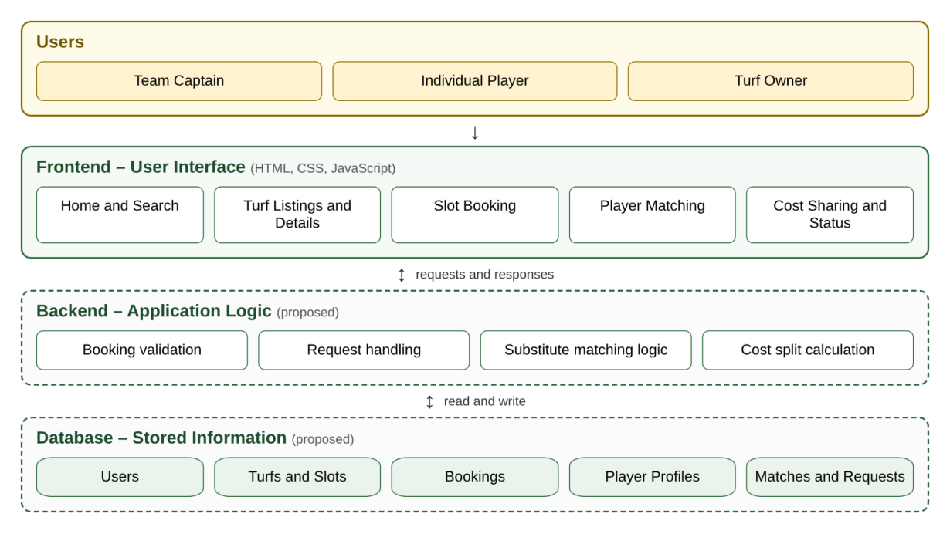
Figure 3.1 Overall system architecture of TRUF

3.7 System Flow
The system flow begins when the user opens TRUF and logs in. The user then chooses between booking a turf and finding players. In the booking path, the system searches the turf list, shows the matching turfs, accepts a slot selection, checks that the slot is available and creates a booking. After the booking, the system compares the confirmed players with the required players. If the squad is complete the match is marked ready; otherwise the user may search for substitutes, send requests and wait for responses until the squad is complete.
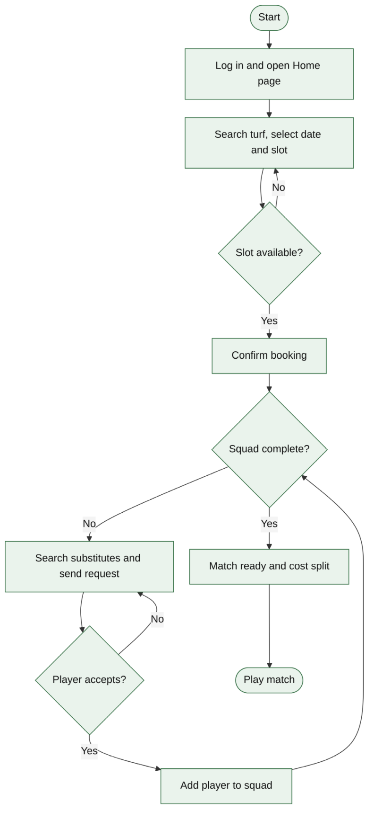
Figure 3.2 Overall system flow diagram

3.8 Use Case Diagram
A use case describes something a user wants to do with the system. The actors of TRUF are the team captain, the individual player and the turf owner. Table 3.2 lists the main use cases and the actors involved.
Table 3.2 Use Cases of TRUF
Use case | Actor | Description
Search turf | Captain, Player | Find turfs by sport, location and time slot.
View turf details | Captain, Player | See price, location and slot information.
Book slot | Captain | Select date and slot and confirm the booking.
Create match | Captain | Enter the sport, time and number of players required.
Find substitutes | Captain | Search for players to fill missing positions.
Respond to request | Player | Accept or decline a substitute request.
Split cost | Captain | Divide the turf cost among team members.
Manage bookings | Turf Owner | View bookings and the slots that are still available.

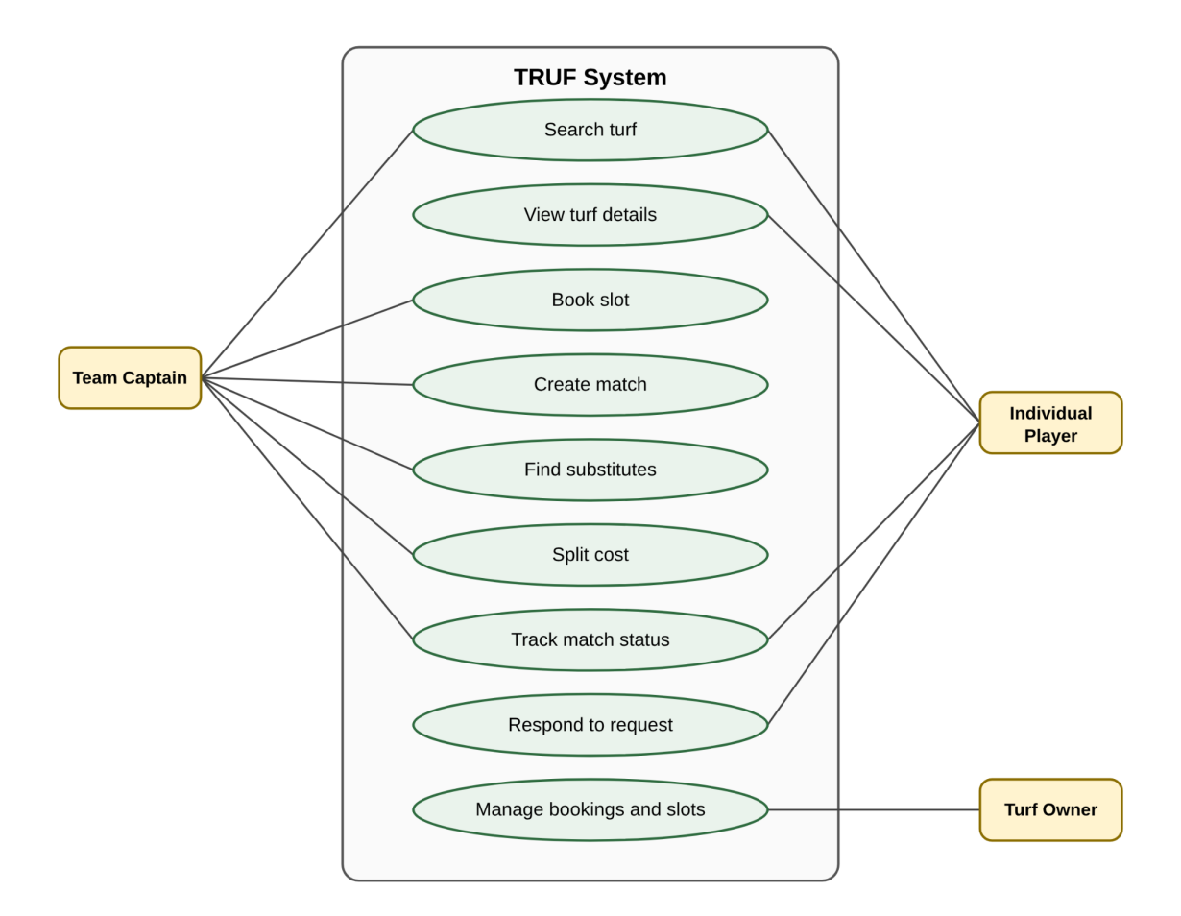
Figure 3.3 Use case diagram of TRUF

3.9 Activity Diagrams
An activity diagram shows the sequence of steps and decisions in a workflow. Two workflows are important for TRUF. In the turf booking workflow, the user enters search details, selects a turf, selects a slot, and the system checks availability. If the slot is available the booking is confirmed and shown on the confirmation screen; if it is unavailable the user is asked to choose another slot.
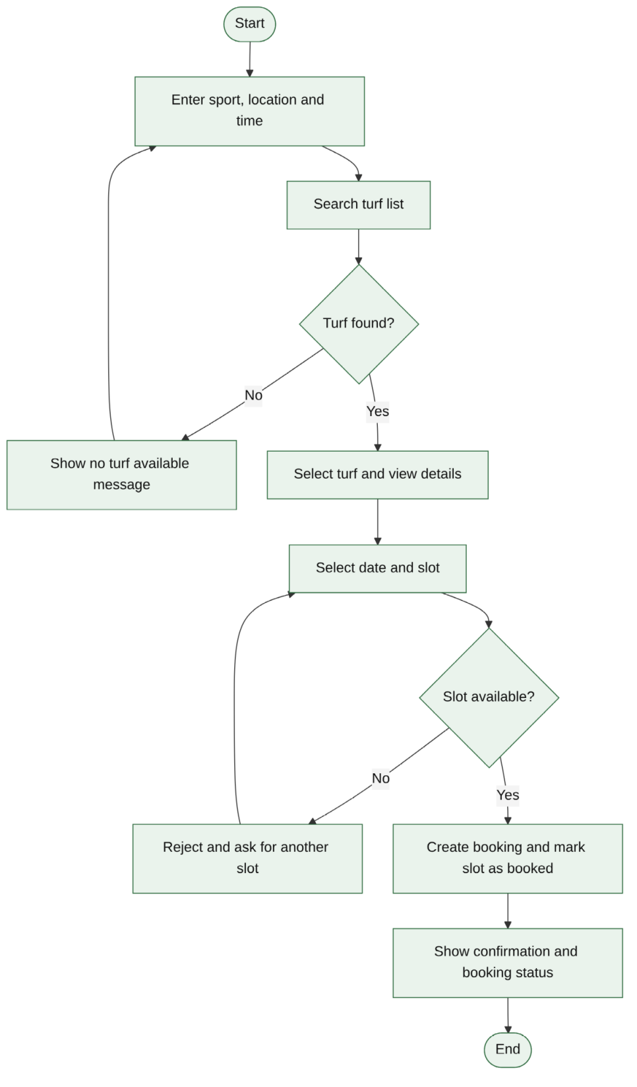
Figure 3.4 Activity diagram for the turf booking workflow
In the substitute matching workflow, the user selects a match, the system identifies the number of missing players, the user searches for substitutes, selects a player and sends a request. A decision then follows: if the player accepts, the player is added to the squad; if the player declines or does not respond, the user may choose another player.
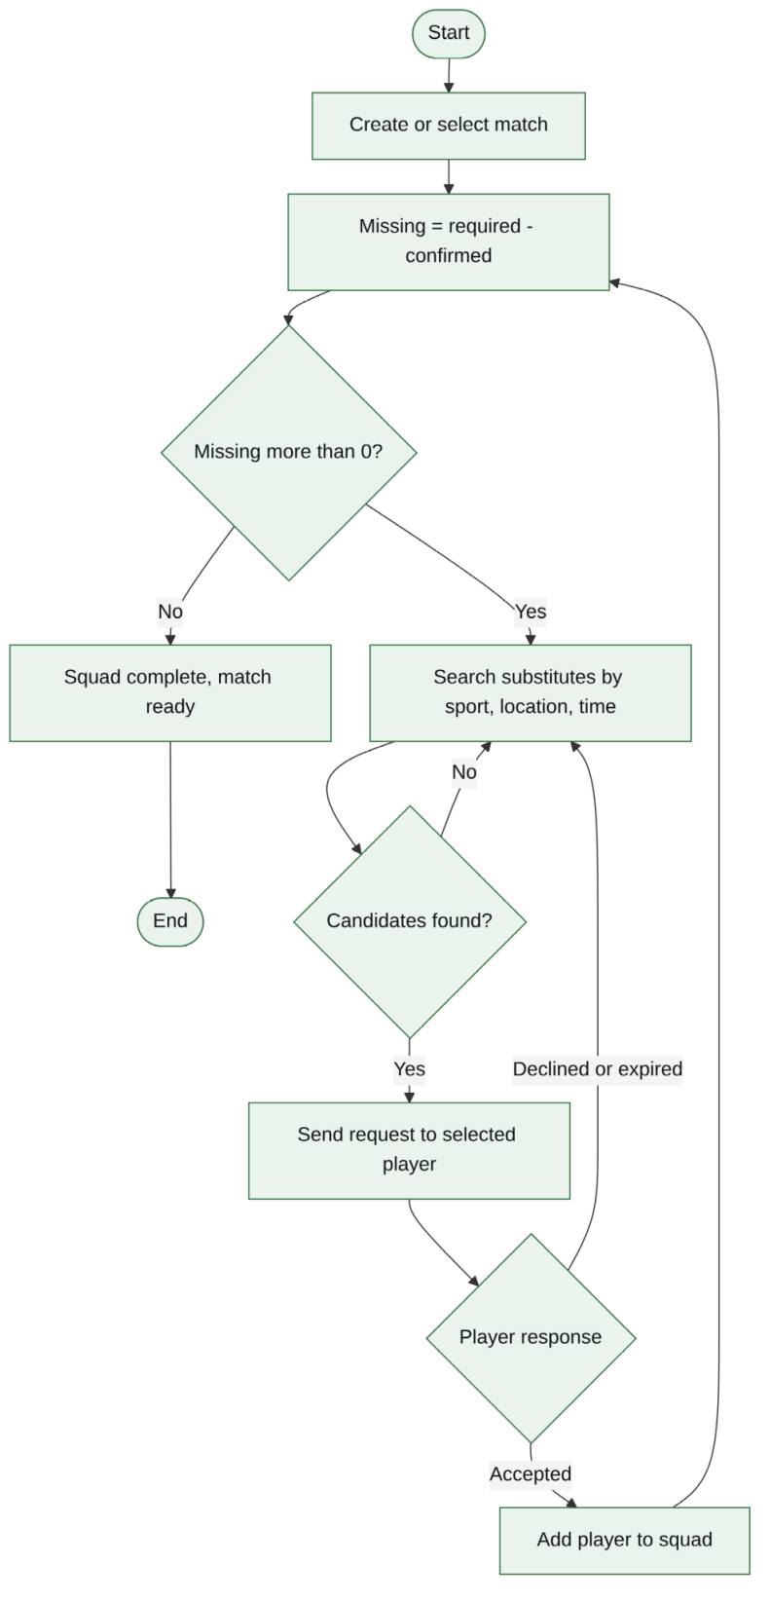
Figure 3.5 Activity diagram for the substitute matching workflow

3.10 Sequence Diagram
A sequence diagram shows the order in which messages are exchanged between participants. For a substitute request the participants are the captain, the TRUF interface, the backend and the substitute player. The captain sends a request through the interface, the backend records the request with the status pending and notifies the player, the player responds, the backend updates the status and the squad, and the interface shows the updated squad to the captain. In the prototype, the backend and the player's response are simulated.
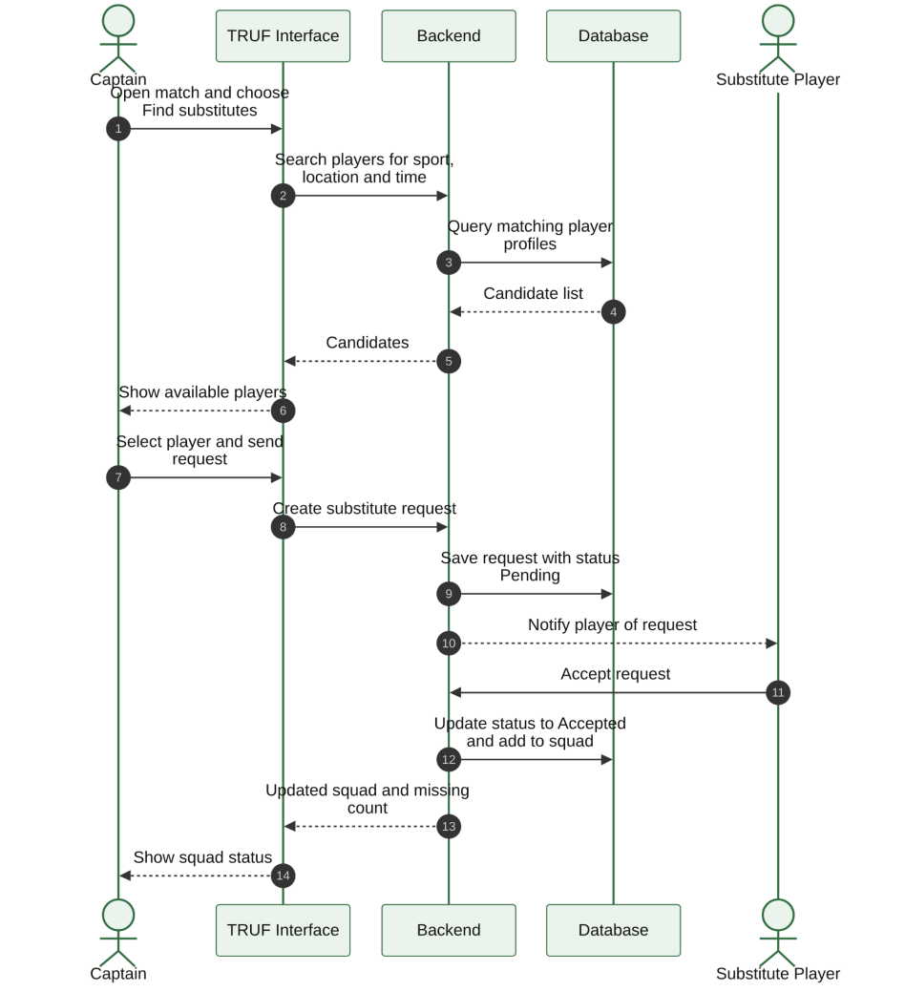
Figure 3.6 Sequence diagram for a substitute request

3.11 App Workflow and Navigation Flow
The navigation flow describes how a user moves between screens. After opening TRUF, the user logs in or signs up and arrives at the Home page. From Home the user can go to Search Turf or Find Players. In the booking path, the user searches a turf, views turf details (price, location and slot information), selects a date and slot, and confirms the booking. In the player path, the user views player profiles, sends a request, and confirms the team. When the booking and team are complete, the match is marked ready. This is the suggested navigation and should be read together with the screen descriptions in Chapter 4.
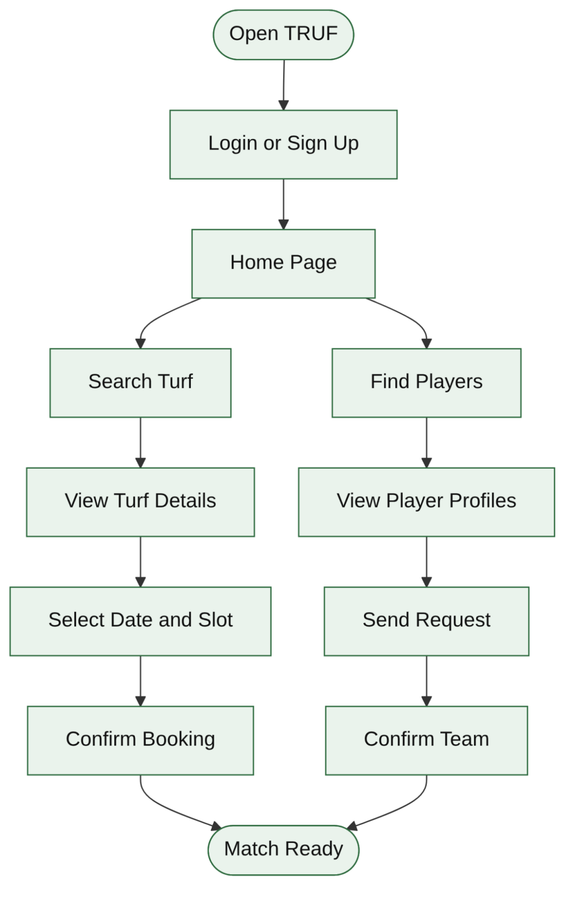
Figure 3.8 App workflow and navigation flow of TRUF

3.12 Substitute Player Matching Workflow
A substitute player is a person who plays in place of a regular team member who cannot attend. This is the most important concept of the project. The workflow has five steps:
- Create or select a match: the user enters the match details and the number of players required.
- Identify missing players: for example, 10 players are required but only 8 are confirmed, so 2 are missing.
- Search for substitutes: players are searched using the sport, location and match time.
- Send and accept the request: an available player receives the request and accepts it.
- Confirm the squad: the accepted substitute is added to the team and the squad becomes complete.
Automatic matching needs data about each player's availability, preferred sport, time and location. The prototype can simulate the search-and-request process, while live matching between real users needs a backend and database.

3.13 Data Schema and Main Entities
A data schema defines what information is stored and how different kinds of data are connected. An entity is an object or category about which the system keeps information. Table 3.3 lists the main entities of TRUF as a conceptual design.
Table 3.3 Main Data Entities of TRUF
Entity | Information stored
User | User ID, name, contact details
Turf | Turf ID, name, location, price
Slot | Slot ID, date, start time, availability
Booking | Booking ID, user, turf, slot, status
Player Profile | Sport, availability, player details
Match | Sport, match time, required players
Substitute Request | Match ID, requesting team, player, request status

3.13.1 Data Dictionary
The tables below propose the attributes of each entity. They are a design proposal; the final schema depends on the database chosen during implementation. PK denotes a primary key and FK a foreign key.
Table 3.4 Data Dictionary of the User and Turf Entities
Entity | Attribute | Type | Description
User | user_id (PK) | Integer | Unique identifier of the user
User | name | Text | Name of the user
User | phone / email | Text | Contact details
User | role | Text | Captain, player or owner
Turf | turf_id (PK) | Integer | Unique identifier of the turf
Turf | name | Text | Name of the turf
Turf | location | Text | Area or address of the turf
Turf | sport_type | Text | Football, cricket or both
Turf | price_per_slot | Decimal | Cost of one time slot

Table 3.5 Data Dictionary of the Slot and Booking Entities
Entity | Attribute | Type | Description
Slot | slot_id (PK) | Integer | Unique identifier of the slot
Slot | turf_id (FK) | Integer | Turf to which the slot belongs
Slot | date | Date | Date of the slot
Slot | start_time | Time | Start time of the slot
Slot | is_available | Boolean | Whether the slot can still be booked
Booking | booking_id (PK) | Integer | Unique identifier of the booking
Booking | user_id (FK) | Integer | User who made the booking
Booking | slot_id (FK) | Integer | Slot that has been reserved
Booking | status | Text | Pending, confirmed or cancelled

Table 3.6 Data Dictionary of the Player Profile, Match and Substitute Request Entities
Entity | Attribute | Type | Description
Player Profile | profile_id (PK) | Integer | Unique identifier of the profile
Player Profile | user_id (FK) | Integer | User who owns the profile
Player Profile | preferred_sport | Text | Sport the player wants to play
Player Profile | availability | Text | Days and times when the player is free
Match | match_id (PK) | Integer | Unique identifier of the match
Match | booking_id (FK) | Integer | Booking for the match
Match | sport | Text | Sport being played
Match | required_players | Integer | Total players needed
Substitute Request | request_id (PK) | Integer | Unique identifier of the request
Substitute Request | match_id (FK) | Integer | Match that needs a player
Substitute Request | profile_id (FK) | Integer | Player who is asked
Substitute Request | status | Text | Pending, accepted or declined

3.13.2 Relationships Between Entities
Table 3.7 Relationships Between Entities
Relationship | Type | Meaning
User creates Booking | One to many | One user can create many bookings
Turf offers Slot | One to many | One turf can offer many slots
Booking reserves Slot | One to one | A booking is reserved for one slot
Booking has Match | One to one | A booking is used for one match
Match receives Substitute Request | One to many | One match can receive many substitute requests
Player Profile responds to Substitute Request | One to many | One player profile can respond to different requests

A database is needed so that user information, turf availability, bookings and player requests can be retrieved and managed systematically [5].
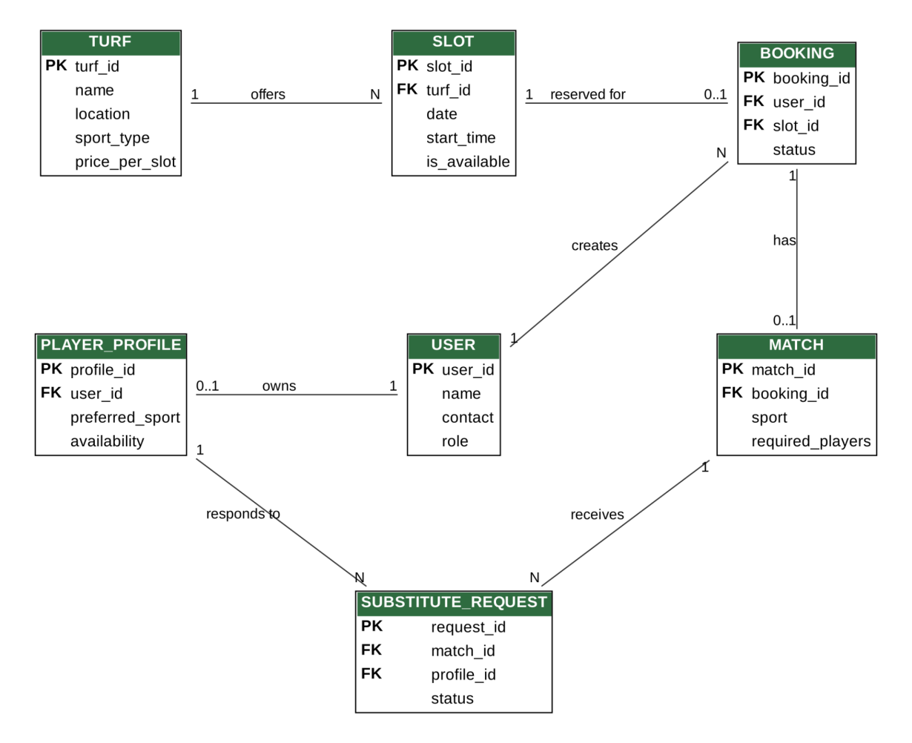
Figure 3.7 Entity relationship diagram of TRUF

3.14 Module Design
TRUF is divided into modules according to responsibility: Turf Listings, Slot Booking, Player Matching, Cost Sharing, and Match and Booking Updates. Turf Listings displays grounds with location, sport type and price. Slot Booking handles date and time selection and confirmation. Player Matching finds substitutes when the squad is short. Cost Sharing divides the total cost among team members. Match and Booking Updates tracks booking status, match details and player confirmations.
This modular design allows each feature to be developed, tested and improved separately, and allows new modules, such as notifications and payments, to be added later without rewriting the existing ones.

CHAPTER 4
DESIGN AND PROTOTYPE IMPLEMENTATION

4.1 Prototype Overview
Unlike a hardware project, TRUF is a software and interface project, so this chapter describes the design and prototype of the application screens. A wireframe is the basic structure of a screen, showing where content and buttons are placed without concern for colour or animation. A mockup shows how the screen will look in its final visual design. Wireframes are used to plan the screen layout and user navigation before the actual application is developed.

4.2 Design Approach
The prototype was designed by first listing the user problems, then defining the core features, then sketching wireframes for the main screens, and finally preparing visual mockups. Decisions about layout followed usability heuristics such as visibility of status and error prevention [3]. The screens are intended for a mobile device, so content is arranged in a single column with clear buttons and cards.

4.3 Proposed Core Features
The five core features of the application are:
- Turf Listings: display of available grounds with location, sport type, pricing and other relevant details.
- Slot Booking: selection of date and time and confirmation of a reservation.
- Player Matching: search for suitable substitutes when the team has a player shortage.
- Cost Sharing: support for splitting the total cost among team members.
- Match and Booking Updates: tracking of booking status, match details and player confirmations.

4.4 Proposed Screens
Table 4.1 lists the main screens of the prototype and the content shown on each.
Table 4.1 Proposed Screens of the TRUF Prototype
Screen | Content and purpose
Login / Sign Up | Entry point for new and returning users.
Home Screen | Search bar, turf listings, navigation menu and booking options.
Turf Listing Screen | Ground cards showing prices, availability and location details.
Turf Details Screen | Price, location and slot information for the selected turf.
Booking Screen | Date and time selection and booking confirmation.
Player Matching Screen | Player details, match timing and request options.
Booking Confirmation Screen | Selected ground, date, slot and booking status.

4.5 Wireframes

4.5.1 Home Screen
The Home Screen is the starting point after login. It contains a search bar for finding turfs by sport, location and time, a list of turfs, a navigation menu and shortcuts to booking and finding players. The aim is that the user can begin the main task within a single tap.
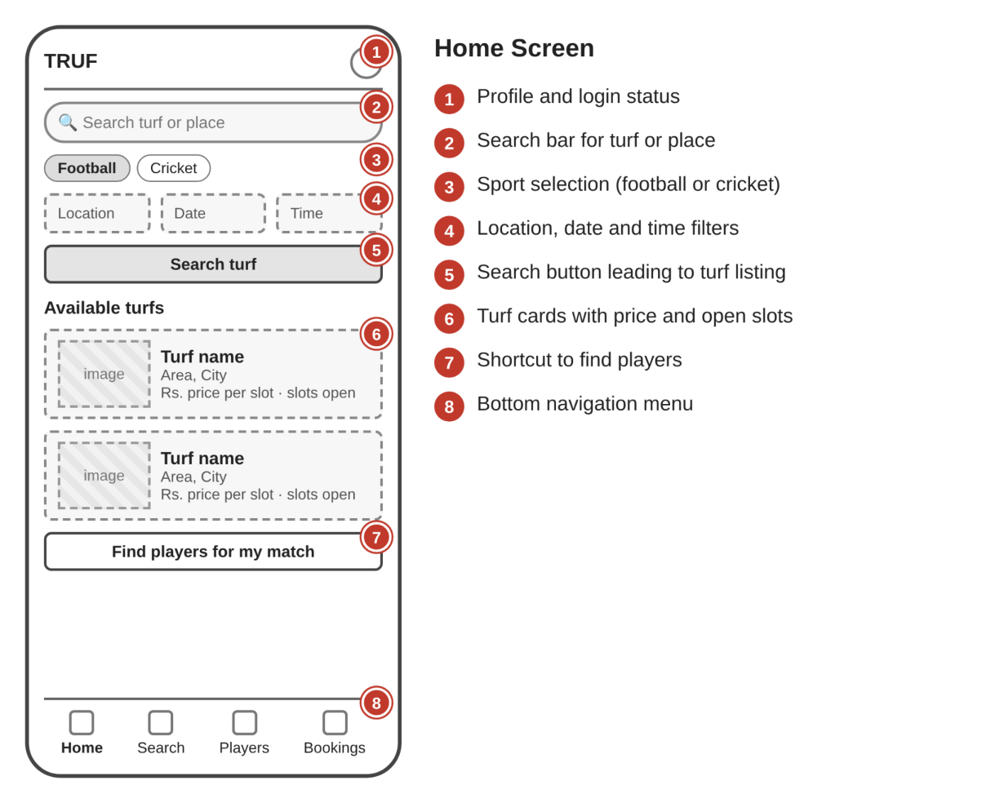
Figure 4.1 Wireframe of the Home Screen

4.5.2 Turf Listing Screen
Turfs are shown as cards with the name, location, sport type, price and availability. Selecting a card opens the details screen with fuller price, location and slot information. Cards are stacked in one column so that they can be scrolled easily on a phone.
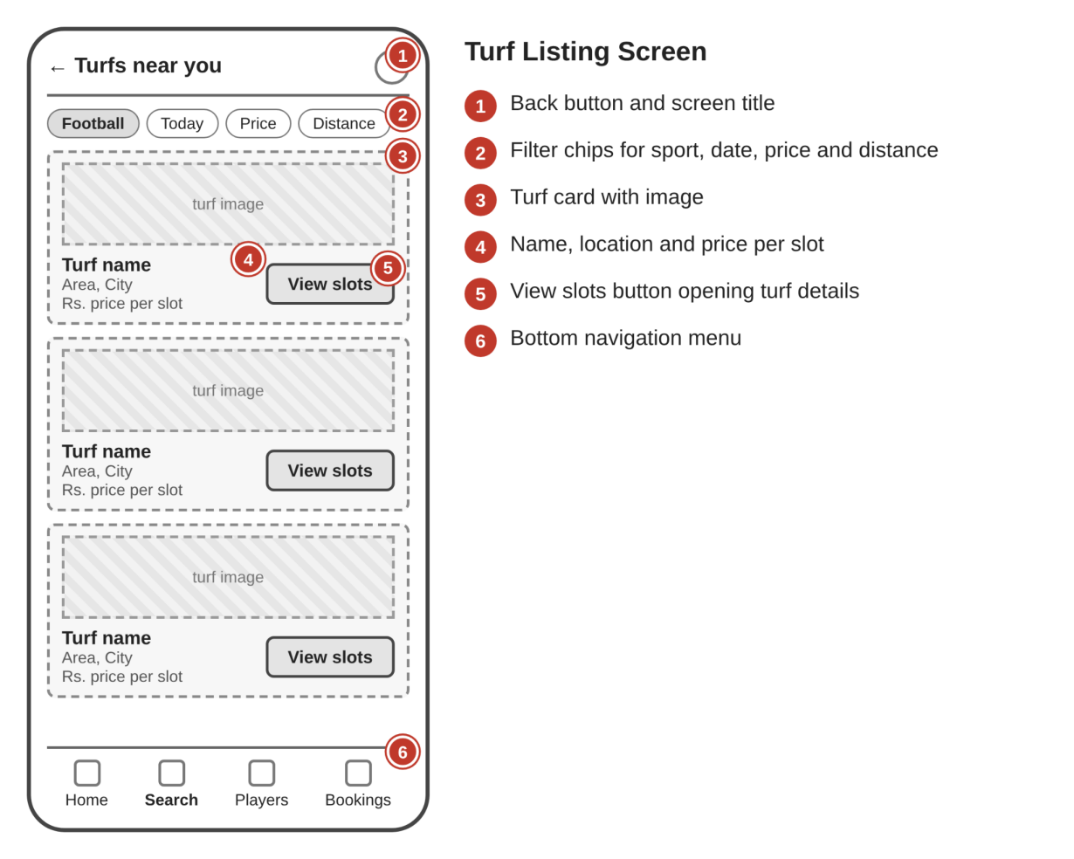
Figure 4.2 Wireframe of the Turf Listing Screen

4.5.3 Player Matching Screen
When the squad is incomplete, this screen shows how many players are missing and lists players who may be available, with their details and the match timing. The user can send a request and see its status (pending, accepted or declined).
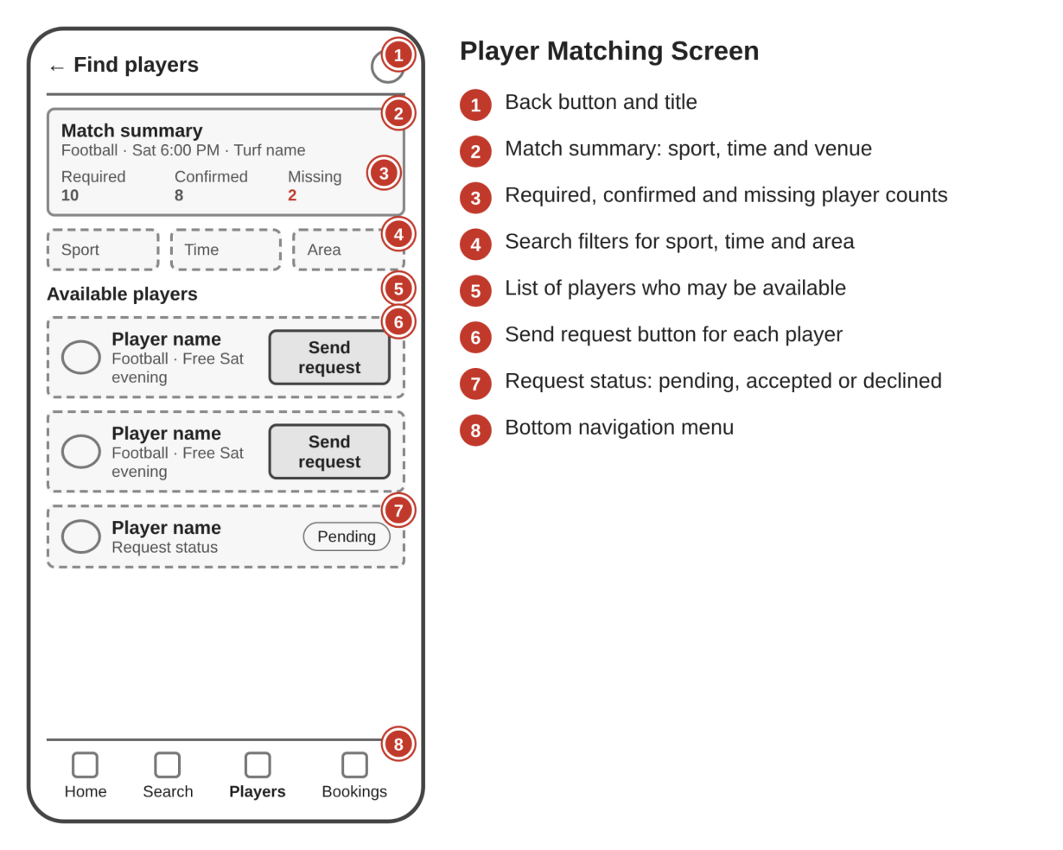
Figure 4.3 Wireframe of the Player Matching Screen

4.5.4 Booking Confirmation Screen
The confirmation screen summarises the selected ground, date, slot and booking status so that the user is never unsure whether the reservation succeeded. It also gives the entry point to the squad and cost-sharing information.
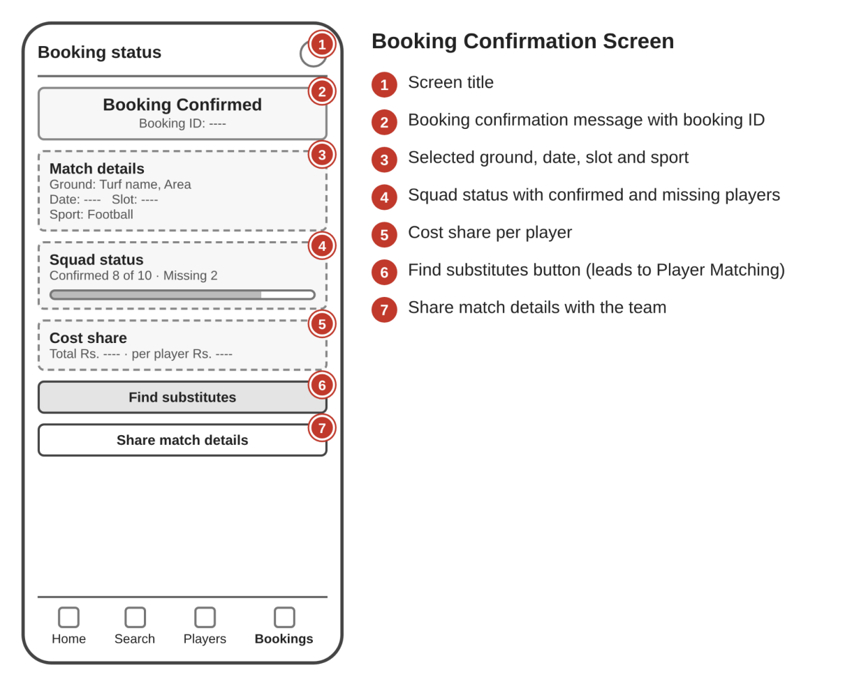
Figure 4.4 Wireframe of the Booking Confirmation Screen

4.6 Mockups
Mockups show how the screens will look in their final visual design. They apply the colours, typography, spacing and icons chosen for TRUF to the structure fixed by the wireframes. The mockups are used to check that the layout remains readable and that the most important button on each screen is easy to find.
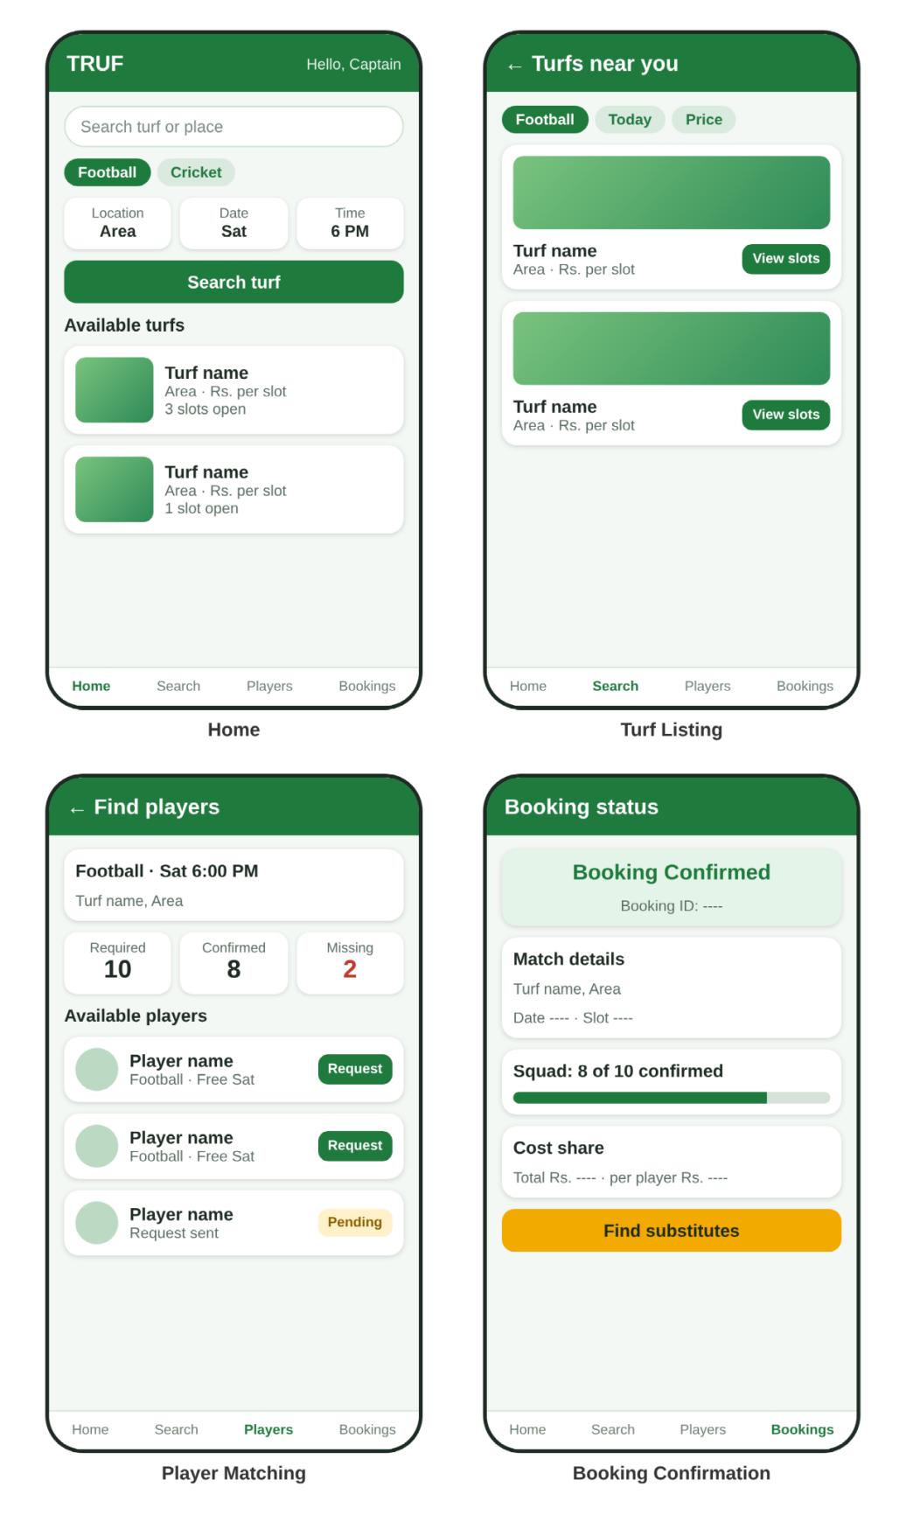
Figure 4.5 Mockups of the main TRUF screens

4.7 Design Guidelines
Table 4.2 lists the guidelines proposed for the interface. They are based on the usability ideas discussed in Chapter 2 [3], [10].
Table 4.2 Proposed Design Guidelines for the Interface
Aspect | Guideline
Layout | Single-column, card-based layout suited to phone screens.
Navigation | A small number of clear destinations; every screen has a way back.
Status visibility | Booking and request status always shown with clear labels.
Buttons | One main action per screen, with a clear label such as Book slot or Find substitutes.
Forms | Ask only for necessary information; show validation messages next to the field.
Readability | Sufficient text size and contrast so that text can be read outdoors.
Consistency | The same colours, terms and icons used for the same things on every screen.

4.8 Working Prototype
The prototype demonstrates the user journey from searching a turf to confirming the team. In its current form it simulates availability, booking and the substitute-request process without live data; actual persistence and real-time matching between users are listed as future work. This distinction between the proposed design, the working prototype and fully implemented functionality is maintained throughout the report.

CHAPTER 5
SOFTWARE IMPLEMENTATION

5.1 Software Architecture and Technology Stack
A technology stack is the combination of technologies used to build an application. For TRUF the proposed stack has three layers: a frontend for the user interface, a backend for the application logic and a database for stored information.
Table 5.1 Proposed Technology Stack of TRUF
Technology | Role in TRUF
HTML | Creates the structure of the pages (forms, lists, buttons).
CSS | Handles colours, layout, spacing and responsive design for mobile screens.
JavaScript | Handles buttons, form validation, search and interactive behaviour.
Backend (proposed) | Executes business rules such as booking validation and matching, and processes data requests.
Database (proposed) | Stores and retrieves users, turfs, slots, bookings and player requests.

The frontend technologies are documented in the MDN Web Docs [8]. The first stage of the project is a frontend prototype built with HTML, CSS and JavaScript. A real login system, permanent booking records and live player matching require the backend and database, which can be added in later stages. The specific backend and database technologies are to be selected at that time.

5.2 Development Stages
The implementation proceeds in six stages:
- Create the HTML pages for each screen.
- Apply the CSS design and a responsive layout.
- Add JavaScript interactions such as search, filtering and slot selection.
- Implement the booking and player-search logic.
- Connect the backend and database if required.
- Test the complete user flow.

5.3 Frontend Implementation
Each screen is implemented as an HTML page or section with a clear structure of headings, cards, forms and buttons. CSS provides a consistent look and adapts the layout to different screen widths using flexible units and media queries [9]. JavaScript is used for form validation, such as showing a message when a form is incomplete, for filtering the turf list by the chosen sport and location, and for updating the status of a booking or substitute request on screen.

5.4 Turf Listings and Search
The search feature accepts the sport, location and time slot and returns the turfs that match. Each turf is represented by its identifier, name, location, sport type and price. The result list is displayed as cards so that users can compare turfs quickly, and selecting a card opens the detailed view. If no turf matches, a clear message is shown instead of an empty page.

5.5 Slot Booking
Slot booking lets the user select a date and a start time. Each slot has an availability status. If the selected slot is unavailable, the booking is prevented or rejected with a clear message. A successful booking creates a record containing the user, turf, slot and booking status, which is shown on the confirmation screen. The status values used for a booking are listed in Table 5.2.
Table 5.2 Booking Status Values
Status | Meaning
Pending | The user has selected a slot and the booking is waiting for confirmation.
Confirmed | The slot has been reserved for the user.
Cancelled | The booking has been cancelled and the slot is available again.
Rejected | The booking could not be made, for example because the slot was unavailable.

5.6 Player Matching
Player matching compares the number of required players with the number of confirmed players and calculates how many substitutes are needed. The user searches for substitutes using the sport, location and match time. A request is sent to a chosen player and carries a status that changes from pending to accepted or declined. When a request is accepted the player is added to the squad and the missing-player count is reduced.
Table 5.3 Substitute Request Status Values
Status | Meaning
Pending | The request has been sent and the player has not responded.
Accepted | The player has agreed to play and is added to the squad.
Declined | The player cannot play; the captain may ask another player.
Expired | No response was received before the match; the request is closed.

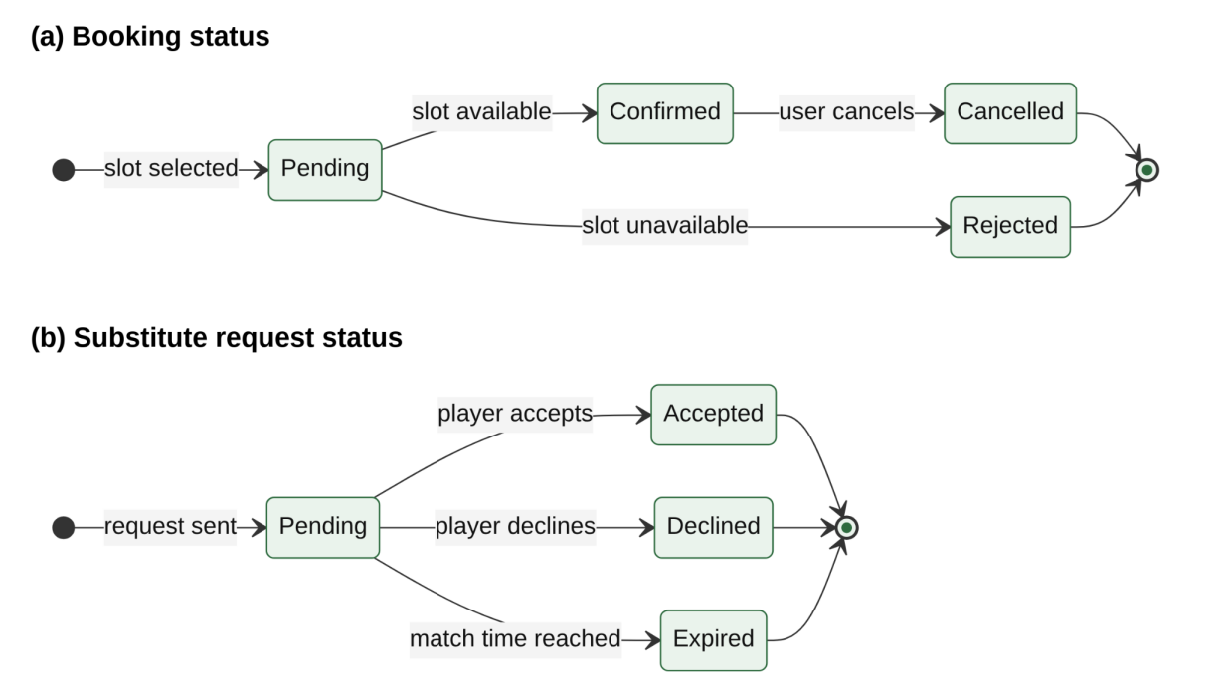
Figure 5.1 State transitions of booking and substitute request status

5.7 Cost Sharing
The cost-sharing feature divides the total turf cost among the players. In the simple equal-split case, each player's share is the total amount divided by the number of players. For example, a turf costing Rs. 2,000 for 10 players gives Rs. 200 per person. When the total does not divide evenly, the difference of a few paise or rupees can be added to one share so that the shares always add up to the total. Automatic collection of the amounts would require an online payment feature, which is part of the future scope.

5.8 Match and Booking Updates
This module collects the booking status, the match details and the player confirmations into one view so that the captain can see at a glance whether the booking is confirmed, how many players have confirmed, and whether any substitute requests are pending. This addresses the problem of scattered information in messaging groups.

5.9 Form Validation
Validation prevents incomplete or invalid data from entering the system. Table 5.4 lists the main rules proposed for the forms of TRUF.
Table 5.4 Form Validation Rules
Field | Rule | Message shown when the rule fails
Sport | A sport must be selected | Please choose a sport
Location | Must not be empty | Please enter a location
Date | Must not be in the past | Please choose a valid date
Slot | A slot must be selected | Please choose a time slot
Required players | A whole number of at least 1 | Enter the number of players needed
Contact number | Digits only and of valid length | Enter a valid contact number

5.10 Error Handling
The system should respond to unexpected situations with a clear message and a way forward rather than a blank screen. Table 5.5 lists the main conditions.
Table 5.5 Error Conditions and System Responses
Condition | System response
No turf matches the search | Show a message and suggest changing the sport, location or time.
Selected slot is unavailable | Reject the booking and ask the user to choose another slot.
Form is incomplete | Show validation messages and do not submit.
No substitutes found | Show a message and suggest changing the time or widening the location.
Substitute declines | Update the request status and allow another request.

5.11 Backend and Database Integration
When the backend and database are added, the frontend will send requests for searching turfs, creating bookings and sending substitute requests. The backend will validate each request, update the database tables corresponding to the entities of Chapter 3 and return the result. Because slot availability must be consistent for all users, the check for an unavailable slot has to be made on the server in the final system, not only in the interface.

5.12 Security and Privacy Considerations
A full system would need to protect user accounts and personal details. Passwords should be stored only in hashed form, communication should use an encrypted connection, and each request should be checked to confirm that the user is allowed to perform it. Contact details of players should be shown to a captain only after a request has been accepted. These measures are proposed for the backend stage and are not part of the front-end prototype.

CHAPTER 6
METHODOLOGY AND ALGORITHMS

6.1 Design Methodology
The project follows the design-thinking process [1], [2]: empathise with the users, define the problem, ideate solutions, build a prototype and test it. Table 6.1 shows how each stage maps to the work of the project.
Table 6.1 Mapping of Design Thinking Stages to Project Work
Stage | Work carried out in TRUF
Empathise | Identify the team captain, individual player and turf owner and their needs (personas).
Define | State the five problems of fragmented discovery, dropouts, group chaos, cost sharing and unclear booking status.
Ideate | Combine booking and substitute matching; define the five core features.
Prototype | Prepare wireframes, mockups and a front-end prototype of the user journey.
Test | Prepare and run the test plan; plan usability tests with representative users.

6.2 Turf Search and Filtering
The search algorithm filters the list of turfs by three criteria. A turf is shown when it supports the chosen sport, is in the chosen location and has at least one available slot at the requested time. The procedure is written below in pseudocode.
FUNCTION searchTurfs(sport, location, time):
results = empty list
FOR each turf IN turfList:
IF turf.sport_type contains sport AND turf.location matches location:
FOR each slot IN turf.slots:
IF slot.start_time == time AND slot.is_available:
add turf to results
BREAK
IF results is empty:
RETURN message "No turf available"
RETURN results

The time taken grows with the number of turfs and slots, so for a small prototype list the search is immediate. In a larger system the same conditions would be expressed as a database query with indexes on sport, location and time.

6.3 Slot Availability Check
Before a booking is confirmed, the system checks the status of the chosen slot. If the slot is available, a booking record is created and the slot is marked as booked. If it is not available, the booking is rejected and the user is informed, which prevents double booking and avoids the uncertainty of an unclear booking status.
FUNCTION bookSlot(user, slot):
IF slot.is_available == false:
RETURN rejected("Slot not available")
slot.is_available = false
booking = create Booking(user, slot, status = "Confirmed")
RETURN booking

In a multi-user system, the check and the update of the slot must be done as one indivisible operation on the server, otherwise two users could book the same slot at the same moment.

6.4 Missing Player Calculation
The number of substitutes needed is the difference between the players required for the match and the players already confirmed:
Missing players = Required players − Confirmed players
For example, if 10 players are required and 8 are confirmed, then 2 substitutes are needed. When the result is zero the squad is complete and no substitute search is necessary. The result is never allowed to be negative; if more players are confirmed than required, the squad is treated as complete.

6.5 Substitute Matching Logic
The proposed matching logic selects candidate players whose profile matches the match. A player is a candidate when the preferred sport equals the match sport, the declared availability covers the match time, and the player's location is acceptable for the match location. Candidates are shown to the captain, who sends requests. When a request is accepted the player is added to the squad and the missing-player count is recalculated.
FUNCTION findSubstitutes(match):
candidates = empty list
FOR each profile IN playerProfiles:
IF profile.preferred_sport == match.sport
AND profile.availability covers match.time
AND profile.location near match.location
AND profile NOT already in match.squad:
add profile to candidates
RETURN candidates

In the prototype the candidate list is simulated; with real data, the candidate list would be produced by a database query on these conditions. A later version could order the candidates by distance or by how often they have attended earlier matches.

6.6 Substitute Request Handling
A request moves through the statuses of Table 5.3. When a request is sent its status is pending. If the player accepts, the status becomes accepted, the player is added to the squad and the missing count is reduced. If the player declines, the status becomes declined and the captain can select another candidate. If the match time is reached with no response, the request expires.
FUNCTION respondToRequest(request, response):
IF request.status != "Pending":
RETURN error("Request already closed")
IF response == "Accept":
request.status = "Accepted"
add request.player to request.match.squad
ELSE:
request.status = "Declined"
RETURN request.status

6.7 Cost Split Calculation
For an equal split, the amount payable by each player is:
Share per player = Total turf cost ÷ Number of players
For a total cost of Rs. 2,000 and 10 players, the share per player is Rs. 200. If the number of players changes because a substitute joins, the share is recalculated. An agreed unequal split could be supported by letting the captain enter custom amounts that must sum to the total. When the total does not divide exactly, the shares are rounded down and the remainder is added to one share, so that the sum of the shares always equals the total.
FUNCTION splitCost(total, players):
share = floor(total / players)
remainder = total - share * players
shares = list of 'players' values, each equal to share
shares[0] = shares[0] + remainder
RETURN shares

6.8 Form Validation
Form validation checks that mandatory fields such as sport, date, slot and contact details are filled in and that values are in a valid format before the form is submitted. An incomplete form produces a validation message and no booking is created. This follows the heuristic of error prevention [3].

6.9 Overall Logic of the User Journey
The overall logic can be summarised as a loop. The user searches and books a slot; the system computes the missing players; while the missing count is greater than zero the user finds substitutes and sends requests; each accepted request reduces the missing count; and when the count reaches zero the match is marked ready. Cost shares are recalculated whenever the squad changes.

CHAPTER 7
TESTING AND RESULTS

7.1 Testing Strategy
Testing verifies that the application behaves as expected. The strategy for TRUF has four parts: functional testing of each feature against expected results, validation and boundary testing of forms and rules, an end-to-end walkthrough of the complete user journey, and usability testing with representative users.

7.2 Test Environment
The prototype is tested in a web browser on a desktop and on a mobile-sized screen, using sample turf, slot and player data. Because the prototype simulates availability and matching, the tests verify the interface behaviour and logic rather than the performance of a live server.
Table 7.1 Test Environment
Item | Details
Application | TRUF front-end prototype
Platforms | Desktop browser and mobile-sized browser window
Test data | Sample turfs, slots, players and matches prepared by the team
Tested by | Project team members
Test date | [To be recorded]

7.3 Functional Test Cases
Table 7.2 gives the functional test cases covering the main features. The status column is to be completed when each test is executed.
Table 7.2 Functional Test Cases
No. | Test case | Expected result | Status
1 | Search for a turf | Relevant turf listings appear | To be recorded
2 | Search with no matching turf | A message says that no turf is available | To be recorded
3 | Open turf details | Price, location and slots are shown | To be recorded
4 | Select a time slot | Selected date and slot are shown | To be recorded
5 | Confirm a booking | Booking confirmation with status is displayed | To be recorded
6 | Try an unavailable slot | Booking is prevented or rejected | To be recorded
7 | Create a match needing 10 players with 8 confirmed | Missing players shown as 2 | To be recorded
8 | Request a substitute | Request status is displayed | To be recorded
9 | Substitute accepts request | Player is added and missing count reduces | To be recorded
10 | Substitute declines request | Status shows declined; another request can be sent | To be recorded
11 | Split Rs. 2,000 among 10 players | Each share shows Rs. 200 | To be recorded

7.4 Validation and Boundary Test Cases
Table 7.3 Validation and Boundary Test Cases
No. | Test case | Expected result | Status
1 | Submit an incomplete form | Validation message appears | To be recorded
2 | Choose a date in the past | Date is rejected with a message | To be recorded
3 | Enter 0 required players | Value is rejected with a message | To be recorded
4 | Enter an invalid contact number | Contact number is rejected | To be recorded
5 | Confirmed players equal required players | Missing players shown as 0; squad complete | To be recorded
6 | Split Rs. 1,000 among 3 players | Shares add up to Rs. 1,000 | To be recorded
7 | Respond to an already closed request | A message says the request is closed | To be recorded

7.5 End-to-End User Journey Check
The complete journey to be verified is: open TRUF, log in, search a turf, view the details, select a date and slot, confirm the booking, see that the squad has missing players, search for substitutes, send a request, receive an acceptance and see the squad marked complete. Each step should show a clear status so that the user always knows what has happened.

7.6 Usability Evaluation Plan
To check whether the design is easy to use, representative users such as a student team captain, an individual player and a turf owner should be asked to complete the main tasks and comment on the screens. Observations on where they hesitate or make mistakes would be used to improve the layout. Table 7.4 lists the proposed tasks and what to observe. The evaluation is planned and its outcomes should be reported only after it has been carried out.
Table 7.4 Usability Test Tasks
Task | What to observe
Find a football turf for a given time | Whether the search is found and understood quickly
Book a slot | Whether the steps are clear and the confirmation is understood
Find two substitutes for a match | Whether the user finds the substitute option without help
Check who has confirmed | Whether the squad status is easy to read
Split the cost | Whether the result is clear and trusted

7.7 Traceability of Objectives
Table 7.5 links each objective of Section 1.5 to the test cases that check it, to make sure that every objective is covered.
Table 7.5 Traceability Between Objectives and Tests
Objective | Covered by
Streamline slot reservations | Functional tests 1–6 and validation tests 1–2
Automate substitute matching | Functional tests 7–10 and validation tests 5 and 7
Transparent cost split | Functional test 11 and validation test 6
Reduce team uncertainty | Functional tests 5, 7, 9 and the end-to-end journey check
Maximise venue utilisation | Owner view of bookings; to be tested when the owner screens are complete

7.8 Results
The status column of Tables 7.2 and 7.3 is to be filled in with the actual outcome of each test once it has been executed. This report does not claim that all tests have passed, and no quantitative performance figures or user-satisfaction scores are reported, because live deployment and formal user studies have not yet been carried out. What the prototype demonstrates is the design of the complete booking and substitute-matching journey.

7.9 Limitations and Discussion
The testing is limited to a prototype with sample data. Live concurrency (two users booking the same slot at the same time), real payments, notifications and matching across many real users cannot be evaluated until the backend and database exist. The personas are design aids and the usability evaluation is still to be completed. Future testing should therefore include server-side validation, tests with real users and tests under realistic load.

CHAPTER 8
CONCLUSION AND FUTURE SCOPE

8.1 Conclusion
TRUF: Smart Turf Booking and Player Matching App aims to simplify sports match organisation by combining turf booking with substitute player matching. Users can search for turfs, select available time slots and manage their bookings, and when team members are unavailable the player-matching concept helps them find substitutes.
The project focuses on reducing booking confusion, simplifying team coordination and improving the overall sports booking experience. Its main idea, that the application should not stop at booking a turf but should also help users complete their team, is what distinguishes it from a plain booking tool.

8.2 Project Achievements
The project has produced a clear problem analysis, five objectives, three user personas, a set of five core features, a five-step substitute-matching workflow, a navigation flow, wireframes and mockups, a proposed architecture and data schema, a prototype of the user journey and a test plan. Together these show how booking, squad management and cost sharing can be connected in a single application.

8.3 Current Limitations
The present version is a prototype. Live slot availability, real login, permanent records, online payment and real-time matching between users are not yet implemented, and the test plan has yet to be fully executed. Existing platforms already offer venue booking and player discovery, so the value of TRUF's match-centred substitute workflow still has to be confirmed through user testing.

8.4 Future Enhancements
The following features are planned for future versions and are not claimed to be part of the current implementation:
- Online payment: paying the booking amount and each player's share through the application.
- Live availability: real-time slot updates for users and owners.
- Location-based matching: finding nearby players automatically.
- Notifications: booking reminders and substitute request alerts.
- Ratings and reviews: feedback about turfs and players.
- Advanced matching: improved matching using sport, availability and player preferences.

8.5 Development Roadmap
A sensible order for future work is as follows. First, add a backend and database so that bookings and player profiles persist and slot availability is checked on the server. Second, add real login and the owner screens for managing slots. Third, add notifications so that substitute requests and reminders reach users on time. Fourth, add online payments and automatic collection of shares. Finally, add ratings and advanced matching once enough real usage data exists.

8.6 Evaluation with Real Users
After the backend is in place, the application should be evaluated with real teams and turf owners. Useful measures include the time taken to complete a booking, how often an incomplete squad is completed through substitutes, and how many cancelled slots are refilled. These measures would show whether TRUF achieves its objectives in practice, which this report does not claim.
Thank you.

REFERENCES
[1] T. Brown, “Design Thinking,” Harvard Business Review, vol. 86, no. 6, pp. 84–92, 2008.
[2] Hasso Plattner Institute of Design at Stanford, An Introduction to Design Thinking: Process Guide, Stanford d.school, 2010.
[3] J. Nielsen, “10 Usability Heuristics for User Interface Design,” Nielsen Norman Group. Available: https://www.nngroup.com/articles/ten-usability-heuristics/
[4] J. J. Garrett, The Elements of User Experience: User-Centered Design for the Web and Beyond, 2nd ed., New Riders, 2010.
[5] R. Elmasri and S. B. Navathe, Fundamentals of Database Systems, 7th ed., Pearson, 2016.
[6] Playo, “Playo – Sports Community App,” product information. Available: https://playo.co
[7] Hudle, “Hudle – Find Sports Activities and List Your Sports Venue,” product information. Available: https://www.hudle.in
[8] Mozilla, “MDN Web Docs: HTML, CSS and JavaScript.” Available: https://developer.mozilla.org
[9] E. Marcotte, “Responsive Web Design,” A List Apart, May 2010.
[10] D. A. Norman, The Design of Everyday Things, revised and expanded ed., Basic Books, 2013.
[11] R. T. Fielding, “Architectural Styles and the Design of Network-based Software Architectures,” Ph.D. dissertation, University of California, Irvine, 2000.
[12] L. Wroblewski, Mobile First, A Book Apart, 2011.

