xplanations.

1. What is Swagger?
2. What are the features provided by Swagger?
3. What is API Testing?
4. What are the Benefits of API testing?
5. What are the types of API testing?
6. What are the protocols used in API Testing?
7. What is Swagger Editor?
8. How can we Add API in Swagger?
9. What is OpenAPI?
10. How can we send custom headers with requests in Swagger UI?
11. How should we generate static docs with swagger?
12. How do we import custom dashboards to grafana using helm?

What is Swagger?

Swagger is used in sharing documentation in the products, managers, testers and developers and also is used by vatious tools in automating API Related processes.It is also used in developing APIs through OpenAPI Specification(OAS), also consists of open source and professional tools.  
Swagger also helps in describing the structure of our APIs for reading by the machines.It does it by asking our API return YAML or JSON which contains deatiled discription of our API.  
  
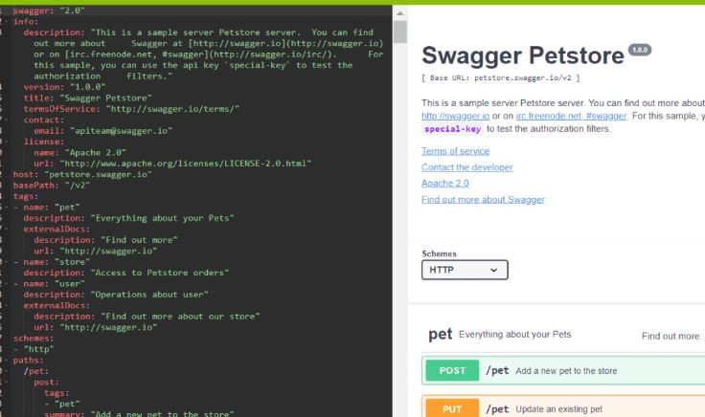

What are the features provided by Swagger?

* **Swagger Editor** used in writing OpenAPI Specs.
* **Swagger UI** helps in rendering OpenAPI Specs as an Interactive API Documentation.
* **Swagger Codegen** used in generating sever stubs and libraries from OpenAPI Spec.

What is API Testing?

API Testing helps in analyzing Application Program Interface in verifying its functionality, security, performance and reliability.It is performed by requesting it to one or more API Endpoints and also in comparing the response with the results.API Testing performs with critical layes such as Business, and in business logic processing it is carried out and all Transactions through the User Interface and Database Layers.  
  
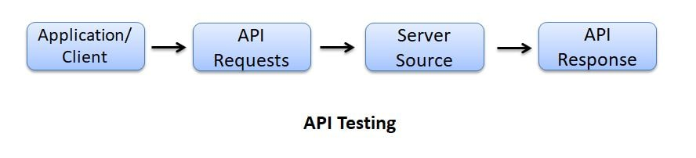

What are the Benefits of API testing?

Benefits of API Testing are as follows:

* Language Independent - used in language automation and also in structuring data, and making the verification and stable.
* GUI Independent - used in performing the app prior to GUI Testing and also can gives feedback and better team productivity.
* Improved Test Coverage - used in creating and allowing automated tests with high coverage.
* Faster Release - used in executing API Testing and testing, allowing the software development and releasing products faster.

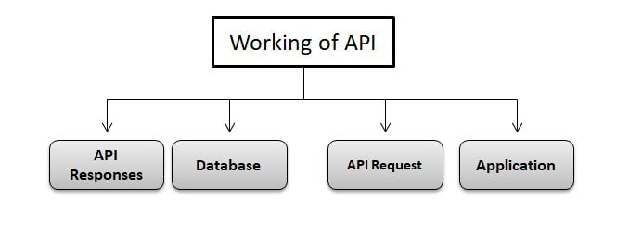

What are the types of API testing?

Types of API Testing are as follows:  
Unit Testing  
Functional Testing  
Load Testing  
Error Detection  
Security Testing  
UI Testing  
Penetration Testing  
Fuzz Testing

What are the protocols used in API Testing?

Protocols used by API Testing are as follows:  
HTTP  
REST  
SOAP  
JMS  
UDDI

What is Swagger Editor?

Swagger Editor is used in designing, defining and documenting RESTful APIs in Swagger Specification.It also helps in bringing the Swagger Editor, UI, Codegen Tools in cloud as an integrated API Design and Documentations which is built for API Teams working with OpenAPI Specification.

How can we Add API in Swagger?

We can add API in Swagger by using the following command:

/

@SWG\Resource(

apiVersion="1.0",

swaggerVersion="1.2",

description="SearchUsers"

)

/

What is OpenAPI?

OpenAPI is an API description format for REST APIs and also allows us in describing our entire APIsuch as Available Endpoints and Operations on each endpoint operations parameters like Input and Output for each operation.  
  
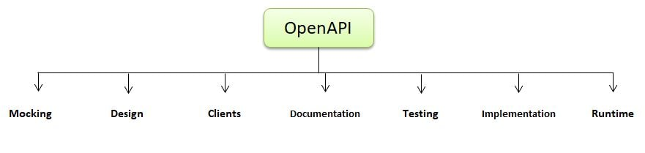

How can we send custom headers with requests in Swagger UI?

We can send custom headers by using the following command:

using System.collections.Generic;

using swashbuckle.AspNetCore.Swagger;

using swashbuckle.AspNetCore.SwaggerGen;

namespace api.infrastructure.filters

{

public class SwaggerSecurityRequirementsDocumentFilter : DocumentFilter

{

public void Apply(Swagger Document document, Document FilterContext context)

{

document.Security = new List<IDictionary<string, IEnumerable<documentstring>>>()

{

new Dictionary<string, IEnumerable<string>>()

{

{ "Bearer", newstring[]{ } },

{ "Basic", newstring[]{ } },

}

};

}

}

}

How should we generate static docs with swagger?

We can generate static documents by using the swagger codegen command:

swagger codegen generate --i <path used in swagger file> -l html2 -o <path used to output location>

How to define an enum in OpenAPI?

We can define an Enum in OpenAPI 2.0 by using the following command:

{

"in": "querys",

"name": "smple",

"description": "Sample parameter with enum value",

"type": "strings",

"enum": [ "5", "6"],

"required": true

}