**AUTOGEN (AG2) vs AUTOGEN (Mainted by Microsoft)**

AutoGen is a framework developed by Microsoft for building multi-agent AI systems that can collaborate to solve tasks. However, after the original creator left Microsoft, the original agentic framework has split into two versions: AG2 and Autogen. Below are the main differences between the two:

AG2

Github: <https://github.com/autogenhub/autogen?tab=readme-ov-file>

Pypi: <https://pypi.org/project/autogen/#related-papers>

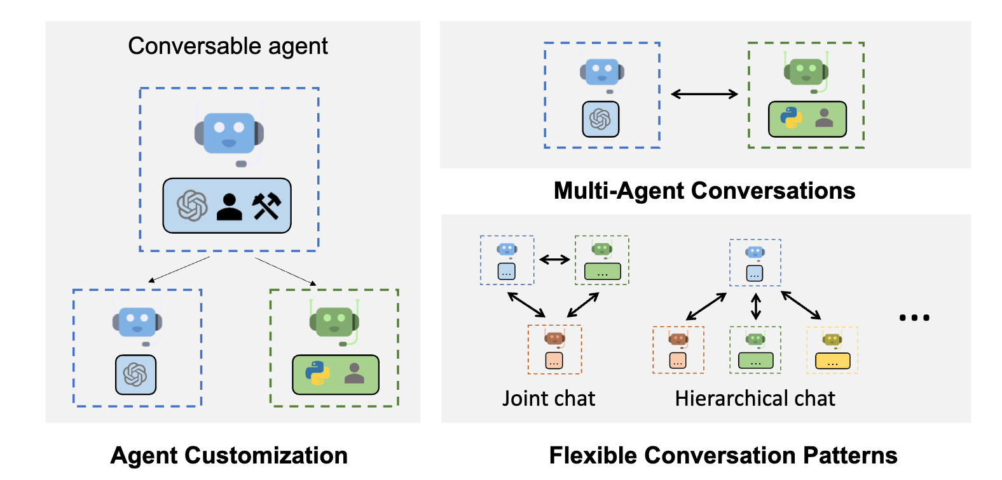

* Built upon the original Autogen framework
* Maintained and contributed by its original creator and an active community
* Core functionalities such as agent creation, group chat, workflow management are maintained and new features are built upon the existing architecture
* Backward compatible

Autogen (Maintained by Microsoft)

Github: <https://github.com/microsoft/autogen>

Pypi: <https://pypi.org/project/autogen-agentchat/>

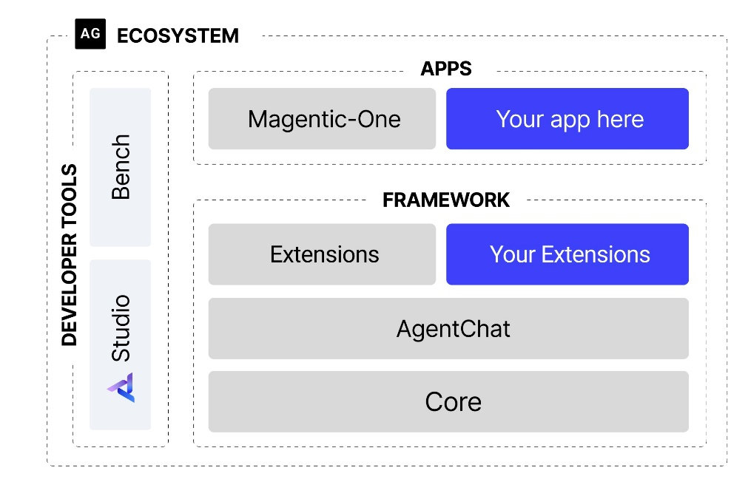

* Complete rewrite and restructure with different architecture from version 0.4 onwards
* Maintained by Microsoft
* Backward incompatible

**Stability and continuous support**

|  |  |
| --- | --- |
| **AG2** | **Autogen** |

At the moment, it can be seen that AG2 receives constant update while the Microsoft Autogen previous versions have been yanked due to conflicts. This raises the question of stability and support for the latter. Another point to note is that the AG2 library is currently at 0.7.1. This can be indicated that the official version will be released soon with version 1.0.0