SOFTWARE REQUIREMENTS SPECIFICATION

FOR

COURSE ADVISER TO STUDENT PLATFORM

CPE461 - SOFTWARE ENGINEERING II

VERSION 1.0

PREPARED BY: CPE461 GROUP 7

REPOSITORY: https://github.com/Evanosas/courseadvisertostudentplatformCPE461

DATE: MARCH 2026

Table of Contents

1. Introduction 1
1.1 Purpose 1
1.2 Document Conventions 1
1.3 Intended Audience and Reading Suggestions 1
1.4 Product Scope 1
1.5 References 1
2. Overall Description 2
2.1 Product Perspective 2
2.2 Product Functions 2
2.3 User Classes and Characteristics 2
2.4 Operating Environment 2
2.5 Design and Implementation Constraints 2
2.6 User Documentation 2
2.7 Assumptions and Dependencies 3
3. External Interface Requirements 3
3.1 User Interfaces 3
3.2 Hardware Interfaces 3
3.3 Software Interfaces 3
3.4 Communications Interfaces 3
4. System Features 4
4.1 User Authentication and Authorization 4
4.2 Advising Session Management 4
4.3 Course Recommendation 5
4.4 Profile Management 5
4.5 Messaging 5
5. Other Non-Functional Requirements 6
5.1 Performance Requirements 6
5.2 Safety Requirements 6
5.3 Security Requirements 6
5.4 Software Quality Attributes 6
5.5 Business Rules 6
6. Other Requirements 7
6.1 UML Design Requirements 7
6.2 Software Design Document Requirements 7
6.3 Implementation Specification 7
6.4 Testing, Verification, and Validation 7
6.5 Process Model 8
Appendix A: Glossary 8
Appendix B: Analysis Models 9
Appendix C: To Be Determined List 9
Revision History
Name | Date | Reason For Changes | Version
CPE461 Team | March 16, 2026 | Initial Release | 1.0

1. Introduction

1.1 Purpose
This Software Requirements Specification (SRS) defines the complete functional and non-functional requirements for the Course Adviser to Student Platform, developed as part of CPE461 Software Engineering. The document serves as the authoritative reference for all development, testing, and validation activities. Version 1.0 covers the full scope of the platform as currently designed and implemented.

1.2 Document Conventions
This document follows the IEEE 830 SRS template. Requirements are prioritized as High (H), Medium (M), or Low (L). Each requirement is assigned a unique identifier in the format REQ-XXX. Bold text is used for defined terms on first use. All headings follow a hierarchical numbering scheme.

1.3 Intended Audience and Reading Suggestions
This SRS is intended for the following stakeholders:
- Developers: Read Sections 3, 4, and 5 for technical and functional requirements.
- Project Manager / Course Instructor: Read Sections 1, 2, and 6 for scope and compliance.
- Testers / QA: Focus on Section 4 (functional requirements) and Section 5 (non-functional requirements).
- End Users (Students and Course Advisers): Review Section 2 for product overview and Section 4 for feature descriptions.

1.4 Product Scope
The Course Adviser to Student Platform is a web-based application designed to bridge the communication and academic advising gap between university course advisers and students. The platform enables students to request advising sessions, receive course recommendations, and access academic resources, while giving advisers tools to manage student interactions efficiently. The system directly supports improved academic outcomes by streamlining advising workflows.

1.5 References
- IEEE Std 830-1998: IEEE Recommended Practice for Software Requirements Specifications
- Karl E. Wiegers, SRS Template, 1999 (base template used for this document)
- GitHub Repository: https://github.com/Evanosas/courseadvisertostudentplatformCPE461
- Node.js Documentation: https://nodejs.org
- Express.js Documentation: https://expressjs.com
- MongoDB Documentation: https://www.mongodb.com/docs

2. Overall Description

2.1 Product Perspective
The Course Adviser to Student Platform is a new, self-contained web application developed for academic use within a university setting. It operates as a standalone system with a client-server architecture: a Node.js/Express.js backend exposes a RESTful API, while an HTML/CSS/JavaScript frontend delivers the user interface in the browser. The platform interfaces with a MongoDB database for persistent storage of user profiles, advising records, and session data. The system is version-controlled via GitHub and is not a replacement for any existing institutional system; rather, it supplements adviser-student interactions through a dedicated digital channel.

2.2 Product Functions
At a high level, the platform provides the following major capabilities:
- User Authentication: Secure registration and login for both students and course advisers.
- Advising Session Management: Students can request, schedule, and track advising sessions.
- Course Recommendation: Advisers can send course recommendations and academic guidance to students.
- Messaging and Notifications: In-platform communication between advisers and students.
- Dashboard Views: Role-specific dashboards for students and advisers showing relevant information at a glance.
- Profile Management: Users can create and update their profiles with academic details.

2.3 User Classes and Characteristics
Two primary user classes are identified:

Students:
Undergraduate or postgraduate students seeking academic advising. They are expected to have basic internet literacy and web browser proficiency. Students interact with the platform to schedule appointments, receive guidance, and track their advising history.

Course Advisers:
Academic staff responsible for guiding students through course selection and academic planning. Advisers have elevated permissions allowing them to manage appointments, send recommendations, and view student profiles. They are expected to be familiar with academic systems and university workflows.

2.4 Operating Environment
The platform is designed to operate in the following environment:
- Server: Node.js runtime (v18+), Express.js framework, hosted on a server supporting HTTPS.
- Database: MongoDB (local or cloud-hosted via MongoDB Atlas).
- Client: Any modern web browser (Chrome, Firefox, Edge, Safari) on desktop or mobile devices.
- Operating System: Platform-independent; server tested on Linux/macOS/Windows environments.
- Network: Internet connectivity required for cloud-hosted deployments; local network for on-premise.

2.5 Design and Implementation Constraints
- The backend is implemented exclusively in JavaScript using Node.js and Express.js.
- The frontend uses vanilla HTML, CSS, and JavaScript (no frontend framework such as React or Vue).
- Authentication is implemented using JSON Web Tokens (JWT) as documented in AUTH_SETUP_GUIDE.md.
- Environment variables are managed via a .env file (template: .env.example); secrets must never be committed to the repository.
- The project follows RESTful API design conventions.
- All source code must be version-controlled using Git and hosted on GitHub.
- Source code must include inline documentation and a comprehensive README file.

2.6 User Documentation
The following documentation components are delivered alongside the software:
- README.md: Project overview, setup instructions, and usage guide.
- AUTH_SETUP_GUIDE.md: Detailed authentication configuration and setup.
- COMPLETE_SETUP_GUIDE.md: End-to-end environment setup and deployment instructions.
- Inline code comments: JSDoc-style comments in server.js, routes, and models.

2.7 Assumptions and Dependencies
- It is assumed that all team members have Node.js (v18+) and npm installed in their development environments.
- The project depends on third-party npm packages as specified in package.json; these are resolved via npm install.
- It is assumed that a MongoDB instance (local or Atlas) is available and accessible via the connection string in .env.
- The project assumes that the operating institution does not have conflicting authentication infrastructure that would prevent JWT-based auth.
- Version control and collaboration depend on GitHub access for all contributors.

3. External Interface Requirements

3.1 User Interfaces
The platform provides browser-based user interfaces built with HTML, CSS, and JavaScript. The key UI requirements are:
- A landing/login page accessible at the application root URL, with separate login flows for students and advisers.
- A student dashboard displaying upcoming sessions, pending recommendations, and recent messages.
- An adviser dashboard displaying student lists, appointment requests, and messaging tools.
- Forms for scheduling advising sessions, updating profiles, and sending course recommendations.
- Responsive design supporting both desktop and mobile viewport sizes.
- Clear error messaging for invalid inputs and failed operations.

3.2 Hardware Interfaces
The platform does not interface with specialized hardware. It operates on standard computing hardware (desktops, laptops, smartphones, tablets) capable of running a modern web browser. The server requires standard network interface hardware to support HTTP/HTTPS communication.

3.3 Software Interfaces
The platform interfaces with the following software components:
- MongoDB: Database layer for persistent storage of users, sessions, and advising records. Interfaced via the Mongoose ODM library.
- Node.js / Express.js: Backend runtime and web framework providing the RESTful API.
- JSON Web Tokens (JWT): Used for stateless authentication between client and server.
- npm ecosystem: Third-party libraries managed via package.json and package-lock.json.

3.4 Communications Interfaces
The platform uses HTTP/HTTPS for all client-server communication. The RESTful API exposes JSON-formatted request and response payloads. JWT tokens are transmitted via HTTP Authorization headers. In production, HTTPS (TLS/SSL) must be enforced to protect user credentials and session data in transit. No external email or SMS gateway interfaces are required for Version 1.0.

4. System Features
The following sections describe the major system features with their associated functional requirements.

4.1 User Authentication and Authorization

4.1.1 Description and Priority
Provides secure user registration, login, and session management for both students and course advisers. Priority: HIGH.

4.1.2 Stimulus/Response Sequences
- User navigates to the registration page and submits credentials → System validates input, hashes password, creates user record, returns success.
- User submits login credentials → System validates against database, issues a JWT token, redirects to role-specific dashboard.
- User attempts to access a protected route without a valid token → System returns 401 Unauthorized.
- Token expires → System prompts re-authentication.

4.1.3 Functional Requirements
Requirement ID | Description | Priority
REQ-101 | The system shall allow new users to register with a unique email address, password, and role (student or adviser). | H
REQ-102 | The system shall hash all passwords using bcrypt before storage. | H
REQ-103 | The system shall issue a signed JWT upon successful login. | H
REQ-104 | The system shall validate JWT tokens on all protected API routes. | H
REQ-105 | The system shall enforce role-based access control (student vs. adviser). | H
REQ-106 | The system shall reject login attempts with invalid credentials with an appropriate error message. | H

4.2 Advising Session Management

4.2.1 Description and Priority
Enables students to request advising appointments and advisers to accept, decline, or reschedule them. Priority: HIGH.

4.2.2 Stimulus/Response Sequences
- Student submits a session request with preferred date/time → System saves the request and notifies the adviser.
- Adviser reviews pending requests and accepts or declines → System updates session status and notifies the student.
- Student views their session history → System returns all past and upcoming sessions for the student.

4.2.3 Functional Requirements
Requirement ID | Description | Priority
REQ-201 | The system shall allow students to submit advising session requests specifying subject and preferred time. | H
REQ-202 | The system shall allow advisers to view all pending session requests. | H
REQ-203 | The system shall allow advisers to accept or decline session requests. | H
REQ-204 | The system shall update session status (pending, confirmed, declined, completed) in real time. | H
REQ-205 | The system shall display a session history to both students and advisers. | M

4.3 Course Recommendation

4.3.1 Description and Priority
Allows course advisers to send personalized course recommendations to individual students. Priority: HIGH.

4.3.2 Stimulus/Response Sequences
- Adviser selects a student and submits a course recommendation → System saves and delivers it to the student's dashboard.
- Student views received recommendations → System displays a list of recommendations with adviser notes.

4.3.3 Functional Requirements
Requirement ID | Description | Priority
REQ-301 | The system shall allow advisers to create and send course recommendations to specific students. | H
REQ-302 | Each recommendation shall include course name, course code, rationale, and adviser name. | H
REQ-303 | Students shall be able to view all recommendations received on their dashboard. | H
REQ-304 | The system shall timestamp all recommendations. | M

4.4 Profile Management

4.4.1 Description and Priority
Allows users to create and update their personal and academic profiles. Priority: MEDIUM.

4.4.2 Functional Requirements
Requirement ID | Description | Priority
REQ-401 | The system shall allow users to view and edit their profile information (name, department, year level, contact). | M
REQ-402 | Profile changes shall be validated before persistence. | M
REQ-403 | Advisers shall be able to view the profiles of students assigned to them. | M

4.5 Messaging

4.5.1 Description and Priority
Enables direct in-platform messaging between students and their assigned advisers. Priority: MEDIUM.

4.5.2 Functional Requirements
Requirement ID | Description | Priority
REQ-501 | The system shall support direct messaging between a student and their adviser. | M
REQ-502 | Messages shall be stored persistently and retrievable in chronological order. | M
REQ-503 | Unread message counts shall be displayed on the dashboard. | L

5. Other Non-Functional Requirements

5.1 Performance Requirements
- The system shall respond to API requests within 2 seconds under normal load (up to 50 concurrent users).
- Database queries shall be optimized with appropriate indexes to ensure response times under 500ms for common read operations.
- The frontend shall load within 3 seconds on a standard broadband connection.

5.2 Safety Requirements
This platform does not control physical systems; therefore, no direct safety hazards are anticipated. However:
- The system shall prevent data loss by performing database backups at regular intervals in production environments.
- The system shall gracefully handle server errors with appropriate HTTP status codes and logging, without exposing stack traces to end users.

5.3 Security Requirements
- All passwords shall be hashed using bcrypt with a minimum cost factor of 10.
- JWT tokens shall have a defined expiration period (maximum 24 hours for session tokens).
- All sensitive configuration (database URI, JWT secret) shall be stored in environment variables and never committed to version control.
- The system shall sanitize all user inputs to prevent injection attacks.
- HTTPS shall be enforced in production deployments.
- Role-based access control shall prevent students from accessing adviser-only endpoints and vice versa.

5.4 Software Quality Attributes
- Maintainability: Source code shall follow consistent naming conventions and include inline documentation. The codebase shall be modular (routes, models, and controllers separated).
- Testability: API endpoints shall be testable via automated test scripts (as evidenced by test_api.js in the repository).
- Reliability: The system shall handle invalid inputs without crashing; all unhandled exceptions shall be caught and logged.
- Usability: The UI shall be intuitive enough for first-time users without requiring a tutorial. Key actions shall require no more than 3 clicks from the dashboard.
- Portability: The application shall be deployable on any Node.js-compatible server environment.

5.5 Business Rules
- Only registered users with the 'adviser' role may send course recommendations or manage session requests.
- A student may only request sessions with advisers assigned to their department or programme.
- All actions performed on the platform shall be associated with an authenticated user account.

6. Other Requirements

6.1 UML Design Requirements
As noted in the project specification, the following UML diagrams must be designed and included in the project deliverables:
- Class Diagrams: Representing the data models (User, Session, Recommendation, Message) and their relationships.
- Sequence Diagrams: Depicting key interaction flows such as login, session booking, and recommendation delivery.
- Context Diagram: A high-level system context diagram showing the platform's interactions with external actors (students, advisers, database).

6.2 Software Design Document Requirements
A separate Software Design Document (SDD) shall accompany this SRS and include:
- Names of all members of the software team and their individual roles.
- Functional requirements traceability to design components.
- Version information for all tools and libraries used.
- UX requirements and wireframes for key screens.

6.3 Implementation Specification
The following implementation choices are specified for the project:
Component | Technology / Library | Reason for Choice
Backend Runtime | Node.js (v18+) | Asynchronous, event-driven; large ecosystem
Web Framework | Express.js | Minimalist, flexible REST API development
Database | MongoDB + Mongoose | Schema-flexible NoSQL; well-suited for document storage
Authentication | JSON Web Tokens (JWT) | Stateless, scalable session management
Password Hashing | bcrypt | Industry-standard secure hashing
Frontend | HTML5 / CSS3 / Vanilla JS | Lightweight; no framework dependency
Version Control | Git + GitHub | Collaboration, history, and code review
Testing | test_api.js (custom) | Lightweight API endpoint validation

6.4 Testing, Verification, and Validation
The platform shall undergo the following testing stages:
- Unit Testing: Individual functions and modules shall be tested in isolation.
- Integration Testing: API routes shall be verified using the test_api.js test framework included in the repository.
- System Testing: End-to-end testing of complete user workflows (registration → login → advising request → recommendation).
- Validation: The completed system shall be validated against this SRS to confirm all requirements are met.
- A formal test report shall document all test cases, results, and any outstanding defects.

6.5 Process Model
The development of this platform follows an iterative development process model. The team may reference outside process model literature beyond the prescribed textbook. Key phases include requirements analysis, design, implementation, testing, and review, with iteration cycles between phases as needed.

Appendix A: Glossary
Term | Definition
API | Application Programming Interface: a set of endpoints for software communication.
JWT | JSON Web Token: a compact, URL-safe token for stateless authentication.
SRS | Software Requirements Specification: this document.
REST | Representational State Transfer: an architectural style for API design.
ODM | Object Document Mapper: maps JavaScript objects to MongoDB documents (e.g., Mongoose).
RBAC | Role-Based Access Control: restricting system access based on user roles.
UML | Unified Modelling Language: a standardized visual language for software design.
bcrypt | A password hashing function designed for secure credential storage.
TBD | To Be Determined: placeholder for requirements not yet fully defined.
CPE461 | The Software Engineering course for which this project is developed.

Appendix B: Analysis Models
The following UML diagrams are required as per the project specification and shall be designed and submitted as part of the project deliverables:

- Class Diagram
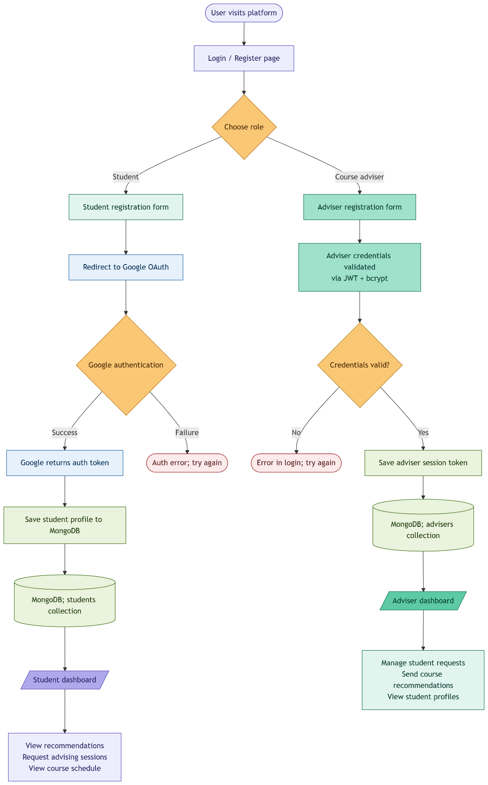

- Sequence Diagram 1
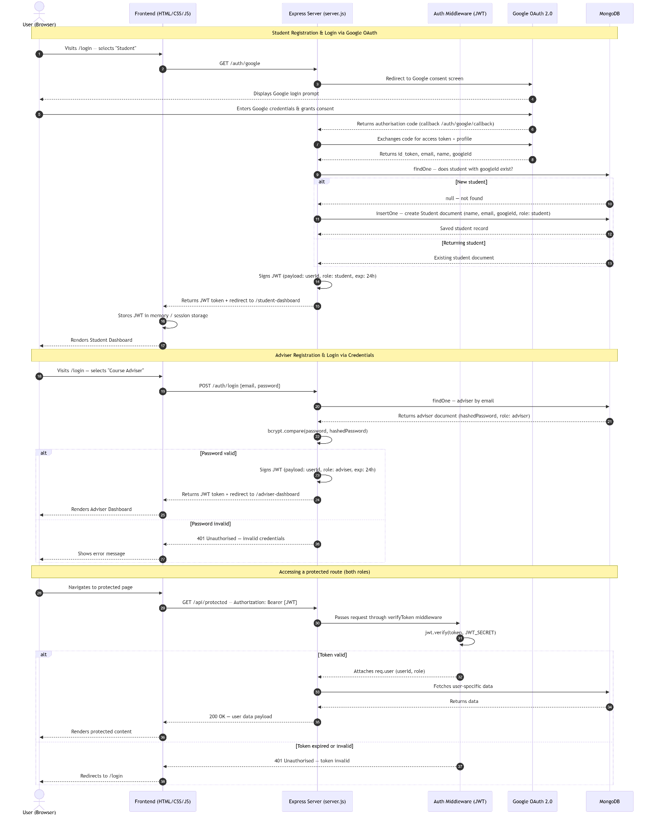
- Sequence Diagram 2
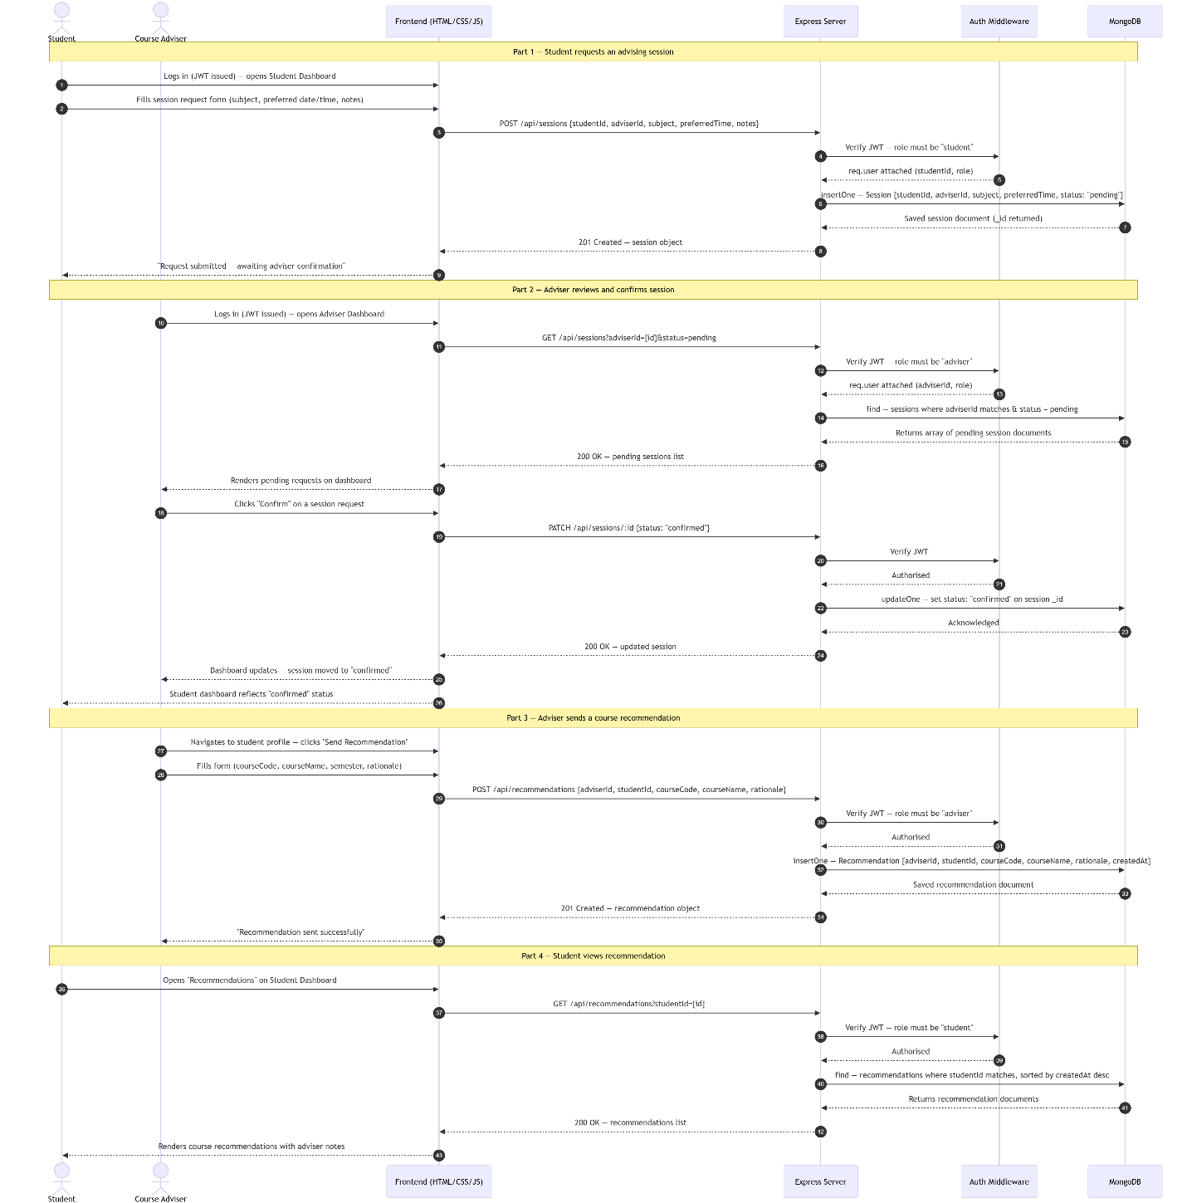

- Context Diagram
- 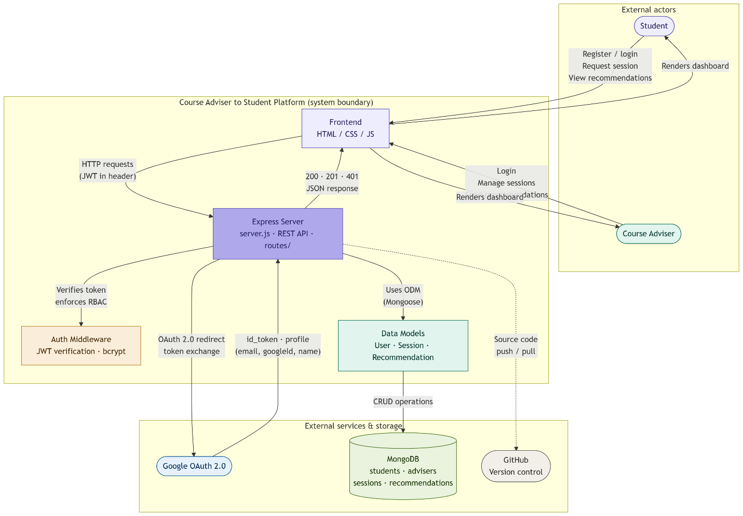

Appendix C: To Be Determined List
TBD # | Description | Target Resolution Date
TBD-1 | Final list of team members and their specific roles (to be confirmed with project supervisor). | Week 1 of development
TBD-2 | Confirmation of MongoDB hosting environment (local vs. MongoDB Atlas). | Prior to deployment
TBD-3 | Notification mechanism for session updates (in-platform only or email integration in v2). | Design phase
TBD-4 | Specific UML tools to be used for diagram creation (e.g., Mermaid.js). | Design phase
TBD-5 | Test framework formalization — whether test_api.js will be extended or replaced with a formal test runner. | Implementation phase

