Weather Site Planning Document

[www.stormchasers.com](http://www.stormchasers.com)

Author: Marshall Evans

Purpose will be to inform the residents of Evans County, particularly the cities of Franklin, Greenville, and Springfield as to current weather info, news, and current events.

The target audience will be teens 12 and up to adults.

Initial sitemap is as follows:

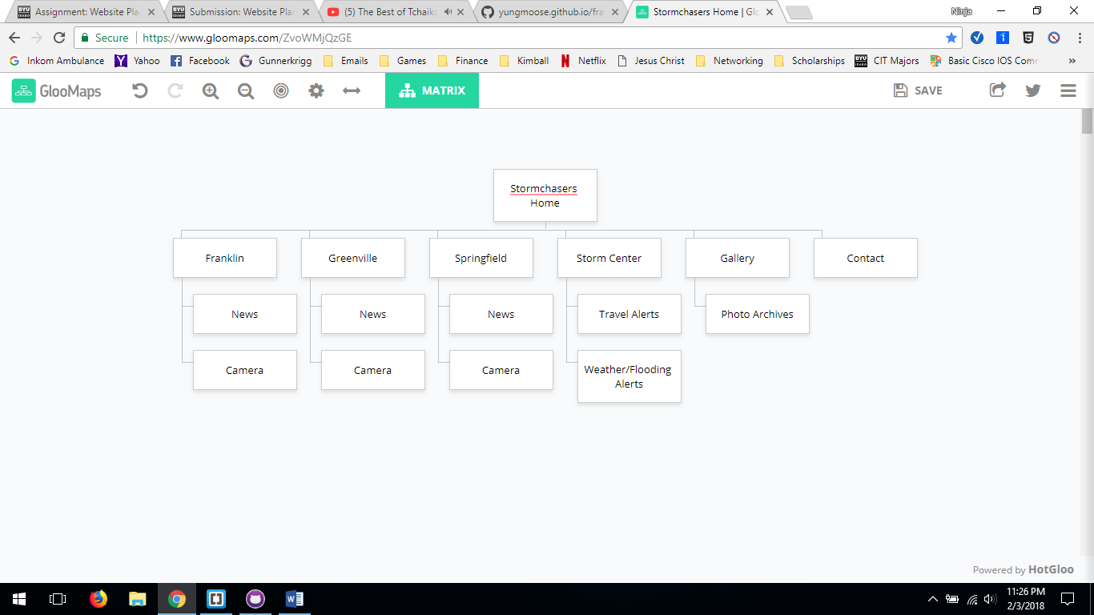

Color scheme will be in light cool colors, using local landscape images as the background of the various pages. Exceptions will be for weather and flooding alerts which will be in bright red.

Typography will be in a bold sans seraph font, to create contrast against the cool color backdrop. Menus will be map based in the medium and large sites.

Rough hand wire-frame sketches are inserted below for small, medium, and large, sites.

Small Site

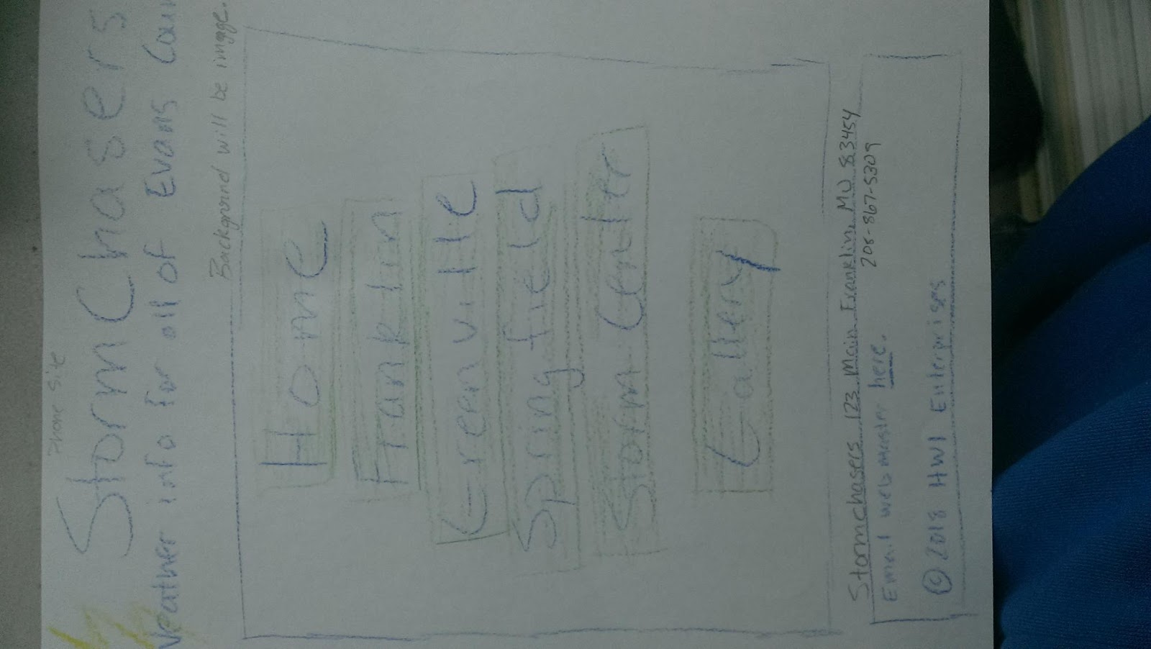

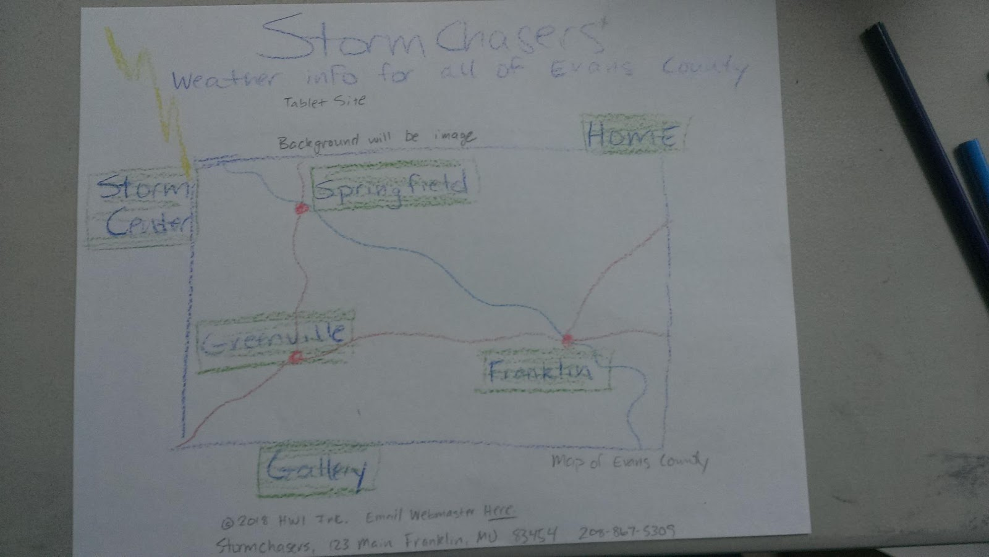

Medium wire-frame

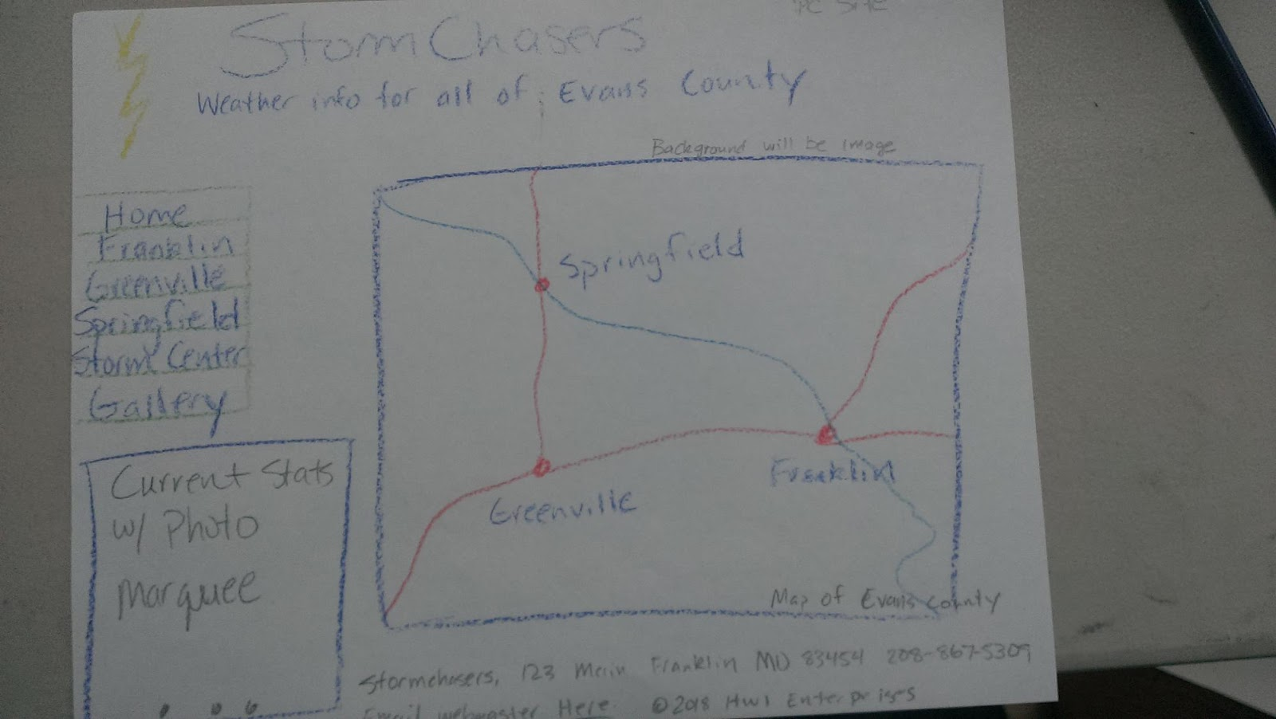

Large wire-frame