**Introduction**

I am going to design a website of bus chartered services through online booking. An exclusive bus chartered service is important of helping passengers get to and from work, schools and excursion activities, recreational events and also military training for army personnel. Providing many people the ability to move across town who might otherwise be home bound with vehicles of their own or the ability to purchase insurance and Certificate of Entitlement.

Booking bus chartered services online do not involve verbal communication, details in words will be filled up in booking form, hence it is clear for the company to proceed the booking. Booking made via telephone might cause incorrect data received if customer speak or pronounce the information wrongly, and resulting service is undelivered or delay in delivery of bus service. Through online booking, it will help customers to lessen the possibility of booking error due to miscommunication with bus transport company.

**Objective**

Today, Internet brings much convenience to everyone, I chose this article because online booking has become a useful tool, so the Company decided to create own website to enable customers to get bus service information and make request easily and precisely.

**Proposed website**

In this website, I have created with a 5 links navigation bars for different of access including Homepage, About Us, Reservation, Feedback, Contact Us. I will be using Testpad with CSS to design my website.

First page, Homepage introduces company name and brief details of company profile including year established, fleet of owned buses and brand of buses. A well-established company provides reliable bus chartered service to customers. It is important to let customer know more details about the company. Second page, About Us including types of buses offered images of some services rendered and types of service provided. Customers could have the best option to choose the type of bus chartered service which meets their requirement. Images of service event done by the Company shows the company’s experience and track records. Third page, Reservation shows the instruction to place bus service order with a booking form for customers to fill up. By referring the clear instruct to place order, customers could be easily fill up the booking details like service execution date and time, capacity of buses required, type of service such as two-way transfer or disposal service, pick up location and drop off location, lastly point of contact details. Fourth page, Feedback is critical for improving performance. Through internet-based feedback, company gets to know drivers’ performance and improve the service quality. Positive feedbacks could be a motivation for the drivers and company to serve better. Last page, Contact Us shows company contact details including company full address, email address, telephone number and fax number. A detailed contact information enables customers to reach the company via various channel.

I will make my website to be user friendly so that all customers are able to use it easily and convenient as clear and precise information are listed and stated in my website.

**Storyboard**

Evans Bus Transportation

Home

Reservation

About

Feedback

Contact Us

Services

Comment

Address

Image

Booking Form

Profile

Email

Telephone and Fax

**Input Specification: Home.html**

Text 1

Hypertext 5

Hypertext 4

Hypertext 3

Hypertext 2

Hypertext 1

Text 2

Image 1

Text 3

Image 2

|  |  |  |
| --- | --- | --- |
| Field | Description | Data Type |
| Text 1 | Company Name | Text |
| Hypertext 1 | Hyperlink to the Home Page | Hypertext |
| Hypertext 2 | Hyperlink to the Our Services | Hypertext |
| Hypertext 3 | Hyperlink to the Reservation | Hypertext |
| Hypertext 4 | Hyperlink to the Feedback | Hypertext |
| Hypertext 5 | Hyperlink to the Contact Us | Hypertext |
| Text 2 | Introduction | Text |
| Image 1 | Image showing Bus | Image |
| Text 3 | Core Value | Text |
| Image 2 | Image Showing Bus | Image |
| Footer | Background Music, Contact and Copyright | Text & Music |

Footer

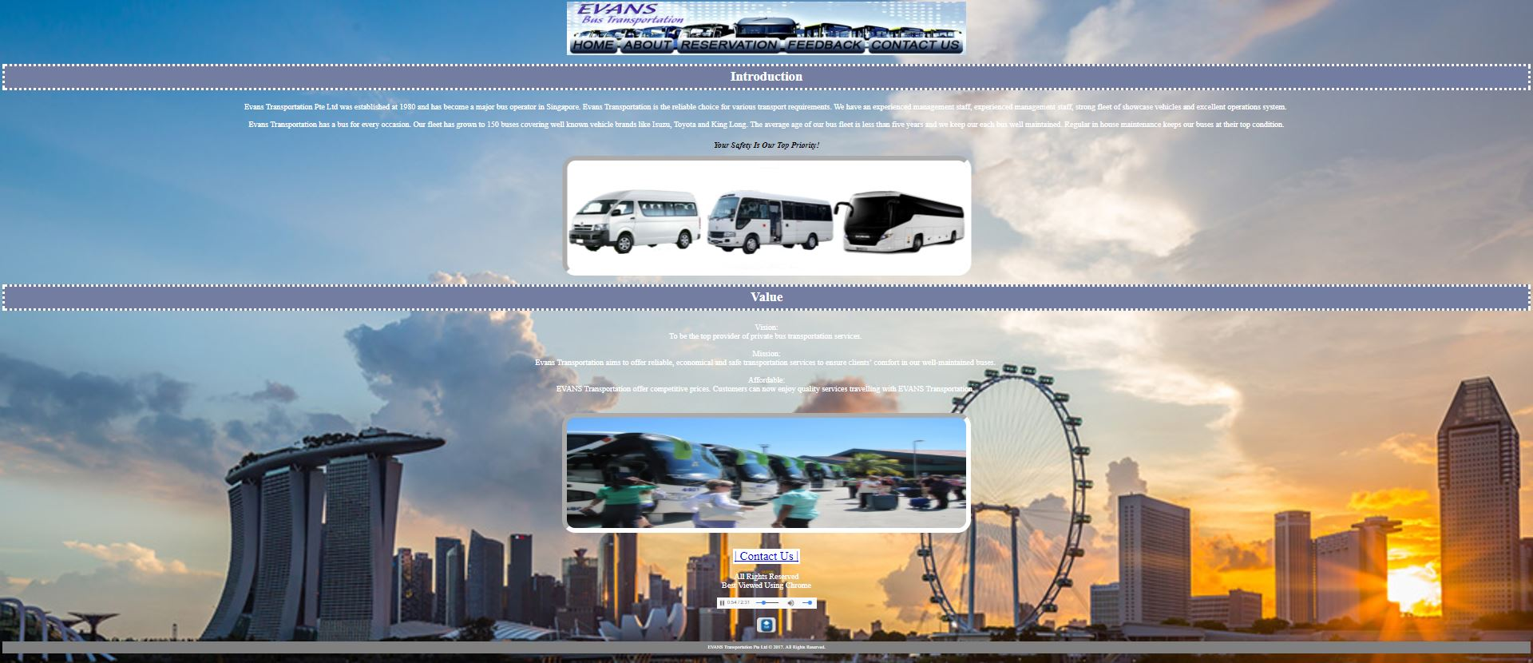

**Input Specification: About Us.html**

Text 1

Hypertext 1

Hypertext 2

Hypertext 3

Hypertext 4

Hypertext 5

Image 1

Video 3

Video 2

Video 1

Image 3

Text 2

Text 4

Footer

|  |  |  |
| --- | --- | --- |
| Field | Description | Data Type |
| Text 1 | Company Name | Text |
| Hypertext 1 | Hyperlink to the Home Page | Hypertext |
| Hypertext 2 | Hyperlink to the Our Services | Hypertext |
| Hypertext 3 | Hyperlink to the Reservation | Hypertext |
| Hypertext 4 | Hyperlink to the Feedback | Hypertext |
| Hypertext 5 | Hyperlink to the Contact Us | Hypertext |
| Image 1 | Image showing buses provided | Image |
| Video | Description of buses provided | Video |
| Text 2 | Table of buses | Table |
| Image 2 | Image showing event involved | Image |
| Text | Services provided | Text |
| Footer | Contact and Copyright | footer |

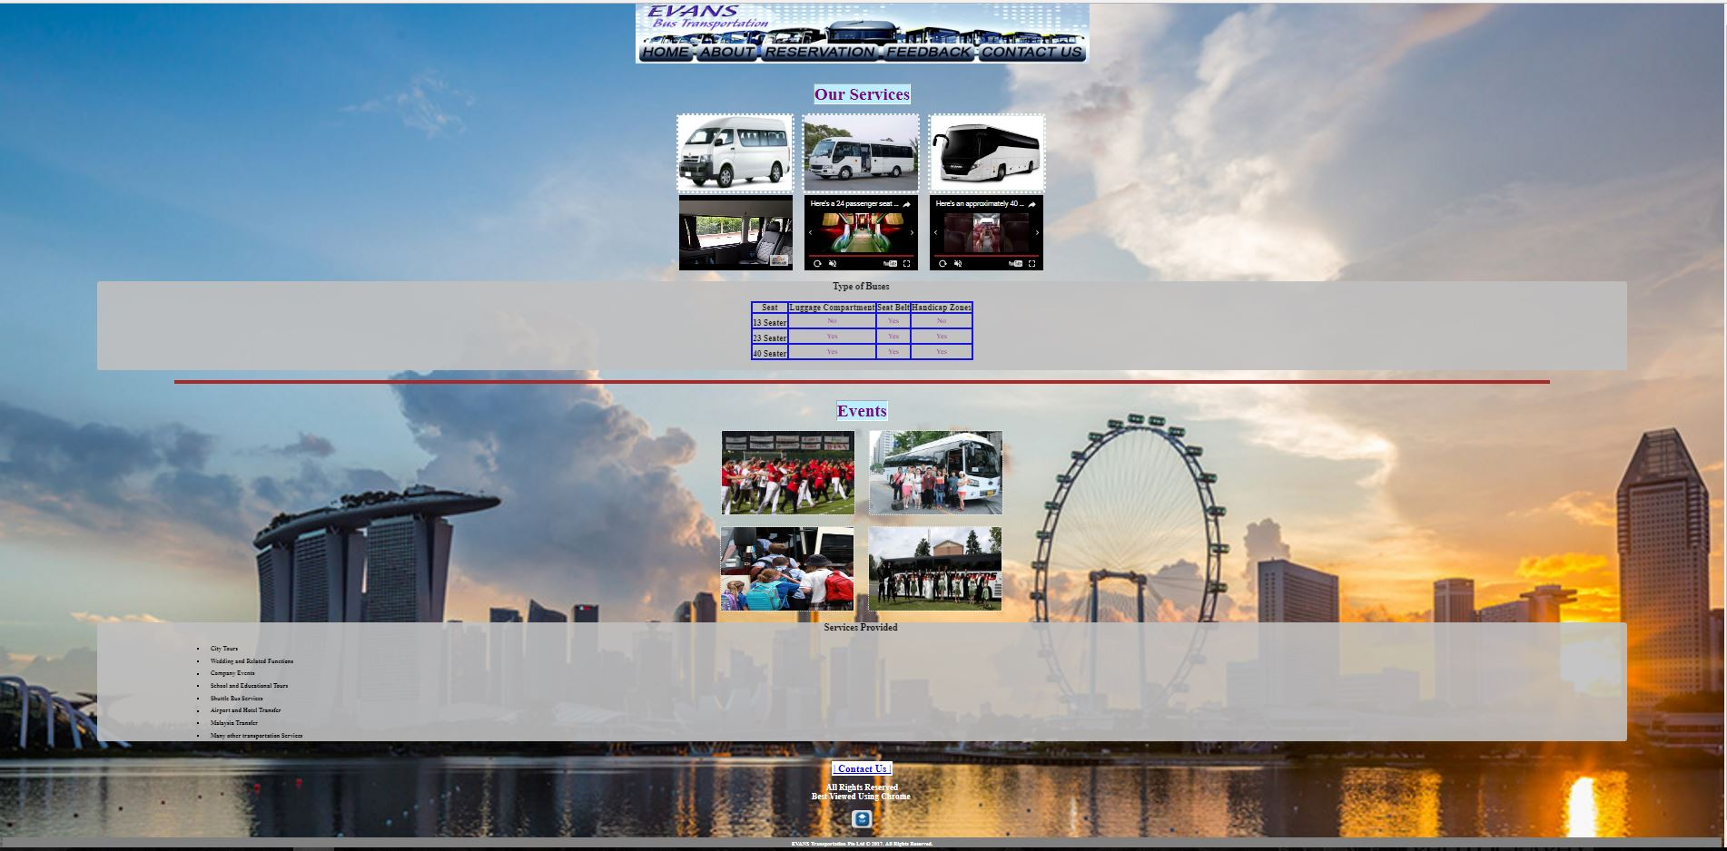

**Input Specification: Reservation.html**

Text 1

Hypertext 5

Hypertext 4

Hypertext 3

Hypertext 2

Hypertext 1

Text 2

Text 3

Text 4

Footer

|  |  |  |
| --- | --- | --- |
| Field | Description | Data Type |
| Text 1 | Company Name | Text |
| Hypertext 1 | Hyperlink to the Home Page | Hypertext |
| Hypertext 2 | Hyperlink to the Our Services | Hypertext |
| Hypertext 3 | Hyperlink to the Reservation | Hypertext |
| Hypertext 4 | Hyperlink to the Feedback | Hypertext |
| Hypertext 5 | Hyperlink to the Contact Us | Hypertext |
| Text 2 | Customer Information | Text |
| Text 3 | Event | Text |
| Text 4 | Disposal | Text |
| Footer | Contact and Copyright | Text |

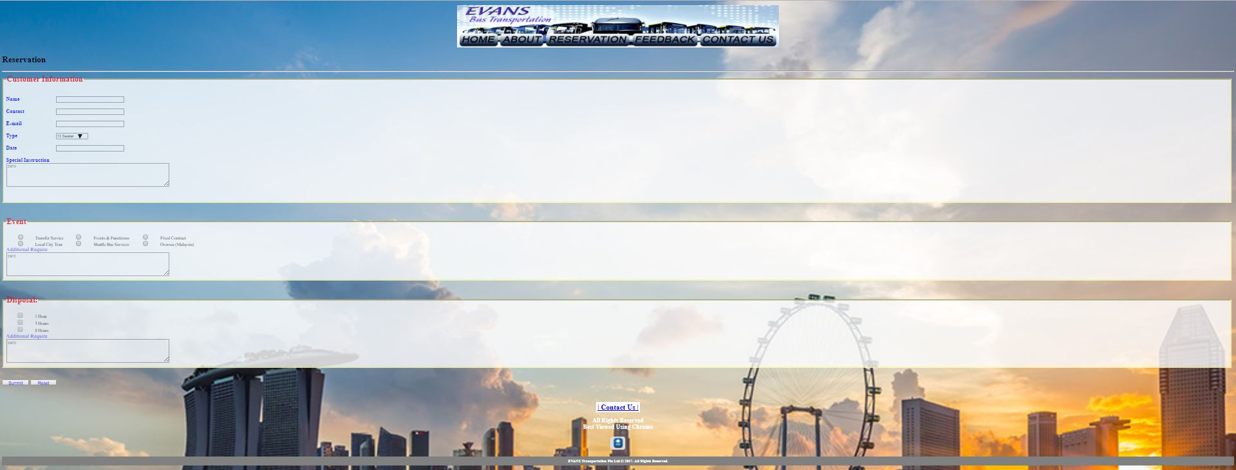

**Input Specification: Feedback.html**

Text 1

Hypertext 5

Hypertext 4

Hypertext 3

Hypertext 2

Hypertext 1

Text 2

|  |  |  |
| --- | --- | --- |
| Field | Description | Data Type |
| Text 1 | Company Name | Text |
| Hypertext 1 | Hyperlink to the Home Page | Hypertext |
| Hypertext 2 | Hyperlink to the Our Services | Hypertext |
| Hypertext 3 | Hyperlink to the Reservation | Hypertext |
| Hypertext 4 | Hyperlink to the Feedback | Hypertext |
| Hypertext 5 | Hyperlink to the Contact Us | Hypertext |
| Text 2 | Particulars and Feedback | Text |

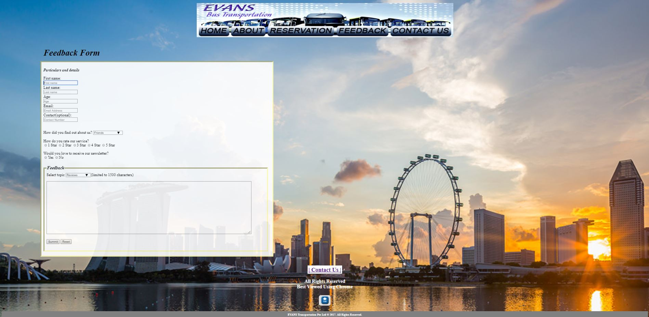

**Input Specification: Contact Us.html**

Text 1

Hypertext 5

Hypertext 4

Hypertext 3

Hypertext 2

Hypertext 1

Image 1

Text 2

Image 2

Footer

|  |  |  |
| --- | --- | --- |
| Field | Description | Data Type |
| Text 1 | Company Name | Text |
| Hypertext 1 | Hyperlink to the Home Page | Hypertext |
| Hypertext 2 | Hyperlink to the Our Services | Hypertext |
| Hypertext 3 | Hyperlink to the Reservation | Hypertext |
| Hypertext 4 | Hyperlink to the Feedback | Hypertext |
| Hypertext 5 | Hyperlink to the Contact Us | Hypertext |
| Map | Image showing Google Map | Map |
| Text 2 | [List] Address, Email, Fax, Telephone | Text |
| Image | Image showing Safe Driver | Image |
| Footer | Contact and Copyright | Footer |

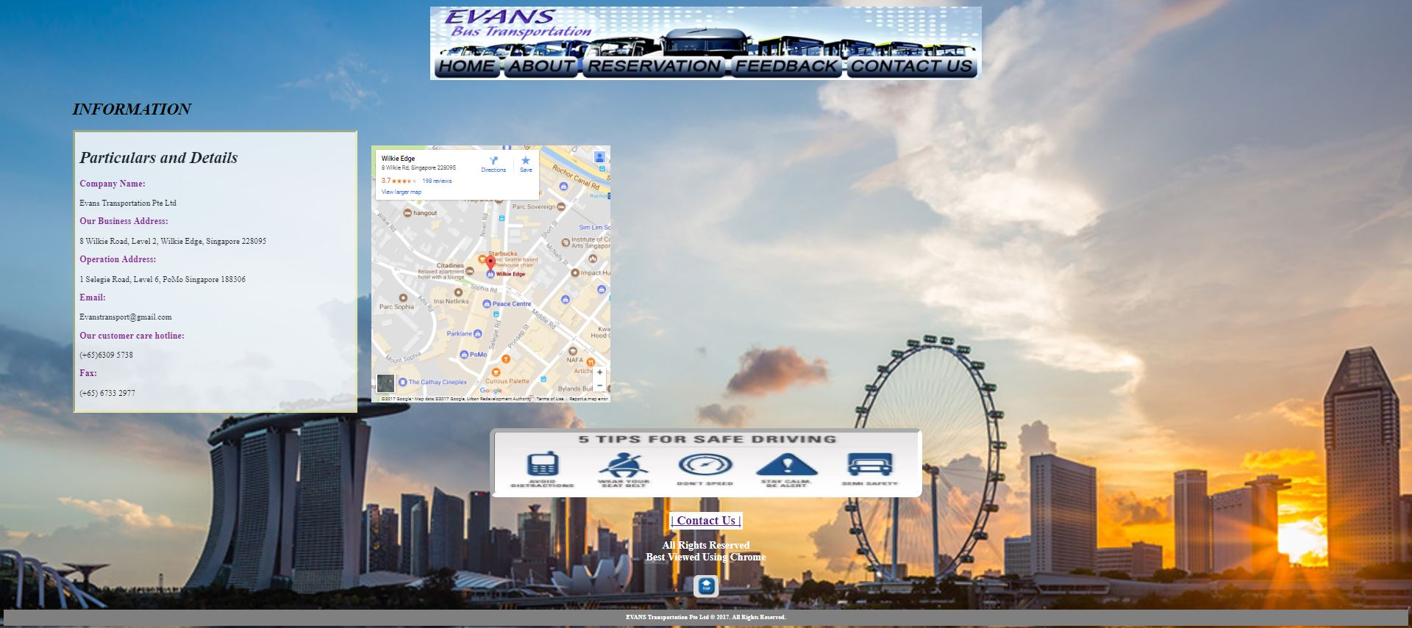

**Reference List**

**Website**

Tong tar transport services Pte Ltd. (1968). - Singapore bus operator. Retrieved July 10, 2017, from <https://www.tongtar.com/>

Woodlands transport services Pte Ltd. (1974). Retrieved July 11, 2017, from <https://woodlandstransport.com.sg/>

Cititrans Bus Transit. (2004). Retrieved July 11, 2017, from <http://cititrans.com.sg/>

**Videos**

*Maxi Cab & Minibus charter singapore* [Video file]. (2014, January 2). Retrieved July 12, 2017, from <https://www.youtube.com/watch?v=qJeQMI63V_g>

*Here's a 24 passenger seat bus* [Video file]. (2015, November 23). Retrieved July 12, 2017, from <https://www.youtube.com/watch?v=kgC_QuK7T8k>

*Here's an approximately 40 seat bus.* [Video file]. (2016, April 7). Retrieved July 12, 2017, from <https://www.youtube.com/watch?v=AHJCE9j7Ws0>