General Application Principles for DARE-Arbo Assessment and Appraisal

1.0 Key steps in the scoring process
Apply the rules in the following sequence: (1) define the target study population; (2) identify the biological synthesis endpoint; (3) identify the observed numerator; (4) identify the assay or explicit diagnostic algorithm that produced that numerator; (5) determine exactly which participants were eligible for and received the endpoint-defining assay or algorithm; (6) assign the measurement pathway and, when relevant, the confirmation tier; (7) identify the matching observed numerator and denominator; and (8) score Q1-Q10 for that endpoint only.

1.1 Primary implementation rule:
The endpoint is defined by the observed biological result that enters the synthesis numerator. The most sophisticated assay reported anywhere in the article must never be allowed to determine the endpoint, denominator, or quality score unless that assay is explicitly part of the endpoint being appraised. A confirmatory test contributes to the appraisal of an outcome only when the article explicitly demonstrates that the confirmation result is linked to the same virus, endpoint, and eligible participant set. Confirmation performed for a different virus, assay-defined subgroup, participant subset, or endpoint must not be used to improve another outcome

1.2 Operational definitions for implementation
Term | Operational definition
Synthesis endpoint | The biological outcome entering the evidence synthesis, defined by its numerator (for example, IgG-positive prior exposure, IgM positivity, NS1 positivity, direct virus detection, or neutralization positivity).
Primary endpoint-defining assay | For a single-assay endpoint, the assay whose observed result directly creates the numerator. Q6a and Q6b are anchored to this assay.
Primary screening assay | The first assay in a staged diagnostic pathway. It does not by itself define the final algorithm-confirmed numerator when the article explicitly requires a second assay before a participant is counted.
Confirmatory assay | An additional assay used to verify or refine a result from the primary assay. Confirmation affects Q6c only when it is explicitly linked to the same endpoint; it changes the endpoint numerator only when the article defines a staged algorithm.
Endpoint-defining diagnostic algorithm | A predefined multi-step rule in which a participant must satisfy the required screening and confirmatory stages before being counted in the numerator.
Endpoint denominator | The observed participants eligible for and actually classified by the endpoint-defining assay or algorithm. It must correspond to the same virus, endpoint, time period and measurement pathway as the numerator.

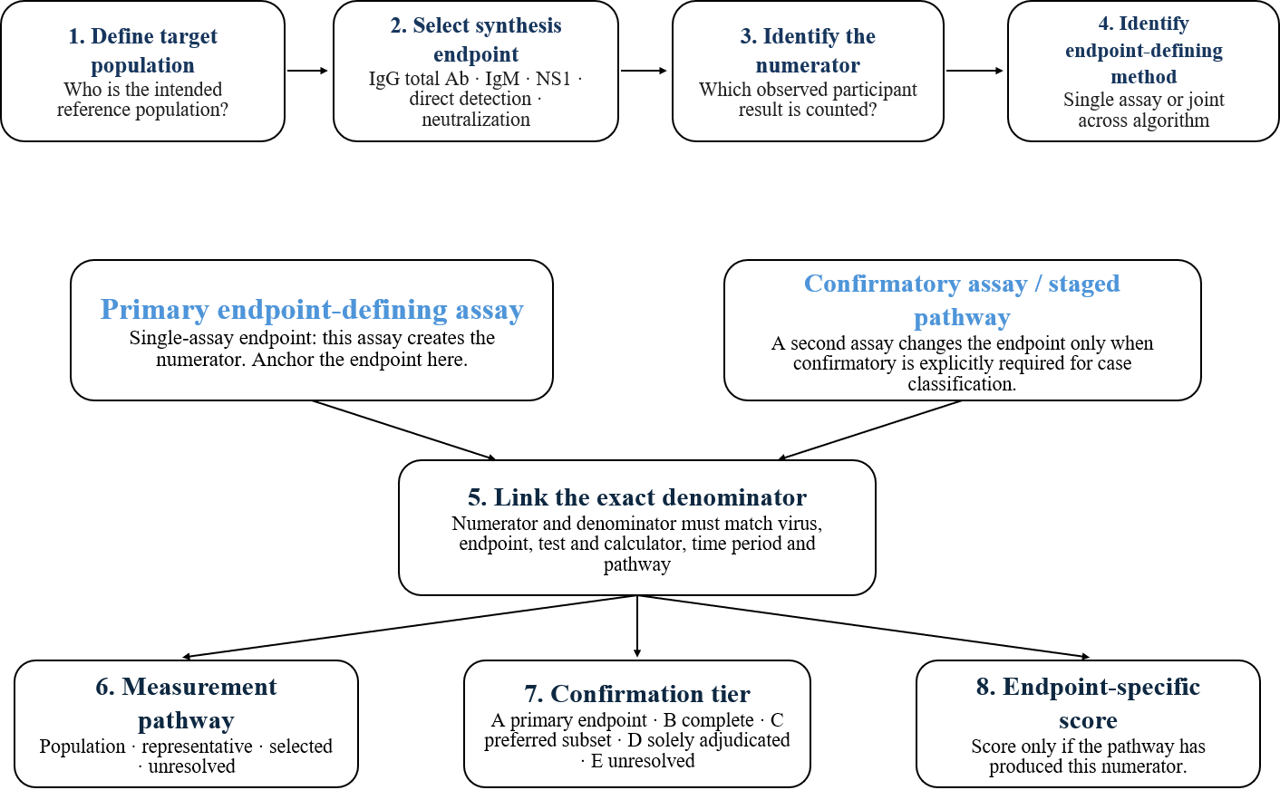
Figure 1. DARE-Arbo endpoint-first implementation workflow. The appraisal begins with the synthesis numerator and its endpoint-defining assay or algorithm, then classifies the tested population and any confirmation pathway before endpoint-specific scoring

Identifying the synthesis endpoint
The endpoint is determined by the biological marker contributing the numerator, not by the study title, authors' terminology, clinical presentation, or the presence of a more specific assay elsewhere in the article.
Synthesis endpoint | Operational definition | Include as this endpoint when | Do not classify as
Prior exposure / total antibody seroprevalence | Evidence of cumulative or previous arbovirus exposure based principally on IgG, total antibody, or another primary non-acute antibody assay. | A distinct IgG-positive, total-antibody-positive, or equivalent primary serologic numerator is reported for a defined tested population. | IgM-only recent infection; neutralizing-antibody prevalence; direct-detection active infection.
Presumptive recent infection - IgM | Arbovirus-specific IgM positivity. | A distinct observed IgM-positive numerator and IgM-tested denominator are available. | Confirmed active infection, even if authors call IgM positivity “acute infection”.
Presumptive active infection - NS1 antigen | Detection of DENV NS1 antigen. | A distinct NS1-positive numerator and NS1-tested denominator are reported. | Molecularly confirmed infection; do not combine NS1 with IgM or PCR numerators.
Neutralizing-antibody prevalence | Neutralizing antibody measured by PRNT, VNT, microneutralization, reporter-virus neutralization or equivalent functional neutralization assay. | Neutralization itself is the endpoint-defining assay and a neutralization-positive numerator plus neutralization-tested denominator are identifiable. | Ordinary primary-assay seroprevalence when neutralization was used only as confirmation.
Confirmed active infection | Direct demonstration of virus by nucleic-acid detection or viable-virus detection. | RT-PCR, RT-qPCR, RT-LAMP, RT-RPA or equivalent NAAT produces the endpoint numerator; viable-virus isolation can also constitute direct active infection. | IgM, NS1 or serologic confirmation alone.
Sequencing: Sequencing supports molecular identification rather than constituting a separate prevalence endpoint unless a distinct sequencing-positive numerator and denominator exist.

2.1 Mixed serology
If separate IgG and IgM counts exist, create separate endpoints. Do not use “IgM and/or IgG positive” as the IgM endpoint. If only a combined IgM/IgG result exists and the components cannot be separated, classify it as mixed/other serologic evidence unless the paper clearly defines the assay as a cumulative antibody/exposure endpoint. Do not infer an IgM numerator or an IgG numerator.

2.2 Multiple markers in the same participants
IgM, NS1, direct-detection and neutralization numerators remain separate unless participant-level overlap is explicitly reported and the synthesis deliberately defines a composite outcome. The presence of multiple markers in the same article does not permit one marker to replace another endpoint numerator.

Endpoint-defining assay, measurement pathway, and confirmation
Implementation requires two separate classifications: (A) the role of the assay in defining the endpoint and (B) who actually received the endpoint-defining assay or algorithm. These dimensions must not be collapsed into a single label.

3.1 Identifying the primary endpoint-defining assay
Use the following decision rule for every endpoint: first identify the observed numerator; then trace that numerator back to the assay result or explicit multi-step rule that made a participant count as positive. If one assay alone determines positivity, that assay is the primary endpoint-defining assay. If the article requires confirmation before a participant counts, the complete staged algorithm is endpoint-defining, and the first test is the primary screening assay.
Do not promote confirmation into the primary endpoint: A PRNT, PCR, sequencing result or other high-specificity method performed on a subset does not replace the primary-assay numerator unless the synthesis endpoint explicitly uses the confirmed result and an appropriate confirmed denominator can be identified.

3.2 Measurement pathway: who actually received the endpoint-defining assay?
The source study population may contain 1,000 participants while only 50 receive the endpoint-defining assay. The tested population must therefore be classified independently of assay quality. The same four measurement-pathway labels apply to primary serologic, direct-detection and primary neutralization endpoints.
Measurement pathway | Explicit rule
Population endpoint | The endpoint-defining assay was applied to the entire eligible study sample, or to the complete representative sample that constitutes the stated endpoint denominator.
Representative subsample | Only a predefined representative/random subsample was tested. The tested subsample, not the full source cohort, is the direct denominator unless valid design-based sampling weights are explicitly used.
Selected subsample | Testing depended on symptoms, another assay result, stored-sample availability, titre, severity, investigator choice or another nonrepresentative mechanism. Report positivity for the tested subset only; do not describe it as unrestricted population prevalence.
Unresolved | The relationship between tested participants and the source population cannot be established. Population prevalence must not be inferred.
Endpoint labels should be combined with the relevant assay class where useful, for example: “population prior-exposure seroprevalence”, “selected direct-detection subsample” or “representative neutralizing-antibody prevalence subsample.

3.3 Confirmatory assays and staged endpoint pathways
A second assay has two possible roles. It may be supporting confirmation for a primary endpoint, in which case the primary numerator and denominator remain unchanged and the confirmation evidence is considered under Q6c. Alternatively, the article may explicitly define a staged algorithm in which confirmation is required before a participant enters the final numerator. In that situation, the complete algorithm is a distinct endpoint pathway and must have its own numerator, denominator, and score.
- Supporting confirmation: primary endpoint numerator remains the result of the primary endpoint-defining assay. Confirmation can affect Q6c but must not automatically change Q6a, Q7 or Q8 for the primary endpoint.
- Algorithm-defined confirmation: the final numerator contains only participants satisfying the stated screening-plus-confirmation rule. Q5, Q7 and Q8 must be evaluated for completion and consistency of the whole algorithm.
- Separate endpoints may coexist in one article. For example, the same study can contribute a primary IgM endpoint and a separate molecularly confirmed staged endpoint; each is appraised independently.

Direct-detection assay role/staged molecular-confirmation tier
Tier | Explicit rule | Interpretation
Tier A - primary direct-detection endpoint | NAAT or viable-virus detection itself is the endpoint-defining assay. | Use the direct-positive numerator and the directly tested denominator. Classify population/representative/selected/unresolved status separately.
Tier B - complete staged molecular confirmation | A predefined primary screen is applied and all participants requiring direct confirmation under the algorithm complete molecular/viable-virus testing. | May support screening-plus-confirmation prevalence when the final numerator and the full algorithm-entry denominator are both observed and linked.
Tier C - predefined subset verification | Only a predefined representative/random subset of screen-positive or otherwise eligible participants undergoes direct confirmation. | Use the directly tested subset denominator for observed subset positivity unless a valid design-based estimator is explicitly reported; do not treat raw subset positives as unrestricted population prevalence.
Tier D - selected or mixed verification | Direct confirmation depends on symptoms, titre, severity, specimen availability, investigator choice, or a mixed positive/negative verification scheme whose sampling structure is not reconstructable. | Verification evidence only; do not infer unrestricted population molecular prevalence.
Tier E - unresolved | Direct-confirmation denominator, participant linkage, or selection mechanism is absent or cannot be verified. | Confirmation-based prevalence is non-analysable.

Neutralization assay role / staged neutralization-confirmation tier
Tier | Explicit rule | Interpretation
Tier A - primary neutralization endpoint | PRNT/VNT/microneutralization or equivalent functional neutralization assay itself defines the endpoint numerator. | Use neutralization-positive participants over the neutralization-tested denominator. Classify population/representative/selected/unresolved status separately.
Tier B - complete staged neutralization confirmation | All participants requiring neutralization under a predefined primary-screen algorithm complete neutralization. | May support screening-plus-neutralization-confirmed prevalence when the final numerator and complete algorithm-entry denominator are observed and linked.
Tier C - predefined subset verification | Only a predefined representative/random subset of primary-screen positives or other eligible participants undergoes neutralization. | Report neutralization positivity in the tested subset unless a valid design-based estimator is explicitly reported.
Tier D - selected or mixed verification | Neutralization depends on titre, specimen availability, severity, investigator choice or a non-reconstructable mixture of positives/negatives. | Not directly interpretable as unrestricted population neutralizing-antibody prevalence.
Tier E - unresolved | Neutralization denominator, participant linkage, or selection mechanism is absent or reconstructed without defensible linkage. | Non-analysable for prevalence.

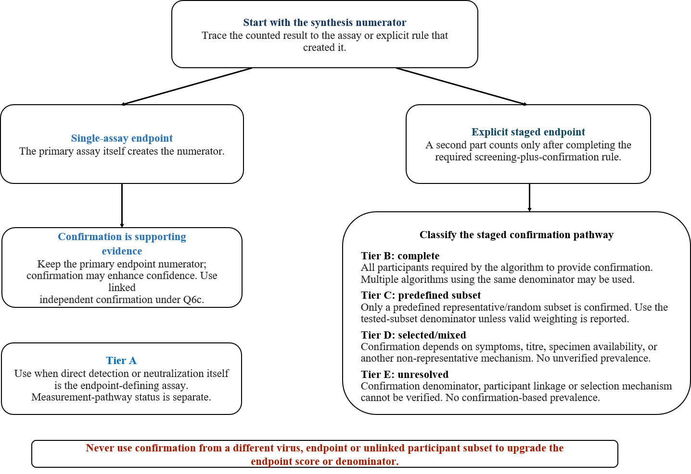
Figure 2. Distinguishing a primary endpoint-defining assay from a confirmatory pathway. Tier A denotes an assay that itself defines the direct-detection or neutralization endpoint; Tiers B-E classify staged confirmation completeness and selection. Measurement-pathway status remains a separate variable.

3.4 Worked implementation examples
Study pattern | DARE-Arbo implementation
IgG ELISA in 500 participants; PRNT on 50 selected ELISA-positive samples | Primary prior-exposure endpoint: ELISA positives / 500 tested. PRNT is selected supporting confirmation; it does not replace the ELISA numerator. A neutralization subset endpoint may be reported only as PRNT positives / 50 PRNT-tested.
IgM in 1,000 participants; all 100 IgM-positive participants receive PCR; 20 are PCR-positive | Two endpoints may be extracted: presumptive recent infection = 100/1,000 IgM; staged molecular-confirmed endpoint = 20/1,000 if the article explicitly defines the complete screening-plus-PCR algorithm. Molecular confirmation is Tier B.
IgM in 1,000 participants; only 20 of 100 IgM-positive participants receive PCR | IgM endpoint remains 100/1,000. Molecular positivity is reported among the 20 PCR-tested participants unless a valid predefined sampling estimator supports broader inference. Do not use PCR positives / 1,000 as raw population molecular prevalence.
PCR applied directly to all eligible participants | PCR is Tier A primary direct detection. The direct-positive numerator is divided by the PCR-tested denominator. A second independent method is required for Q6c; PCR controls alone are Q6b evidence, not Q6c.

Domain appraisal
Endpoint-specific scoring: Q1-Q4 may be inherited across endpoints only when the target population, source frame, recruitment pathway, and relevant data source are genuinely identical. Q1, Q3 and Q4 are separate constructs: Q1 assesses achieved-sample representation of the target; Q3 assesses frame coverage; Q4 assesses selection. Scores must not compensate for one another. Q2 remains a data-provenance item. Q5 and Q6a-Q10 must be checked for each endpoint; Q5 may be inherited only when endpoint-specific eligibility and completeness are demonstrably identical.

4.1 Study-design application sequence for Q1, Q3 and Q4
Apply these items in the following order: define the article-outcome and explicit target; classify that target using the hierarchy below; score Q1; identify the source frame and score Q3; identify selection at each consequential stage and score Q4; then record separate rationales. Do not infer unreported methods or broaden the target beyond what the paper supports.
Target-population classification rule. Use the first applicable category in the priority sequence. Secondary descriptors such as pregnancy, occupational exposure or outbreak status should be retained as qualifiers when they do not define the primary category.
Decision order | Classification | Operational trigger
1 | Suspected arbovirus population | Arbovirus-specific suspected/probable/confirmed/linked case definition or referral/testing defines eligibility.
2 | Non-malarial febrile population | Fever is required and malaria must be negative/excluded for eligibility.
3 | General febrile population | Fever/acute febrile illness defines eligibility; rules 1-2 do not apply.
4 | Non-febrile patients | Explicitly afebrile/non-febrile patients sampled through clinical services.
5 | General outpatients | General healthcare attendees/outpatients with none of rules 1-4 or another specific target criterion.
6 | Other defined target | Otherwise classify the explicit target: community/general, antenatal, donor, occupational/zoonotic, other clinical, archived/residual, mixed, or unclear.

Q1: Target-population representation [0-1]
Q1 evaluates achieved-sample representation relative to the explicitly defined target population. It is not a score for the recruitment method, and it is not an automatic test of national representativeness. First classify the target population using the decision rule above, then compare the achieved age and sex distribution with the groups expected within that target. Required evidence includes the eligibility definition, source setting, achieved age/sex distribution, important exclusions and the scope of inference or conclusions. A restricted target such as children, pregnant women, blood donors, occupationally exposed groups, or attendees of a named facility may score 1 when that is the population the study actually intends to represent and relevant demographic groups are adequately represented. The same sample should score 0 when it is generalized to a materially broader target without justification. Archived/residual specimens score 0 when the original target or achieved demographic distribution cannot be reconstructed. For mixed populations, separate article-outcomes when population-specific numerators and denominators are available; otherwise score against the explicitly defined mixture. If representation cannot be judged from the report, Q1=0.

Score | Application rule
0 | The defined target is unclear; age/sex information is insufficient to judge representation; important age or sex groups expected within the target are materially underrepresented/overrepresented; or a special subgroup is generalized to a broader target without justification.
1 | The achieved sample includes and adequately represents the age and sex groups expected for the explicitly defined target, with no major unexplained demographic restriction that makes it a poor representation of that target.
Minimum audit evidence for Q1: explicit target population and eligibility; achieved age and sex distribution; major exclusions/restrictions; and the population to which the paper interprets or generalizes the result. Do not infer community representativeness from facility attendance, blood donation, pregnancy, occupation, or archival availability

Q2: Direct participant-derived data or specimens [0-1]
This criterion concerns the origin of the measurement, not target-population representation, frame coverage, or recruitment quality. Archived or stored specimens can score 1 because a specimen does not cease to be participant-derived merely because it was collected previously or stored in a biobank. Conversely, a direct participant-derived specimen does not imply that the study is representative. Q2 must therefore be scored independently of Q1, Q3 and Q4. For example, an archived convenience specimen may receive Q2=1 while Q3 or Q4 score 0-1.
Score | Application rule
0 | Outcome derives only from proxy respondents, aggregated surveillance reports, line lists, medical records, modelled/reconstructed results, or another secondary source without direct participant biological measurement; or provenance cannot be established.
1 | The arbovirus parameter is measured from an individual participant-derived blood, serum, plasma, CSF, urine, saliva, or other biological specimen, or directly collected participant data relevant to the endpoint.

Q3: Sampling-frame representation [0-1]
Q3 evaluates frame coverage - who could have entered the endpoint denominator - rather than how eligible units were selected; selection is Q4. Identify the actual source frame for the article-outcome, such as a population/household enumeration frame, a health-facility attendee frame, a surveillance/case-report/outbreak frame, an archived specimen/record/parent-study frame, or an occupational/exposure-defined frame. Score that frame against the explicitly defined target, not against a broader population that the frame was never designed to cover. A complete eligible-attendee frame from a named hospital may score Q3=1 for that hospital-attendee target but Q3=0 if used to infer all febrile residents of a city. Surveillance or outbreak frames score 1 only when the case definition and reporting/network structure reasonably cover the stated surveillance-case target. For archived or secondary studies, evaluate the parent source and whether major eligible segments remained available; selective specimen retention or an unreconstructedly source frame supports Q3=0. Named communities without sufficient enumeration detail, mixed frames whose coverage cannot be reconstructed, and any frame whose coverage cannot be established score 0. Multisite recruitment may improve coverage but does not by itself establish Q3=1.
Score | Application rule
0 | The frame is unclear or its coverage cannot be established; structurally excludes important parts of the defined target; is purposively restricted/obsolete; relies on a narrow facility/laboratory for a materially broader target; or, in an archived/secondary study, major eligible segments are unavailable or selectively retained.
1 | The source frame is identifiable and reasonably covers the explicitly defined target with respect to relevant geography, clinical setting, age/sex eligibility, surveillance network, or exposure-group structure.
Minimum audit evidence for Q3: the target population; the source list/frame or parent cohort; geography and sites/settings; relevant eligibility restrictions; and evidence that important target segments were not systematically excluded. A strong recruitment method cannot repair an under-covering frame

Q4. Sampling and recruitment method [0-3]
Q4 evaluates how units were selected at each consequential stage: sites/communities, participants, and - for retrospective or secondary analyses - specimens or records. Score the actual selection pathway that generated the endpoint denominator rather than the authors' design label. Consecutive enrolment identifies a non-probability method and scores 1, not 0. Convenience, volunteer, referral, purposive, blood-donor, routine residual-specimen, and availability-based archived sampling are also generally Q4=1. Simple/systematic random selection within a defined frame scores 2. A predefined multisite non-probability structure may also score 2 only when the site structure materially broadens capture of the defined target; merely adding convenience sites is insufficient. Multistage, stratified, cluster-probability or comparable implemented probability sampling scores 3, as does verified census/universal capture of all eligible units across the defined target frame. Archived status alone does not determine Q4: random secondary selection can justify 2 and formal multistage/stratified probability selection can justify 3. Case-based, sentinel or outbreak enrollment is usually non-probability unless complete capture of the defined eligible case/contact frame is demonstrated. For mixed/hybrid recruitment, document all stages and score according to the weakest consequential selection stage affecting the endpoint denominator.
Score | Explicit application
0 | Recruitment/site/specimen-selection method is inadequately reported, so the assessor cannot determine how the endpoint sample was assembled. Do not infer random, consecutive, or universal sampling.
1 | Convenience, purposive, volunteer, referral-based, consecutive, blood-donor, routine residual specimen, availability-based archived/secondary sample, case-based/sentinel or comparable non-probability selection.
2 | Simple/systematic random selection within a defined frame; or a predefined multisite healthcare/community non-probability structure that materially broadens capture of the explicitly defined target but is not a full multistage/stratified probability design or census.
3 | Implemented multistage, stratified, cluster-probability or comparable probability sampling; or verified census/universal capture of all eligible participants/specimens across the explicitly defined target population or relevant multisite network.
Minimum audit evidence for Q4: how sites or communities were chosen; how eligible participants were approached/selected; how stored specimens or records were selected when applicable; the randomization/systematic interval, strata/clusters or census rule when claimed; and evidence that the stated procedure was implemented. Design labels alone are insufficient. Q4 does not correct Q3 undercoverage and does not determine Q1 representation

Q5: Nonresponse, missingness, or completeness bias [0-2]
Q5 evaluates completeness for the specific endpoint being assessed. For a single-assay endpoint, calculate completeness using participants eligible for that endpoint-defining assay. For an explicit staged algorithm, a participant is completely classified only when all stages required by the algorithm have been completed. A predefined subset-verification design is not “missing confirmation” for the subset endpoint, but it cannot be treated as a complete population algorithm endpoint:
$$\text{Completeness}= 100 × \frac{\text{participants with an interpretable endpoint result }}{\text{participants eligible for that endpoint}}$$
For a staged algorithm, “interpretable endpoint result” means completion of every stage required for final classification. For surveillance/retrospective studies, use record/specimen completeness rather than conventional questionnaire response. Missing required confirmation must not be coded as a negative result. Conversely, molecular testing restricted by a predefined subset design should be assessed against the subset endpoint denominator rather than misclassified as missingness in the source population.
Score | Explicit application
0 | <70% response/completeness; substantial potentially differential missingness; required pathway completion is substantially incomplete; or relevant endpoint completeness is not reported and cannot be established.
1 | 70% to <80% complete, or moderate missingness/pathway incompleteness is adequately described and unlikely to cause major bias.
2 | ≥80% complete; near-complete census/universal capture; or endpoint completeness is high and analyses demonstrate no important difference between included and excluded/nonresponding participants in relevant infection-risk characteristics. Comparability analyses should not by themselves rescue grossly incomplete endpoint ascertainment.

Q6. Assay validity, standardization, and independent confirmation [0-4]
Q6 contains three deliberately distinct constructs. Q6a scores the intrinsic appropriateness and diagnostic validity of the endpoint-defining assay or algorithm. Q6b scores evidence that the assay was validated/standardized and implemented with appropriate performance specifications or quality controls. Q6c scores independent orthogonal confirmation of the same endpoint. The same evidence should not be counted twice.

Q6a: Overall validity of the endpoint-defining assay or diagnostic algorithm [0-4]
Anchor Q6a to the endpoint numerator: For a primary single-assay endpoint, score the assay that produced the numerator. For an explicit staged endpoint, score the validity of the entire stated diagnostic algorithm. Do not raise Q6a solely because a more specific method was performed on a different or selected subset.
Score | Explicit application
0 | Assay insufficiently described, inappropriate for the endpoint, or insufficient evidence exists to establish that it measures the intended arbovirus outcome.
1 | Low-validity screening method with minimal information supporting endpoint specificity or reliability.
2 | Recognized commercial, published or laboratory-developed single assay appropriate for the endpoint, but the method class provides only moderate specificity, or the article provides limited evidence supporting diagnostic performance.
3 | Method/algorithm provides good endpoint validity and specificity, but important residual specificity limitations remain, or the endpoint relies on a non-reference single-assay approach.
4 | Reference-standard/high-specificity endpoint-defining measurement or robust high-specificity diagnostic algorithm. Examples within this framework include PRNT/VNT/microneutralization when neutralization itself defines the endpoint; validated direct-detection NAAT or viable-virus detection when direct detection defines the endpoint; or an equivalently strong endpoint-defining multi-assay algorithm.

Q6b: Validation/standardization before study use [0-1]
Q6b concerns how the endpoint-defining assay was validated, standardized and quality-controlled before or during study use. Acceptable evidence includes manufacturer-validated commercial kits used according to the prescribed protocol, regulatory/reference authority validation, previously validated in-house methods, cited validated published protocols, documented performance/cut-offs, reference standards, and appropriate internal/external controls for molecular assays. A materially modified commercial or published assay should not automatically receive 1 if the modification could affect diagnostic performance and no revalidation is described.
Score | Application rule
0 | No evidence of manufacturer validation, regulatory/reference-laboratory validation, established published protocol, assay-performance specification, defined cut-off validation, or appropriate quality-control system.
1 | At least one defensible indicator of pre-use validation, standardization or relevant quality control is documented for the endpoint-defining assay.

Q6c: Independent confirmation of the arbovirus result [0-2]
Q6c is endpoint-specific. The confirmation must be explicitly linked to the same virus and endpoint result. Internal controls, duplicate wells, routine repetition of the same assay or rerunning the same platform are not independent confirmation. A reference-standard assay used as the primary endpoint-defining assay contributes to Q6a; it does not automatically give Q6c=2 without an additional independent confirmation pathway.
Score | Application rule
0 | No independent confirmation beyond the primary endpoint-defining assay; or the reported confirmatory testing concerns a different virus, endpoint, or unlinked participant set.
1 | Limited/supportive confirmation: an orthogonal or additional method supports the result but is less definitive, is applied only to a predefined or selectively tested subset or does not systematically confirm the full relevant eligible set.
2 | Strong independent confirmation directly supports virus-specific identification or the endpoint result using a high-specificity orthogonal method and is systematically applied to the relevant positive/eligible set for that endpoint.

Q7: Consistency of data collection and sample analysis [0-1]
Q7 is scored against the endpoint-defining procedure. A primary endpoint can score 1 when the primary assay is applied consistently even if optional confirmation is uneven, provided that confirmation does not define that primary numerator. An explicit staged endpoint can score 1 only when the staged diagnostic rule is predefined and consistently applied to everyone eligible at each required stage.
Score | Application rule
0 | Participants/specimens receive materially different endpoint-defining procedures without a predefined rule; required confirmation depends on convenience, specimen availability, titre, severity, clinician/investigator preference, or another mechanism likely to bias classification.
1 | The same collection and endpoint-defining assay is applied to all participants/specimens relevant to the endpoint, or a single predefined staged diagnostic algorithm is applied consistently to all participants eligible at each stage.

Q8: Appropriate observed numerator and denominator [0-1]
The numerator and denominator must correspond to the same virus, endpoint, population, time period and measurement pathway. Q8=1 only when both are clear, observed and internally consistent for the declared endpoint. Q8=0 when either is missing, ambiguous, mismatched, reconstructed without defensible linkage, or taken from different populations/time points. Observed integer event counts are required for the raw binomial endpoint; posterior-derived “expected true positives” are not observed numerators:
Endpoint | Correct numerator | Correct denominator
Prior-exposure seroprevalence | Primary serologic-assay positives | Participants tested by that primary assay
IgM presumptive recent infection | IgM positives | Participants tested for IgM
NS1 presumptive active infection | NS1 positives | Participants tested for NS1
Direct Tier A - primary direct detection | Direct-detection positives | Participants directly tested by NAAT/virus isolation
Direct Tier B - complete staged confirmation | Participants satisfying the full screen-plus-direct-confirmation rule | All participants entering the complete screening algorithm, only when every required positive/eligible participant completes confirmation and the article reports this as the endpoint
Direct Tier C/D - subset or selected verification | Direct-detection positives in the verified subset | Directly tested subset only for the observed raw proportion; do not use unrestricted source-population N unless a valid design-based estimator is explicitly reported
Neutralization Tier A - primary neutralization | Neutralization positives | Participants tested by neutralization
Neutralization Tier B - complete staged confirmation | Participants satisfying the full primary-screen-plus-neutralization rule | All participants entering the complete screening algorithm, only when all participants requiring neutralization complete it and the algorithm-confirmed endpoint is reported
Neutralization Tier C/D - subset or selected verification | Neutralization positives in tested subset | Neutralization-tested subset for the observed raw proportion; do not use unrestricted source-population N without a valid design-based estimator
Tier E / unresolved confirmation | - | No valid confirmation-based prevalence denominator can be established
Weighted estimates: When a representative sampling design produces a weighted/standardized prevalence, retain the observed raw event count and tested n for count-based extraction and store the weighted estimate and its uncertainty separately. Do not manufacture an integer numerator from the weighted prevalence.

Q9: Age/sex standardization or adjustment [0-1]
Q9 measures formal adjustment of the endpoint estimate, not population representativeness. Q1 addresses whether the achieved sample represents the defined target. Examples supporting Q9=1 include direct age/sex standardization, survey weighting incorporating age/sex, model-based standardized prevalence or an adjusted model that produces the endpoint estimate being synthesized. If age/sex appear only as covariates in a risk-factor regression while the synthesized prevalence remains crude, use Q9=0.
Score | Application rule
0 | No formal adjustment of the prevalence estimate. Descriptive age/sex tables, subgroup prevalence, chi-square tests or reporting an age/sex association do not count.
1 | The endpoint estimate used for inference is formally standardized, weighted or adjusted for age and/or sex.

Q10: Correction for assay sensitivity and specificity [0-1]
Q10 applies only to prior-exposure / primary-assay antibody seroprevalence based on IgG, total antibody, or an equivalent cumulative-exposure assay. Q10=0 when the article reports observed/apparent prevalence without correction for diagnostic sensitivity and specificity. Q10=1 when the article itself estimates true/corrected prevalence using assay sensitivity and specificity through an explicit algebraic, Bayesian, latent-class, measurement-error, or equivalent correction.
Review-level post-processing performed later by the DARE-Arbo synthesis does not retrospectively give the original study Q10=1. Neutralization is analysed as its own endpoint/pathway and is not incorporated into the primary-assay true-prevalence correction score
This should be endpoint-specific.
Endpoint | Q10 application
Prior-exposure / primary-assay antibody seroprevalence | Applicable: 0 or 1
IgM presumptive recent infection | Applicable: 0 or 1
NS1 presumptive recent infection | Applicable: 0 or 1
Neutralizing-antibody prevalence | N/A
Confirmed active infection by NAAT/virus isolation | N/A

Endpoint-specific applicable total
The DARE-Arbo workbook should carry endpoint-specific quality scores whenever one article contributes more than one synthesis pathway. Never let the most sophisticated assay reported anywhere in the paper determine the quality score for every outcome. Score the assay pathway that produced the numerator actually entering that synthesis:
Synthesis endpoint | Q10 | Maximum DARE score
Prior exposure / primary antibody seroprevalence | 0–1 | 19
Presumptive recent infection – IgM | 0–1 | 18
Presumptive active infection - NS1 | 0–1 | 18
Neutralizing-antibody prevalence | N/A | 18
Confirmed active infection | N/A | 18

Implementation checklist for assessor and app
- Create one appraisal record for each virus × synthesis endpoint × materially different tested population/pathway.
- Record the observed numerator before recording any confirmatory assay.
- Record the exact assay or explicit diagnostic algorithm that generated that numerator.
- Record the assay role: primary endpoint-defining assay, primary screen in a staged algorithm, supporting confirmatory assay, or endpoint-defining staged algorithm.
- Record the exact eligible/tested denominator and classify population, representative subsample, selected subsample or unresolved.
- If confirmation exists, verify same virus, same endpoint, participant linkage, selection rule and completion; then assign Tier A-E as applicable.
- For a primary endpoint, do not change its numerator/denominator because of subset confirmation. Use confirmation only for Q6c unless a distinct confirmed endpoint is explicitly extracted.
- For a staged endpoint, require numerator and denominator to represent completion of the whole declared algorithm; required but missing confirmation is not a negative result.
- Score Q6a/Q6b against the endpoint-defining assay or algorithm; score Q6c against independent confirmation only.
- Reassess Q5-Q10 for each endpoint. Inherit Q1-Q4 only when their underlying population and sampling design are truly identical.
- Apply Q10 only to prior-exposure primary-antibody seroprevalence; all other listed endpoints have a maximum DARE score of 18.

