EPI-USE Assessment Project

User Manual

Contents

Accessing the application 2

Log In 2

Editor page 4

Filtering 5

Search by name or ID 5

Filter by “older than” birthdate 5

Employee 6

Edit Employee 7

Role field 7

Reports to field 7

Add employee 7

Edit employee details 7

Save employee details 7

Employee Roles and editing 8

Adding a role 8

Editing a role 8

Deleting a role 8

# Accessing the application

The application can be accessed through your web browser (e.g. Google Chrome) at  
<https://epi-use-assessment.herokuapp.com/>

## Log In

The application will display the login screen:

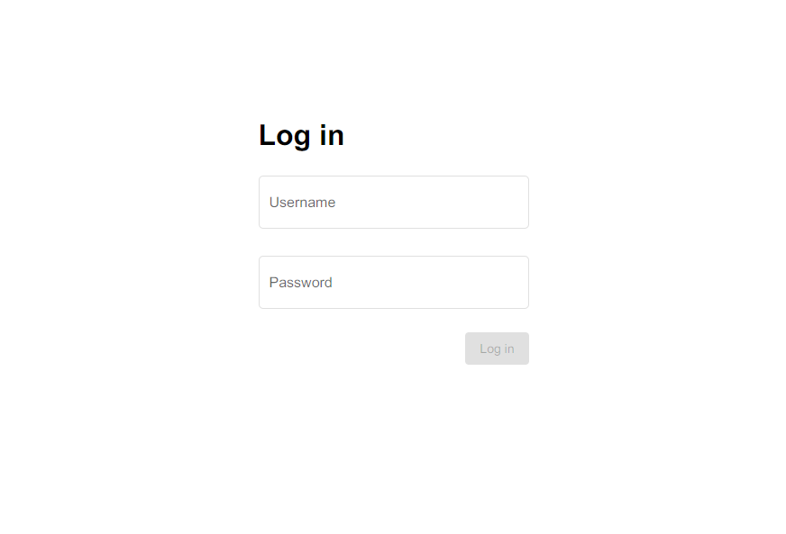

Click on the **username** field and enter your username (e.g. *admin*).

Click on the **password** field and enter your password (this will be provided for you).

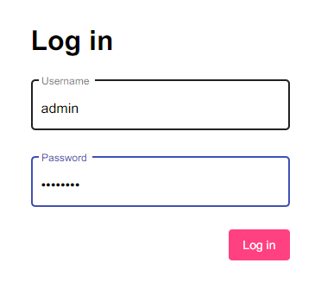

The log in button will change colour and become clickable once a username and password have been entered.

Click the **Log In** button to log in.

This may take a few seconds.

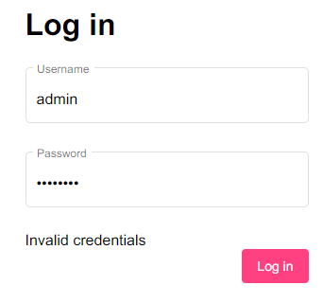

If either the username or password you entered were incorrect, an error message “*invalid credentials”* will be displayed.

Enter different credentials (username/password) and try log in again.

Once a valid username/password combination is entered, you will be redirected to the editor page.

# Editor page

User interface guide

**Add new  
employee**

**Employee connection**

**Employee**

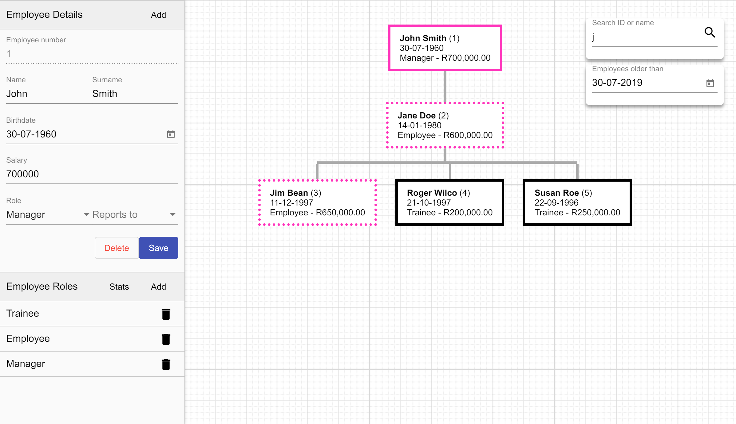

**Delete employee role**

**View employee role statistics (highest earning employees per role)**

**Add employee role**

**Employee editor**

**View, edit employee roles**

**Save employee details**

**Delete  
employee**

**View, edit employee details**

**Filter employees by older than birthdate**

**Search for employee**

## Filtering

### Search by name or ID

The search bar is at the top-right of the screen

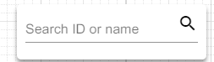

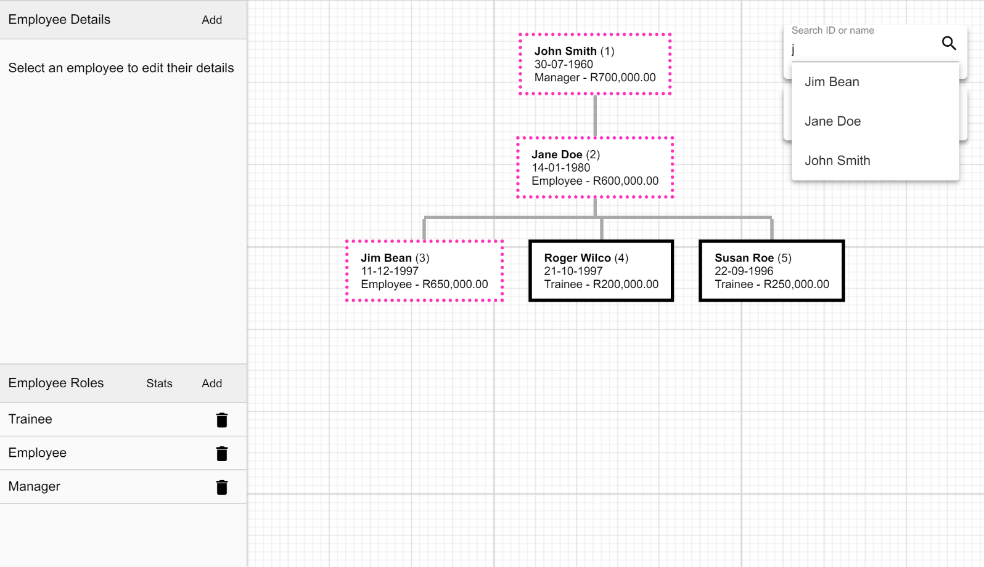

You can enter an employee’s name and/or surname (e.g. *Matthew Evans* or *Evans*) to search by name. Note that uppercase and lowercase letters are treated the same (e.g. *Matthew* is the same as *matthew*).

As you type, a dropdown list of employees who match the selected criteria will appear. These employees will also receive a dotted border highlighting them in the editor.

You can also search by ID (the ID must match fully and will not show suggestions).

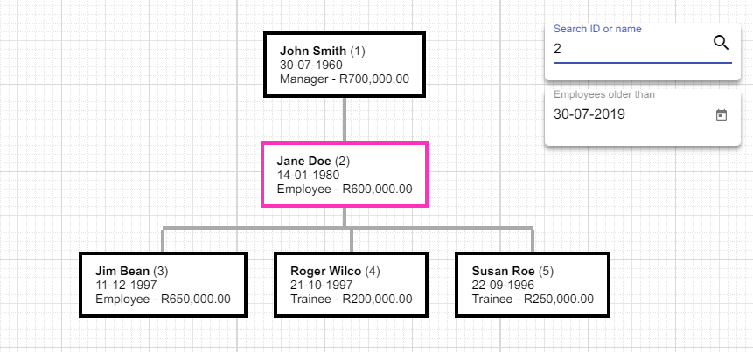

You can select an employee from the dropdown to select that specific employee (though you do not have to). You can scroll down to view more results if there are many results.

When selecting a name, your search term will be replaced by the employee’s employee number.

## Filter by “older than” birthdate

The filter is available at the top-right of the editor. This is used to filter employees by finding those who are older than a given date. Employees younger than this date (i.e. who were born after the date selected) are made less visible in the editor.

# Employee

Every employee has the following properties:

* Employee number
* Name
* Surname
* Birthdate
* Salary
* Role designation (henceforth referred to as “role”)
* Reports to employee

Employees are represented in a hierarchy. Employees who do not report to anyone appear at the furthest top of the hierarchy.

For example, consider Jane Doe in the following example:

**Employee number**

**Name**

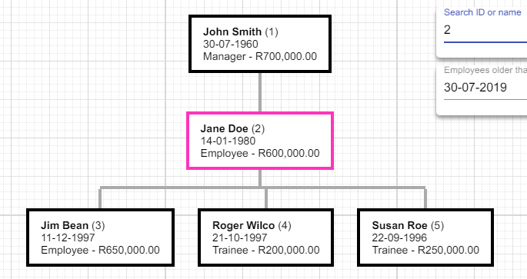

**Selected employee**

**Birthdate**

**Salary**

**Role**

**Relationship lines**

Jane reports to John Smith. Jim Bean reports to Jane Doe.

John Smith reports to nobody.

## Edit Employee

To view an employee’s details, edit their details, or delete the employee, start by clicking on the employee.

The employee will become highlighted, as seen on the right.

***\*\*Note: An employee role must exist before an employee can be added. Please see the section on employee roles for information on how to add a role.***

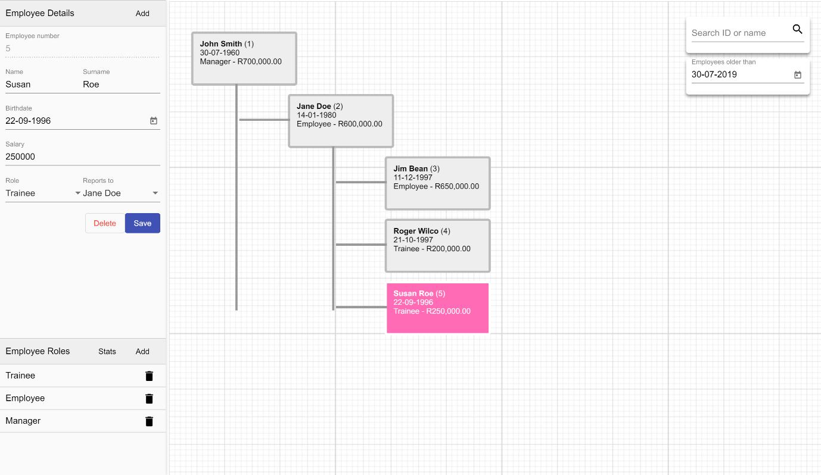In the sidebar, as on the left, the employee’s details will become visible.

Here, you can change the employee’s details. An employee’s employee number cannot be modified. This is automatically handled by the system.

### Role field

The role field contains any of the roles added in the ***Employee Roles*** editor. The available roles in this list will change instantaneously when changed in the ***Employee Roles*** editor.

### Reports to field

This field shows only employees who the selected employee can report to. Employees cannot report to themselves, and they cannot report to anyone who directly or indirectly reports to them. For example, if John Doe reports to Jane Doe, Jane Doe cannot report to John Doe.

### Add employee

Click the **Add** button to the right of the *Employee Details* header. This will set the employee details rows as empty. Click the **save** button to save the employee.

### Edit employee details

Click the **save** button to save the employee’s details. If this button is not pressed, your changes will not be applied.

### Save employee details

Click the **delete** button to delete the employee. A dialog box will pop up to confirm deletion:

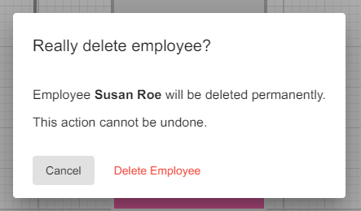

# Employee Roles and editing

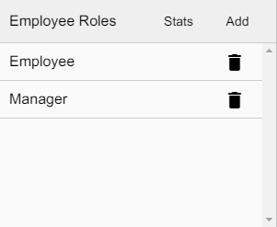The employee roles editor is visible in the sidebar to the bottom-left of the page. This editor allows you to view, add, edit and delete employee roles.

### Adding a role

To add a role, click the **Add** button at the top-right. This will add a new role called “*New Role*”.

## Editing a role

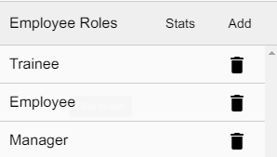To change the name of a role, simply click on its name. This will allow you to now edit the role’s name. Click away from the field to save it.

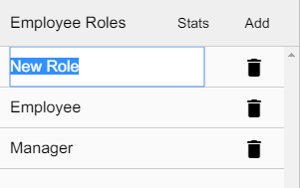

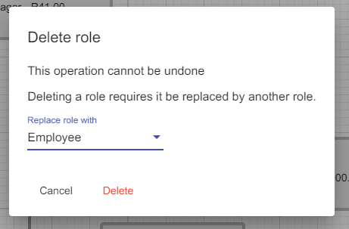

### Deleting a role

To delete a role, click the trash can icon to the right of the corresponding role. If there is only one role, this button will be disabled, as there must always be at least one role present.

Upon clicking the button, a dialog will be presented as is visible to the right.

You must select a different role to replace the role you are deleting. Every employee who currently has the role being deleted will be assigned to this role.