

1. Research (20 points)

Research and compare given microcontrollers 16F628A and 16F877A. Include in your research: the total number of pins, number of ports, number of banks, ram storage and serial communication pins

|  |  |
| --- | --- |
| **PIC16F628A** | **PIC16F877A** |
|  |  |
| Has a total of 18 pins. | Has a total of 40 pins. |
| Has only 2 ports; PORTA, and PORTB and hence 2 registers; TRISA, and TRISB | Has 5 ports; PORTA, PORTB, PORTC, PORTD, and PORTE. It has 5 registers for each port; TRISA, TRISB, TRISC, TRISD, and TRISE |
| Has four banks | Has four banks |
| It has 224 bytes of RAM. | It has 368 bytes of RAM. |
| Communicate only through UART communication protocol, and has one module. | Communicate through UART, SPI, and I2C communication protocols and has one module of each. |

1. Explain Diversity in Workplace.

List at least 4 advantages (10p)

Diversity in the workplace has become increasingly important in any workplace set-up. Managers should perceive diversity in the workplace as more than a mere legal compulsion and appreciate its strategic benefits. An inclusive workforce provides a diversified range of individuals who contribute to the overall productivity of the company. These differences include those of race, orientation, age, gender, religion, ethnicity, ideologies, physical and cognitive capacities or approaches to challenges, and socio-economic status. It is therefore invaluable that managers should understand the complexity of diversity in order to be able to manage the entire workforce. People have composite work characteristics that render them unique from each other.

McKinsey (2015), in a research study affirmed that companies that are characterized by diversity in ethnicity and race outperform industry norms by an average of thirty-five percent. From previous statistical evidence, the more diversified companies manage to achieve more in terms of employee satisfaction, customer attitudes and orientation which lead to a virtuous cycle of increasing returns for the company. This reality establishes that diversity brings with it competitive advantage over other institutions that do not practice the same.

The numerous benefits of diversity at a workplace also include a broad range of perspectives that allows the company to address challenges with little to no bias. A diverse workforce increases creativity, increases profits, improves employee engagement, reduces cases of employees turning over, improves the company’s reputation, and enhances cohesion towards the global goal of unity in diversity. Diversity allows team members within a company to exercise their individual strengths, which avails more talent to the company. As companies embrace diversity at their workplace, they in turn create job opportunities for minority groups.

Diversity at the workplace can be invaluable for any company or organization, however, it may be difficult to enforce due to challenges such as unconscious bias. In this case, there is need for companies that desire to practice diversity at the workplace to incorporate a transformation program which is aimed at explicitly addressing unconscious bias. A statistical driven program would serve to keep track and reduce cases of unconscious bias in the course of conducting everyday business. It would ensure that the employees become more aware of actions that may be translated as bias in order to avoid them especially in the course of work.

Diversity has numerous benefits but brings with it its fair share of disadvantages including the fact that employment manager may base their selection of employees on diversity and fail to select qualified individuals in a bid to achieve diversity. It goes beyond the constraints of, race ethnicity and perceptions, but this can be a source of undue conflict, where employees may indulge in conflicts due to too many opinions which eventually cause hostility and fall-outs. Another challenge includes the fact that diversity can yield individuals who are overqualified for their job descriptions. It provides a haven in which employees can grow learn new skills, and perfect their skills after which they become overqualified for their job descriptions.

1. Code. (20 points)

Write code for 16F877A using C Programming language that will send a serial message as given below using UART protocol (baud rate is 19200)

**Sample Output Format:**

**ID (Send using only UART1_Write)**

**Name Surname (Send as Text)**

**I love microcontrollers (Send as Text)**

|  |
| --- |
| program UART  ' Declarations section  dim id as longint ' id is in the range of the long int  main:  ' Main program  UART1_Init(19200) ' initialize UART at baud rate 19200  Delay_ms(100)' wait for the module to stabilize  id = 89169 ' assign decimal to the id  UART1_Write(id) ' send the id  ' sending the messages in an infinite loop  while(1)  UART1_Write_Text("Abdul Kareem") ' user name  UART1_Write_Text("I love microcontrollers") ' message  Wend ‘ end while loop  end. |

1. Calculate. (10 points/ 2 points each)

Analog to Digital operations. Include steps.

1. Calculate the digital output:

**VREF=** 6V

**ADC Resolution=** 10 Bits

**VIN=** 2.2V

**DOUT=**

Total steps = 210 – 1 = 1023

Step size = = = 5.865 x 10 -3 v

Number of steps = $\frac{2.2}{5.865x 10 ^(-3)}$ = 375.1 steps

Truncated steps = 375 steps N/B: Truncating steps makes sure that the digital equivalent of any analogue voltages is lesser.

Convert 375 to binary i.e digital equivalent

(375)10 = (101110111)2

**Ans** = (101110111)2

1. Calculate the digital output:

**VREF=** 5V

**ADC Resolution=** 8 Bits

**VIN=** 4V

**DOUT=**

Total steps = 28– 1 = 255

Step size = $\frac{V ref}{steps }$ = $\frac{5}{255}$ = 0.01961 v

Number of steps = $\frac{5}{0.01961}$ = 255 steps

Truncated steps = 255 steps N/B: Truncating steps makes sure that the digital equivalent of any analogue voltages is lesser.

Convert 255 to binary i.e digital equivalent

(255)10 = (11111111)2

**Ans** = (11111111)2

1. Calculate the input voltage:

**VREF=** 6V

**ADC Resolution=** 10 Bits

**DOUT=** 320

**VIN=**

Total steps = 210 – 1 = 1023

Step size = = = 5.865 x 10 -3 v

Number of steps = $\frac{x}{5.865x 10 ^(-3)}$ = 320 steps

Therefore x = 5.865 x 10-3 x 320 = 1.8768 v

**Ans :** Vin = 1.8768 V

1. Calculate the input voltage:

**VREF=** 5V

**ADC Resolution=** 8 Bits

**DOUT=** 96

**VIN=**

Total Steps = 28 – 1 = 255

Step size = $\frac{V ref}{steps }$ = $\frac{5}{255}$ = 0.01961v

Number of steps = $\frac{x}{0.01961}$ = 96 steps

Therefore x = 0.01961 x 96 = 1.8824 v

**Ans :** Vin = 1.8824 V

1. Calculate the input voltage:

**VREF=** 8V

**ADC Resolution=** 16 Bits

**DOUT=** 21000

**VIN=**

Total steps = 216 – 1 = 65535

Step size = = = 1.2207 x 10 -4 v

Number of steps = $\frac{x}{1.2207 x 10^(-4)}$ = 21000 steps

Therefore x = 1.2207 x 10-4 x 21000 = 2.5635 v

**Ans :** Vin = 2.5635 V

1. Calculate. (10 points/ 2 points each)

Do the following requested conversions. Include steps.

1. (1011101)2=(___)16
2. (111001)2=(___)10
3. (F40)16=( )2
4. (29)16=( )2
5. (71)10=( )16
6. Code. (20 points)

1. Write a C code to show lowercase letter ‘n’ on four seven segment displays available on PICSimLab using **spare parts**. Each code line should be explained using comments.

Also add LCD to spare parts showing your name. (10 points)

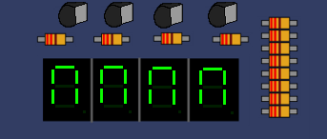

|  |
| --- |
| program nSeg  ' Declarations section  dim LCD_RS as sbit at RB4_bit ' reset  LCD_EN as sbit at RB5_bit ' enable  LCD_D4 as sbit at RB0_bit ' Data pins  LCD_D5 as sbit at RB1_bit  LCD_D6 as sbit at RB2_bit  LCD_D7 as sbit at RB3_bit  LCD_RS_Direction as sbit at TRISB4_bit  LCD_EN_Direction as sbit at TRISB5_bit  LCD_D4_Direction as sbit at TRISB0_bit  LCD_D5_Direction as sbit at TRISB1_bit  LCD_D6_Direction as sbit at TRISB2_bit  LCD_D7_Direction as sbit at TRISB3_bit      main:  ' Main program  '------------- 7 segment --------------------  TRISD = 0X00 ' set PORTD as the output  ' Pin aliases have been added to the SpareParts segment Properties  PORTD.RD0 = 1 ' set pin RD0 to HIGH  PORTD.RD1 = 1 ' set pin RD1 to HIGH  PORTD.RD2 = 1 ' set pin RD2 to HIGH  PORTD.RD3 = 1 ' set pin RD3 to HIGH  PORTD.RD4 = 1 ' set pin RD4 to HIGH  ' ----------- LCD ----------------------  Lcd_Init() ' Initialize the LCD  Lcd_Cmd(_LCD_CLEAR) ' Clear LCD screen  Lcd_Cmd(_LCD_CURSOR_OFF) ' turn the cursor off  Lcd_Out(1,1,"Fall 2020")  Lcd_Out(2,1,"Kareem 89169")  Delay_ms(2000)  end. |

1. Simulate the code using PICSimLab using spare parts for the 7-segment display. Show your configuration. Paste screenshots below of LCD and 7 –segment configurations and output. (10 points)

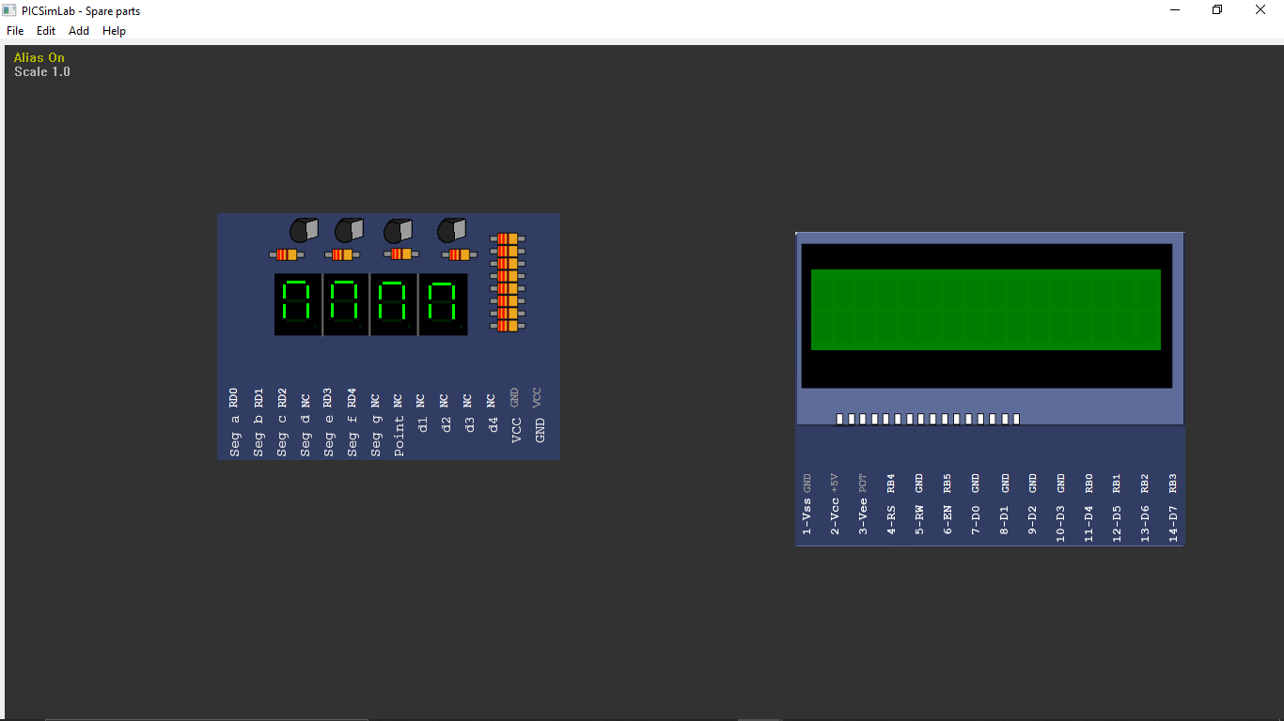

This is the result of the above code.

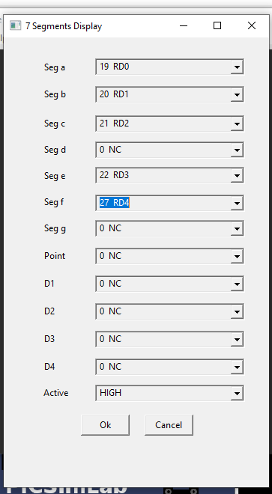

This is the result with the configuration screen.

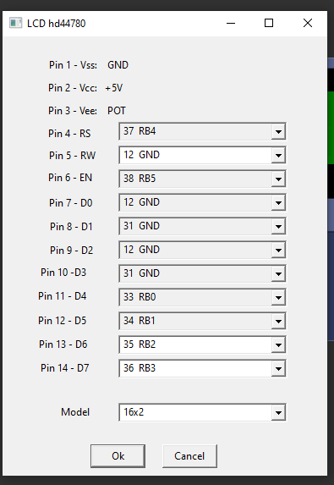

1. Analysis (10 points/Each 5)

It is requested to configure the PIC16F877a microcontroller for the bellow scenario:

A Temperature Sensor is connected to the PIC16F877A ADC Channel 2. The ADC has a Reference Voltage of 5V and a 10-Bit resolution. When the Temperature Sensor measures 60 ºC the DOUT is equal to the MAX DOUT for 10-Bit resolution. When the temperature is higher than 25 ºC, the system should inform the user that is too hot. Given that we use 8MHz oscillator on the PIC16F877A.

1. On which pin number the sensor is connected and how should the (CH2:CH0) of ADCON0 be configured? In addition, which bit has to be configured as input pin? Explain.

The output of the sensor is connected to the pin of the microcontroller with an internal ADC. Pin 2 of the microcontroller RA0/AN0 is channel-1 of the internal ADC. The analogue voltage output of the sensor is converted into its equivalent degree Celsius value calculated by the software.

The output is fed to channel-1 (CH0) of ADCONO. This pin has an internal ADC.

1. Calculate Dout for 25 ºC.

Explain.

Step size = Vref/2n  where n is the number of bits

= 5/210  = 4.88x10-3v

Full scale output range = (2n -1/2n) x Vref

= {(2(10)-1)/(210) } * 5 = 4.995117 v

4.995117 V = 600 C

10 c = 4.995117 / 60 = 0.08325V

For 25oC

Voltage equivalent = 25 x 0.08325 = 2.08230 V