- Generate the random Maze:
-First, define a 2-D array as the maze, then initialize the maze like below
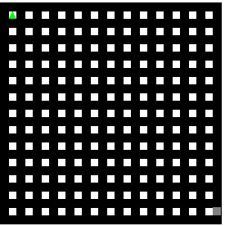
which is easy to break the wall.
-Then, choose the start point(1, 1), check if there any neighbour. If yes, randomly choose a neighbour then break the wall between the start point and its neighbour and set values of the start point and the wall which has been broken as 5( to ensure the road won’t come back ). Then continue this operation until there is no wall to create.
-Then, if there is no neighbour to create, go back to the previous point which can break walls in other direction, then keep doing that until there is no wall can be broken over this maze.

- Robot find the path to exit.(DFS())
- Let the robot check the directions in order: right, down, left, up.
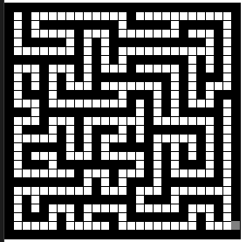
- For example, from the start, the robot will first check if there any road on the right, there is no road then it checks down. It has, so the robot will go down, then set the current position has been visited. Then using the recursion to let the robot keep checking and moving.
- In this maze, the robot will keep going down then hit the wall, so it will then check right first then go right.
- If the four directions are unable to be accessed, it will return back to the previous recursion, (which is the previous point, then keep check if there any road to ), and set the previous point to be not visited(because we use a for loop to represent the direction, so it won’t come back to the previous direction, so it won’t go back).
- Keep checking if finding any road can access in the multiple previous recursions/points. Then if the robot achieve the exit, game over.

