Student ID: 103681990

Name: Eve Joyce

# Setup Screenshot

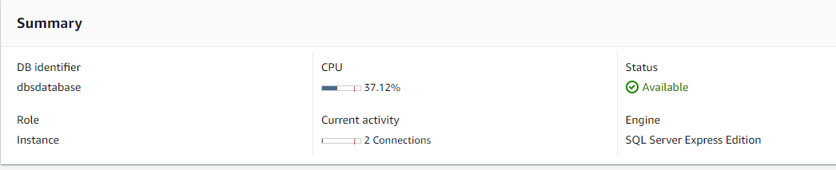



# Task 2 Screenshot





# Task 3 Screenshot



