Git repository:

<https://github.com/EveJoyceStudent/SelectionAssignment>

Testing age<17, gender F

Numbers that sum to >10

Incorrect username

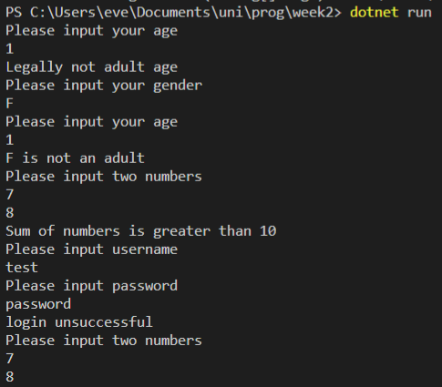

Testing age>17, gender M

Numbers that sum to 10 (note, no output after first number inputs)

Correct username/password

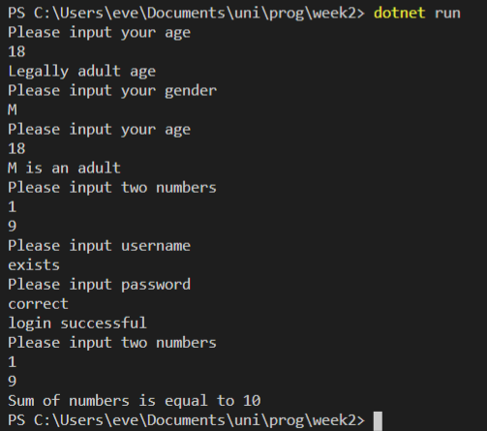

Testing age = 17 either gender

Numbers that sum to less than 10

Correct username incorrect password

