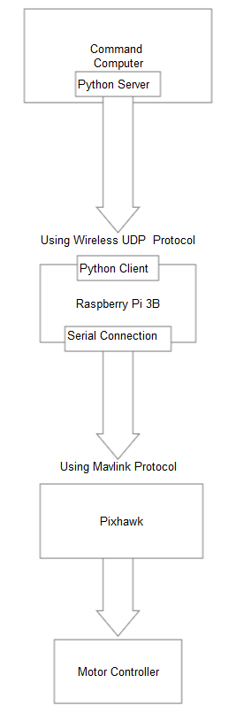

Command

Computer Python Server

Using Wireless UDP Protocol

Python Client

Raspberry Pi 3B

Serial Connection

Using Mavlink Protocol

Pixhawk

Motor Controller