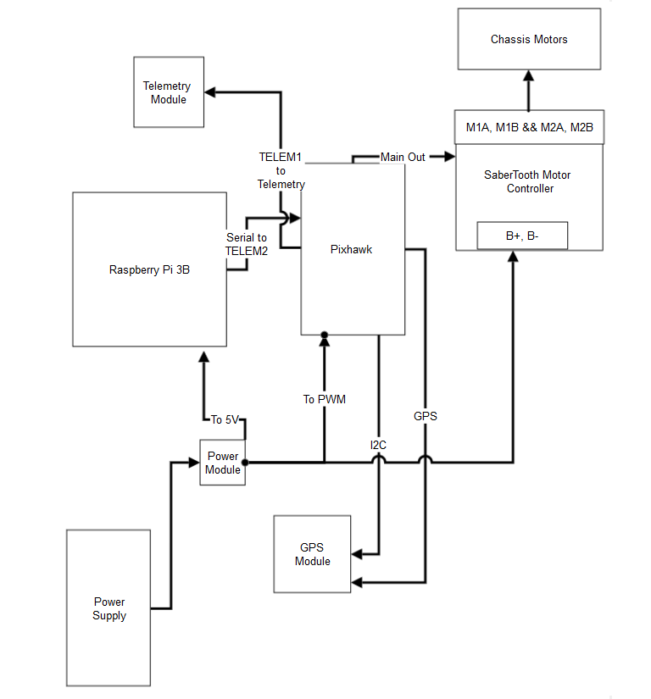

Chassis Motors

Telemetry Module

M1A, M1B && M2A, M2B

TELEM1

Main Out

**to**

Telemetry

Saber Tooth Motor

Controller

B+, B

Serial to TELEM2

Pixhawk

Raspberry Pi 3B

To PWM

To 5V

GPS

Power Module

GPS Module

Power Supply