opilane@KLASSA302-30 MINGW64 ~

$ git clone https://github.com/AarneA/kta-19e_tund1.git

Cloning into 'kta-19e_tund1'...

remote: Enumerating objects: 44, done.

remote: Counting objects: 100% (44/44), done.

remote: Compressing objects: 100% (31/31), done.

remote: Total 44 (delta 16), reused 34 (delta 8), pack-reused 0

Unpacking objects: 100% (44/44), 48.86 KiB | 384.00 KiB/s, done.

opilane@KLASSA302-30 MINGW64 ~

$

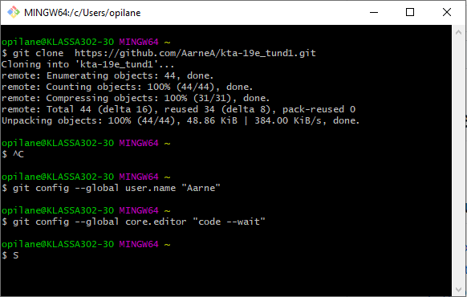

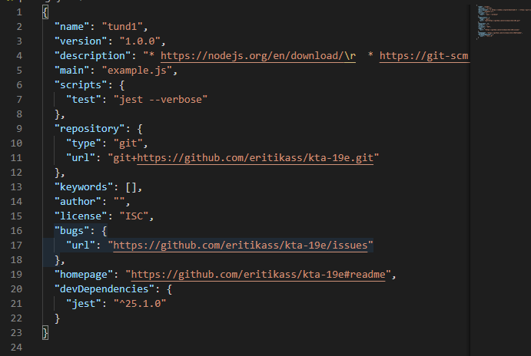

npm install

opilane@KLASSA302-30 MINGW64 ~/kta-19e_tund1 (master)

$ npm install

npm WARN optional SKIPPING OPTIONAL DEPENDENCY: fsevents@2.1.2 (node_modules\fsevents):

npm WARN notsup SKIPPING OPTIONAL DEPENDENCY: Unsupported platform for fsevents@2.1.2: wanted {"os":"darwin","arch":"any"} (current: {"os":"win32","arch":"x64"})

added 487 packages from 285 contributors and audited 1203821 packages in 9.054s

19 packages are looking for funding

run `npm fund` for details

found 0 vulnerabilities

opilane@KLASSA302-30 MINGW64 ~/kta-19e_tund1 (master)

$

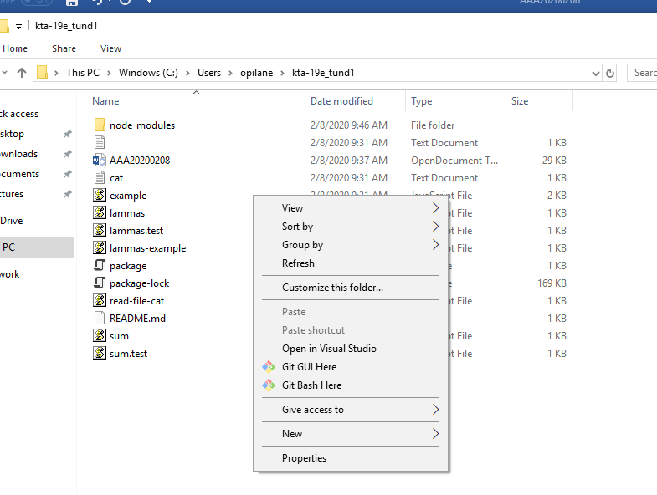

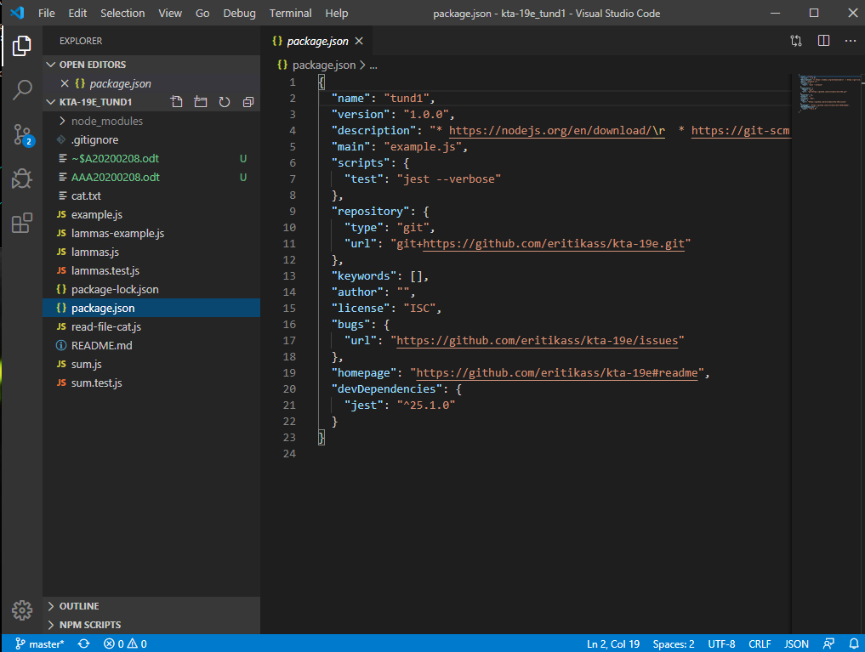

opilane@KLASSA302-30 MINGW64 ~/kta-19e_tund1 (master)

$ npm run test

> tund1@1.0.0 test C:\Users\opilane\kta-19e_tund1

> jest --verbose

PASS ./lammas.test.js

√ create Lammas with name dolly, check that name is dolly (2ms)

PASS ./sum.test.js

√ sum 1 + 2 equals 3 (2ms)

√ sum 1 + 4 equals 5

√ sum(1, 2) => 3

√ sum(5, 4) => 9 (1ms)

√ sum(10, 100) => 110

√ sum(11, 101) => 112

√ sum(-5, 9) => 4

√ sum(5, -9) => -4 (1ms)

√ sum(0, 0) => 0

√ sum(-5, -4) => -9

Test Suites: 2 passed, 2 total

Tests: 11 passed, 11 total

Snapshots: 0 total

Time: 2.118s

Ran all test suites.

opilane@KLASSA302-30 MINGW64 ~/kta-19e_tund1 (master)

$

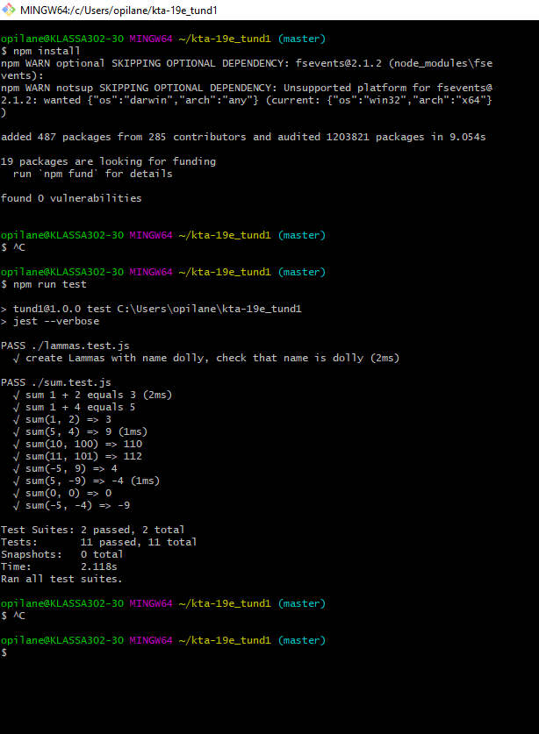

Uus

