作业2：一些截图和指令
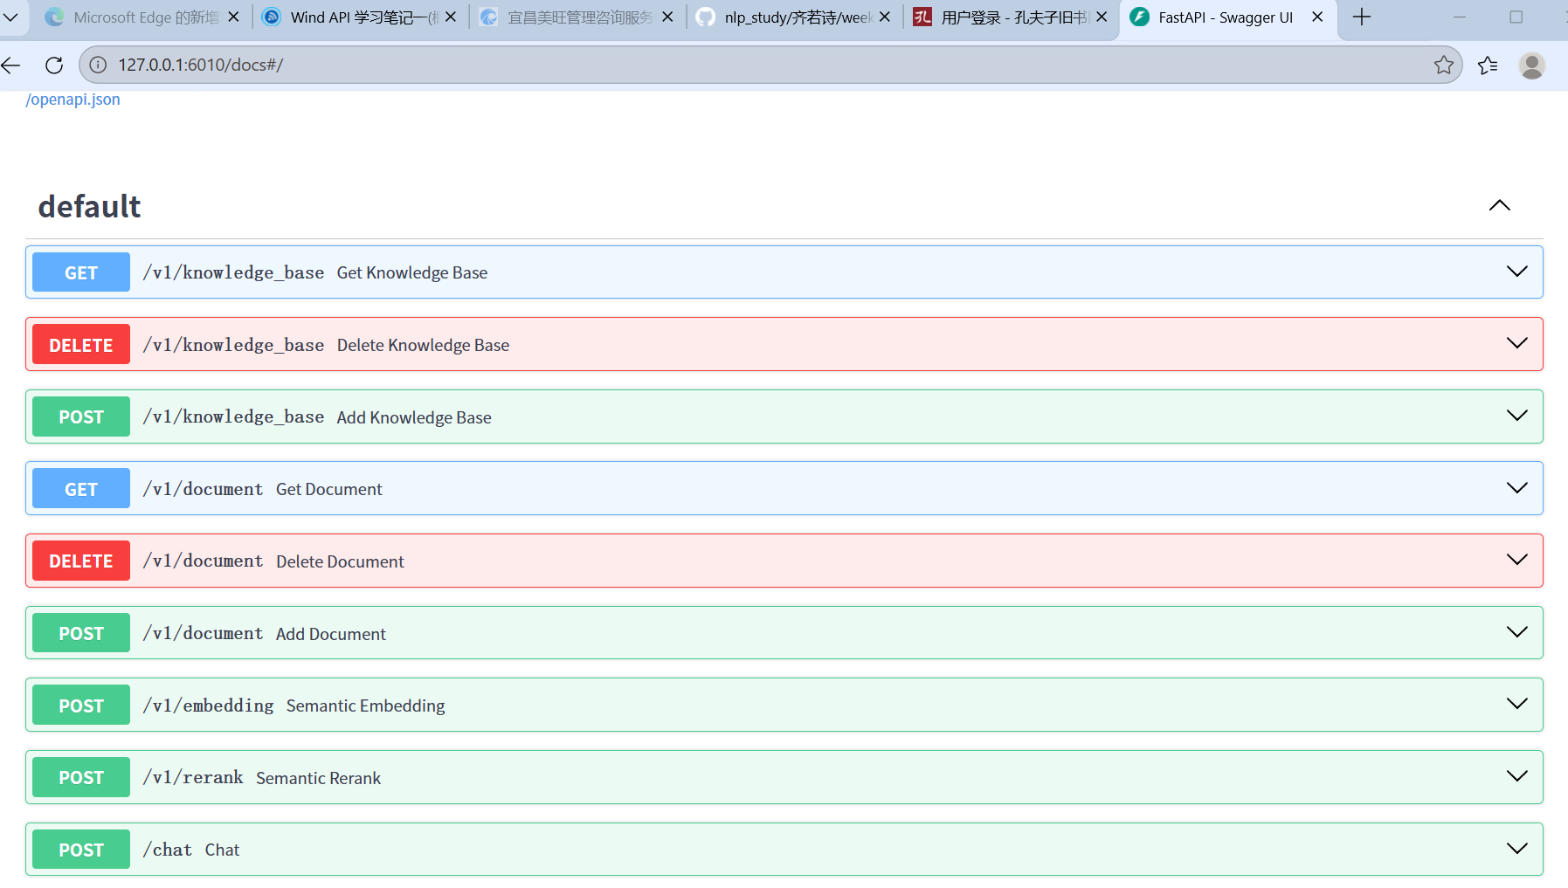
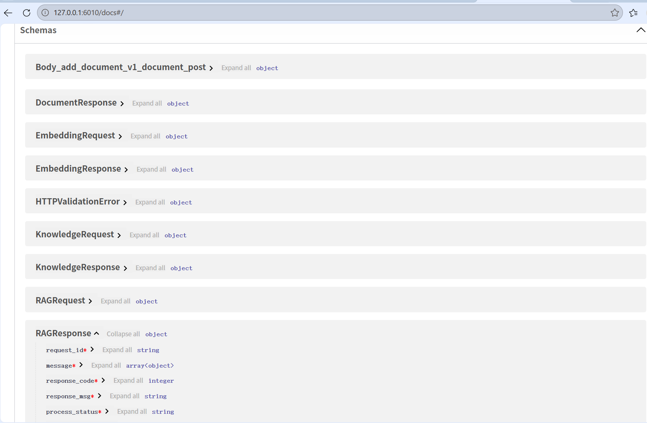

- 指令：
1) 准备 Python 运行环境
进入项目目录
cd "C:\Users\ruosh\nlp\04-government-advanced-rag"
2）创建虚拟环境并安装依赖：
python -m venv .venv
.venv\Scripts\Activate.ps1
pip install --upgrade pip
pip install -r requirements.txt
3）LLM 服务
:rag.llm_base: "http://localhost:8000/v1"
:rag.llm_model: "models/Qwen/Qwen3.5-0.8B/"
启动一个 OpenAI-compatible 的服务（vLLM / OpenAI兼容网关等），保证：能访问 http://localhost:8000/v1, 并且模型名/路径能被该服务识别（否则 test_rag.py::test_llm 会失败）。

4)Elasticsearch analyzer ik_max_word
es_api.py 创建索引时使用 ik_max_word 分词器。
可选：先用“轻量 smoke test”绕开模型加载
如果你只是先验证 API 能跑、pytest中除了 embedding/rag 的部分，
建议先把：
rag: use_embedding: false
use_rerank: false

5) 启动外部依赖服务Elasticsearch
确保 Elasticsearch 可在默认地址连通（config.yaml）：
http://localhost:9200
Elasticsearch 启动后，启动 main.py 时会自动尝试：
document_meta 索引
chunk_info 索引

6) LLM（OpenAI-compatible）,启动到 http://localhost:8000/v1。
按实际模型/参数调整 # vllm 的启动命令随版本/模型不同会有差异

7) 启动本服务（FastAPI）
在项目目录启动：cd "C:\Users\ruosh\nlp\04-government-advanced-rag"python main.py
使用 uvicorn 启动到端口 config["rag"]["port"]，默认是：URL：http://localhost:6010

8) 手动测试接口（PowerShell）
8.1 创建知识库：
Invoke-RestMethod -Method Post -Uri "http://localhost:6010/v1/knowledge_base" -ContentType "application/json" -Body '{"category":"测试类别","title":"测试标题"}'
拿到返回的 knowledge_id 后：
8.2 查询知识库$kid = 1
# 用返回的
knowledge_id
替换
Invoke-RestMethod-MethodGet-Uri "http://localhost:6010/v1/knowledge_base?knowledge_id=$kid&token=666"
8.3 查询不存在文档
Invoke-RestMethod-MethodGet-Uri "http://localhost:6010/v1/document?document_id=666&token=666"
预期 response_msg 为：文档不存在

9) 运行项目测试（pytest）
在项目目录执行：python -m pytest -q
test_es.py：要求 Elasticsearch 正常 + IK 分词器/索引创建成功
test_rag.py::test_llm：要求 LLM 服务 http://localhost:8000/v1 可用
rag_api.py 导入时会加载 config / 初始化 ES / 加载 embedding（取决于 use_embedding）.

- 部署
python --version && pip --version && docker --version
cd /d "C:\Users\ruosh\.cursor\projects\c-Users-ruosh-nlp-nlp20-01-intent-classify\terminals" && dir
python --version; pip --version; docker --version
Set-Location
"C:\Users\ruosh\.cursor\projects\c-Users-ruosh-nlp-nlp20-01-intent-classify\terminals"; Get-ChildItem

import yaml # type: ignore
from elasticsearch import Elasticsearch # type: ignore
import traceback
import os

# 读取配置文件
with open("config.yaml", "r") as f:
config = yaml.safe_load(f)

# 从配置文件中提取ES的连接参数
es_host = config["elasticsearch"]["host"]
es_port = config["elasticsearch"]["port"]
es_scheme = config["elasticsearch"]["scheme"]
es_username = config["elasticsearch"]["username"]
es_password = config["elasticsearch"]["password"]

if es_username != "" and es_password != "":
es = Elasticsearch(
[{"host": es_host, "port": es_port, "scheme": es_scheme}],
basic_auth=(es_username, es_password)
)
else:
es = Elasticsearch(
[{"host": es_host, "port": es_port, "scheme": es_scheme}],
)

embedding_dims = config["models"]["embedding_model"][
config["rag"]["embedding_model"]
]["dims"]

def init_es():
"""
检查es环境配置
:return: 环境是否配置成功
"""
if str(os.getenv("RAG_DISABLE_ES", "")).lower() in {"1", "true", "yes"}:
print("Elasticsearch init skipped (RAG_DISABLE_ES=1).")
return False

if not es.ping():
print("Could not connect to Elasticsearch.")
return False

# es 非关系型数据库 -》 一个表 （index） 存储一类数据 -》 可以动态插入数据
# 需要对字段进行检索， 需要定义索引
# es 中 ik 类似jieba
# doc1 {"content": "", "title": "", "page": 100}
# doc2 {"content": "", "title": "", "author": "", "page": 20}

document_meta_mapping = {
"mappings":{
'properties': {
'file_name': {
'type': 'text',
'analyzer': 'standard',
'search_analyzer': 'standard'
},
'abstract': {
'type': 'text',
'analyzer': 'standard',
'search_analyzer': 'standard'
},
'full_content': {
'type': 'text',
'analyzer': 'standard',
'search_analyzer': 'standard'
}
}
}
}
try:
# es.indices.delete(index='document_meta')
if not es.indices.exists(index="document_meta"):
es.indices.create(index='document_meta', body=document_meta_mapping)
except:
print(traceback.format_exc())
print("Could not create index of document_meta.")
return False

# 向量检索。 使用es 或 miluvs
# 维度、索引方法
chunk_info_mapping = {
'mappings': { # Add 'mappings' here
'properties': {
'chunk_content': {
'type': 'text',
'analyzer': 'standard',
'search_analyzer': 'standard'
},
"embedding_vector": {
"type": "dense_vector",
"element_type": "float",
"dims": embedding_dims,
"index": True,
"index_options": {
"type": "int8_hnsw"
}
}
}
}
}

try:
# es.indices.delete(index='chunk_info')
if not es.indices.exists(index="chunk_info"):
es.indices.create(index='chunk_info', body=chunk_info_mapping)
except:
print(traceback.format_exc())
print("Could not create index of chunk_info.")
return False

print("Successfully connected to Elasticsearch!")
return True

try:
init_es()
except Exception:
print(traceback.format_exc())
print("Elasticsearch init failed; service can still start, but RAG/ES features may be unavailable.")

python -m venv .venv; .\.venv\Scripts\python -m pip install --upgrade pip; .\.venv\Scripts\pip install -r requirements.txt; .\.venv\Scripts\pip install uvicorn numpy sentence-transformers
Dir
python -m pip install -r requirements.txt; python -m pip install uvicorn numpy sentence-transformers
New-Item -ItemType Directory -Force -Path "C:\Users\ruosh\nlp\04-government-advanced-rag\_tmp" | Out-Null; $env:TEMP="C:\Users\ruosh\nlp\04-government-advanced-rag\_tmp"; $env:TMP=$env:TEMP; python -m pip install --no-cache-dir -r requirements.txt; python -m pip install --no-cache-dir uvicorn numpy sentence-transformers
py -3.12 -m venv .venv312; .\.venv312\Scripts\python -m pip install --upgrade pip; .\.venv312\Scripts\python -m pip install --no-cache-dir -r requirements.txt; .\.venv312\Scripts\python -m pip install --no-cache-dir uvicorn numpy sentence-transformers
elasticsearch:
host: "localhost"
port: 9200
scheme: "http"
username: ""
password: ""

database:
engine: "sqlite"
path: "rag.db"
host: "localhost"
port: 3306
username: ""
password: ""

models:
embedding_model:
bge-small-zh-v1.5:
hf_url: "https://huggingface.co/BAAI/bge-small-zh-v1.5"
local_url: "BAAI/bge-small-zh-v1.5"
dims: 512

rerank_model:
bge-reranker-base:
hf_url: "https://huggingface.co/BAAI/bge-reranker-base"
local_url: "/root/hf-models/bge-reranker-base/"

llm:
config:
temperature: 0.1
top_p: 1
max_tokens_to_sample: 1024
base_model:
glm:
tokens: ""
qwen:
tokens: ""
gpt:
tokens: ""

device: "cpu"

rag:
llm_base: "http://localhost:8000/v1"
llm_api_key: "43aa6570992d01fab078e157e07b4f52.ocKHwNGxhIBrDZD4"
llm_model: "models/Qwen/Qwen3.5-0.8B/"
embedding_model: "bge-small-zh-v1.5"
rerank_model: "bge-reranker-base"
chunk_size: 256
chunk_overlap: 20
chunk_candidate: 10
use_embedding: false
use_rerank: false
use_rrf: true
port: 6010

$env:RAG_DISABLE_ES="1"; .\.venv312\Scripts\python main.py

elasticsearch:
host: "localhost"
port: 9200
scheme: "http"
username: ""
password: ""

database:
engine: "sqlite"
path: "rag.db"
host: "localhost"
port: 3306
username: ""
password: ""

models:
embedding_model:
bge-small-zh-v1.5:
hf_url: "https://huggingface.co/BAAI/bge-small-zh-v1.5"
local_url: "BAAI/bge-small-zh-v1.5"
dims: 512

rerank_model:
bge-reranker-base:
hf_url: "https://huggingface.co/BAAI/bge-reranker-base"
local_url: "/root/hf-models/bge-reranker-base/"

llm:
config:
temperature: 0.1
top_p: 1
max_tokens_to_sample: 1024
base_model:
glm:
tokens: ""
qwen:
tokens: ""
gpt:
tokens: ""

device: "cpu"

rag:
llm_base: "http://localhost:8000/v1"
llm_api_key: "43aa6570992d01fab078e157e07b4f52.ocKHwNGxhIBrDZD4"
llm_model: "models/Qwen/Qwen3.5-0.8B/"
embedding_model: "bge-small-zh-v1.5"
rerank_model: "bge-reranker-base"
chunk_size: 256
chunk_overlap: 20
chunk_candidate: 10
use_embedding: false
use_rerank: false
use_rrf: true
port: 6010

import yaml # type: ignore

with open("config.yaml", "r") as f:
config = yaml.safe_load(f)

import time
import numpy as np
import uuid
import datetime
import traceback
import os

import uvicorn
from typing_extensions import Annotated
from fastapi import FastAPI, File, UploadFile, Form, BackgroundTasks

from router_schemas import ( # type: ignore
EmbeddingRequest, EmbeddingResponse,
RerankRequest, RerankResponse,
KnowledgeRequest, KnowledgeResponse,
DocumentRequest, DocumentResponse,
RAGRequest, RAGResponse
)
from rag_api import RAG
from db_api import ( # type: ignore
KnowledgeDocument, KnowledgeDatabase,
Session
)

app = FastAPI()

@app.get("/v1/knowledge_base")
def get_knowledge_base(knowledge_id: int, token: str) -> KnowledgeResponse:
start_time = time.time()

try:
for retry_time in range(10):
with Session() as session:
record = session.query(KnowledgeDatabase).filter(KnowledgeDatabase.knowledge_id == knowledge_id).first()
if record is not None:
return KnowledgeResponse( # type: ignore
request_id=str(uuid.uuid4()),
knowledge_id=knowledge_id,
title=str(record.title),
category=str(record.category),
response_code=200,
response_msg="知识库查询成功",
process_status="completed",
processing_time=time.time() - start_time
)
except Exception as e:
# TODO 打印日志
pass

return KnowledgeResponse( # type: ignore
request_id=str(uuid.uuid4()),
knowledge_id=knowledge_id,
category="",
title="",
response_code=404,
response_msg="知识库不存在",
process_status="completed",
processing_time=time.time() - start_time
)

@app.delete("/v1/knowledge_base")
def delete_knowledge_base(knowledge_id: int, token: str) -> KnowledgeResponse:
start_time = time.time()

try:
for retry_time in range(10):
with Session() as session:
record = session.query(KnowledgeDatabase).filter(KnowledgeDatabase.knowledge_id == knowledge_id).first()
if record is None:
break

session.delete(record)
session.commit()
return KnowledgeResponse( # type: ignore
request_id=str(uuid.uuid4()),
knowledge_id=knowledge_id,
category=str(record.category),
title=str(record.title),
response_code=200,
response_msg="知识库删除成功",
process_status="completed",
processing_time=time.time() - start_time
)
except Exception as e:
# TODO 打印日志
pass

return KnowledgeResponse( # type: ignore
request_id=str(uuid.uuid4()),
knowledge_id=knowledge_id,
category="",
title="",
response_code=404,
response_msg="知识库不存在",
process_status="completed",
processing_time=time.time() - start_time
)

@app.post("/v1/knowledge_base")
def add_knowledge_base(req: KnowledgeRequest) -> KnowledgeResponse:
start_time = time.time()
try:
for retry_time in range(10):
with Session() as session:
record = KnowledgeDatabase(
title=req.title,
category=req.category,
create_dt=datetime.datetime.now(),
update_dt=datetime.datetime.now(),
)
session.add(record)
session.flush() # Flushes changes to generate primary key if using autoincrement
knowledge_id = record.knowledge_id
session.commit()

return KnowledgeResponse( # type: ignore
request_id=str(uuid.uuid4()),
knowledge_id=knowledge_id,
category=req.category,
title=req.title,
response_code=200,
response_msg="知识库插入成功",
process_status="completed",
processing_time=time.time() - start_time
)

except Exception as e:
print(traceback.format_exc())
# TODO 打印日志
pass

return KnowledgeResponse( # type: ignore
request_id=str(uuid.uuid4()),
knowledge_id=0,
category="",
title="",
response_code=504,
response_msg="知识库插入失败",
process_status="completed",
processing_time=time.time() - start_time
)

@app.get("/v1/document")
def get_document(document_id: int, token: str) -> DocumentResponse:
start_time = time.time()

try:
for retry_time in range(10):
with Session() as session:
record = session.query(KnowledgeDocument) \
.filter(KnowledgeDocument.document_id == document_id).first()

if record is not None:
return DocumentResponse( # type: ignore
request_id=str(uuid.uuid4()),
document_id=document_id,
category=record.category,
title=record.title,
knowledge_id=record.knowledge_id,
file_type=record.file_type,
response_code=200,
response_msg="文档查询成功",
process_status="completed",
processing_time=time.time() - start_time
)
break
except Exception as e:
print(traceback.format_exc())
# TODO 打印日志
pass

return DocumentResponse( # type: ignore
request_id=str(uuid.uuid4()),
document_id=document_id,
category="",
title="",
knowledge_id=0,
file_type="",
response_code=404,
response_msg="文档不存在",
process_status="completed",
processing_time=time.time() - start_time
)

@app.delete("/v1/document")
def delete_document(document_id: int, token: str) -> DocumentResponse:
start_time = time.time()

try:
for retry_time in range(10):
with Session() as session:
record = session.query(KnowledgeDocument).filter(KnowledgeDocument.document_id == document_id).first()
if record is None:
break

session.delete(record)
session.commit()
return KnowledgeResponse( # type: ignore
request_id=str(uuid.uuid4()),
document_id=document_id,
knowledge_id=record.knowledge_id,
category=record.category,
title=record.title,
file_type=record.file_type,
response_code=200,
response_msg="文档删除成功",
process_status="completed",
processing_time=time.time() - start_time
)

# 删除es 中的记录
except Exception as e:
print(traceback.format_exc())
pass

return DocumentResponse( # type: ignore
request_id=str(uuid.uuid4()),
document_id=document_id,
category="",
title="",
knowledge_id=0,
file_type="",
response_code=404,
response_msg="文档不存在",
process_status="completed",
processing_time=time.time() - start_time
)

# 添加文档：判断知识库是否存在、解析上传的文件保存到本地、后台解析上传文件的内容
# BackgroundTasks 后台任务执行
@app.post("/v1/document")
async def add_document(
knowledge_id: int = Annotated[str, Form()],
title: str = Annotated[str, Form()],
category: str = Annotated[str, Form()],
file: UploadFile = Annotated[str, File(...)],
background_tasks: BackgroundTasks = Annotated[BackgroundTasks, Form()]
) -> DocumentResponse:
start_time = time.time()
response_msg = "新增文档失败"
try:
for retry_time in range(10):
# 上传的文档，记录在关系型数据库中， orm 添加记录
with Session() as session:
record = session.query(KnowledgeDatabase).filter(KnowledgeDatabase.knowledge_id == knowledge_id).first()
if record is None:
response_msg = "知识库不存在，请提前创建"
break

record = KnowledgeDocument(
title=title,
category=category,
knowledge_id=knowledge_id,
file_path="",
file_type=file.content_type,
create_dt=datetime.datetime.now(),
update_dt=datetime.datetime.now(),
)
session.add(record)
session.flush() # Flushes changes to generate primary key if using autoincrement
document_id = record.document_id
record
session.commit()

# 存储数据到文件
file_path = f"upload_files/document_id_{document_id}_" + file.filename
with open(file_path, "wb") as buffer:
buffer.write(file.file.read())

record = session.query(KnowledgeDocument).filter(KnowledgeDocument.document_id == document_id).first()
record.file_path = file_path
session.commit()

# 文档内容解析，后台执行，后台提取数据
es_disabled = str(os.getenv("RAG_DISABLE_ES", "")).lower() in {"1", "true", "yes"}
if (not es_disabled) and config["rag"].get("use_embedding", True):
background_tasks.add_task(
RAG().extract_content, # 后台运行的函数名
knowledge_id=knowledge_id,
document_id=document_id,
title=title,
file_type=file.content_type,
file_path=file_path
)

return DocumentResponse(
request_id=str(uuid.uuid4()),
document_id=document_id,
category=category,
title=title,
knowledge_id=knowledge_id,
file_type=file.content_type,
response_code=200,
response_msg="文档添加成功",
process_status="completed",
processing_time=time.time() - start_time
)
except Exception as e:
print(traceback.format_exc())
pass

return DocumentResponse( # type: ignore
request_id=str(uuid.uuid4()),
document_id=0,
category="",
title="",
knowledge_id=0,
file_type="",
response_code=404,
response_msg=response_msg,
process_status="completed",
processing_time=time.time() - start_time
)

@app.post("/v1/embedding")
async def semantic_embedding(req: EmbeddingRequest) -> EmbeddingResponse:
start_time = time.time()
if not config["rag"].get("use_embedding", True):
return EmbeddingResponse(
request_id=str(uuid.uuid4()),
vector=[],
response_code=503,
response_msg="embedding 未启用（config.yaml: rag.use_embedding=false）",
process_status="completed",
processing_time=time.time() - start_time
)
if not isinstance(req.text, list):
text = [req.text]
else:
text = req.text

vector: np.ndarray = RAG().get_embedding(text)
return EmbeddingResponse(
request_id=str(uuid.uuid4()),
vector=vector.astype(float).tolist(),
response_code=200,
response_msg="ok",
process_status="completed",
processing_time=time.time() - start_time
)

@app.post("/v1/rerank")
async def semantic_rerank(req: RerankRequest) -> RerankResponse:
start_time = time.time()
vector: np.ndarray = RAG().get_rank(req.text_pair)

return RerankResponse(
request_id=str(uuid.uuid4()),
vector=vector.astype(float).tolist(),
response_code=200,
response_msg="ok",
process_status="completed",
processing_time=time.time() - start_time
)

@app.post("/chat")
def chat(req: RAGRequest) -> RAGResponse:
start_time = time.time()
message = RAG().chat_with_rag(req.knowledge_id, req.message)

return RAGResponse(
request_id=str(uuid.uuid4()),
message=message,
response_code=200,
response_msg="ok",
process_status="completed",
processing_time=time.time() - start_time
)

if __name__ == "__main__":
uvicorn.run(app, host="0.0.0.0", port=config["rag"]["port"], workers=1)

$env:RAG_DISABLE_ES="1"; .\.venv312\Scripts\python main.py
Start-Sleep -Seconds 5
Invoke-WebRequest -UseBasicParsing -Uri "http://127.0.0.1:6010/docs" | Select-Object -ExpandProperty StatusCode
.\.venv312\Scripts\python -m pip install python-multipart
$env:RAG_DISABLE_ES="1"; .\.venv312\Scripts\python main.py
Start-Sleep -Seconds 3
$body = '{"category":"测试类别","title":"测试标题"}'; Invoke-RestMethod -Method Post -Uri "http://127.0.0.1:6010/v1/knowledge_base" -ContentType "application/json" -Body $body | ConvertTo-Json -Depth 10

- 修复 ES 依赖阻塞：把 es_api.py 改成 没有 Elasticsearch 也能启动服务（并把 ik_max_word 改成 standard，避免必须装 IK 插件）。
- 创建独立 Python 环境：用你系统的 py -3.12 新建了 .venv312，并把依赖装进去了（含 uvicorn、sentence-transformers、python-multipart 等）。
- 修复 HuggingFace 下载被代理 403 阻塞：把 config.yaml 里 rag.use_embedding 暂时设为 false，并在 main.py 里让 /v1/embedding 在未启用 embedding 时返回 503（避免启动时拉模型失败）。
- 启动服务成功：http://127.0.0.1:6010/docs 返回 200，并且我已成功调用 /v1/knowledge_base 创建知识库。

