原图 噪声图 降噪图

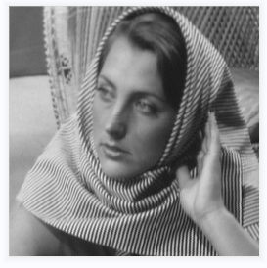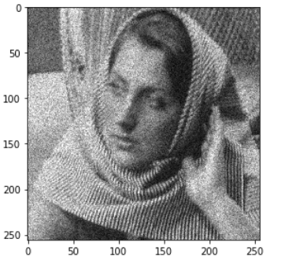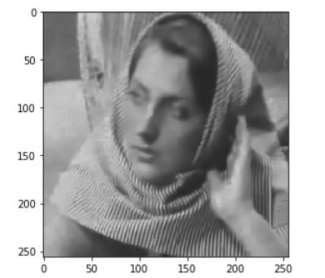

|  |  |  |
| --- | --- | --- |
| Sigma=2 | 噪声图 | 降噪图 |
| PSNR | 21.180207605531137 | 29.052190246547287 |
| SSIM | 0.5253606096362449 | 0.8618712656217996 |

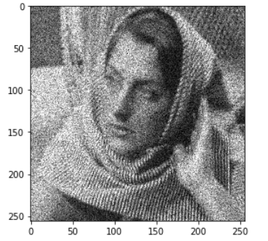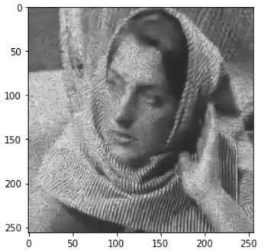

|  |  |  |
| --- | --- | --- |
| Sigma=3 | 噪声图 | 降噪图 |
| PSNR | 17.7673 | 25.06212070710656 |
| SSIM | 0.37933044763503915 | 0.7095456559632705 |

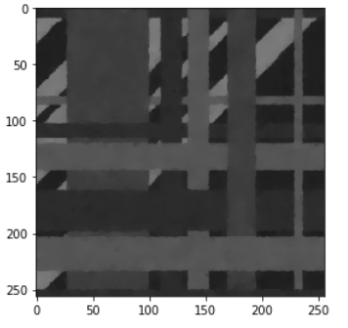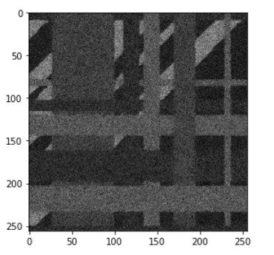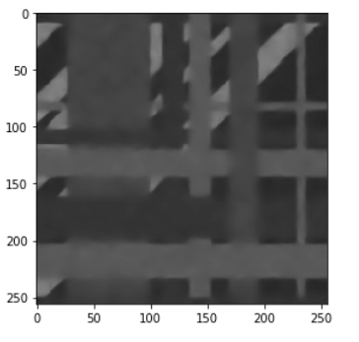

|  |  |  |
| --- | --- | --- |
| Sigma=2 | 噪声图 | 降噪图 |
| PSNR | 24.165110016763624 | 36.326701327674876 |
| SSIM | 0.36020822207279396 | 0.9484761783718765 |

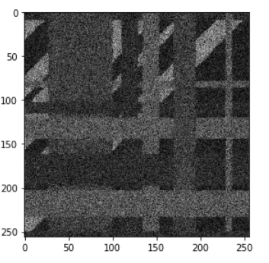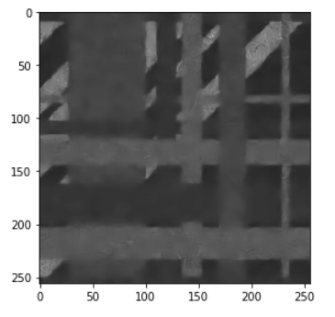

|  |  |  |
| --- | --- | --- |
| Sigma=3 | 噪声图 | 降噪图 |
| PSNR | 20.708606348841784 | 34.58286793061456 |
| SSIM | 0.23354097056626394 | 0.9271380248980148 |

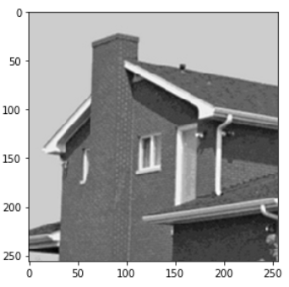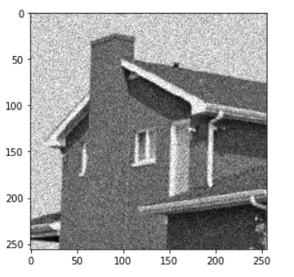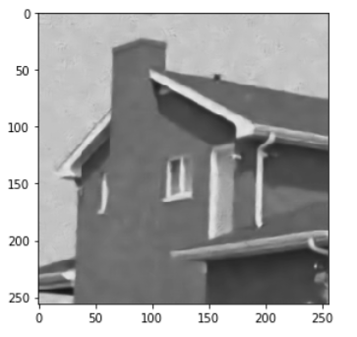

|  |  |  |
| --- | --- | --- |
| Sigma=2 | 噪声图 | 降噪图 |
| PSNR | 20.9459871760681 | 32.374391108538006 |
| SSIM | 0.23354097056626394 | 0.8594182392597788 |

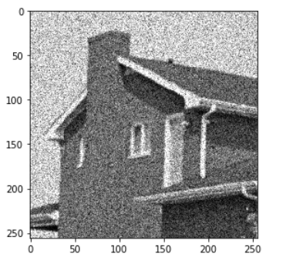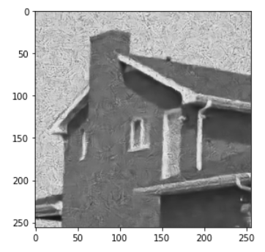

|  |  |  |
| --- | --- | --- |
| Sigma=3 | 噪声图 | 降噪图 |
| PSNR | 17.720084412739787 | 26.14486820422831 |
| SSIM | 0.252882334309857 | 0.616057889292142 |

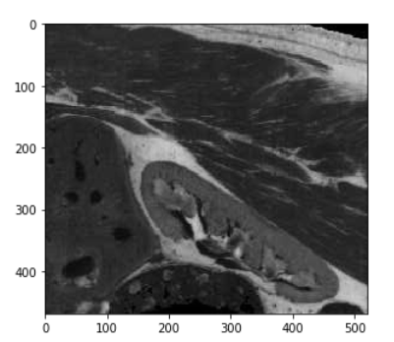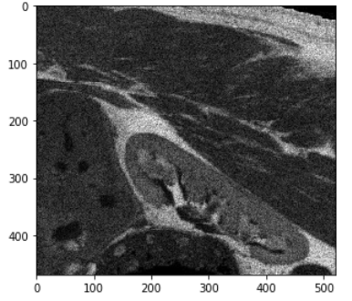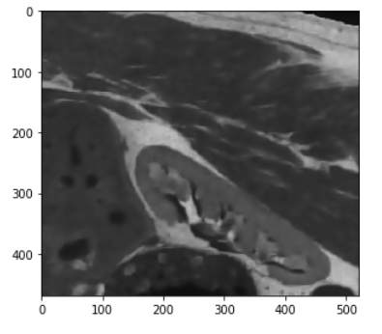

|  |  |  |
| --- | --- | --- |
| Sigma=2 | 噪声图 | 降噪图 |
| PSNR | 24.133187212301088 | 32.23020104802225 |
| SSIM | 0.4400977938098277 | 0.8394363912642617 |

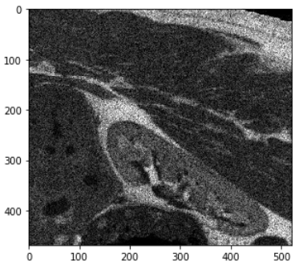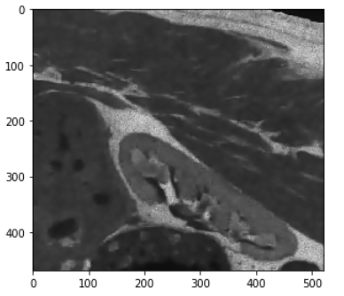

|  |  |  |
| --- | --- | --- |
| Sigma=3 | 噪声图 | 降噪图 |
| PSNR | 20.676458970926497 | 30.043320017796646 |
| SSIM | 0.2886859771669902 | 0.8077245945163348 |

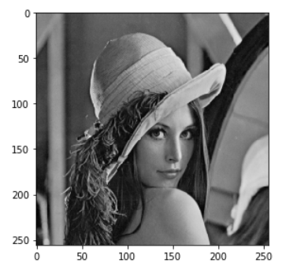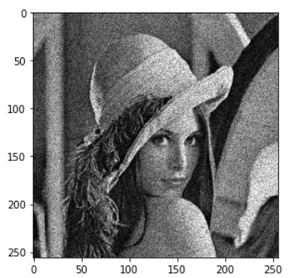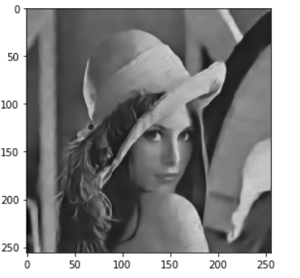

|  |  |  |
| --- | --- | --- |
| Sigma=2 | 噪声图 | 降噪图 |
| PSNR | 22.19037148320412 | 30.041768360994496 |
| SSIM | 0.5179863744054428 | 0.8576409392812295 |

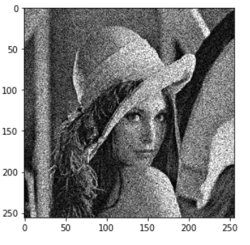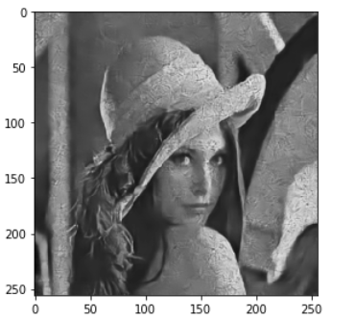

|  |  |  |
| --- | --- | --- |
| Sigma=3 | 噪声图 | 降噪图 |
| PSNR | 18.80315447146604 | 27.02995248814085 |
| SSIM | 0.3940873094191087 | 0.7467814058231941 |

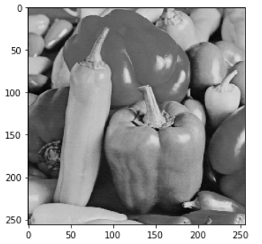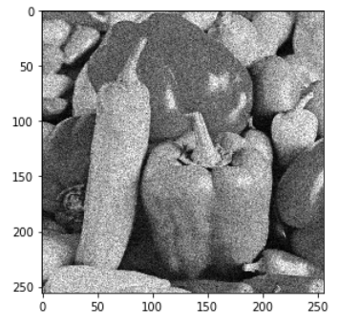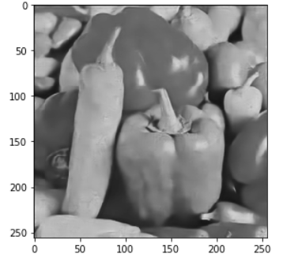

|  |  |  |
| --- | --- | --- |
| Sigma=2 | 噪声图 | 降噪图 |
| PSNR | 21.23386572178472 | 30.231468929694483 |
| SSIM | 0.45027125044765126 | 0.8663620126044506 |

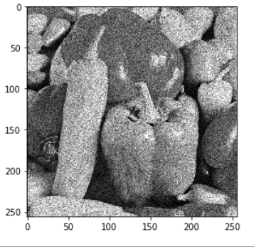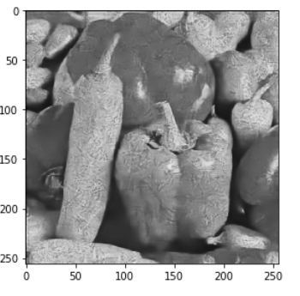

|  |  |  |
| --- | --- | --- |
| Sigma=3 | 噪声图 | 降噪图 |
| PSNR | 17.856402397079545 | 25.672964175428387 |
| SSIM | 0.33180670942572166 | 0.6883440083233753 |