原图 噪声图 降噪图

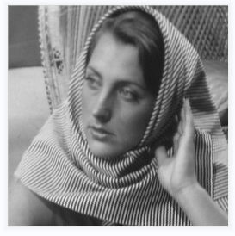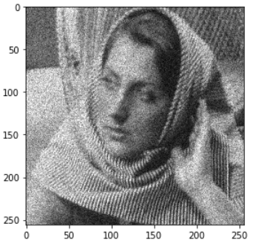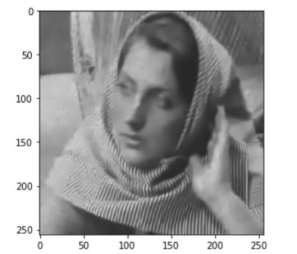

|  |  |  |
| --- | --- | --- |
| Sigma=2 | 噪声图 | 降噪图 |
| PSNR | 21.180207605531137 | 26.871371025181574 |
| SSIM | 0.5253606096362449 | 0.8222894738877146 |

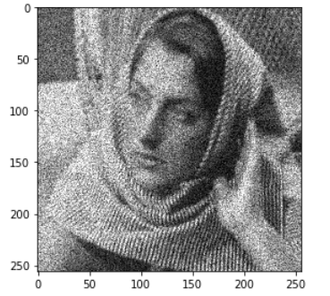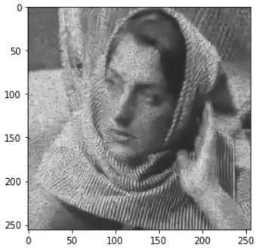

|  |  |  |
| --- | --- | --- |
| Sigma=3 | 噪声图 | 降噪图 |
| PSNR | 17.7673 | 24.75103876847419 |
| SSIM | 0.37933044763503915 | 0.6978485565290989 |

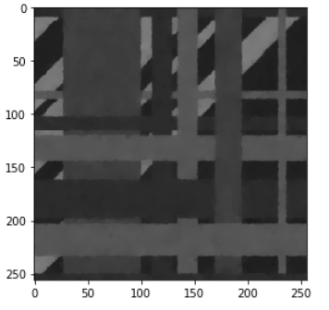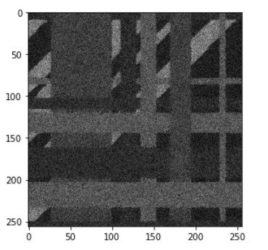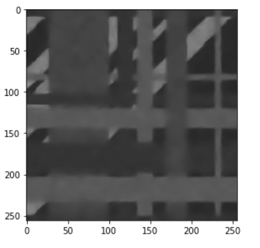

|  |  |  |
| --- | --- | --- |
| Sigma=2 | 噪声图 | 降噪图 |
| PSNR | 24.165110016763624 | 29.470081983955243 |
| SSIM | 0.36020822207279396 | 0.9273386871598813 |

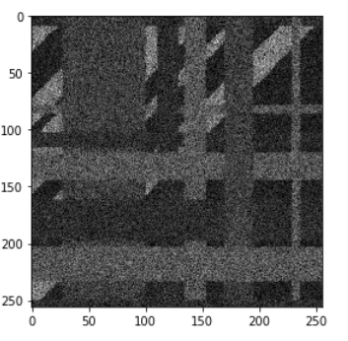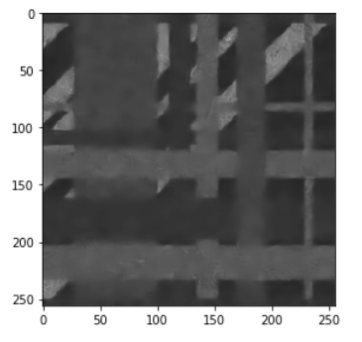

|  |  |  |
| --- | --- | --- |
| Sigma=3 | 噪声图 | 降噪图 |
| PSNR | 20.708606348841784 | 29.08498758830556 |
| SSIM | 0.23354097056626394 | 0.9055971037924697 |

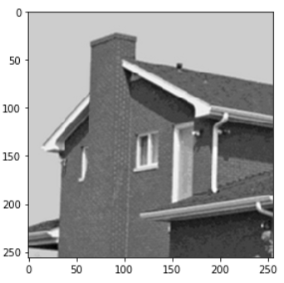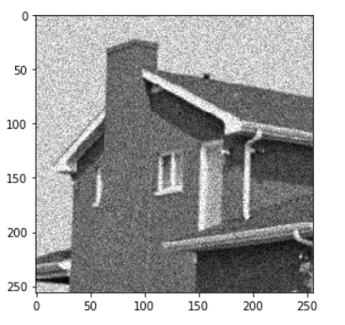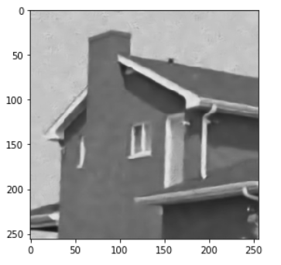

|  |  |  |
| --- | --- | --- |
| Sigma=2 | 噪声图 | 降噪图 |
| PSNR | 20.9459871760681 | 28.59837144743922 |
| SSIM | 0.23354097056626394 | 0.844879139102473 |

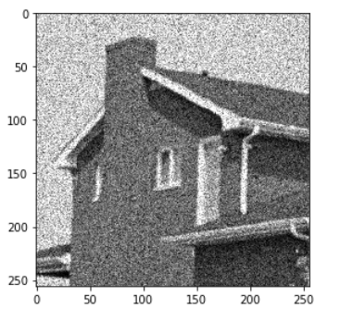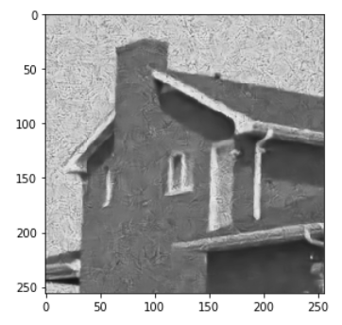

|  |  |  |
| --- | --- | --- |
| Sigma=3 | 噪声图 | 降噪图 |
| PSNR | 17.720084412739787 | 25.269575320270757 |
| SSIM | 0.252882334309857 | 0.6118327236919172 |

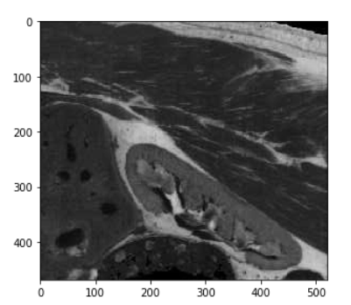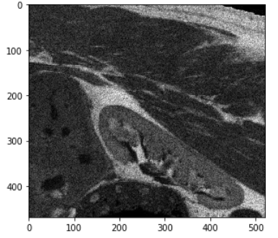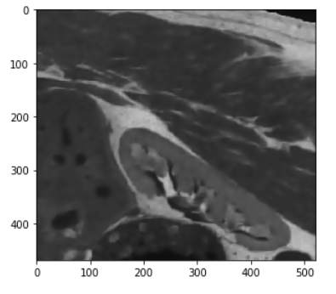

|  |  |  |
| --- | --- | --- |
| Sigma=2 | 噪声图 | 降噪图 |
| PSNR | 24.133187212301088 | 27.897384395575475 |
| SSIM | 0.4400977938098277 | 0.8207963512045687 |

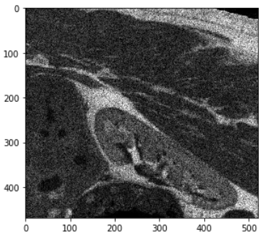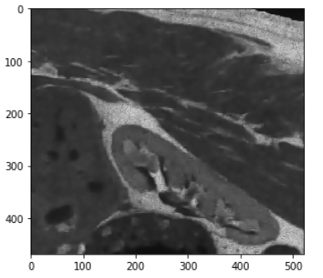

|  |  |  |
| --- | --- | --- |
| Sigma=3 | 噪声图 | 降噪图 |
| PSNR | 20.676458970926497 | 27.059562005881588 |
| SSIM | 0.2886859771669902 | 0.7935702202840078 |

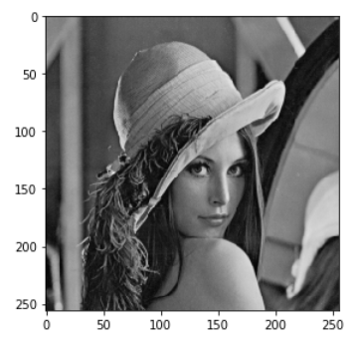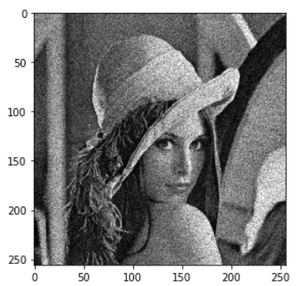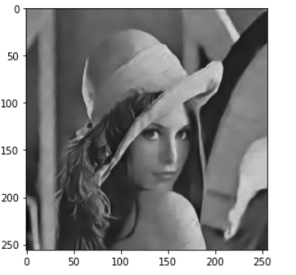

|  |  |  |
| --- | --- | --- |
| Sigma=2 | 噪声图 | 降噪图 |
| PSNR | 22.19037148320412 | 27.395820091492887 |
| SSIM | 0.5179863744054428 | 0.830481968260924 |

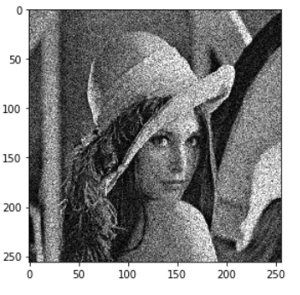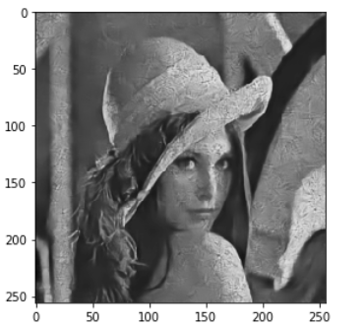

|  |  |  |
| --- | --- | --- |
| Sigma=3 | 噪声图 | 降噪图 |
| PSNR | 18.80315447146604 | 25.91234580071636 |
| SSIM | 0.3940873094191087 | 0.7276203535053579 |

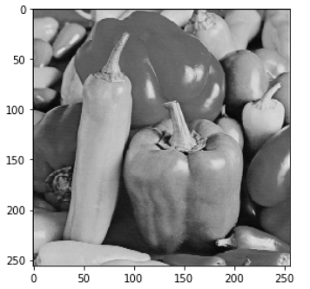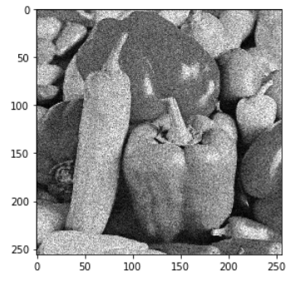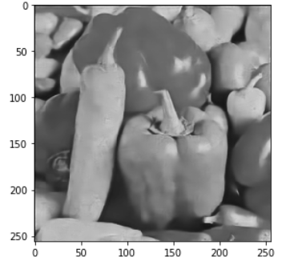

|  |  |  |
| --- | --- | --- |
| Sigma=2 | 噪声图 | 降噪图 |
| PSNR | 21.23386572178472 | 27.89585132708554 |
| SSIM | 0.45027125044765126 | 0.8497569732894351 |

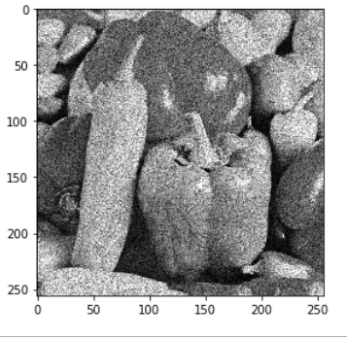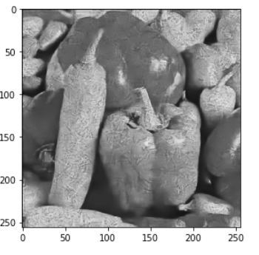

|  |  |  |
| --- | --- | --- |
| Sigma=3 | 噪声图 | 降噪图 |
| PSNR | 17.856402397079545 | 25.42197260995468 |
| SSIM | 0.33180670942572166 | 0.6876261277262558 |

真实超声图像（没有原图）

原图 降噪图

