Wangzisheng
Report of Updating REST service , those code is snowing what did I practice of this part, please have look below is all right,
https://github.com/EveningReeze/express-api-main.git
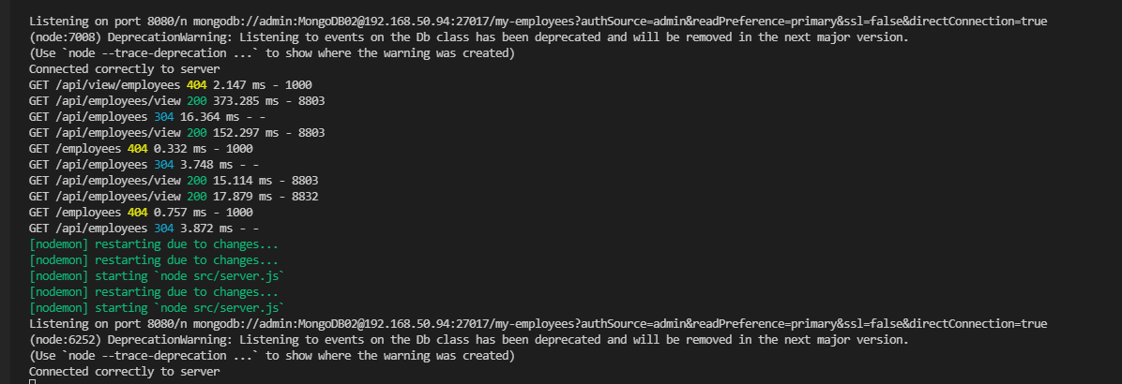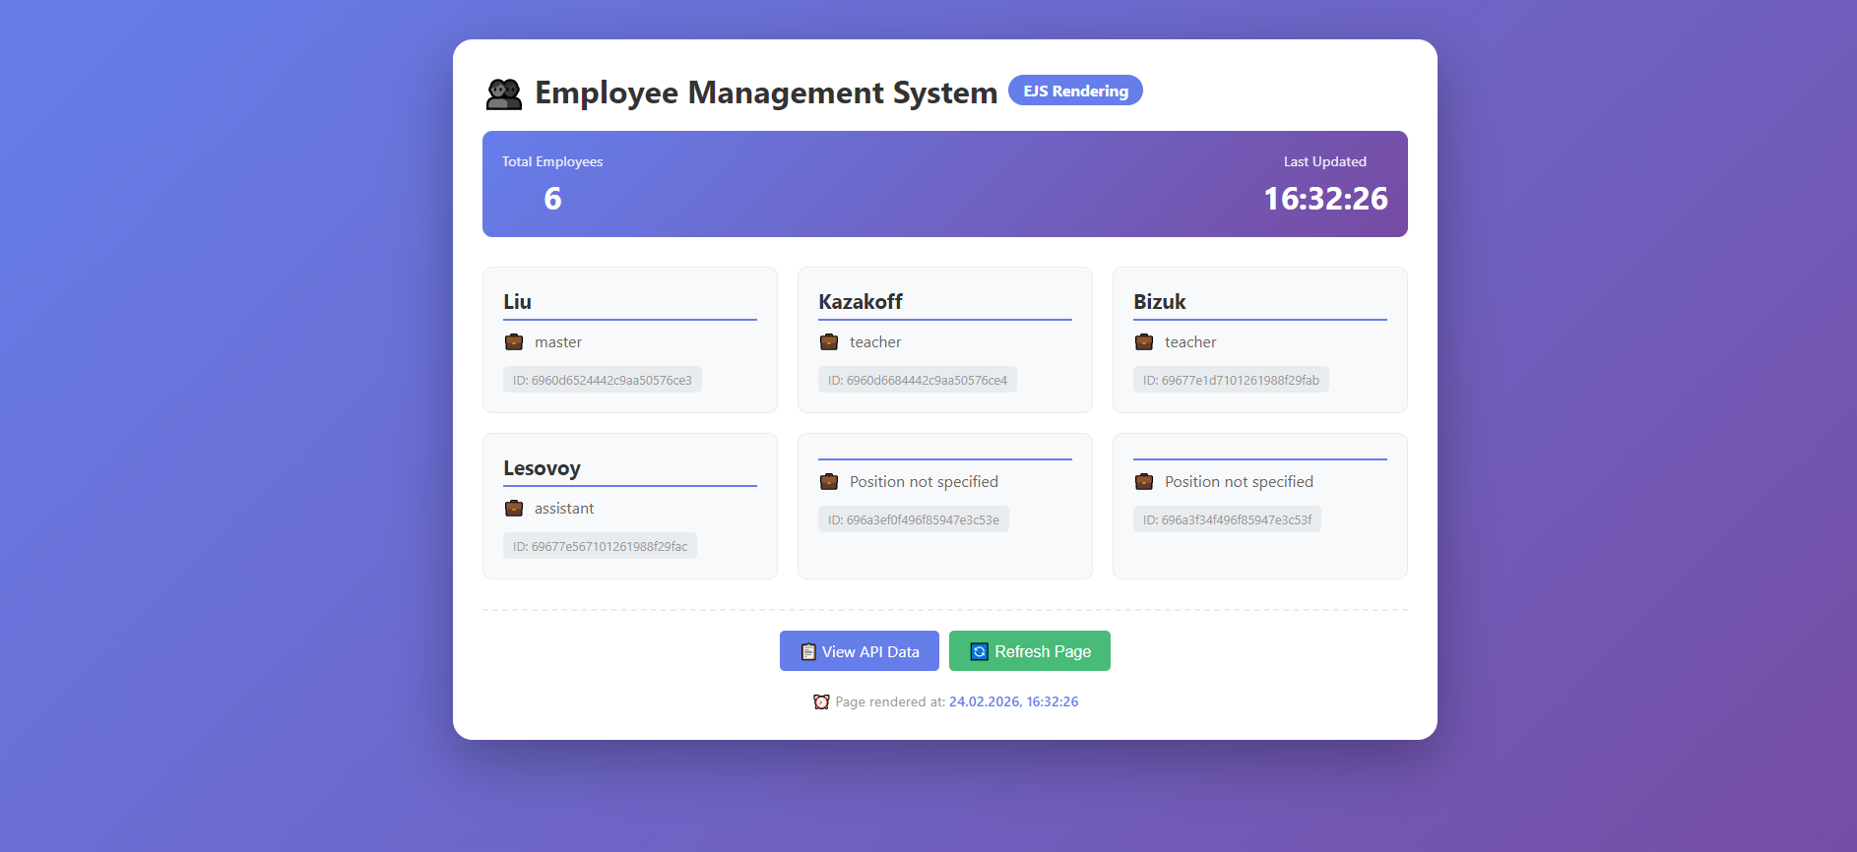

1.get all users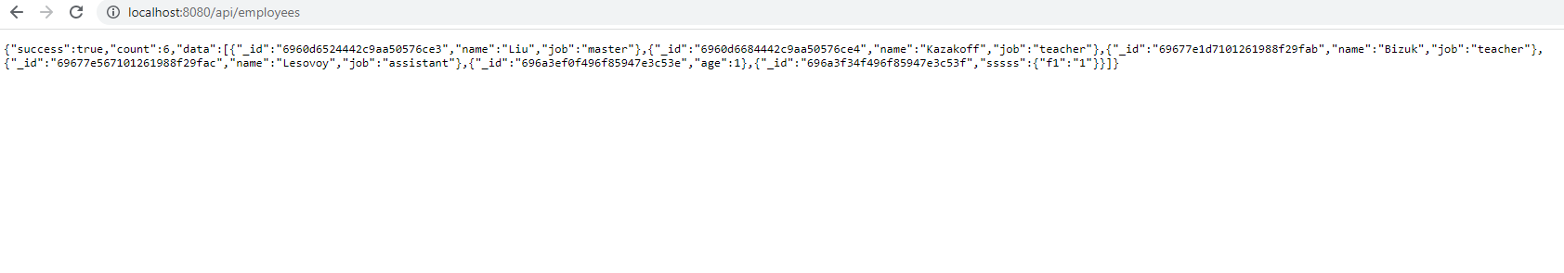
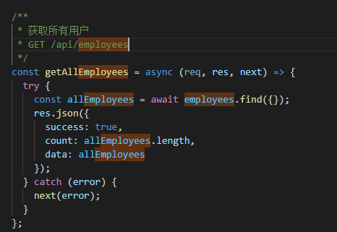

2. get a user with appropriate username
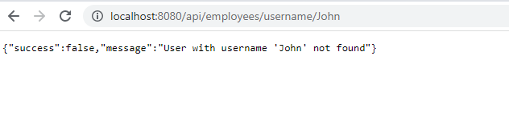
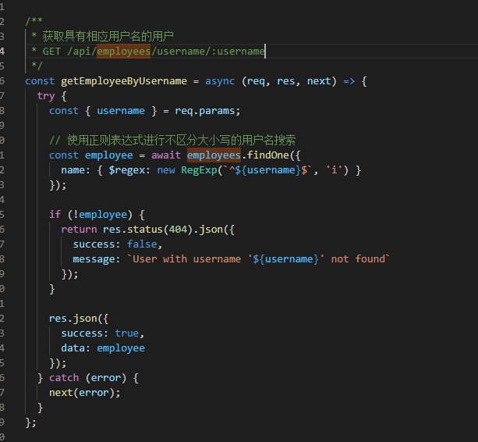

3, get a user with appropriate _id
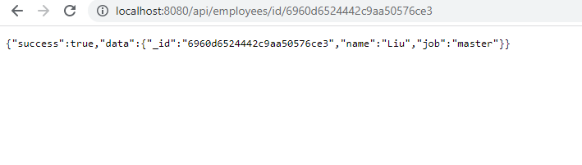
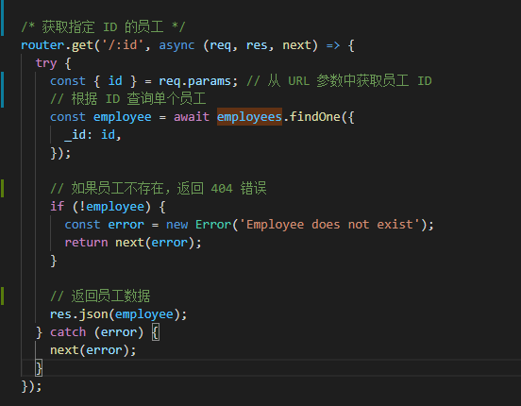

4. get all jobs presented in the database 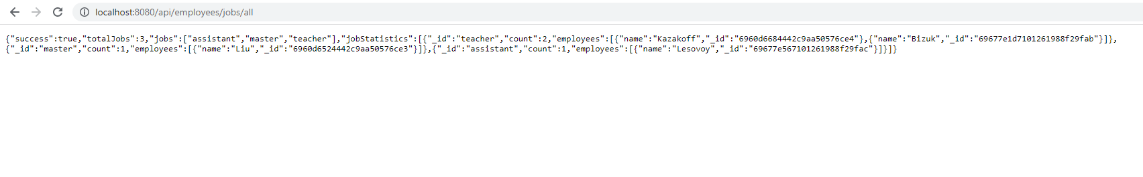
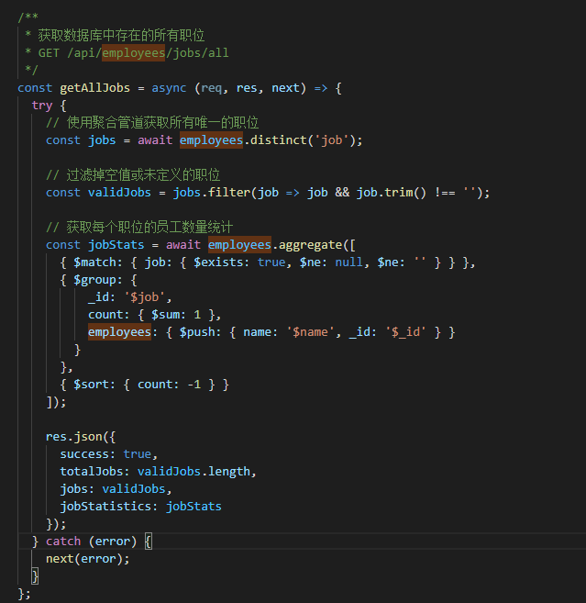

5. get users with IDs within a given range
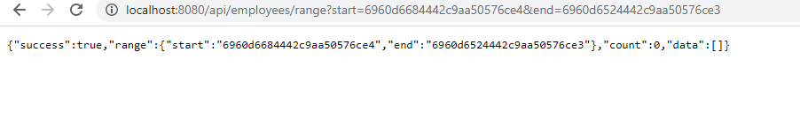
const getEmployeesInIdRangePaginated = async (req, res, next) => {
try {
const {
start,
end,
page = 1,
limit = 10,
sort = 'asc'
} = req.query;

if (!start || !end) {
return res.status(400).json({
success: false,
message: 'Please provide both start and end ID parameters'
});
}

const pageNum = parseInt(page);
const limitNum = parseInt(limit);
const skip = (pageNum - 1) * limitNum;

// 构建查询
const query = {
$and: [
{ _id: { $gte: start } },
{ _id: { $lte: end } }
]
};

// 获取总数
const total = await employees.count(query);

// 获取分页数据
const employeesInRange = await employees.find(query, {
limit: limitNum,
skip: skip,
sort: { _id: sort === 'asc' ? 1 : -1 }
});

res.json({
success: true,
pagination: {
currentPage: pageNum,
itemsPerPage: limitNum,
totalItems: total,
totalPages: Math.ceil(total / limitNum),
hasNextPage: pageNum < Math.ceil(total / limitNum),
hasPrevPage: pageNum > 1
},
range: {
start,
end
},
data: employeesInRange
});
} catch (error) {
next(error);
}
};

