EVENT CO-ORDINATION ENGINE

DECLARATION
I declare that the project report entitled “EVENT CO-ORDINATION ENGINE” has been done by me as a part of skill development in FASTAPI during the interval of JULY 2024 - SEPTEMBER 2024. Being a Data Engineer, I would like to explore some Development Skills in Python Related Frame work.

PLACE: RAIPUR DUGGIRALA YATEESH CHANDRA
DATE: 30-09-2024 DATA ENGINEER

ABSTRACT

ABSTRACT

The Event Coordination Engine (ECE) is a web-based application designed to streamline the process of event management, supporting both event proposals and registrations. Built with a Fast API backend and a React frontend, the system provides role-based access control (RBAC), ensuring that administrators have full control over event management, while regular users can propose and register for events. The system includes functionalities for user authentication, event creation, approval, and attendance tracking. Admins can review and approve event proposals, manage event details, and monitor attendees, while users can submit event proposals, register for events, and view event details. The application ensures security through password encryption, email validation, and robust role-based access. It is built to handle multiple concurrent users efficiently, offering a user-friendly interface for both desktop and mobile platforms. The ECE aims to provide a scalable, secure, and reliable solution for managing events, ensuring high performance and usability.

CONTENT
- INTRODUCTION  - Overview  - Computational Approach  - Problem Statement  - SYSTEM ANALYSIS  - Introduction  - Software Requirement Specification  - SYSTEM DESIGN  - Introduction  - Design Approaches  - Method and Algorithm  - Sequential Diagrams  - Flow Chart  - IMPLEMENTATION  - Introduction to Technology  - Sample Code  - Outputs  - TESTING  - Introduction  - Maintenance  - Strategy  - CHALLENGES  - Introduction  - Challenges  - CONCLUSION AND FUTURE WORKS | 6  7  9  10  12  13  14  17  18  18  23  24  26  28  29  31  37  46  47  49  49  50  51  51  55

LIST OF FIGURES

FIGURE | NAME OF THE FIGURE | PAGE NO
2.1 | Expected ER Model | 15
3.1 | Approach of the Proposed Model | 20
3.2 | DFD of the Proposed Model | 22
3.3 | Sequential Diagram for User | 25
3.4 | Sequential Diagram for Admin | 26
3.5 | Flowchart of the model | 27
4.3 | Outputs | 37-45
5.3 | Strategy | 49

CHAPTER I
INTRODUCTION
CHAPTER I
INTRODUCTION

  - OVERVIEW
The Event Coordination Engine is an online platform designed to help users create, manage, and attend events easily. The system serves two types of users: admins and regular users. Each role has specific functionalities, ensuring the platform operates smoothly.
Key Features:
- User Roles:
  - Admin: Admins oversee the entire platform. They can create, approve, edit, and delete events. They also manage attendee lists and ensure the platform runs efficiently.
  - Regular User: Users can propose new events for approval by admins, register for approved events, and view details about the events they are interested in.
- Event Proposal: Users can suggest new events by submitting a proposal that includes the event title, description, date, time, and location. Admins then review and either approve or reject the event.
- Event Management: Once an event is approved, admins can manage event details, such as updating information or canceling the event if needed. This ensures that all events are up to date and relevant.
- Registration: Users can browse available events and sign up for those they wish to attend. The system prevents users from registering for the same event multiple times and ensures that only approved events are available for registration.
- Event Attendance: Admins can track and manage the attendees for each event, ensuring smooth coordination of participants. Users can also check details about the events they registered for, such as the time, location, and event description.
- Notifications: The system sends emails to users, informing them about upcoming events they may be interested in, helping them stay engaged and informed.
User-Friendly Interface:
The platform has a simple and intuitive design. Users can easily navigate through different sections, whether they are proposing events, registering for them, or managing attendees as admins.
Security and Access Control:
The platform ensures a secure environment by enforcing role-based access control (RBAC). This means that admins have access to all management features, while regular users have restricted access to specific actions like event proposals and registrations. Data security is also maintained by implementing strong passwords and ensuring unique email accounts.

  - COMPUTATIONAL APPROACH
The Event Coordination Engine is designed using a web application framework. Specifically, from previous discussions, we know that the project uses FastAPI for the backend and React for the frontend.
- FastAPI is used to handle backend logic, such as API requests, user authentication, and database interactions.
- React is used to manage the user interface, making it responsive and interactive.
These two frameworks together provide a highly efficient and modern architecture for handling event management tasks.
The computational approach in the Event Coordination Engine refers to how data is processed and manipulated for the various components of the system, such as events, users, and registrations.
1. Object-Oriented Programming (OOP):
- The system likely uses object-oriented design where events, users, and registrations are represented as objects (or classes). Each object would have its own attributes and methods.
- This approach encapsulates data and operations, allowing the system to manage event-related actions efficiently.
2. Database-Driven Computation:
- Events and users are likely stored as database entities. Queries are used to fetch, update, and manipulate data. For example, when a user registers for an event, a database query updates the relevant event and user objects.
- SQLAlchemy is used to map Python objects to database tables, enabling seamless database interaction.
3. Efficient Data Retrieval:
- The system likely employs efficient querying and filtering methods (e.g., fetching only approved events or filtering events by date) to ensure minimal computational load while retrieving event data for users or admins.
1.3 PROBLEM STATEMENT
In today's fast-paced environment, organizing and managing events can be a daunting task for individuals and organizations. Traditional methods of event management often lead to various challenges, such as miscommunication, lack of organization, and difficulty in tracking event details and attendee participation.
The Event Coordination Engine aims to address these challenges by providing a streamlined, user-friendly platform that facilitates the creation, management, and participation of events. Users often struggle with the following issues:
- Inefficient Event Proposals: Users need a simple way to propose new events, which can be cumbersome with traditional methods, leading to missed opportunities and delays in approvals.
- Complex Registration Processes: Attendees often face challenges when registering for events due to fragmented processes, leading to confusion and a poor user experience.
- Lack of Communication: Event organizers and attendees frequently miss important updates or changes regarding event details, leading to frustration and decreased attendance.
- Ineffective Event Management: Organizers often find it difficult to manage multiple events, track registrations, and handle attendee communication efficiently, resulting in a lack of organization.
- Data Integrity and Security: Ensuring that user data and event information are secure while complying with regulations is crucial but often overlooked in traditional systems.
The Event Coordination Engine addresses these issues by providing a centralized platform where users can easily propose and manage events, register for participation, and receive timely notifications. By implementing robust role-based access control and ensuring data security, the platform enhances the overall event management experience for both users and organizers.

CHAPTER II
SYSTEM ANALYSIS

CHAPTER 2
SYSTEM ANALYSIS

2.1 INTRODUCTION
System Analysis is the first stage of System Development Life Cycle. This System Analysis is a process that starts with the Analysis, which is a detailed study of the various operations performed by a system and their relationships within and outside the system. One aspect of the analysis is defining the boundaries of the system and determining whether or not a candidate should consider other related systems. Logical system models and tools are used in analysis.

FEASIBILITY STUDY:
An important outcome of the preliminary investigation is the determination that system requested is feasible. It is proposed to solve the problem development a computer-based information system for job searching. Since the data is voluminous and involves a lot of overhead, it is the best activity for computerization.

- TECHNICAL FEASIBILITY:
The technical feasibility is measured with the current Equipment, existing software technologies and available personnel are sufficient for the proposed system.

- ECONOMIC FEASIBILITY:
Economic feasibility is measured that the proposed System having sufficient benefits in the economic point of view. Since the necessary hardware and software are available in the organization, there is no need to procure and install new hardware and software. Thus, initial investment on hardware and software is nothing..

- OPERATIONAL FEASIBILITY:
The operational feasibility is measured by the usage of the system after implementation and resistance from the users. Hence, it is encouraging to undertake a detailed system analysis.

2.2 SOFTWARE REQUIREMENT SPECIFICATION
To derive the requirements, we need to have clear and thorough understanding. The software requirements specification document enlists all necessary requirements that are required for the project development of the products to be developed.

PURPOSE:
The purpose of this SRS document is to specify software requirements for the determined project. It is intended to be a complete specification of what functionality it provides. The main purpose of the system is to automate the task carried out in the domain model. The specifications will include the functional requirements and data requirements, non-functional requirements both of which will describe how the developers will design the product in order to achieve a determined system of new generation. This document will serve as a guide for the client and the developers allowing for a common document to understand the implementation is the software itself.

2.2.1 FUNCTIONAL REQUIREMENTS:
In software Engineering and Systems Engineering, a functional requirement defines a function of a system or its component, where a function is described as a specification of behavior between outputs and inputs. Functional requirements may involve calculations, technical details, data manipulation and processing and other specific functionality that define what a system is supposed to accomplish. Behavioral requirements describe all the cases where the system uses the functional requirements. Functional requirements are supported by non-functional requirements also known as “quality requirements, which impose constraints on the design or implementation. As defined in requirements engineering, functional requirements engineering, functional requirements, which specify overall characteristics such as cost and reliability. Functional requirements drive the application architecture of a system, while non-functional requirements drive the technical architecture of a system.
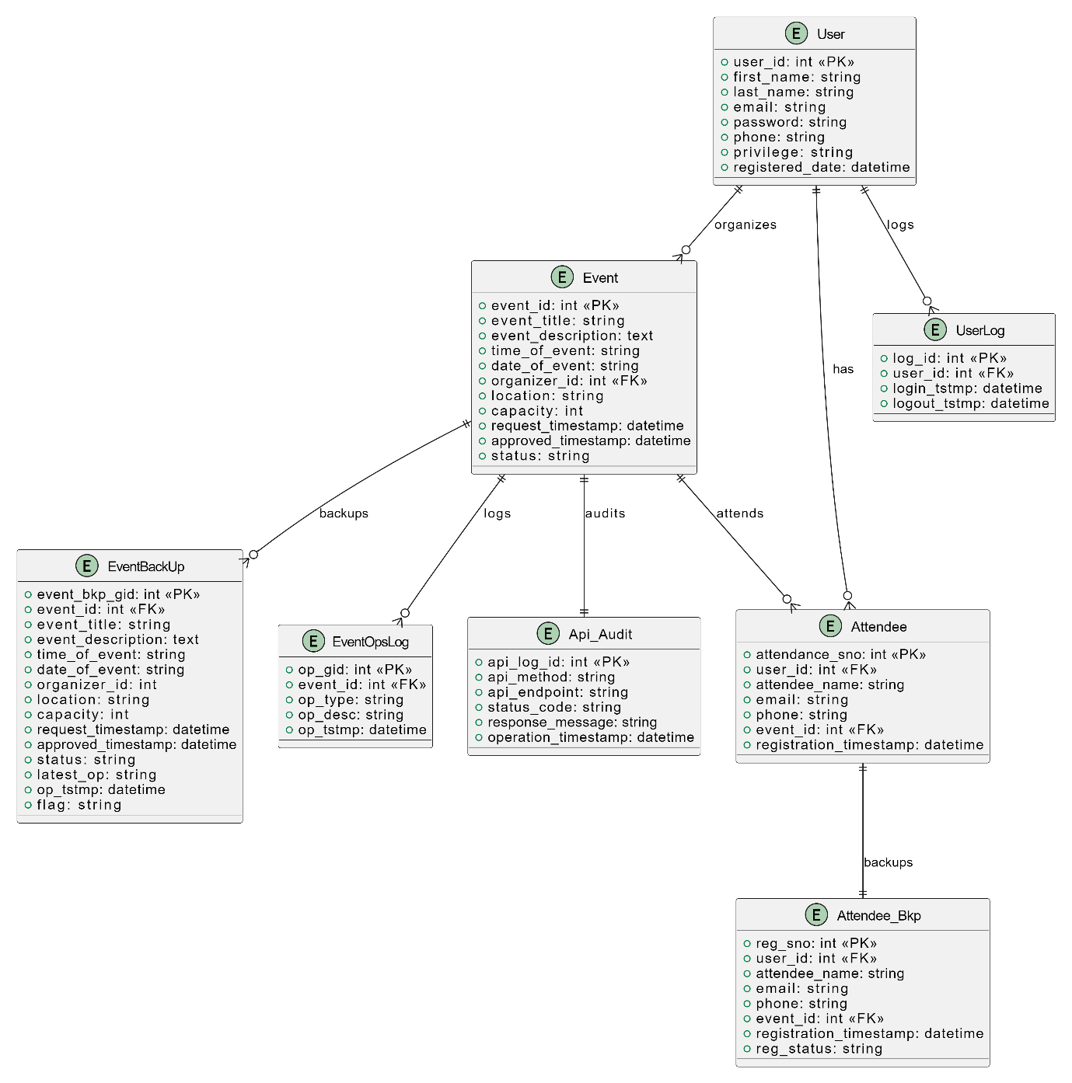

FIG 2.1 Expected ER Diagram

2.2.2 NON-FUNCTIONAL REQUIREMENTS:
In systems engineering and requirements engineering, a non-functional requirement (NFR) is a requirement that specifies criteria that can be used to judge the operation of a system, rather than specific behaviors. They are contrasted with functional requirements that define specific behavior or functions. The plan for implementing functional requirements is detailed in the system design. The plan for implementing non-functional requirements is detailed in the system architecture, because they are usually architecturally significant requirements.

The Non-Functional requirements for the proposed model are as follows:
- Secure access of confidential data user’s details
- 24*7 availability.
- Better component design to get better performance at peak time
- Flexible service-based architecture will be highly desirable for future extension.

2.2.3 HARDWARE REQUIREMENTS
- RAM : 4GB and Higher
- PROCESSOR : Intel i5 and above
- HARD DISK : 500GB (Minimum)

2.2.4 SOFTWARE REQUIREMENTS
- OS : Windows
- Programming used : Java Script, HTML, Python
- Database : PostgreSQL
- Frameworks : FastAPI (Python), React JS
- Testing : Postman For Backend
- Version Control : Git and GitHub
CHAPTER III
SYSTEM DESIGN

CHAPTER 3
SYSTEM DESIGN
3.1 INTRODUCTION:
System design is the process of defining the elements of a system such as the architecture, modules and components, the different interfaces of those components and the data that goes through that system. It is meant to satisfy specific needs and requirements of a business or organization through the engineering of a coherent and well-running system. Systems design mainly concentrates on defining the architecture, components, modules, interfaces, and data for a system to satisfy specified requirements. It implies a systematic approach to the design of a system. It may take a bottom-up or top-down approach, but either way the process is systematic wherein it takes into account all related variables of the system that needs to be created—from the architecture, to the required hardware and software, right down to the data and how it travels and transforms throughout the system.

3.2 DESIGN APPROACHES

SOFTWARE DEVELOPMENT LIFE CYCLE:
There are various software development approaches defined and designed which are used/employed during development process of software, referred as "Software Development Process Models". Each process model follows a particular life cycle in order to ensure success in process of software development.

REQUIREMENTS:
Business requirements are gathered in this phase. This phase is the main focus of the project managers and stake holders. Meetings with managers, stake holders and users are held in order to determine the requirements. Who is going to use the system? How will they use the system? What data should be input into the system? These are general questions that get answered during the requirements gathering phase. This produces a nice big list of functionalities that the system should provide, which describes functions the system should perform, business logic that processes data, what data is stored and used by the system, and how the user interface should work. The overall result is the system as a whole and how it performs.
DESIGN:
The software system design is produced from the results of the requirements phase. Architects have the ball in their court during this phase and this is the phase in which their focus lies. This is where the details on how the system will work is produced. Architecture, including hardware and software, communication, software design (UML is produced here) are all part of the deliverables of a design phase.

IMPLEMENTATION:
Code is produced from the deliverables of the design phase during implementation, and this is the longest phase of the software development life cycle. For a developer, this is the main focus of the life cycle because this is where the code is produced. Implementation may overlap with both the design and testing phases. Many tools exist (CASE tools) to actually automate the production of code using information gathered and produced during the design phase.

TESTING:
During testing, the implementation is tested against the requirements to make sure that the product is actually solving the needs addressed and gathered during the requirements phase. Unit tests and system/acceptance tests are done during this phase. Unit tests act on a specific component of the system, while system tests act on the system as a whole. So, in a nutshell, that is a very basic overview of the general software development life cycle model. Now let’s delve into some of the traditional and widely used variations.

3.2.1 ARCHITECTURE:
The design of a system is probably the foremost crucial issue warm heartedness the standard of the software package. It’s a serious impact on the later part, notably testing and maintenance. The output of this part is that the style of the document. The design activity is commonly divided into 2 separate phases System Design and Detailed Design.
System Design referred to as top-ranking style aims to spot the modules that ought to be within the system, the specifications of those modules, and the way them move with one another to supply the specified results at the top of the system style all the main knowledge structures, file formats, output formats, and also the major modules within the system and their specifications square measure set.
System design is that the method or art of process the design, components, modules, interfaces, and knowledge for a system to satisfy the needs.

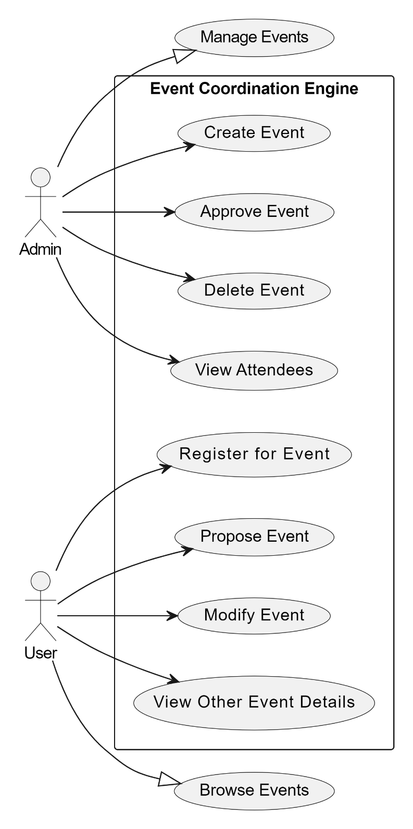

FIG 3.1 Approach of the Proposed Model

3.2.2 DATA FLOW DIAGRAM:
Data Flow Diagram can also be termed as bubble chart. It is a pictorial or graphical form, which can be applied to represent the input data to a system and multiple functions carried out on the data and the generated output by the system.
The DFD is also known as a data flow graph or a bubble chart. The Basic Notation used to create a DFD’s are as follows:

- Dataflow:

- Process:

- Source:

- Decision:

- Data Store:

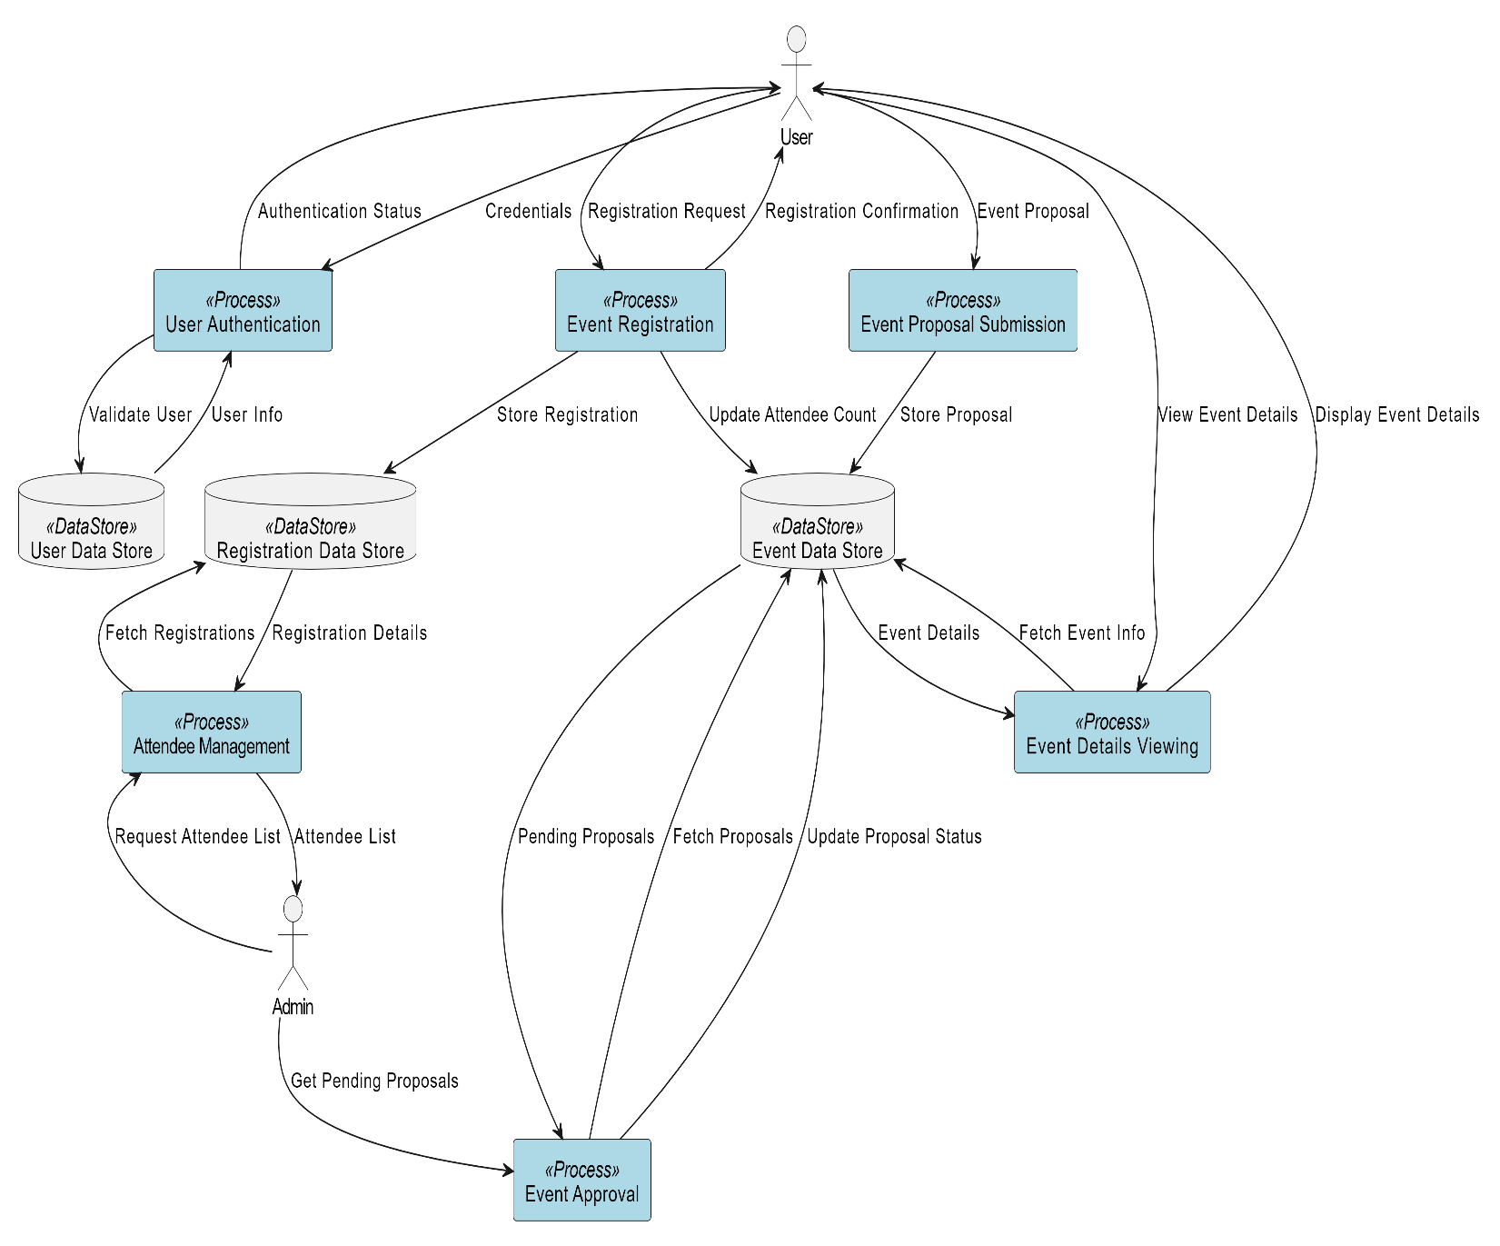

FIG 3.2 DFD of the Proposed Model

3.3 ALGORITHM AND METHODS:
3.3.1 METHODS:
HTTP Method | API | Functionality
POST | /user/register | This method is used to Register Users
POST | /user/login | This method is used to login Users
PUT | /user/logout/{id} | This method is used to logout User with id
POST | /create-event | Creates an event and post it to database
PUT | /event/{event_id} | Updates an event with an event_id
GET | /all-events | Fetches all events from the database
GET | /pending-events | Fetches all pending events from database
GET | /approved-events | This gets all the approved events
GET | /available-events/{id} | This gets all the available events for user_id
DELETE | /delete-event/{event_id} | Deletes an event with event_id
GET | /event/{event_id} | Fetches an event with event_id
GET | /event_by_user/{user_id} | Getting an event by user with user_id
GET | /event_by_user/pending/{user_id} | Fetching pending events by user_id
PUT | /approve-event/{event_id} | This approves event with event_id
PUT | /approve-all-events | This approves all Pending events
POST | /register_event | This registers an event
GET | /registered_event/users/{user_id} | This returns various registered events from user with user_id
GET | /registered_event/events/{event_id} | This returns various registered events from Events with event_id
GET | /all_registered_events | This returns all registered events
GET | /all_inactive_events | This returns all inactive events to admin
GET | /daily_recom | This triggers recommendation mails

3.3.2 ALGORITHM FOR THE EXECUTION:
- Setup and configure the properties of Database
- Open Python ID Environment
- Install the required Libraries in IDE including FastAPI / Uvicorn
- Our server is running in Uvicorn at our desired Port.
- Define Classes for Model such that They exhibit Object Relational Mapping
- Write the Functions for API with required HTTP Methods showing different functionalities.
- Define the CORS Middle Properties such that APIs can be called from wherever needed.
- Once you are done with the Development, Start the backend
- Create React Application using npx create-react-app frontend
- Develop the components Using React JSX.
- Call the APIs using axios from frontend
- Start the Frontend.

3.4 SEQUENTIAL DIAGRAMS:
Sequential diagrams, often referred to as sequence diagrams, are a type of interaction diagram used in software engineering and systems design to illustrate how objects interact in a particular scenario of a use case. These diagrams emphasize the order of messages exchanged between objects, showcasing how they collaborate to fulfill a specific task or function. Each diagram represents a sequence of messages sent and received, laid out in a time-ordered format from top to bottom.
One of the key benefits of sequence diagrams is their ability to clarify complex interactions in a system, making it easier for stakeholders to understand the flow of control and data. By breaking down interactions into distinct messages and their respective sequences, developers can identify potential bottlenecks, redundancies, and other design flaws early in the development process. Moreover, these diagrams are particularly useful for modeling scenarios where timing and order are critical, as they visually represent not just what is communicated, but when.
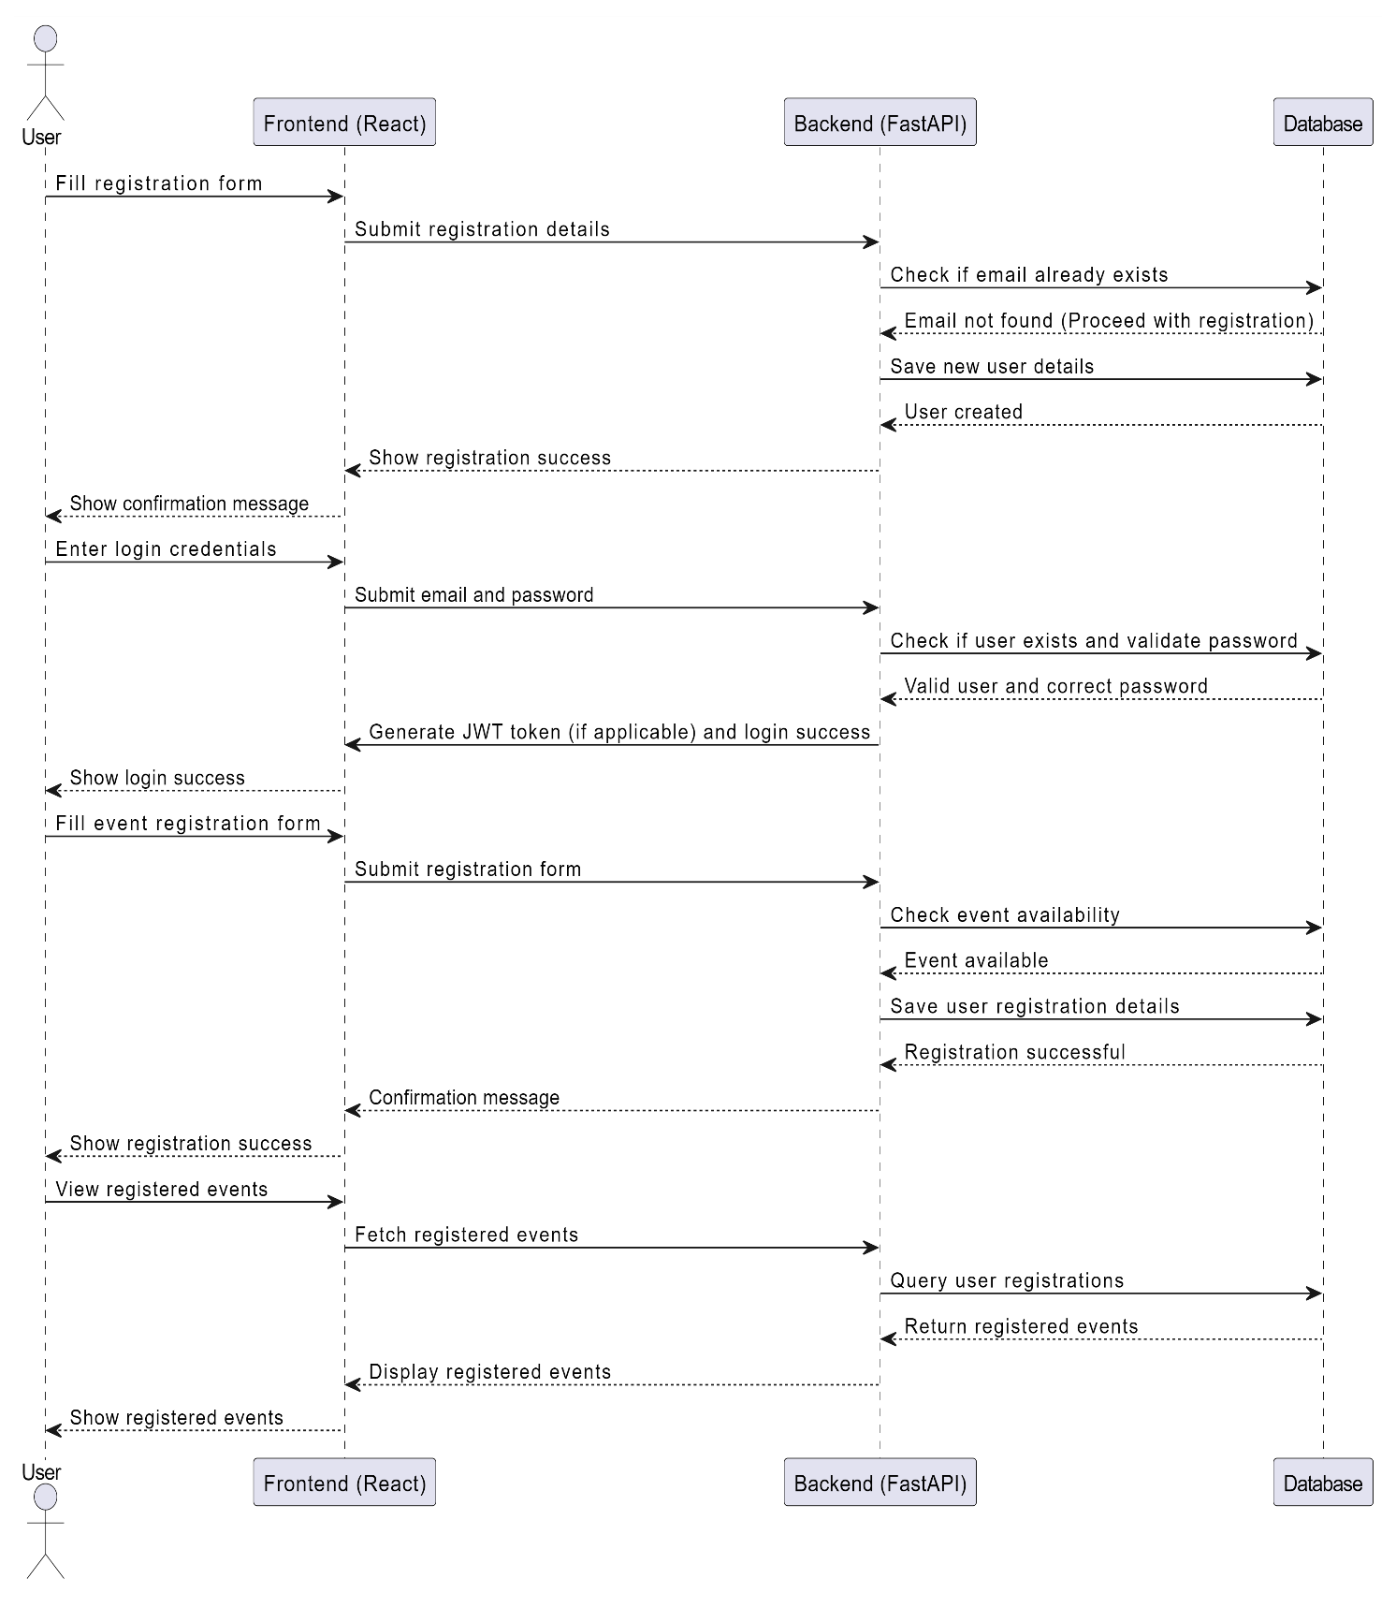

FIG 3.3 Sequential Diagram For User

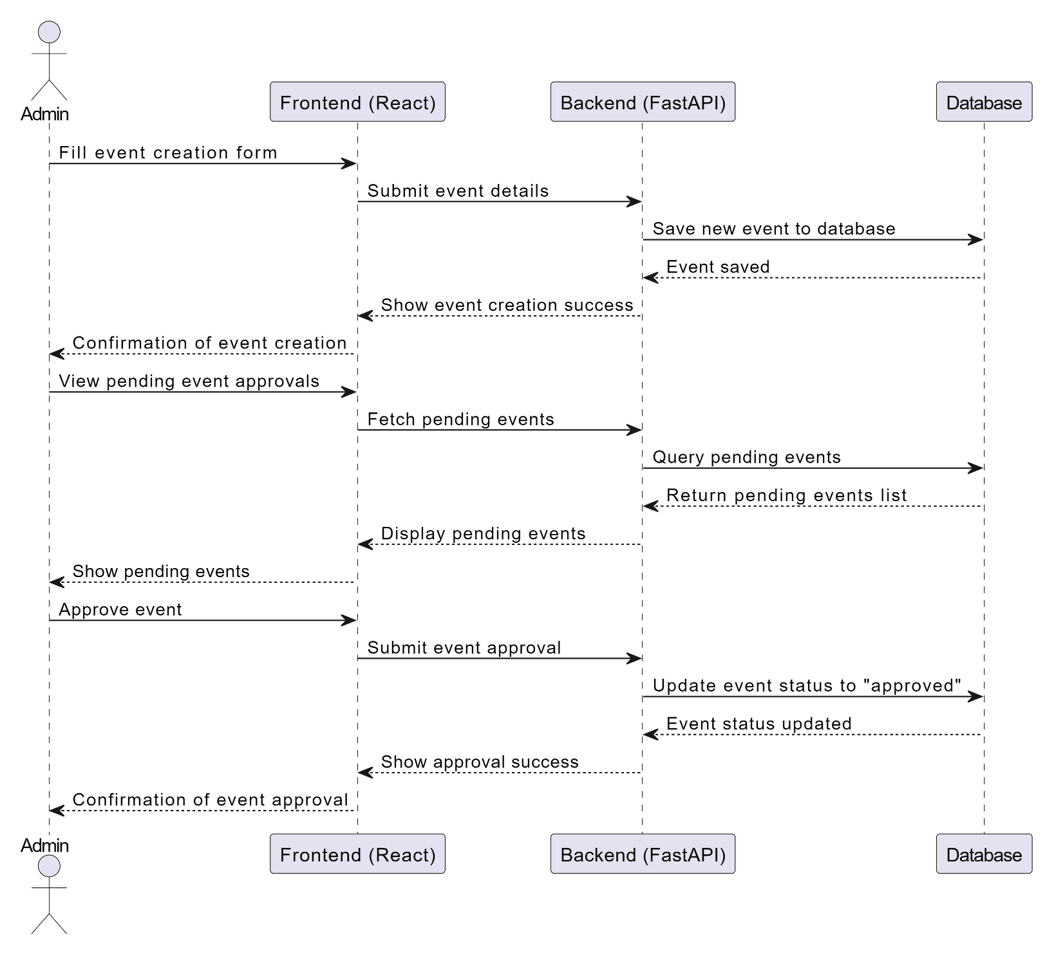
FIG 3.4 Sequential Diagram For Admin

3.5 FLOW CHART:
A graphical representation of a computer program in relation to its sequence of functions (as distinct from the data it processes. The flowchart shows the steps as boxes of various kinds, and their order by connecting the boxes with arrows. This diagrammatic representation illustrates a solution model to a given problem.
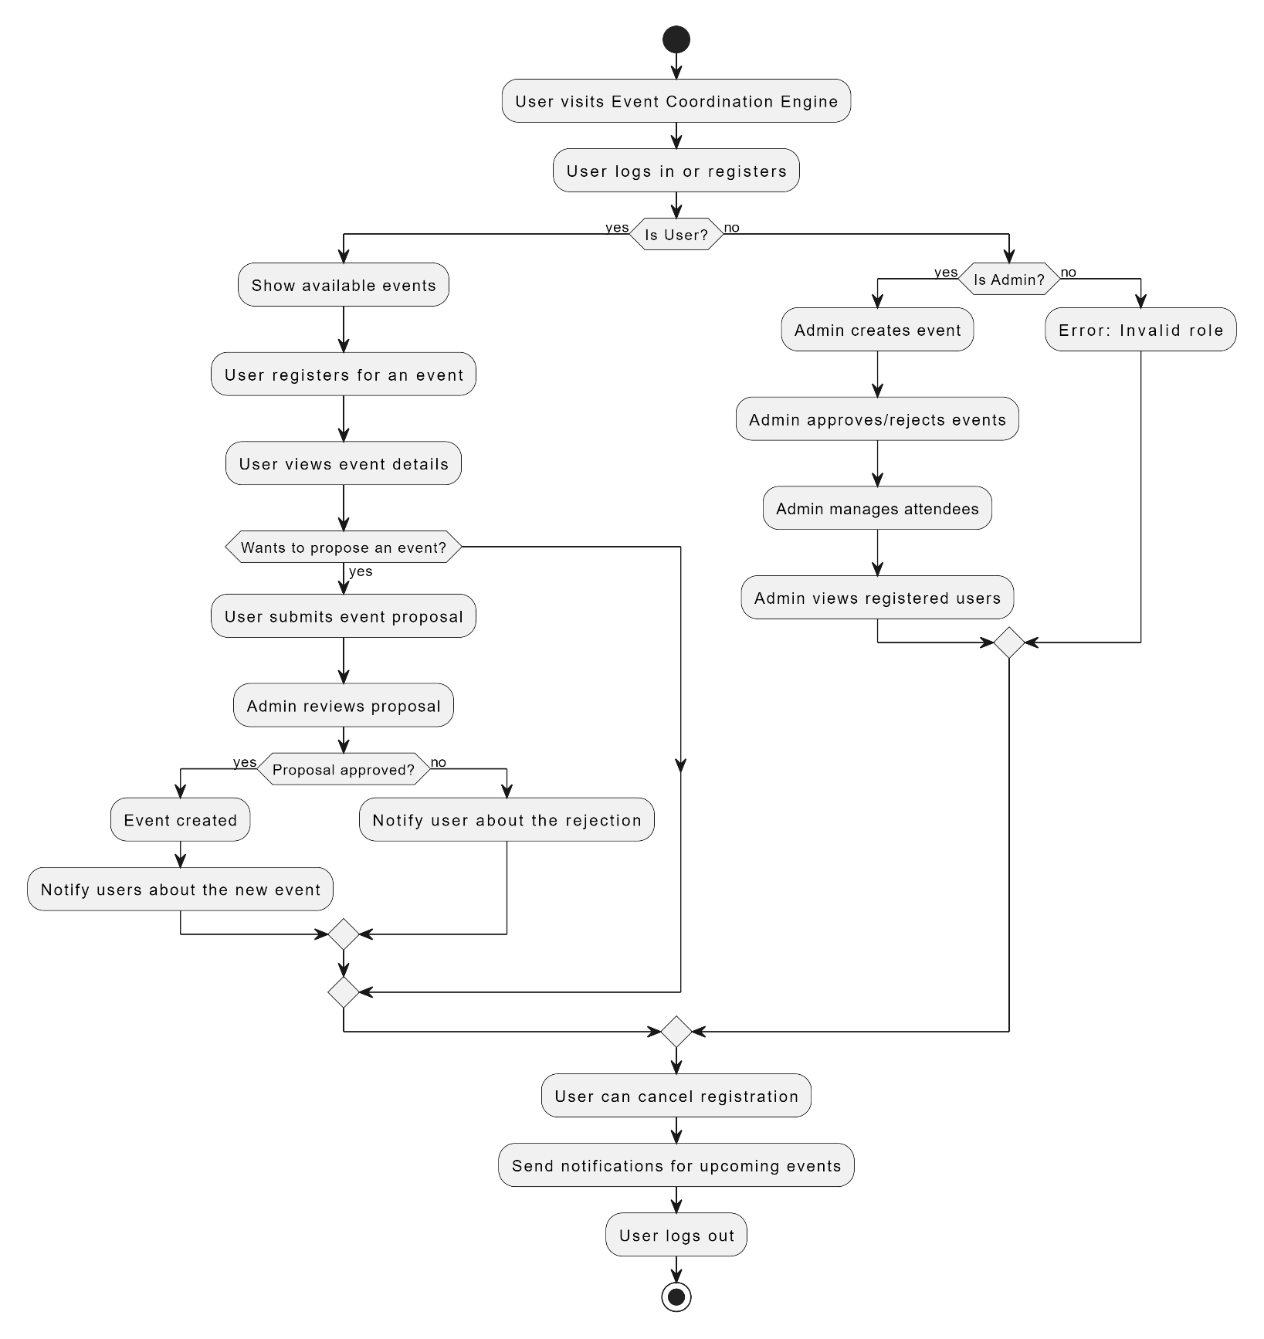
FIG 4.8 Flowchart of the proposed multi-classification model

CHAPTER IV
IMPLEMENTATION

CHAPTER 4

IMPLEMENTATION

4.1 INTRODUCTION TO TECHNOLOGY

4.1.1 PYTHON PROGRAMMING LANGUAGE:
Python is an interpreted, high-level and general-purpose programming language. It is created by Guido van Rossum and was first released in 1991. Object-oriented programming and structured programming are fully supported, and many of its features support functional programming and aspect-oriented programming including by meta programming and meta objects . Python is often described as a "batteries included" language due to its comprehensive standard library. Python interpreters are available for many operating systems. A global community of programmers develops and maintains CPython, a free and open-source reference implementation. Current of python is 3.9 released on October 5, 2020.

4.1.2 FASTAPI:
FastAPI is a modern, fast (high-performance) web framework for building APIs with Python 3.7+ based on standard Python type hints. It allows developers to create RESTful APIs quickly and efficiently, leveraging the asynchronous capabilities of Python. One of FastAPI's standout features is its automatic generation of interactive API documentation using Swagger UI and ReDoc, making it easier for developers to understand and test endpoints. With built-in support for data validation and serialization using Pydantic models, FastAPI ensures that input data conforms to expected types, reducing the likelihood of runtime errors. This framework is particularly well-suited for microservices and applications that require high performance, as it is designed to handle large numbers of concurrent requests efficiently.

4.1.3 UVICORN:
Uvicorn is a lightning-fast ASGI (Asynchronous Server Gateway Interface) server for Python, designed to run asynchronous web frameworks like FastAPI and Starlette. Built on top of the asyncio library, Uvicorn is capable of handling high-throughput applications with low latency. Its simple and lightweight design makes it easy to deploy and integrate into existing Python projects. Uvicorn supports WebSockets, HTTP/2, and is designed to run on both Windows and UNIX systems. Additionally, it comes with features like automatic code reloading and support for custom middleware, making it a popular choice for developers looking to build modern, responsive web applications.

4.1.4 SQLALCHEMY:
SQLAlchemy is a powerful and flexible Object Relational Mapping (ORM) library for Python, allowing developers to interact with relational databases in a more Pythonic way. It provides a set of high-level API tools for managing database connections, executing SQL statements, and mapping Python classes to database tables. With SQLAlchemy, developers can define their data models using Python classes, making database interactions more intuitive and maintainable. The library supports a wide variety of database backends and offers a robust querying system that abstracts away raw SQL, enabling developers to write complex queries using Python syntax. This makes SQLAlchemy an essential tool for projects that require database integration, as it promotes cleaner code and reduces boilerplate.

4.1.5 BCRYPT:
Bcrypt is a password hashing function designed to provide robust security for storing user credentials. It employs a slow hashing algorithm that makes it difficult for attackers to use brute-force methods to crack passwords, as the time taken to hash passwords increases with the complexity of the input. By incorporating a salt, Bcrypt ensures that even if two users have the same password, their hashed values will differ, adding an extra layer of security. Developers typically use Bcrypt in combination with frameworks like FastAPI to handle user authentication, ensuring that passwords are securely hashed before being stored in a database.

4.1.6 SMTPLIB:
SMTPLib is a built-in Python library used for sending email messages via the Simple Mail Transfer Protocol (SMTP). It provides a straightforward interface for connecting to an SMTP server and sending messages using standard email protocols. SMTPLib supports various features such as sending HTML emails, attaching files, and managing email headers.
4.1.7 REACT:
React is a popular JavaScript library for building user interfaces, particularly for single-page applications. Developed and maintained by Facebook, React allows developers to create reusable UI components, enabling efficient rendering and updating of the user interface in response to data changes. One of its core features is the virtual DOM, which optimizes updates by only re-rendering components that have changed, improving application performance. React's component-based architecture promotes code reusability and maintainability, making it easier for developers to manage complex applications.

4.2 SAMPLE CODE
Complete Code: Github Link
from fastapi import FastAPI, Depends, BackgroundTasks, status, Request
from fastapi.middleware.cors import CORSMiddleware
from database import Base, SessionLocal, engine
app = FastAPI()
logging.basicConfig(level=logging.INFO, filename=f'loggers/app_{datetime.now().strftime("%Y%m%d")}.log', filemode='a', format='%(asctime)s - %(levelname)s - %(message)s')
logger = logging.getLogger(__name__)

# Create the tables provided in metadata
Base.metadata.create_all(bind = engine)
@app.post("/user/register", status_code=201)
def register_user(user_obj : UserRegistrationDTO, request : Request, db : db_dependency, background_tasks: BackgroundTasks):
logger.info("Endpoint Accessed - 'POST /user/register'")
# Check if the email already exists
If db.query(User).filter(func.lower(User.email) == user_obj.email.strip().lower()).first():
raise_validation_error(db, request, 400, "User with the same email already exists", logger)

# Validate email
if not user_obj.email or not re.match(r"^[a-zA-Z0-9._%+-]+@[a-zA-Z0-9.-]+\.[a-zA-Z]{2,}$", user_obj.email):
raise_validation_error(db, request, 400, "Invalid or missing email", logger)
# Validate phone number
if not user_obj.phone or len(user_obj.phone) < 10:
raise_validation_error(db, request, 400, "Invalid or missing phone number", logger)

# Validate first name
if not user_obj.first_name.strip():
raise_validation_error(db, request, 400, "First Name is mandatory", logger)

# Validate password
if not user_obj.password or len(user_obj.password.strip()) < 7:
raise_validation_error(db, request, 400, "Password must be at least 7 characters", logger)
if not re.match(r"^(?=.*[a-z])(?=.*[A-Z])(?=.*\d)[A-Za-z\d@#$%^&+=]+$", user_obj.password):
raise_validation_error(db, request, 400, "Weak password: Use a combination of uppercase, lowercase, and numbers", logger)

# Encrypt the password
encrypted_pwd = get_password_hash(user_obj.password)

# Create new user object
new_user = User(
first_name=user_obj.first_name.strip(),
last_name=user_obj.last_name.strip() if user_obj.last_name else None,
email=user_obj.email.strip(),
password=encrypted_pwd,
registered_date=datetime.now(),
phone=user_obj.phone.strip()
)

# Add user to the database
db.add(new_user)
db.commit()
log_api(db, request, status.HTTP_201_CREATED, "User Successfully Registered", log=logger)
# Send a registration email in the background
user_name = f"{new_user.first_name} {new_user.last_name}".strip()
background_tasks.add_task(utils.registration_email, new_user.email, user_name)

return {"status_code": 201, "message": "User Successfully Registered"}

@app.post("/user/login", status_code=200)
def login_user(user_login_obj : UserLoginDTO, db : db_dependency, request : Request):

logger.info("Endpoint Accessed - 'POST /user/login'")
db_user = db.query(User).filter(User.email == user_login_obj.email).first()

if not db_user:
raise_validation_error(db, request, 401, "Unregistered Email", logger)
if not verify_password(user_login_obj.password, db_user.password):
raise_validation_error(db, request, 401, "Invalid Credentials", logger)
if db_user.last_name is None:
db_user.last_name = ""

db.query(UserLog).filter(UserLog.user_id == db_user.user_id, UserLog.logout_tstmp == None).update(
{UserLog.logout_tstmp: datetime.now()},
synchronize_session=False
)
db.commit()

# Create a new login session
login_obj = UserLog(user_id=db_user.user_id, login_tstmp=datetime.now())
db.add(login_obj)
db.commit()

user_passon_dto = UserResponseDTO(
email=db_user.email,
user_id=db_user.user_id,
name=db_user.first_name + " " + db_user.last_name,
phone=db_user.phone,
log_id=login_obj.log_id,
privilege=db_user.privilege
)
log_api(db, request, status.HTTP_200_OK, "Successfully Logged in..!", log=logger)
return {"status_code": 200, "message": "Successfully Logged in..!", "body": user_passon_dto}

# app.js :
import './App.css';
import Index from './components/Index';
import HomePage from './pages/Home';
import Login from './pages/Login';
import Registration from './pages/Registration';
import { BrowserRouter, Route, Routes } from "react-router-dom";

function App() {
return (
<div className="App">
<BrowserRouter>
<Routes>
<Route path="/" element={<HomePage />} />
<Route path="/register" element={<Registration />} />
<Route path="/login" element={<Login />} />
<Route path="/dashboard/*" element={<Index />} />
</Routes>
</BrowserRouter>
</div>
);
}

export default App;
4.3 OUTPUTS:
Initially the Home Page looks as:
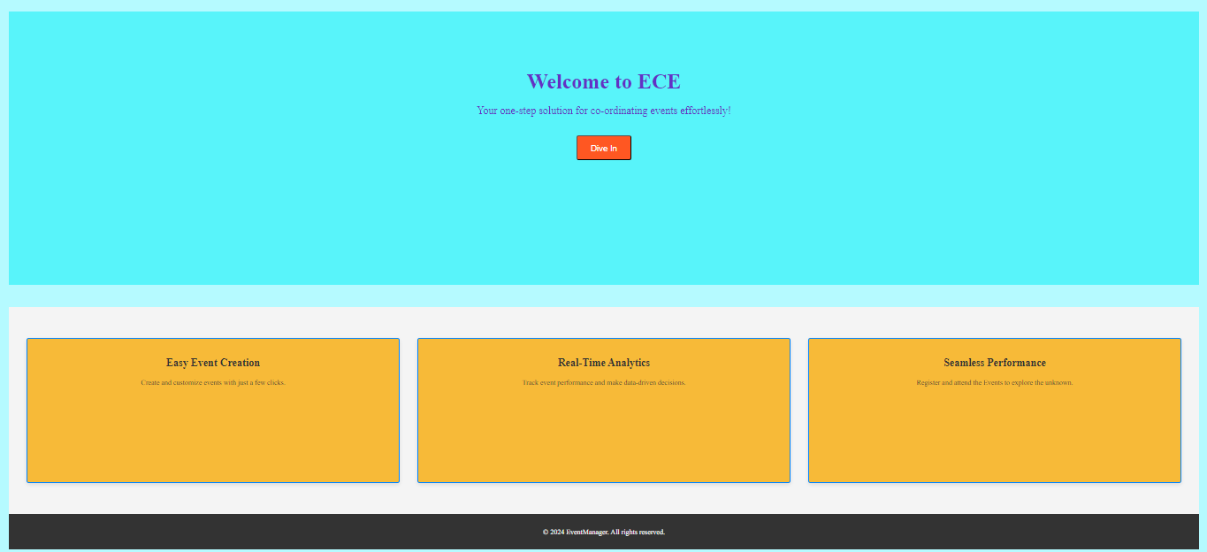
Given Below are the Outputs for different Roles: Admin and Users
  - Admin:
    - While admin clicks on the Login, Enters details:
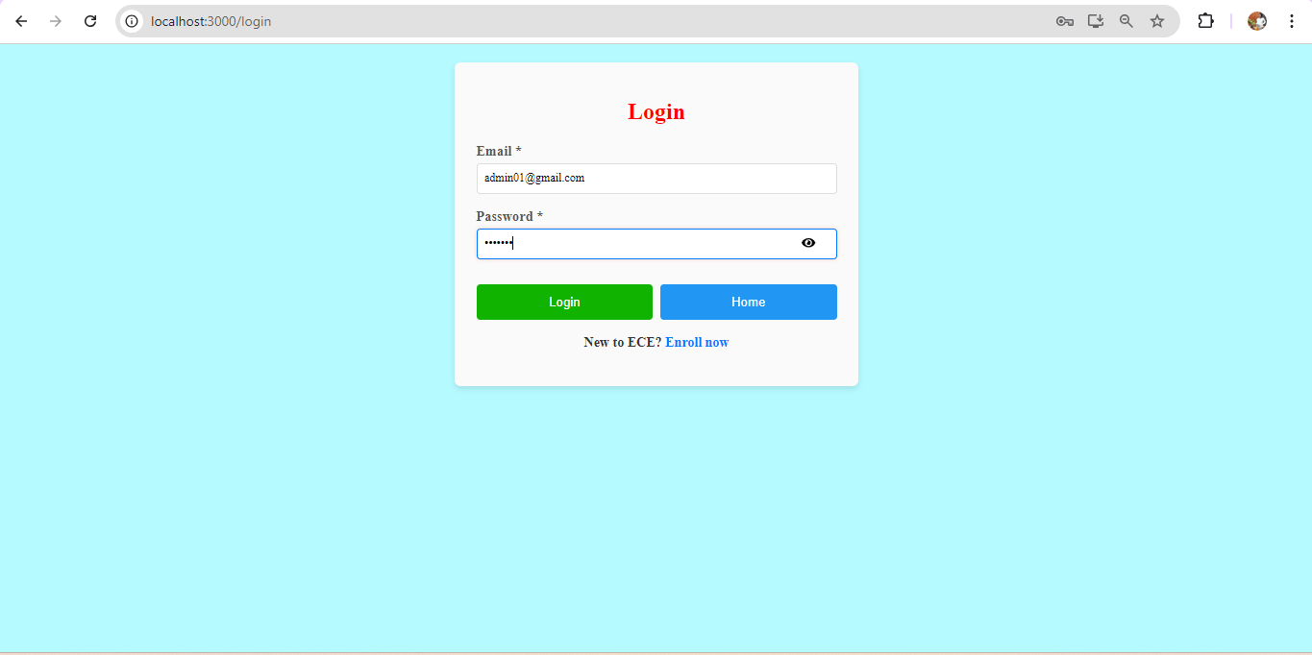

Once Admin Logins, He will view the dashboard
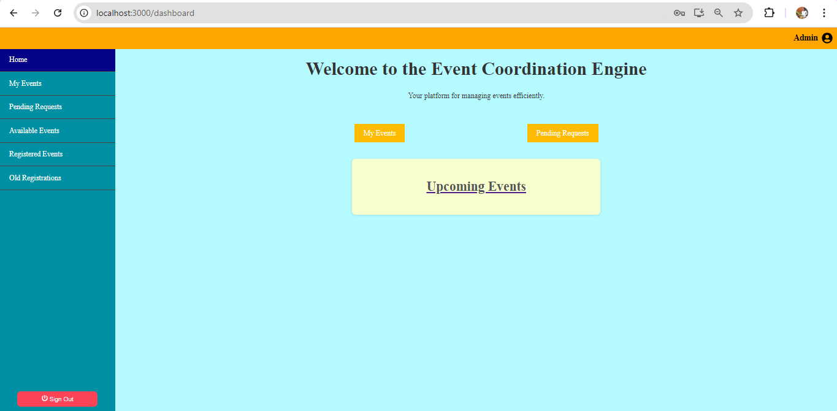

Admin can view all the Options from Side Nav Bar as shown:
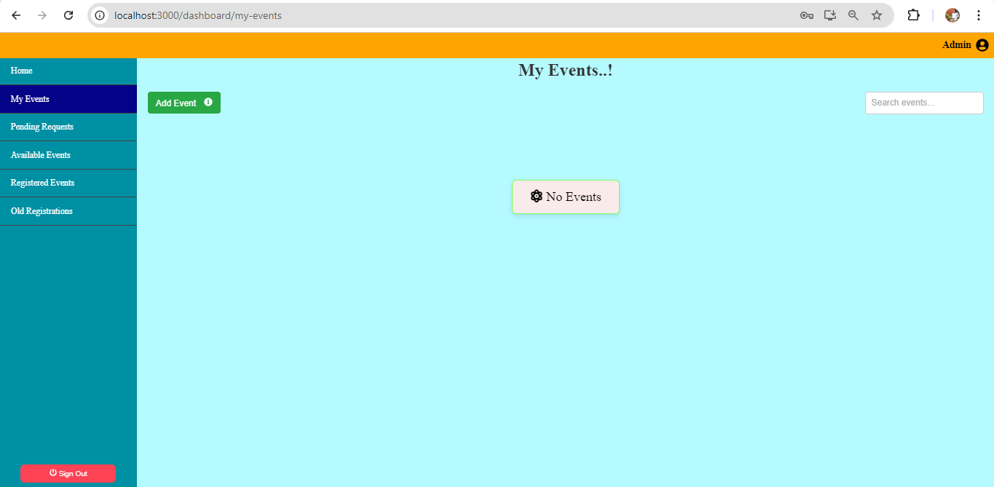

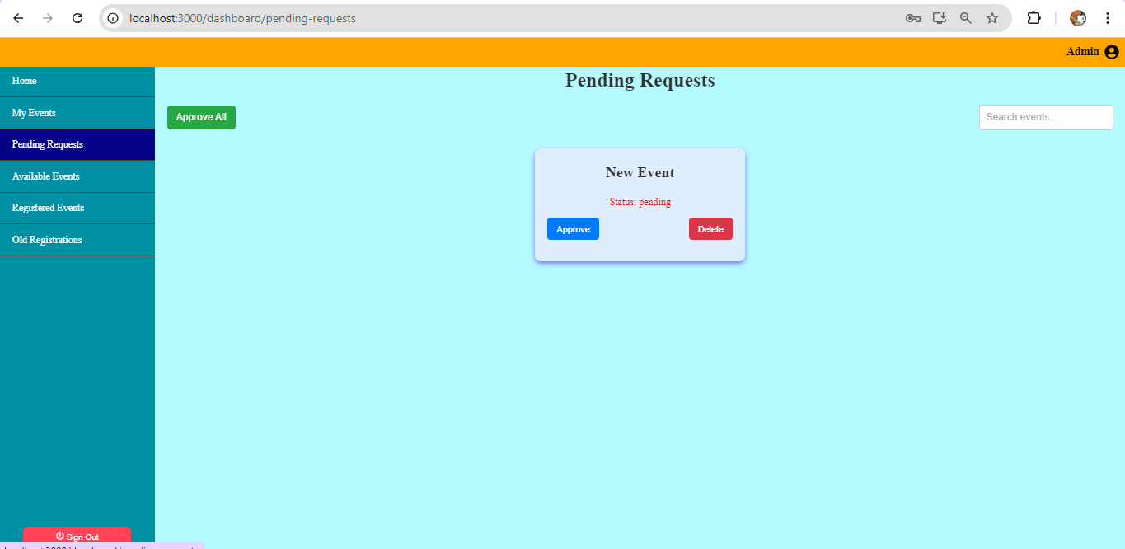

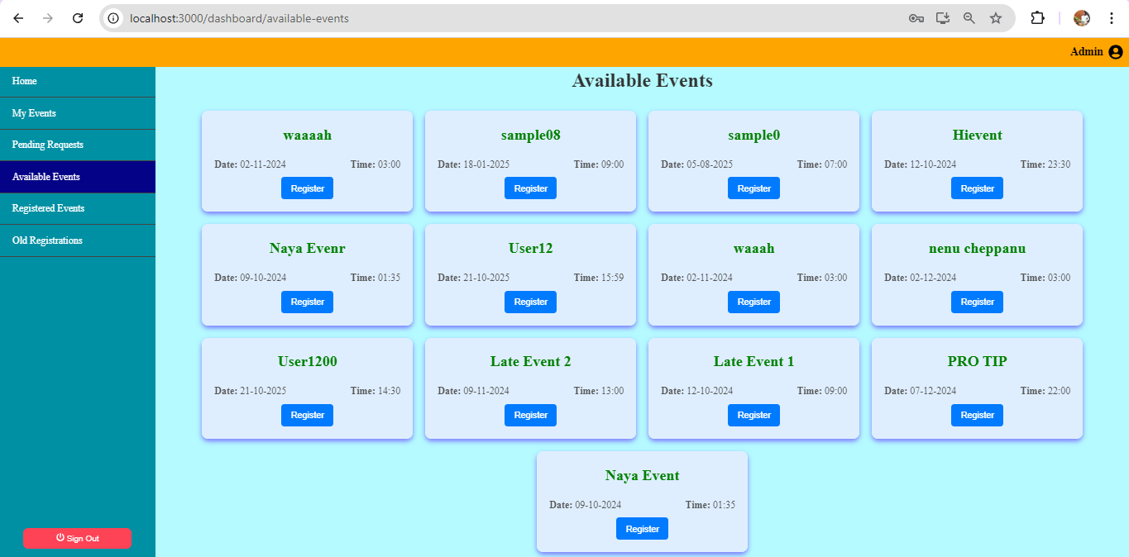

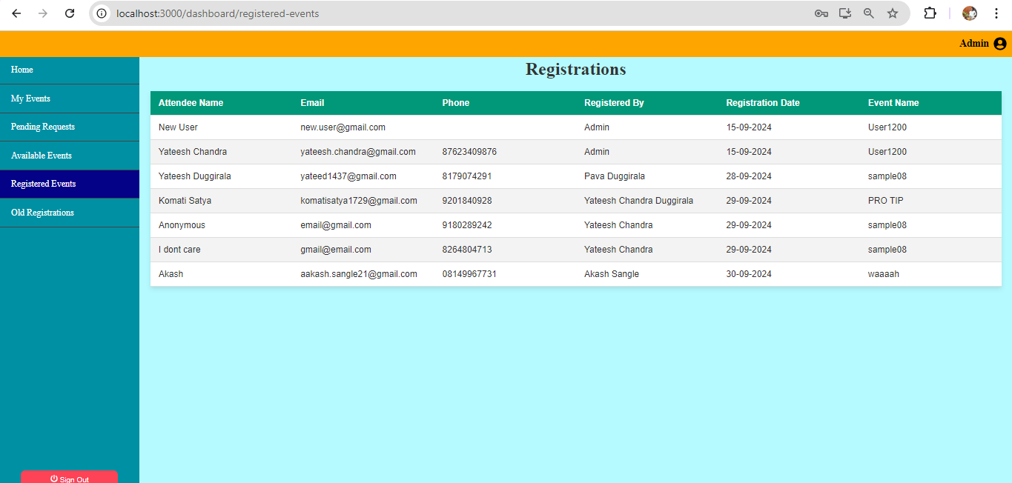
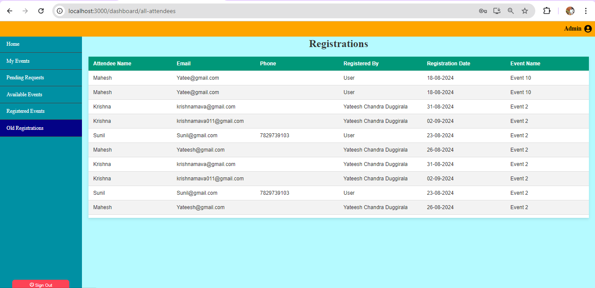

Once Admin clicks on Add event:
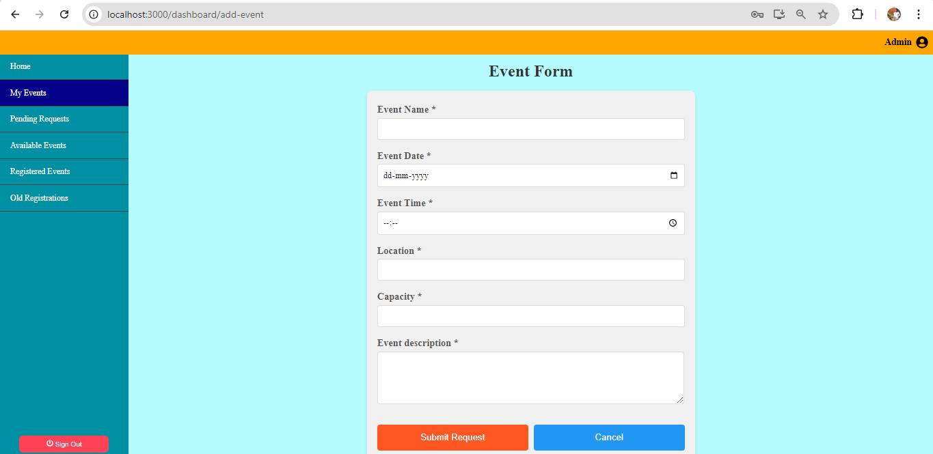
Once Admin wishes to modify the event:
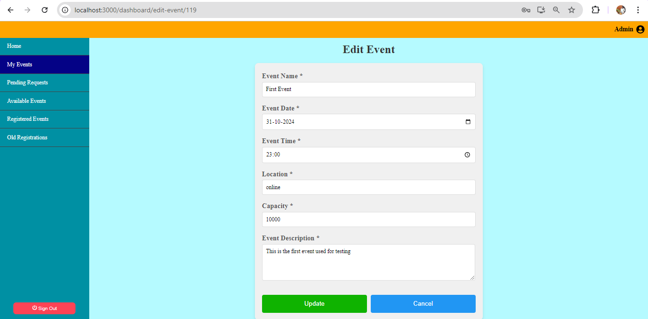

Once Admin wants to delete the event:
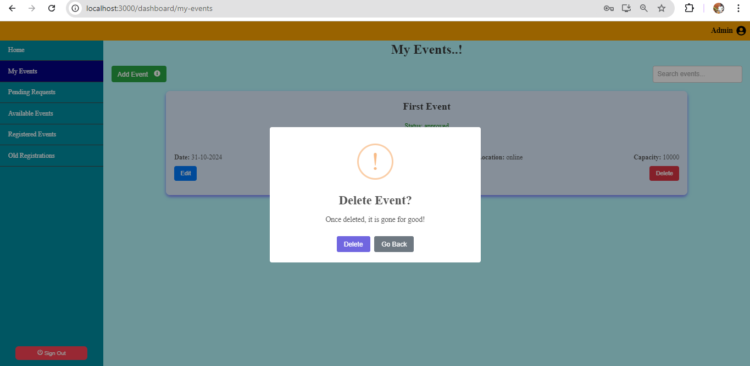

When Admin is done with his session, He can click on Signout:
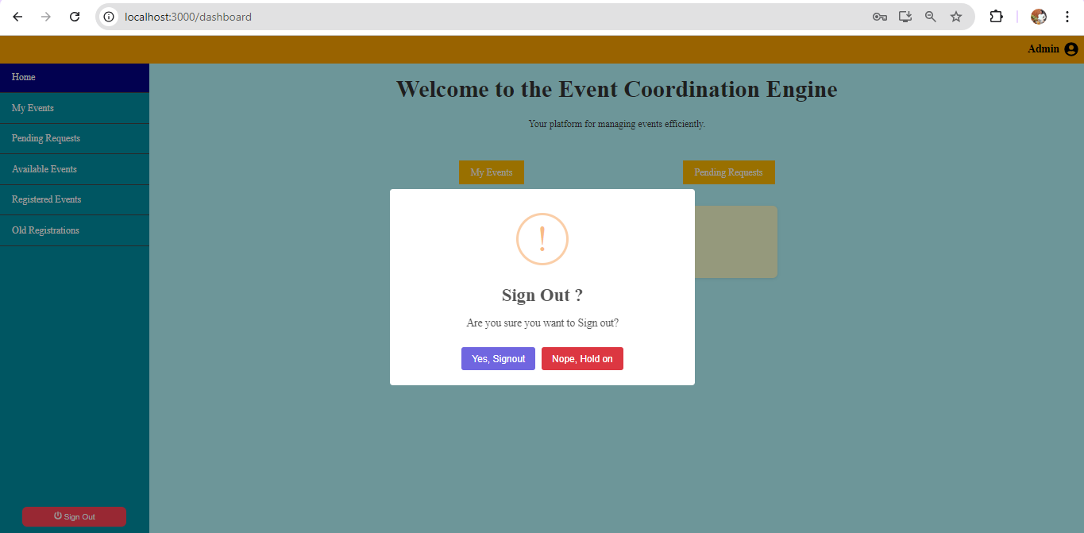

  - User:
    - If User wants to register,
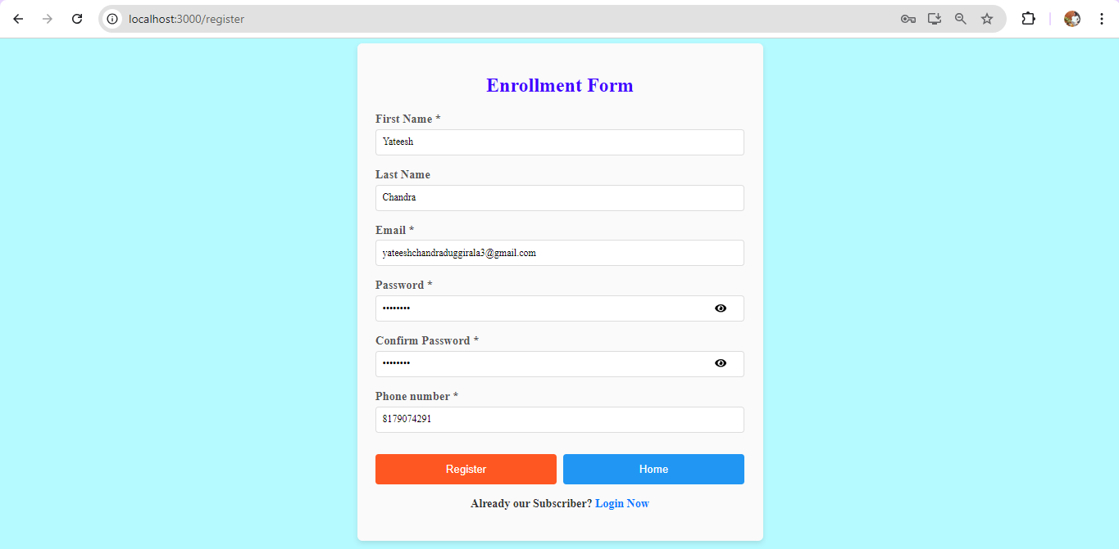
After registration, he can try logging in:
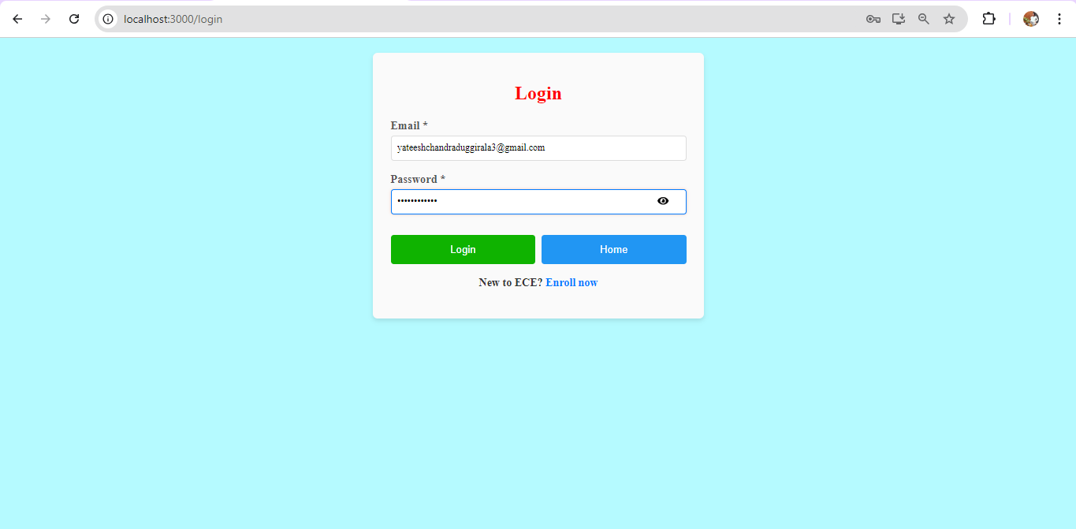

User Dashboard will be as follows:
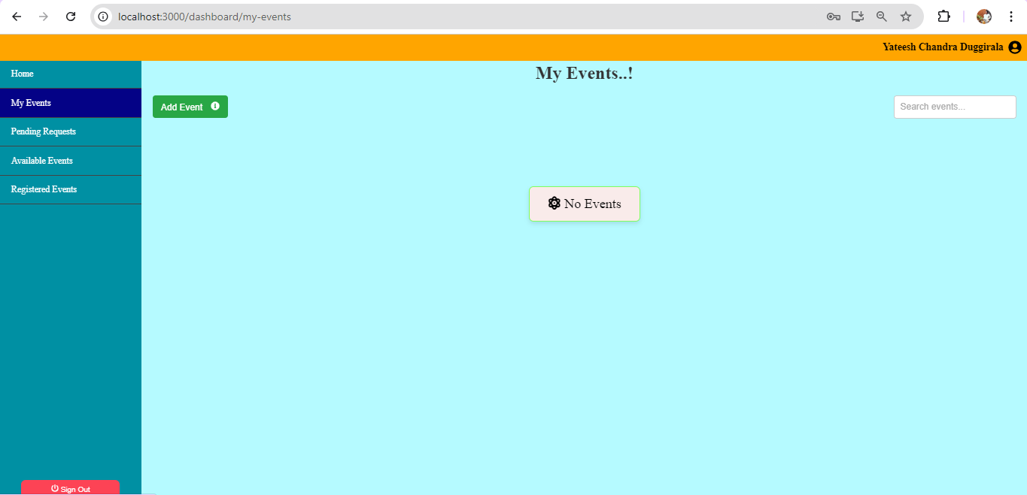
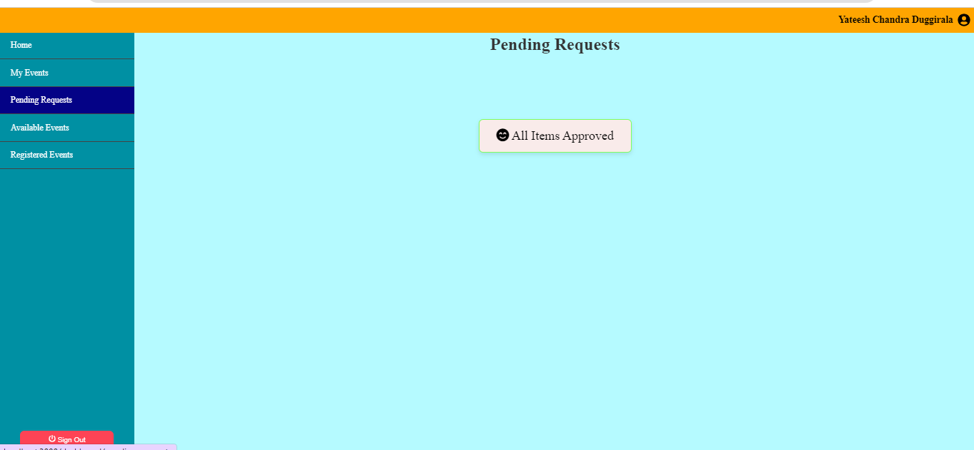
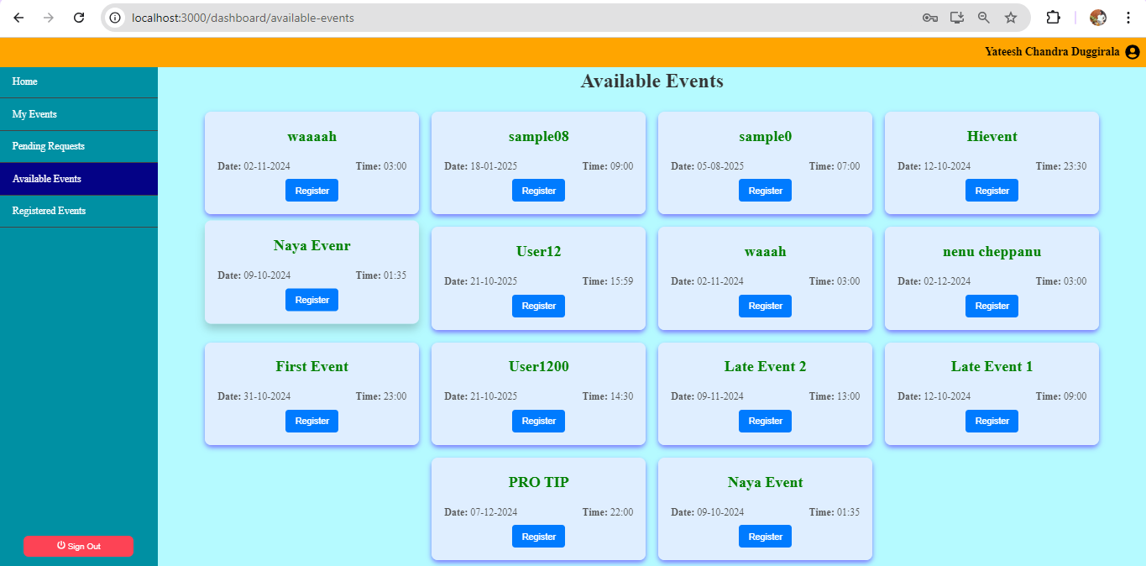
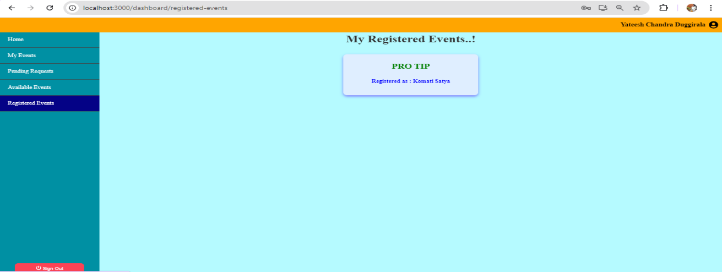
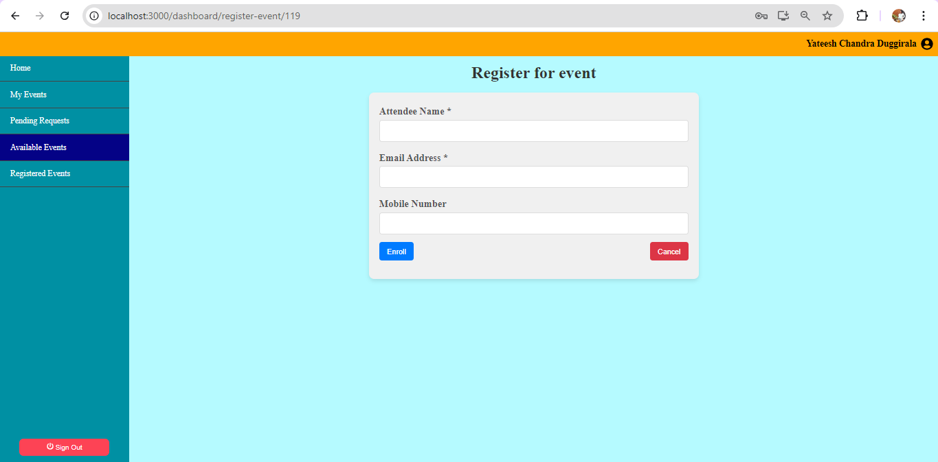

Finally, User can Log out..!

CHAPTER V
TESTING

CHAPTER 5
TESTING
5.1 INTRODUCTION
The purpose of testing is to discover errors. Testing is a process of trying to discover every conceivable fault or weakness in a work product. It provides a way to check the functionality of components, sub-assemblies, assemblies and/or a finished product. It is the process of exercising software with the intent of ensuring that the software system meets its requirements and user expectations and does not fail in an unacceptable manner. Software testing is an important element of the software quality assurance and represents the ultimate review of specification, design and coding. The increasing feasibility of software as a system and the cost associated with the software failures are motivated forces for well-planned through testing.

TYPES OF TESTING
In order to make sure that the system does not have errors, the different levels of testing strategies that are applied at different phases of software development are:

1. Unit Testing:
Unit testing is done on individual models as they are completed and becomes executable. It is confined only to the designer's requirements. Unit testing is different from and should be preceded by other techniques, including:
● Inform Debugging
● Code Inspection

2. Black Box testing:
In this strategy some test cases are generated as input conditions that fully execute all functional requirements for the program.
3. White Box testing:
In this the test cases are generated on the logic of each module by drawing flow graphs of that module and logical decisions are tested on all the cases.

4. Integration Testing:
Integration testing ensures that software and subsystems work together a whole. It tests the interface of all the modules to make sure that the modules behave properly when integrated together. It is typically performed by developers, especially at the lower, module to module level.

5. System Testing:
This Involves in house testing of the entire system before delivery to the user. The aim is to satisfy the user the system meets all requirements of the client’s specifications. It is conducted by the testing organization if a company has one.

- Acceptance Testing:
It is a pre-delivery testing in which entire system is tested at client’s site on real world data to find errors.

- Functional Testing:
Functional testing is a software testing process used within software development in which software is tested to ensure that it conforms with requirements. Software is tested by providing it with some related input so that the output can be evaluated to see how it conforms, relates or varies compared to its base requirements.

- Non-Functional Testing:
Non-functional testing is a type of testing to check non-functional aspects (performance, usability, reliability, etc.) of a software application. It is designed to test the readiness of a system as per nonfunctional parameters which are never addressed by functional testing.

- Performance Testing:
In software performance testing is the process of determining how a system responds under a particular workload or task. In general, performance testing tests the speed, stability, and scalability of an application.

5.2 MAINTENANCE:
This covers a wide range of activities including correcting code and hardware design errors. To reduce the need for maintenance in the long run, this system has been developed to satisfy the needs to the largest possible extent. And as part of maintenance, most of the features and expected outcomes of end users are taken into account while developing this system. With development in IoT technology, it may be possible to add many more features based on the requirements in future. The coding and designing are simple and easy to understand which will make maintenance easier.
5.3 STRATEGY:
We used a Postman to test various Scenarios, they can be found in the Spreadsheet
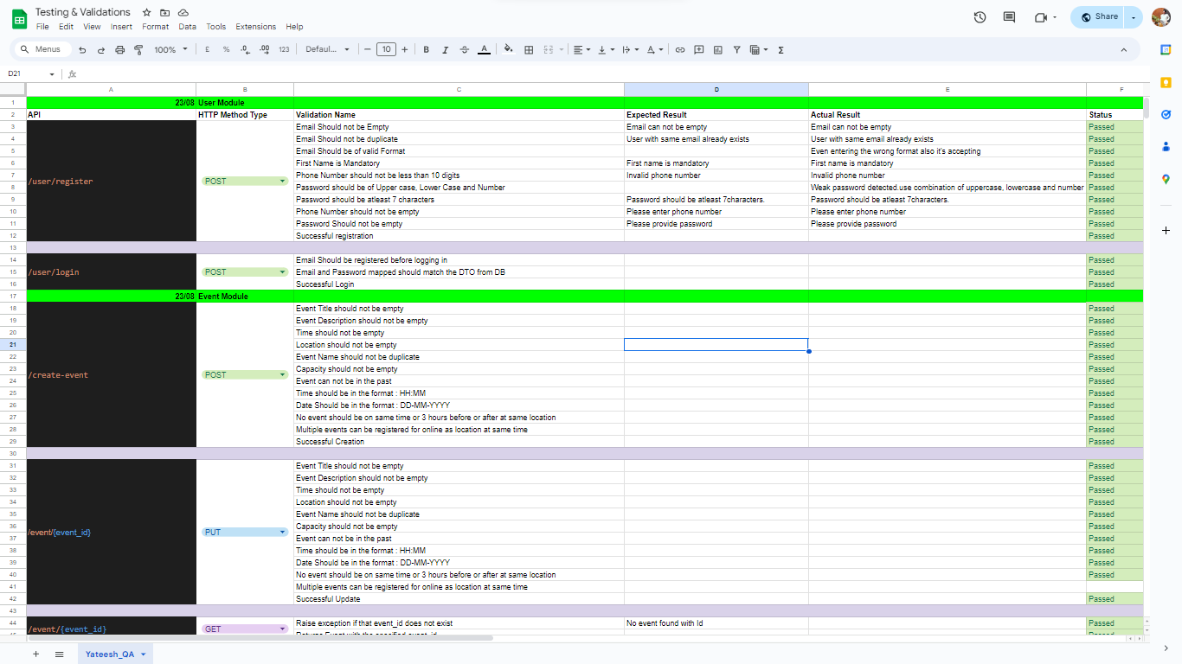
CHAPTER VI
CHALLENGES

CHAPTER 6
CHALLENGES
6.1 INTRODUCTION
In this chapter, the Outcome of this Project is discussed as a part of how the project was done based on the Challenges faced and how the versions are released.
6.2 CHALLENGES
This project was done in 10 Weeks! And we could generate the desired output, Multiple issues were faced. When A bug was raised, we could analyse deeper to find the root cause and worked on them. Here, I am attaching the list of releases we worked on.
Release Version | Bug / Feature | Description
1.0.2 | Bug | Worked on the Authorisation part of the Page
1.0.2 | Bug | Made sure the functionality is addressed as a common point
1.0.2 | Bug | Cancel button from front end are not added so far
1.0.2 | Bug | Set the Normalised Font for the forms
1.1 | Feature | Event Backup as a new Table.  - This new table contains the latest operation that was called and the time_stamp  - If the Records are deleted from the event table, They still stay in the Bkp Table  - Flag shows whether they are active or not. If they are inactive, they are no longer present in the Event Table
1.1 | Feature | Event Backup Logs as a new Table.  - This new table contains the list of operations log that was called by event api and the time_stamp  - This contains the logs very detailed where as the Table BKP table contains latest Log and status
1.1 | Feature | Attendee Backup table as a new Table.  - This new table contains the status flag  - This contains the attendees of the expired or deleted events
1.1 | Feature | User Log Table is included as a new table.  - This new table contains the Login and Logout Timestamp for each user  - Once User logs in, Login timestamp is set  - Once he logs out the value is updated to the time of logout  - If a session is active, but he logs in, then the time he logs in will be marked as logged out  - Every log in repairs previous logout to same timestamp as login  - Before the Server shuts down, all the null log_out timings will be marked as the time of server shutdown
1.1 | Bug | Admin cannot register himself
1.1 | Bug | Registrations for admin table made responsive with header static
1.1 | Bug | The API "/all_registered_events" is now displaying all results irrespective of the organizers
1.1.6 | Bug | Mark * for mandatory fields
1.1.6 | Bug | Click anywhere on the side navbar to navigate
1.1.6 | Bug | Once the navbar option is clicked it should navigate there and immediately hide in smaller screens
1.1.6 | Bug | Make sure that the Card when clicked, Is not laying over top bar
1.1.6 | Bug | Push footer at the bottom for responsive screens
1.1.7 | Bug | Once the Event is deleted, All the attendees associated to that Event should also get deleted
1.1.7 | Bug | After editing the event, the status should again change to "PENDING".
1.1.7 | Bug | Make phone validation if not null in attendees
1.1.7 | Bug | User should be able to register email once in every event.!
1.1.8 | Feature | Data Status:  - When No items are there, It should Display No Items!  - When No Events are registered, It should be displayed, You have registered No events until now  - Everywhere, set Loading with some symbol before the data is loaded.  - Also during sign in, After certain period the data should be displayed
1.2 | Feature | Email Trigger :  - Format a new Email that is good looking to send..  - Email task should be triggered when  a. There is a New Registration  b. Admin approved the event
1.2.2 | Bug | Set Validation that user can view until one day before data and not more than that.
1.2.2 | Feature | Miscellaneous:  - Once Capacity is reached, The Event should not allow Register button in front end  - Events should not be visible than today's date. (Clean up the data in the table once date is crossed)  - Add Old Registrations for those already inactive  - All Registrations and active registrations should be shown separately  - Event Cleanup should lead to updating the flags in the event_bkp  - Registrations which are active should only be present in the table (attendee)  - Registrations in attendee_bkp should contain both active and flag  - The event clean-up should change the flag and clean as shown above
1.2.3 | Bug | Email should be made case insensitive
1.2.3 | Bug | Location online should be case insensitive
1.2.3 | Feature | - Approve all Events... Functionality  - Implement Search Bar
1.2.4 | Feature | - Home button should contain only Register Button and few events!  - Add Info Button telling request needs admin approval!
1.3 | Feature | Logger:  - Log All APIs and Logs with bodies with Logger  - CRUD Audit Log  - Recommended events for the day through Email Triggered  - After registering the event, user should get a gratitude email for registering
1.3.1 | Enhancement | Standardisation:  - Remove Comments  - Check Style (Using PyCodeStyle)  - Indentation of 4 spaces  - Few identified fixes

CHAPTER VII
CONCLUSION AND FUTURE WORKS

CHAPTER 7
CONCLUSION AND FUTURE WORKS
In this paper, combining modern technologies like FastAPI, Uvicorn, SQLAlchemy, Bcrypt, SMTPLib, and React creates a robust and scalable foundation for building web applications, such as the Event Coordination Engine. Each technology plays a pivotal role: FastAPI enables the rapid development of APIs with built-in data validation, while Uvicorn ensures high performance with asynchronous processing. SQLAlchemy simplifies database management, and Bcrypt provides a secure method for handling user authentication. SMTPLib facilitates communication via email, an essential feature for sending event notifications or confirmations. On the frontend, React’s component-based architecture ensures a responsive and interactive user interface, contributing to a seamless user experience. Together, these tools form a powerful stack capable of meeting both functional and non-functional requirements, from security to usability, all while ensuring high performance and maintainability.
As for future works, we can focus on the below Features:
  - Add responsiveness to the emails such that they can be neet on other devices as well
  - Dashboard of Analytics of users
  - Add the Occupation column to the backend for attendee..!
  - Do not show the events whose maximum capacity is reached..! (The fix should be done by adding new column "Num_oF_Events_registered" to event)
  - Organizer should be able to view his attendees and registrations and his old events
  - After registering the event, user should get a reminder email a day before
  - Emails log should be maintained..!
  - Add Filters to Registration from Admin to the table
  - Check who made which API Calls
  - User can fill an excel sheet and give it to admin, (Admin can upload the file to do automated event creation)

THANK YOU

