

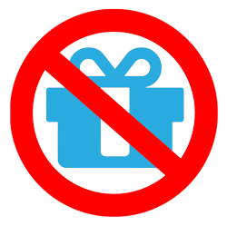

**MineCraft Client**

**IP : *92.52.12.02***

**Mojang Server**

**Server with SayNoToMcLeaks**

**1. Email and Password**

**2. AccessToken**

**3. Name : *rexbut***

**4. Name and IP : *rexbut, 92.52.12.02***

**5. Same IP : True**

|  |  |
| --- | --- |
| Name | IP |
| rexbut | ***92.52.12.02*** |
| … | **…** |

**6. Connection : *Authorized***

***Authentication***

***Verification***

***Connection***