Use case diagram for online library management system

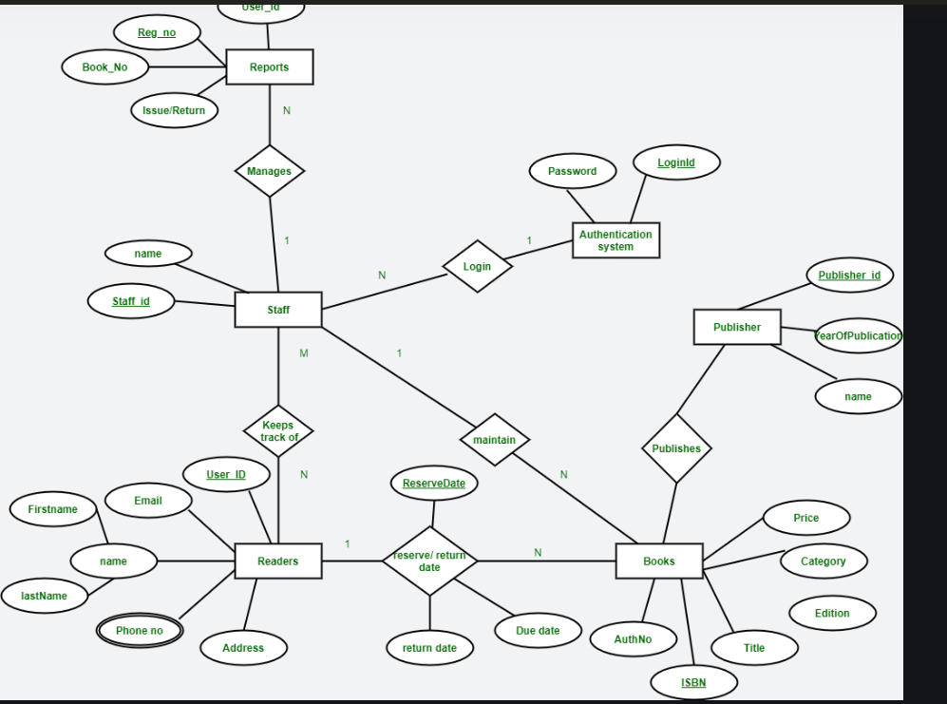

Sequence diagram of food delivery system

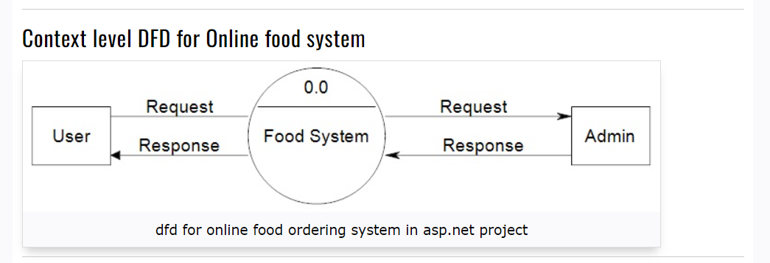

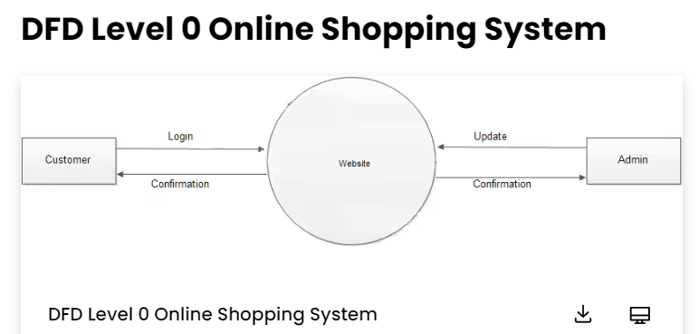

Class diagram for online banking system

