**Theater Project**

Website LogIn Page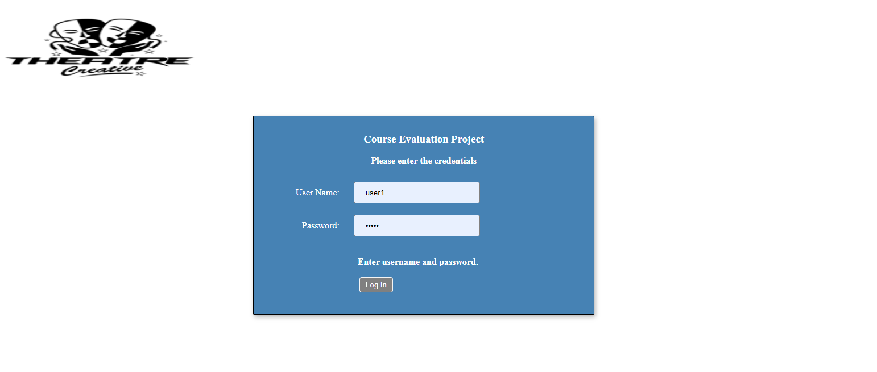

Main Page for Administrator

Manage Users

Manage Theater Rooms

Add New Theater Room

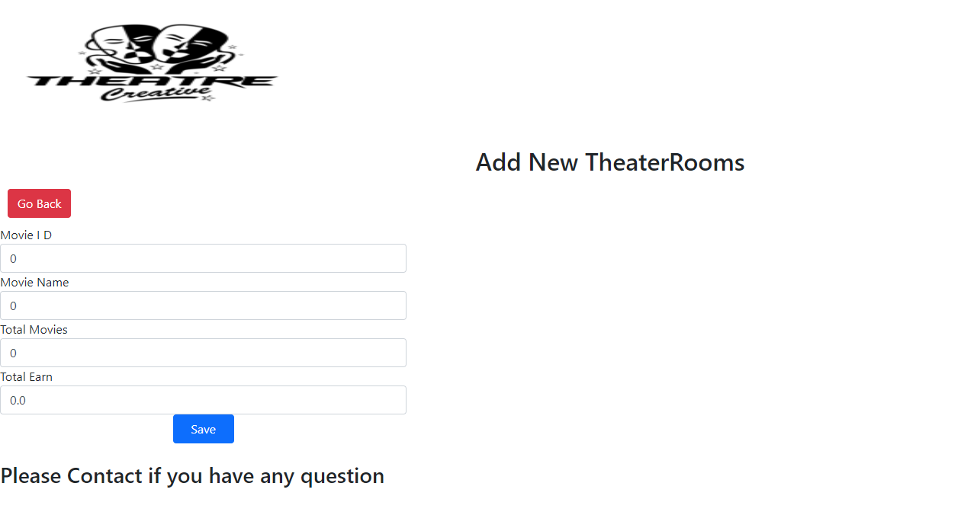

Manage Movies

Manage Plays/Movie Shows

Manage Reservations

Add New Reservation

Movie Search and Display for Anonymous Users

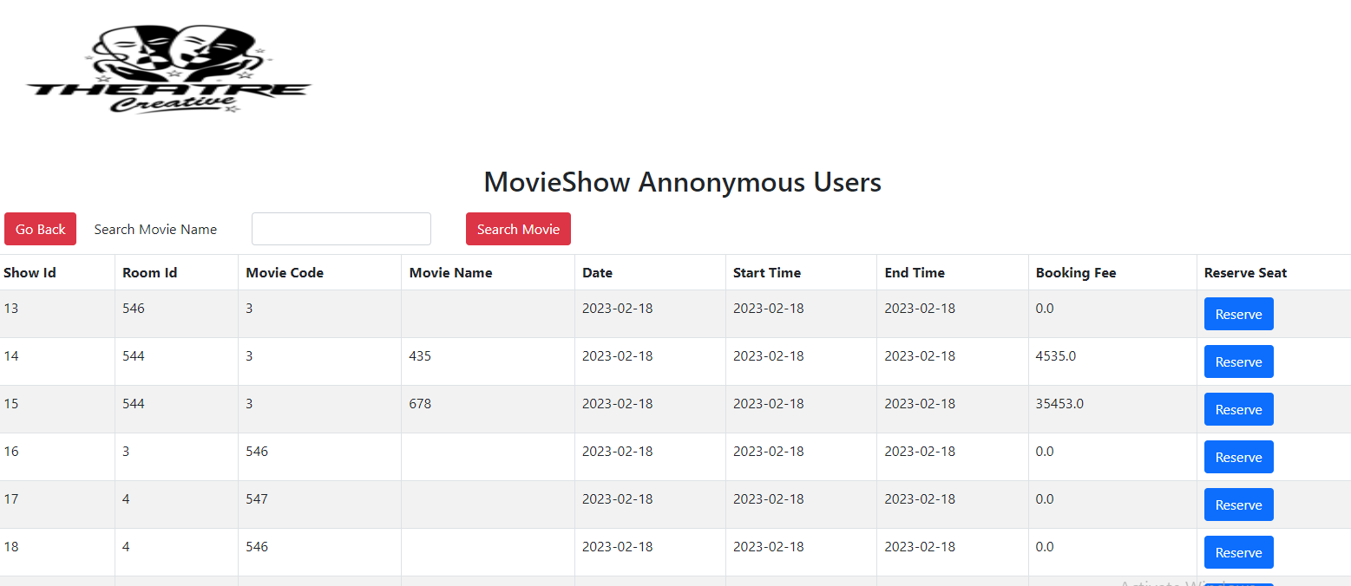

Payment Records

Add New Payment

**Customers Management**

**Editing Profile**

**Searching for Movie Shows**

**Retrieving Payment History**

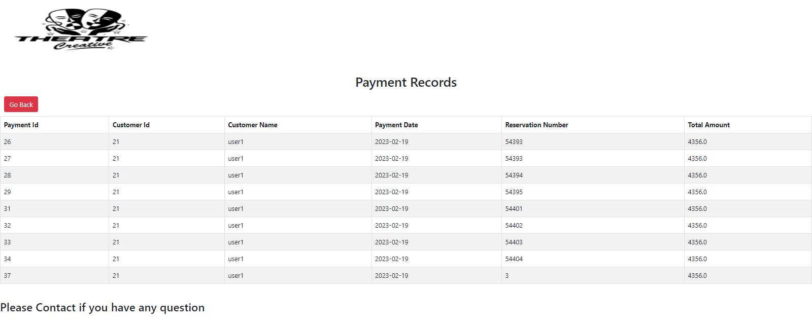

**Rest Api**

**Retrieving List of Movie Shows**

URL: http://localhost:8080/theater/MovieShow/

**Retrieving Movie Show by Movie Name**

http://localhost:8080/theater/MovieShow/435

**Business to Business API Service**

**Retieving Movie Plays Data from API**

**Retrieving Specific Play Data from API**

**Booking Seats for the specific Play using API**

