Sam's Fourth Superpower
Adventures with Sam and Robo -- Book 4
Everlight Kids | Everlight Ventures

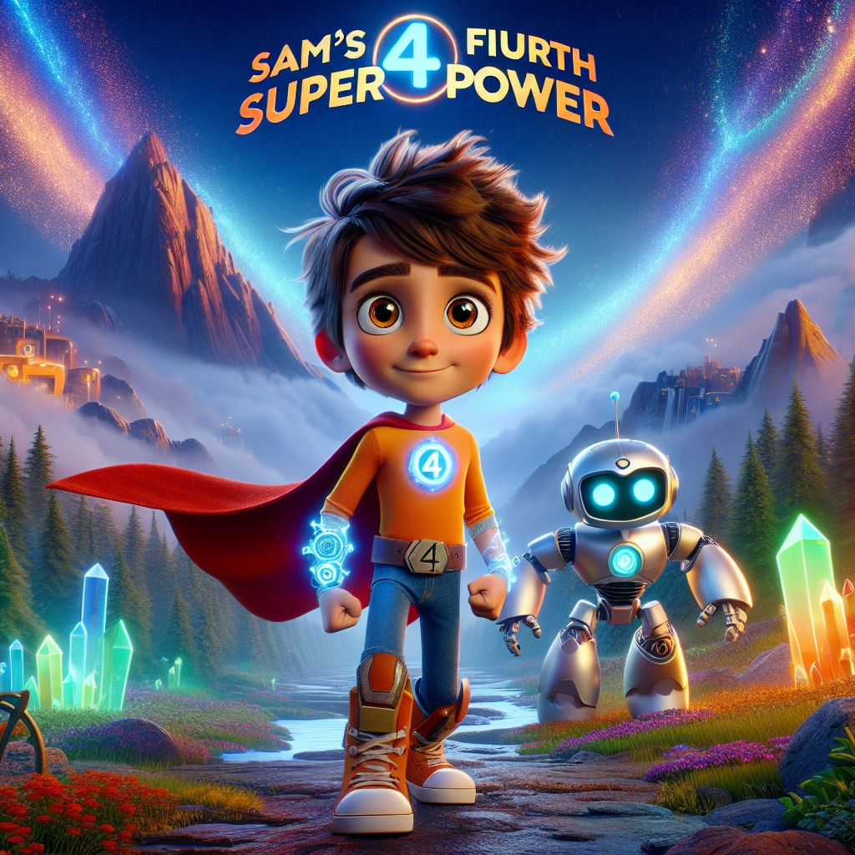

Adventures with Sam and Robo -- Book 4
SERIES RECAP (inside front cover)
Sam's Superpowers So Far:
In Book 1, Sam met his best friend Robo and unlocked the superpower of understanding animals -- learning to listen, observe, and care for living creatures.
In Book 2, Sam and Robo explored a magical science lab and unlocked the superpower of scientific tasks -- learning that curiosity, experiments, and healthy habits make the world better.
In Book 3, Sam and Robo followed a mysterious note on a scavenger hunt and unlocked the superpower of heightened senses -- learning to notice clues, solve problems, and help friends through careful observation and empathy.
Now, in Book 4, Sam and Robo are about to discover that the world around them needs their help -- and that the greatest superpowers are the ones you use for someone else...

CHAPTER 1: The Mysterious Riverbank
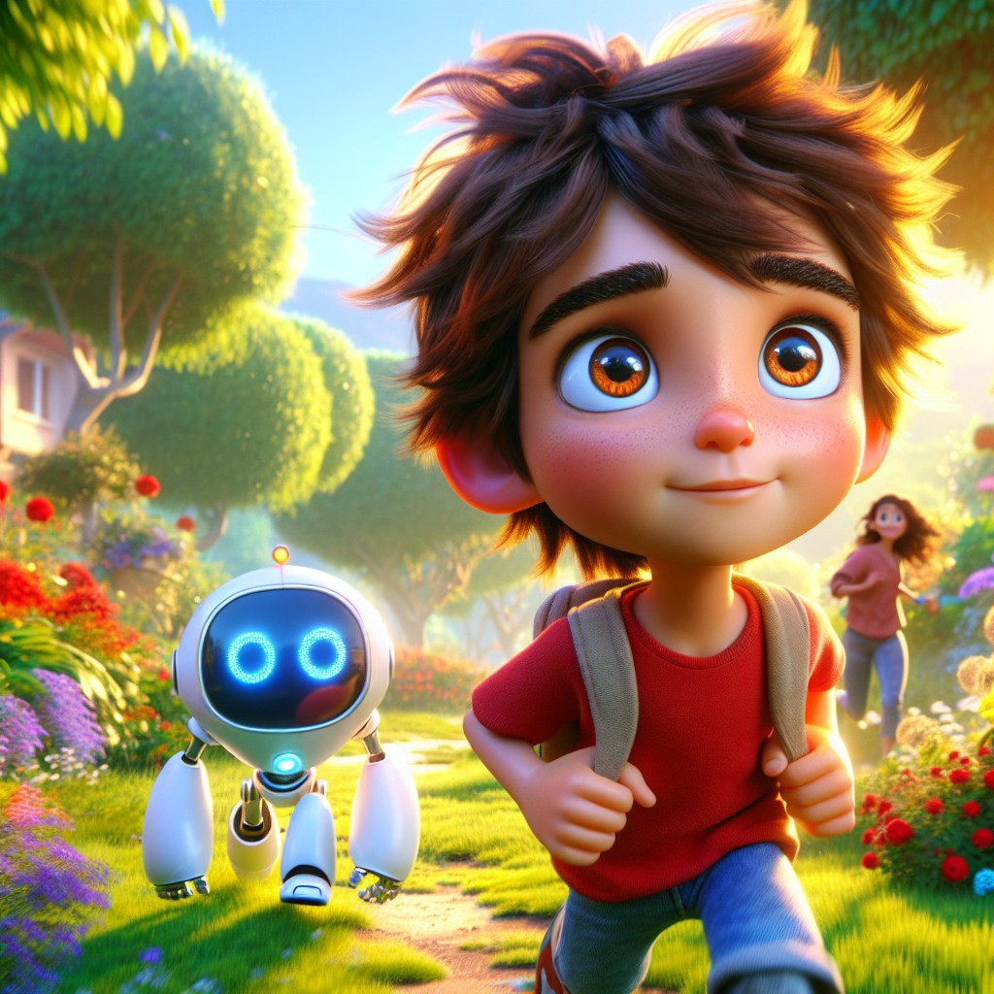
Sam and Robo woke up to a bright and sunny day, ready for a new adventure.
They remembered their past adventures and the valuable lessons they had learned about understanding animals, science experiments, and using their heightened senses to help friends. Today felt like another day to put those lessons to good use.
As they stepped outside, their friend Lily came running toward them.
"Sam! Robo! Come quick! There's something wrong at the riverbank," Lily exclaimed.
"What's wrong?" Sam asked.
"You have to see it," said Lily. "It's a mess."
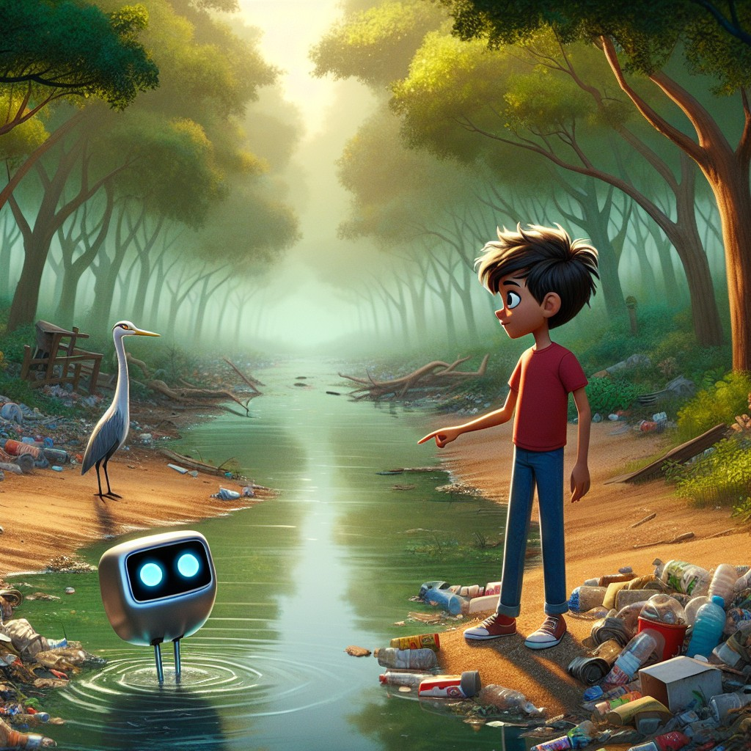
Curious, Sam and Robo followed Lily to the riverbank. They were shocked to see trash everywhere and the water polluted.
Plastic bottles. Tangled netting. Something grey and stuck in the reeds.
A heron stood at the water's edge, perfectly still. She was waiting.
"We need to clean this up," Sam said determinedly.
Robo beeped in agreement. "Let's use our superpowers to solve this problem!"
They used Sam's first superpower of understanding animals to talk to the fish in the river. The fish told them how the pollution was affecting their home.
"The water used to be so clear," said one small fish. "We could see the stones at the bottom. Now we can barely breathe."
"Don't worry, we'll clean this up," Sam reassured them.
Sam noticed something about the fish's words. "Robo -- clear, stones, breathe. Those words have long vowel sounds!"
Robo's display lit up. "Correct! The letter e at the end is silent -- but it makes the vowel before it say its own name."
"Like a secret helper," said Sam.
"Precisely," said Robo. "Like us."
Using their second superpower of scientific tasks, Sam and Robo collected trash bags and gloves. They worked together, sorting and picking up every piece of trash they could find.
Sam used his third superpower -- heightened senses -- to spot trash hidden in places most people would miss. Under rocks. Tangled in roots. Half-buried in mud.
"I can see things other people walk right past," Sam said quietly.
Lily smiled. "That's because you pay attention, Sam. That's a real superpower."
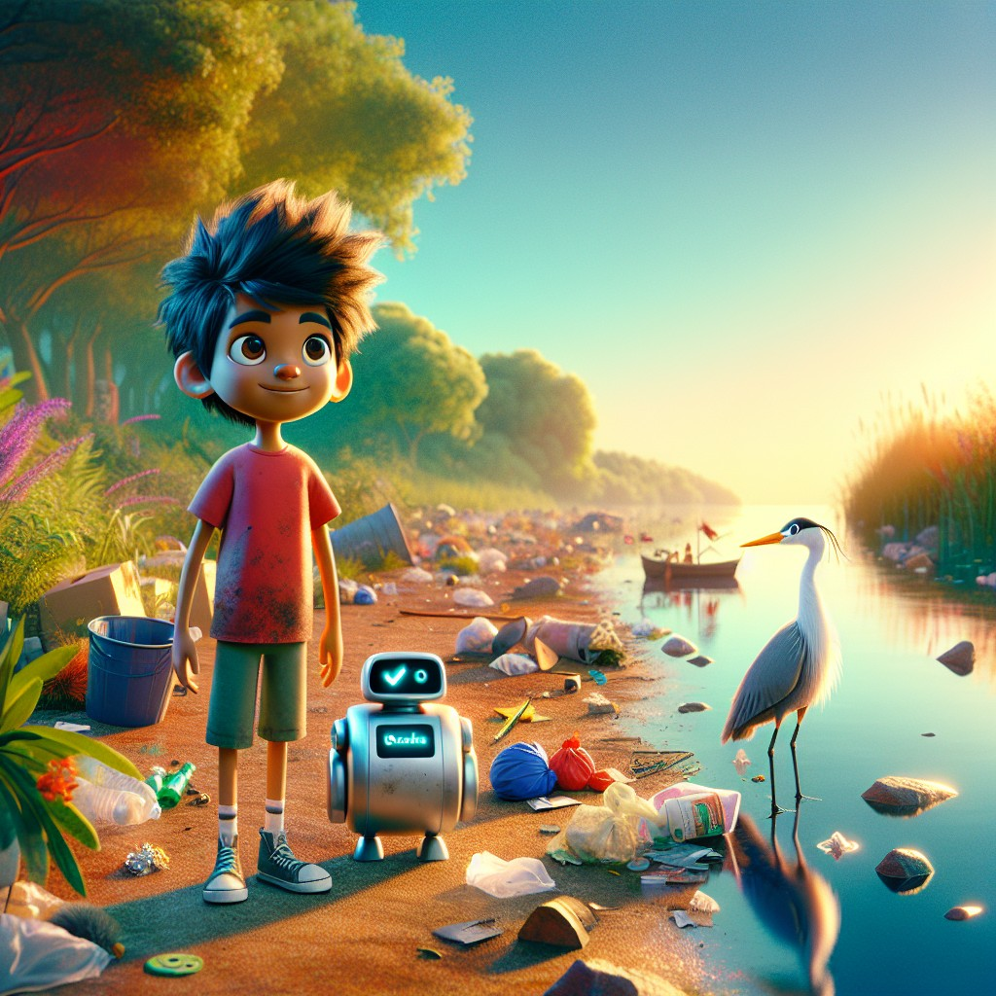
After hours of hard work, the riverbank was cleaner, and the water was starting to look a little better. Sam and Robo felt proud of their efforts.
But Sam looked at the river and frowned.
"It's better," he said. "But it's not enough. How do we keep it from getting dirty again?"
Robo processed this. His display showed a small lightbulb icon.
"We need to learn more," said Robo. "About recycling. About conservation. About how to protect this place -- not just today, but every day."
Sam tightened his backpack straps.
"Then let's go learn."
Interactive Moment: Can you help Sam and Robo find all the trash around the riverbank? Point to where you think the trash is hiding! How many pieces can you count?
Question: What was the problem Sam and Robo found at the riverbank?
Answer: The riverbank was polluted with trash, and the water was dirty and making it hard for the fish to breathe.
Coloring Pages
Color these scenes from the chapter!

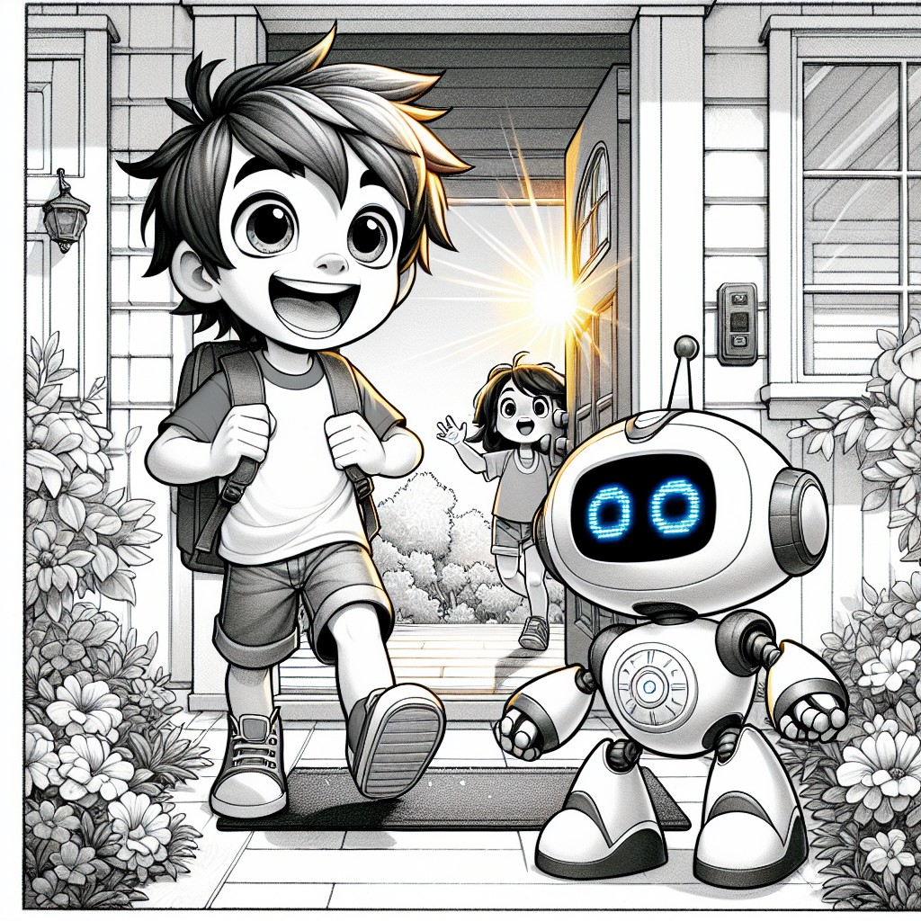

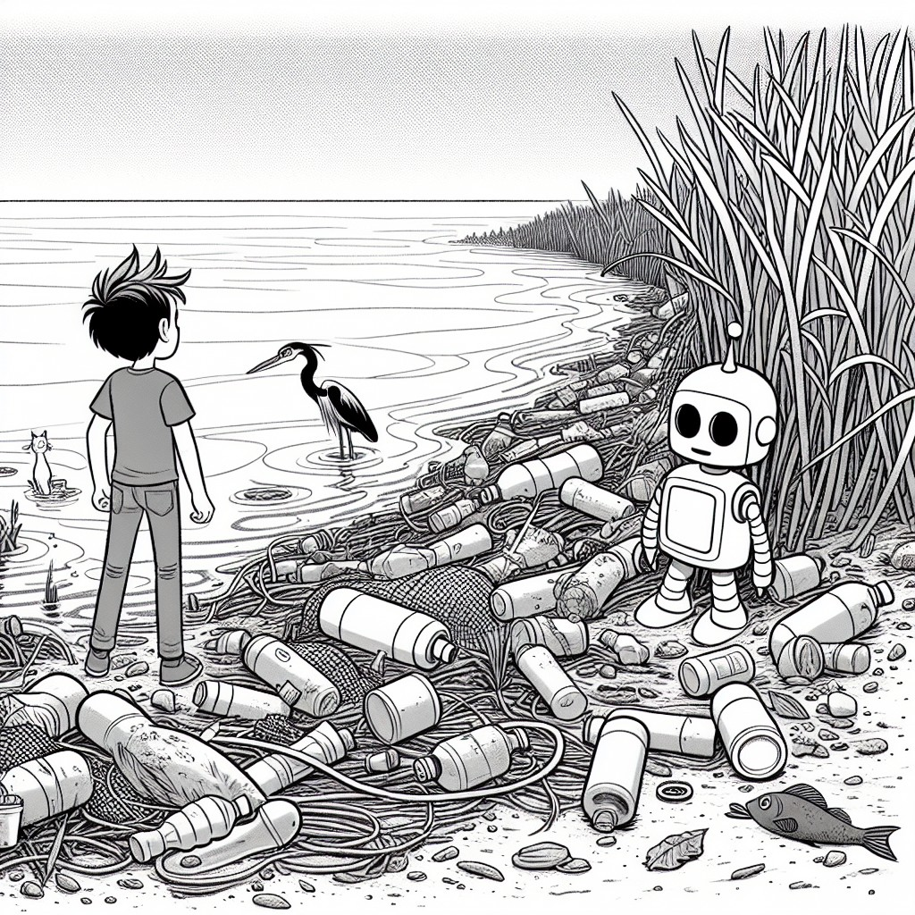

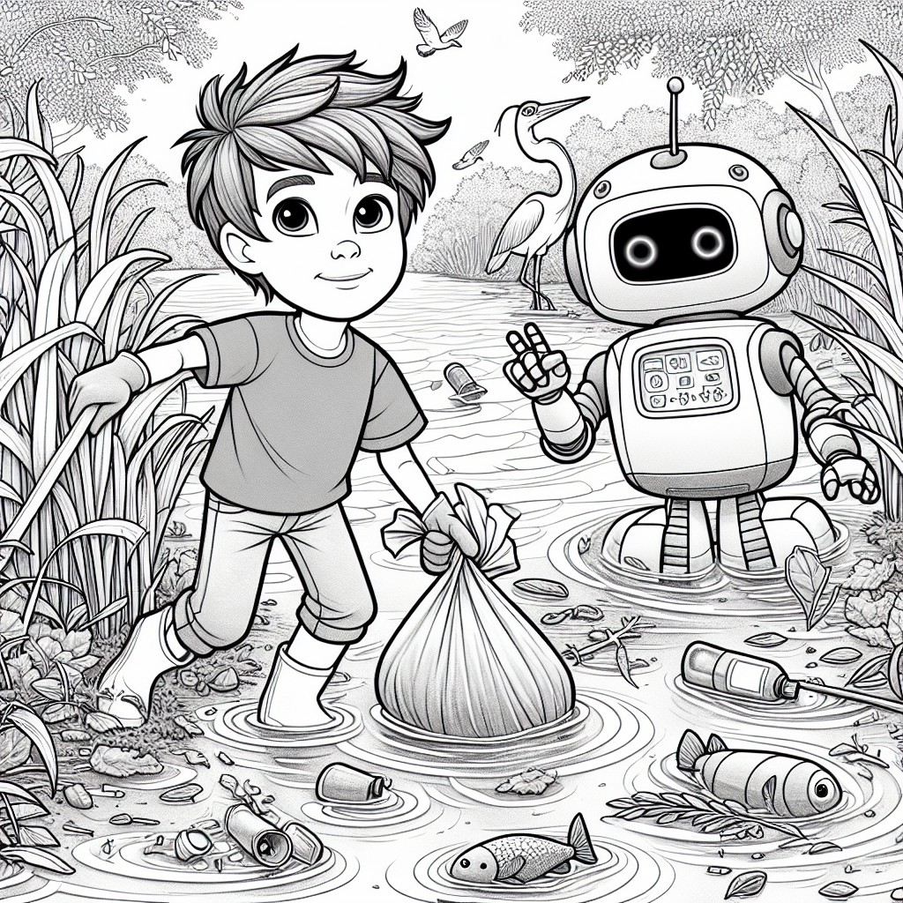

CHAPTER 2: Recycling Adventure
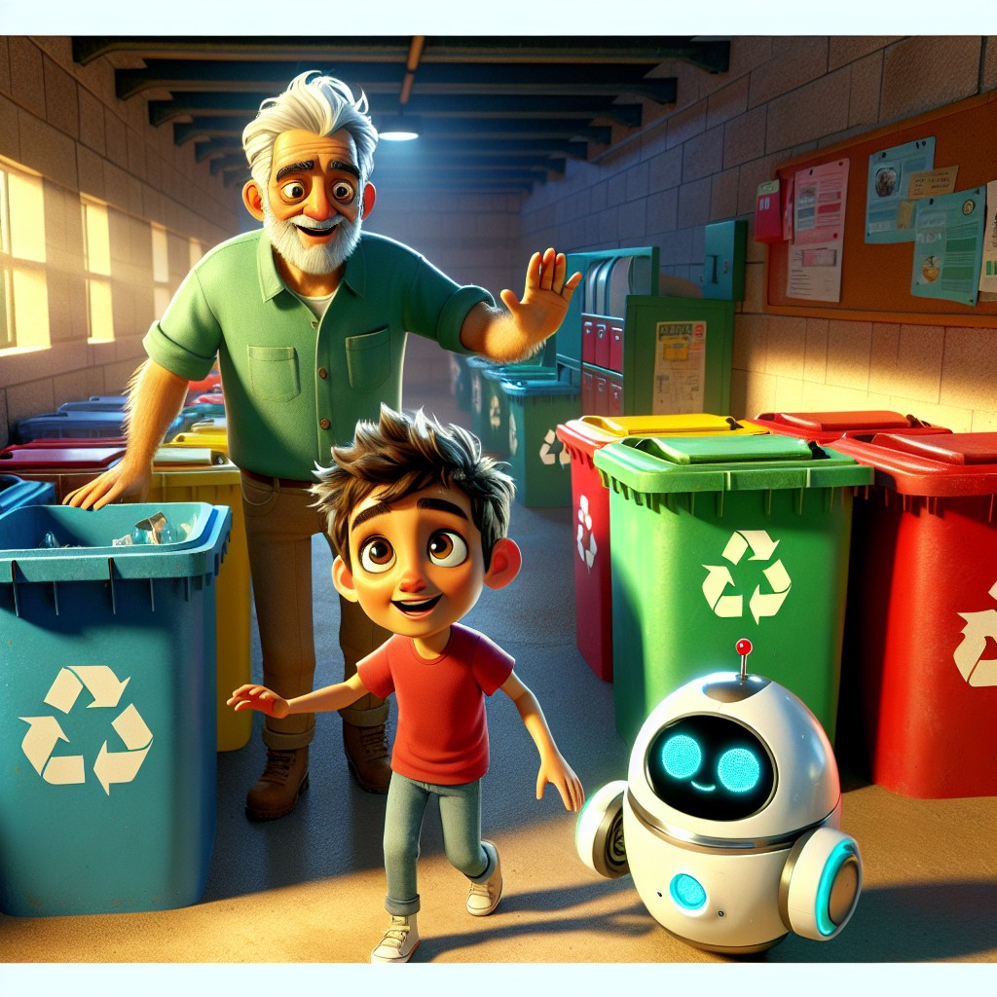
The next day, Sam and Robo decided to learn more about recycling. They visited a local environmentalist named Mr. Green, who welcomed them with a warm smile.
"Welcome, welcome!" said Mr. Green. "I've been hoping some young helpers would show up. The planet needs people who care."
"Recycling is very important for our planet," Mr. Green explained. "Let me show you how to sort different materials."
Mr. Green showed them bins for paper, plastic, metal, and glass. "Each material goes into a specific bin. This helps us recycle efficiently."
"Mr. Green," said Sam, reading the signs on the bins. "These words -- paper, waste, recycle, reuse -- some of them have that long vowel sound we noticed yesterday!"
"The silent e again!" said Robo. His display showed: waste → the a says its name. recycle → the final e changes the sound.
Mr. Green chuckled. "You're learning about the environment AND about reading at the same time. That's what I call efficiency!"
Sam and Robo practiced sorting different items into the correct bins. They learned that recycling helps reduce pollution and conserve resources.
"Every bottle you recycle is one less bottle in that river," said Mr. Green.
Sam thought about the fish. He thought about the heron, still waiting.
"Then every bottle matters," Sam said.
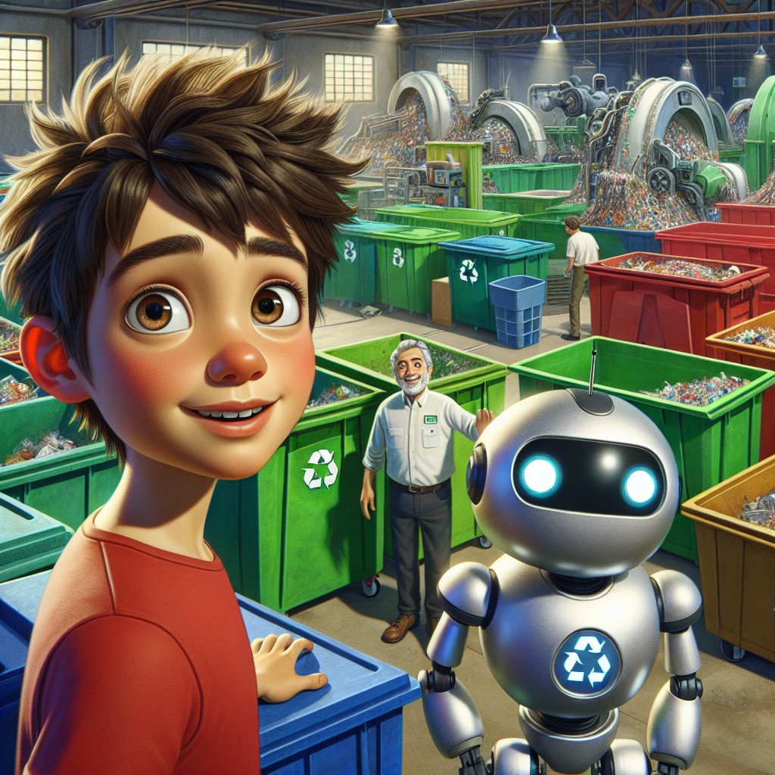
After sorting, Mr. Green gave them a tour of the recycling center. They saw how materials were processed and turned into new products.
"This plastic bottle," said Mr. Green, holding one up, "can become a park bench. This newspaper can become a cereal box. Nothing has to be waste if we choose to give it a second life."
"That's amazing," said Sam. "Recycling really makes a difference."
Robo beeped thoughtfully. "Mr. Green -- the word life has a long i sound. The silent e makes the i say its name."
Mr. Green laughed. "Robo, I think you might be the smartest robot I've ever met."
"I am the only robot you have ever met," said Robo.
Everyone laughed.
"Remember," said Mr. Green as they left, "recycling is not just about bins. It's about respect. Respect for the materials, respect for the earth, and respect for the people who come after you."
Sam looked at Robo. "Respect. That's what Grandma always says."
"Your grandmother sounds wise," said Mr. Green.
"She is," said Sam. And he meant it.
Interactive Moment: Can you help Sam and Robo sort these items into the correct bins? Point to the right bin for each item! Which bin does a plastic bottle go in? What about a newspaper? What about an aluminum can?
Question: Why is recycling important?
Answer: Recycling helps reduce pollution, conserve resources, and gives materials a second life instead of ending up as waste.
Coloring Pages
Color these scenes from the chapter!

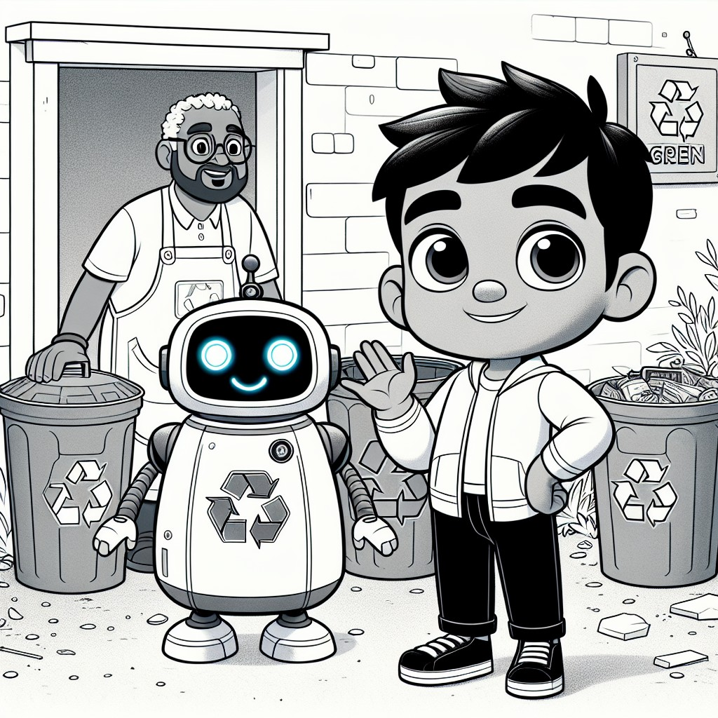

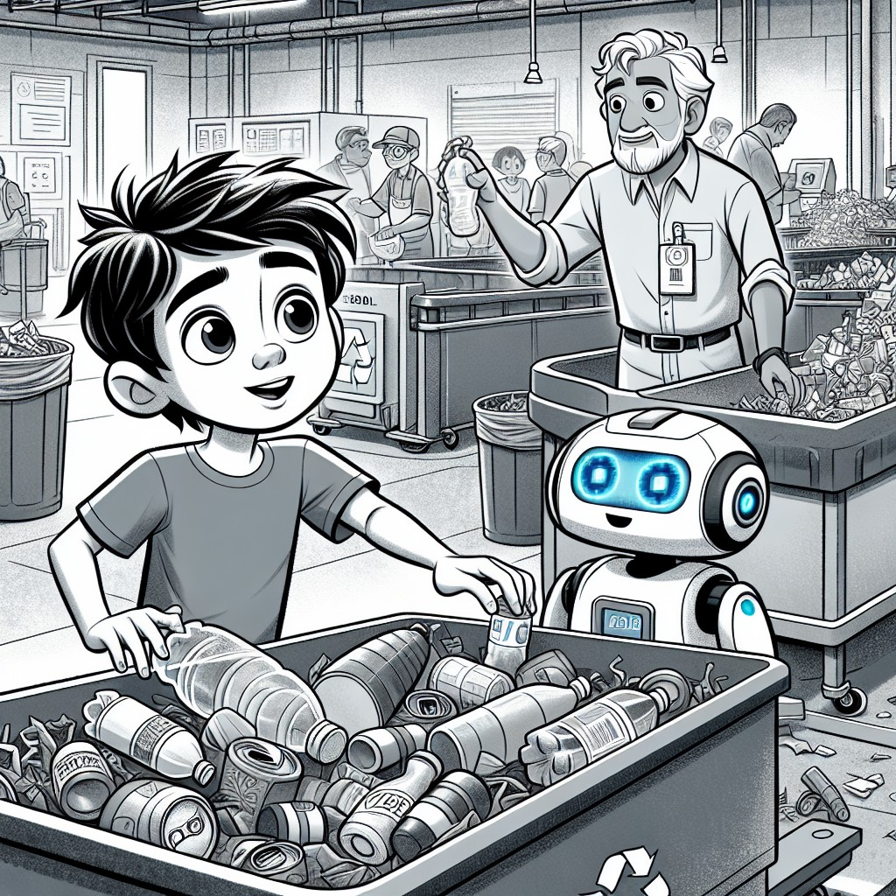

CHAPTER 3: Conserving Water
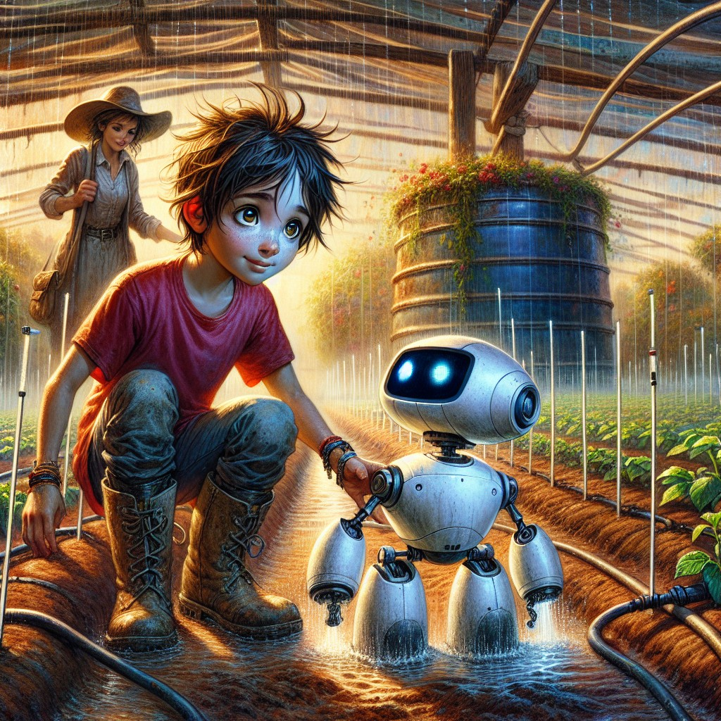
One sunny afternoon, Sam and Robo visited a farm. They met Farmer Brown, who taught them about water conservation.
"Water is essential for life," Farmer Brown said, wiping his brow. "And we must use it wisely. Every drop matters."
"How do you water all these plants without wasting water?" Sam asked, looking at the rows and rows of vegetables stretching toward the horizon.
Farmer Brown smiled and pointed to thin tubes running along the ground.
"Drip irrigation," he said. "This method saves water by delivering it directly to the plant roots. No sprinklers throwing water into the air. No puddles evaporating in the sun. Just water, going exactly where it needs to go."
"That's like being precise in a science experiment!" said Sam, remembering his second superpower.
"Exactly right," said Farmer Brown. "Farming IS science. Every day."
Sam and Robo helped set up a new drip irrigation line for a fresh row of tomatoes. They also learned to find and fix leaks -- Robo's sensors could detect even tiny drips that human eyes would miss.
"My heightened senses help too!" said Sam, pressing his ear to a pipe. "I can hear a tiny leak right... here."
Farmer Brown patched it. "You two are naturals."
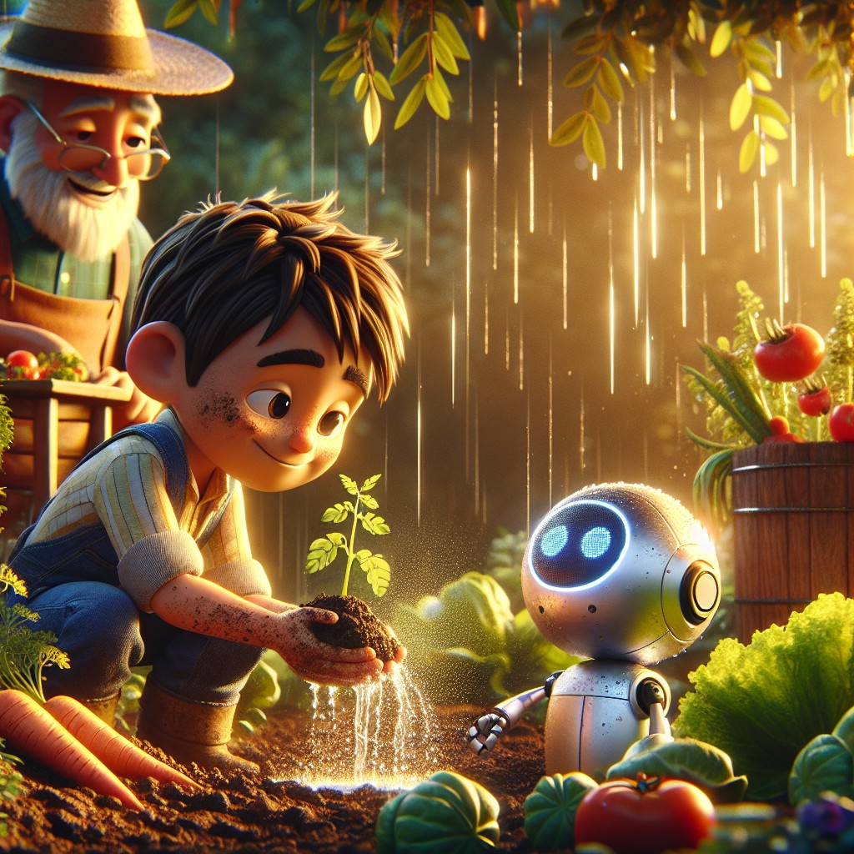
Then Farmer Brown showed them the rain barrels.
"When it rains," he said, "we catch the water instead of letting it run away. We save it for dry days."
"Catch, save, make, take," said Robo, processing. "More long vowel patterns. The silent e is everywhere today."
Sam grinned. "It's like the silent e is a secret saver too. It doesn't make a sound, but it changes everything around it."
Farmer Brown tipped his hat. "I like that. A secret saver. That's what conservation IS -- doing the quiet work that makes the big difference."
They noticed how much water they saved by using these methods. Sam and Robo were excited to share these tips with their friends and family.
"My grandma has a garden," said Sam. "I bet she'd love a rain barrel."
"Then you should help her build one," said Farmer Brown. "The best way to learn something is to teach it to someone you love."
"Conserving water is important for our environment," Robo added. "Every drop we save today is a drop available tomorrow."
As they left the farm, Sam turned back one more time.
"Farmer Brown -- thank you. Not just for teaching us. For taking care of all this."
Farmer Brown smiled. "That's what responsibility looks like, son. Showing up every day. Even when nobody's watching."
Sam thought about the heron at the riverbank. She showed up every day too.
Interactive Moment: Can you help Sam and Robo set up the drip irrigation system? Point to where they should place the tubes to water the plants! Can you spot where the leak is in the pipe?
Question: What method did Sam and Robo learn to water plants efficiently?
Answer: Drip irrigation -- it delivers water directly to the plant roots and saves water.
Coloring Pages
Color these scenes from the chapter!

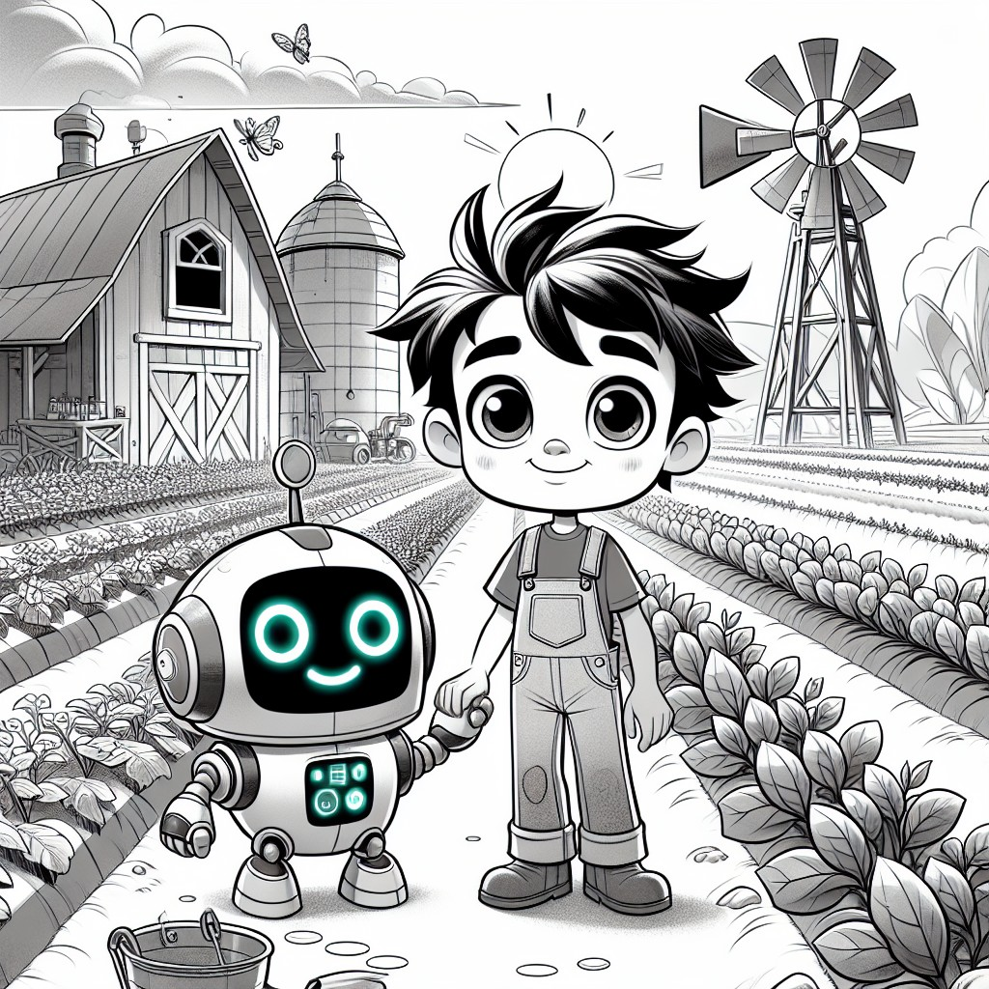

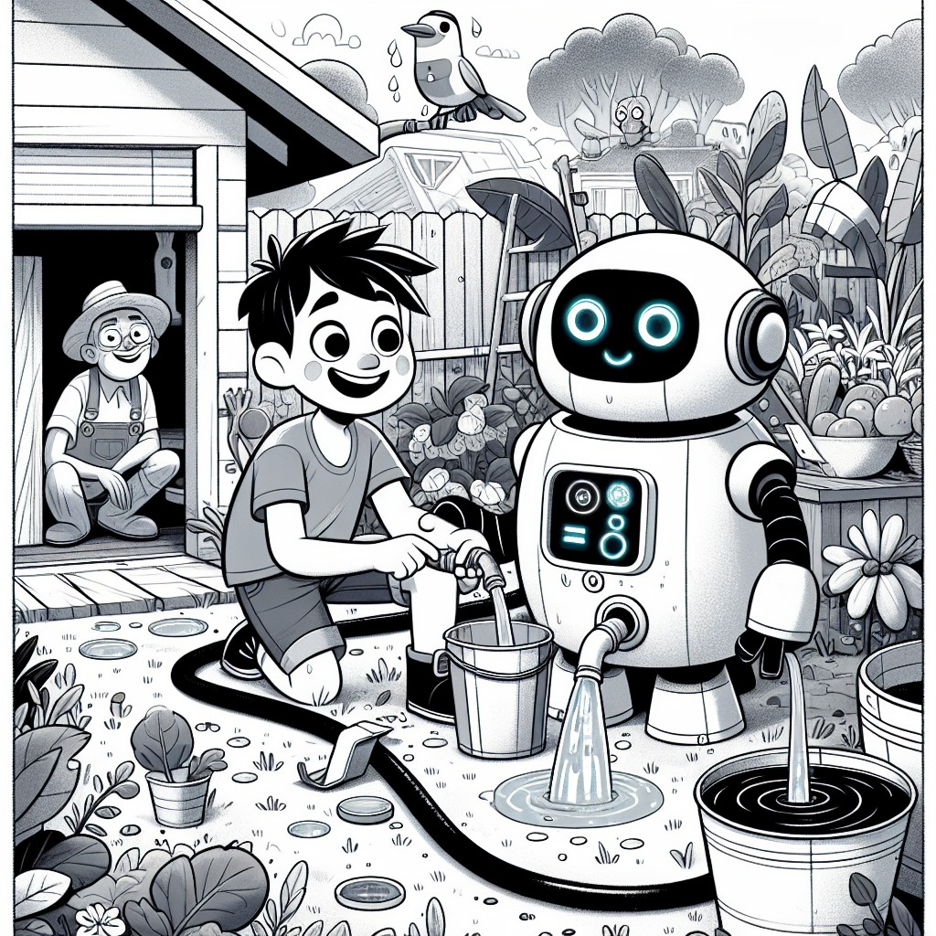

CHAPTER 4: Protecting Wildlife
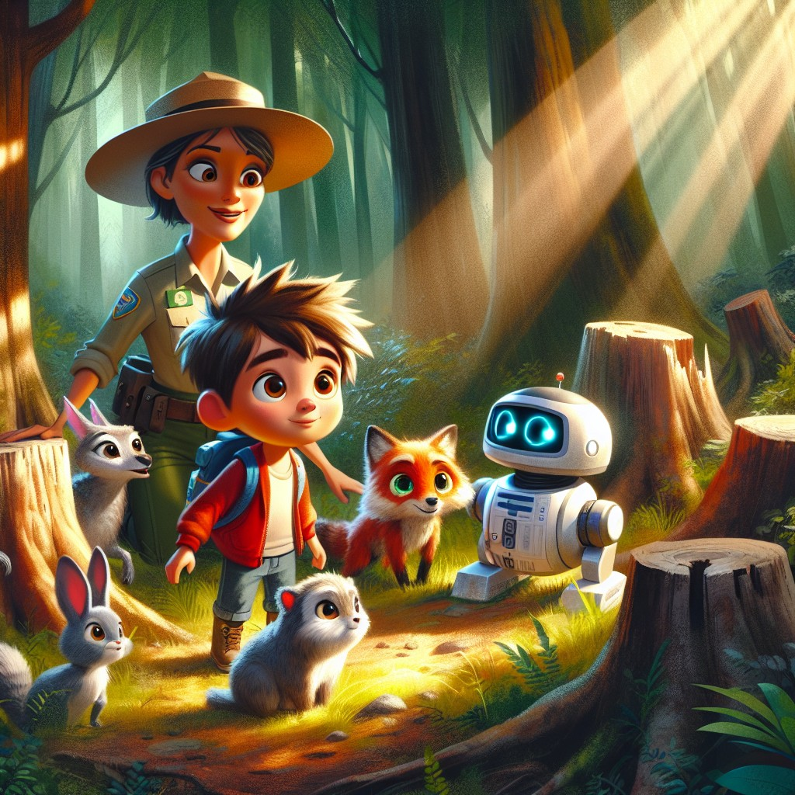
Sam and Robo joined a wildlife rescue team to protect animal habitats. They met Ranger Jane, who showed them a forest that needed their help.
"Many animals live here," Ranger Jane said, spreading her arms wide, "and we must protect their homes. This forest has been here longer than any of us. It deserves our respect."
"What happened to those trees?" Sam asked, pointing to the bare stumps on the hillside.
"People needed the wood," said Ranger Jane. "But they took too much, too fast, without planting anything back. The animals who lived in those trees had to find somewhere else to go."
Sam and Robo used their first superpower to talk to the animals. They learned that the animals were losing their homes due to deforestation.
A small deer stepped forward. "We don't need much," she said quietly. "Just a safe place to live. A home that stays."
Sam noticed the long vowel words again. "Place. Live. Home. Safe. Even the animals speak in long vowels."
"Because long vowels carry weight," said Robo. "They are the sounds of things that matter."
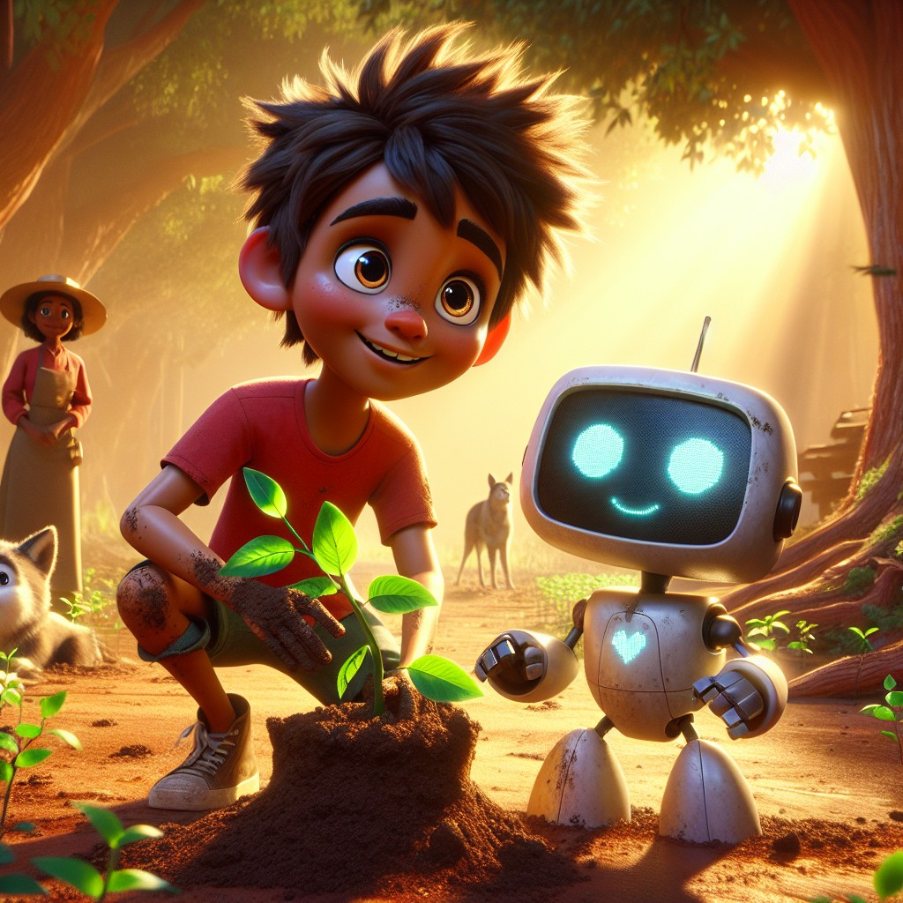
"We need to plant more trees and create safe spaces for the animals," Sam said.
"That's exactly right," said Ranger Jane. She handed Sam a young sapling. "Every tree you plant today will be a home for someone in ten years."
They planted trees all afternoon. Row after row. Robo calculated the best spacing for sunlight. Sam used his heightened senses to find the spots with the richest soil.
They also built small shelters for ground animals -- simple structures from fallen branches and leaves that gave rabbits and hedgehogs a safe place to rest.
"Ranger Jane," Sam asked as he patted soil around a new tree, "why do YOU do this? Every day?"
Ranger Jane was quiet for a moment.
"Because my grandmother brought me to this forest when I was your age," she said. "She told me: 'The earth doesn't belong to us. We belong to the earth. And you take care of what you belong to.'"
Sam sat with that.
"My grandma says something like that too," he said. "She says hard work and kindness are never wasted."
"Your grandma is right," said Ranger Jane. "And right now, you're doing both."
As they worked, they realized the importance of empathy and teamwork. They knew that protecting wildlife was essential for a healthy planet.
Sam looked at the row of new saplings, swaying slightly in the breeze.
"We made something today," he said. "Something that will still be here when we're old."
Robo's display showed a small heart icon. He didn't say anything.
He didn't need to.
Interactive Moment: Can you help Sam and Robo plant trees and build shelters for the animals? Point to where they should plant the trees! Can you spot all the animals watching from the forest?
Question: Why did Sam and Robo plant trees and build shelters?
Answer: To protect animal habitats, replace trees that were cut down, and give wildlife safe homes.
Coloring Pages
Color these scenes from the chapter!

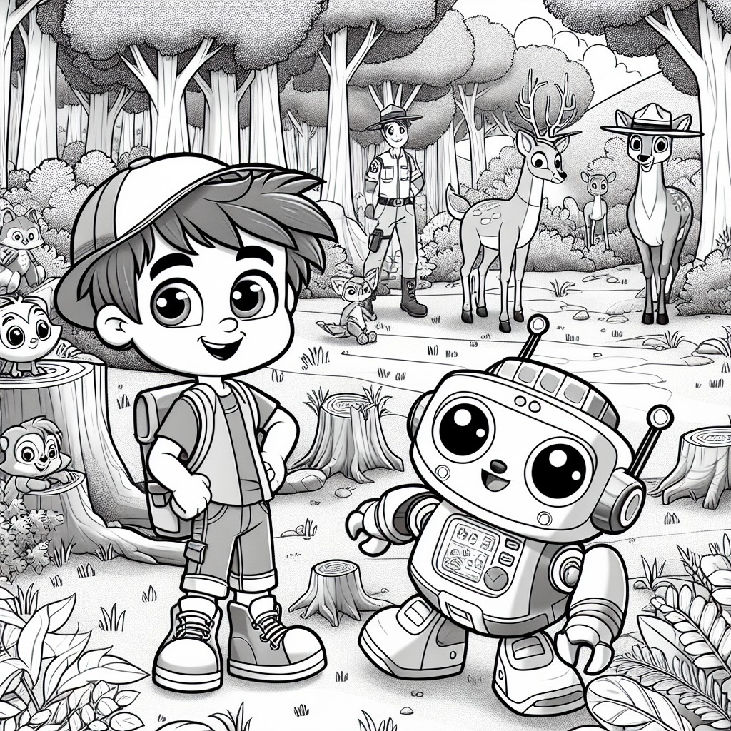

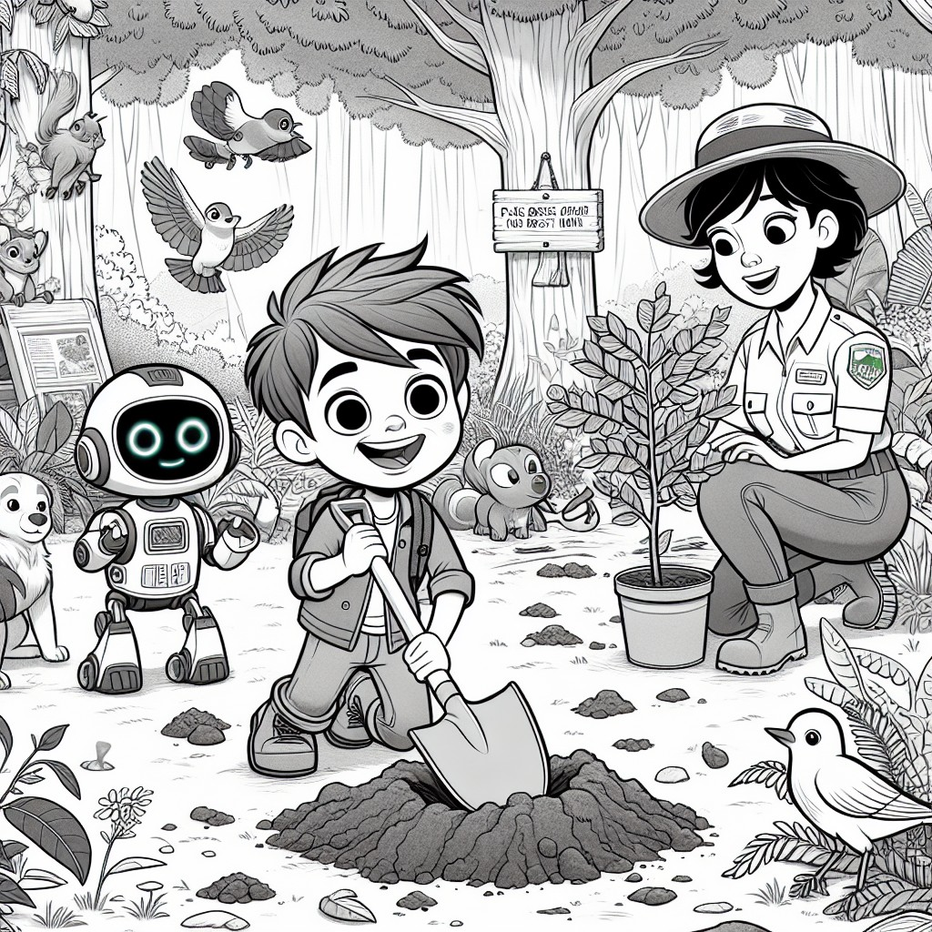

CHAPTER 5: The Great Mountain Hike
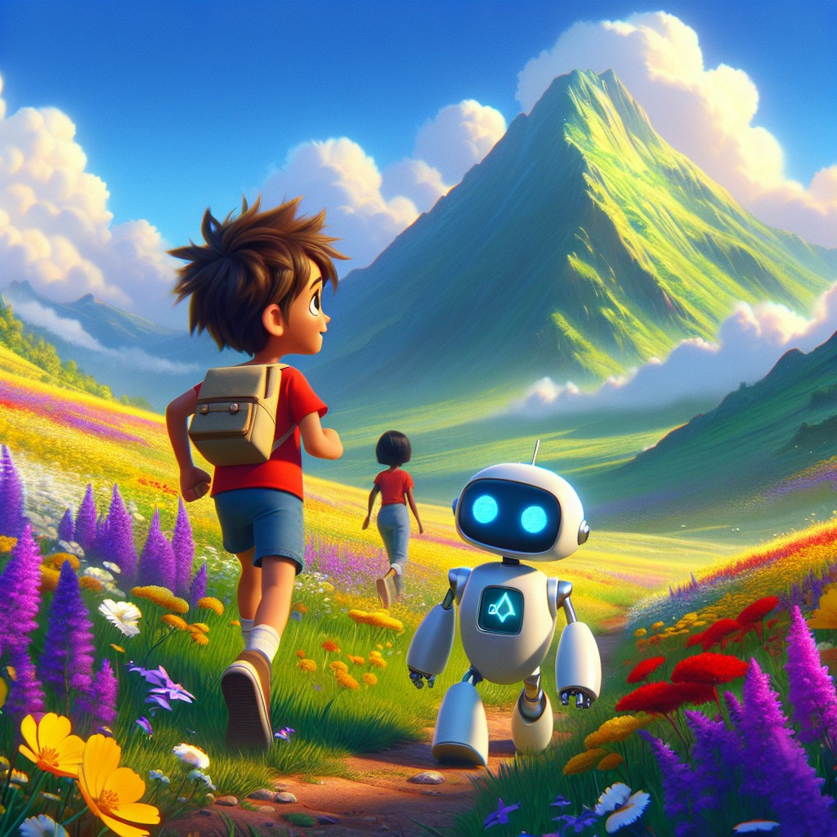
For their final adventure, Sam and Robo went on a mountain hike with their friends. They were excited to use all the skills they had learned.
"We've cleaned the river," said Sam, counting on his fingers. "We've learned to recycle. We've saved water. We've planted trees."
"But there is still one more lesson," said Robo.
"What is it?" asked Sam.
Robo's display went blank for a moment. Then it showed a single question mark.
"I do not know yet," said Robo. "But I believe the mountain does."
During the hike, they encountered various challenges. A fallen tree blocked the path -- they used teamwork to climb over it. The stream crossing had no bridge -- Robo calculated the safest stepping stones. Lily spotted animal tracks and Sam used his heightened senses to follow them safely around the wildlife.
"This whole mountain is alive," Sam said, stopping to listen. The wind in the trees. The water over rocks. Birds calling to each other across the valley.
"It has always been alive," said Robo. "You are only now learning to hear it."
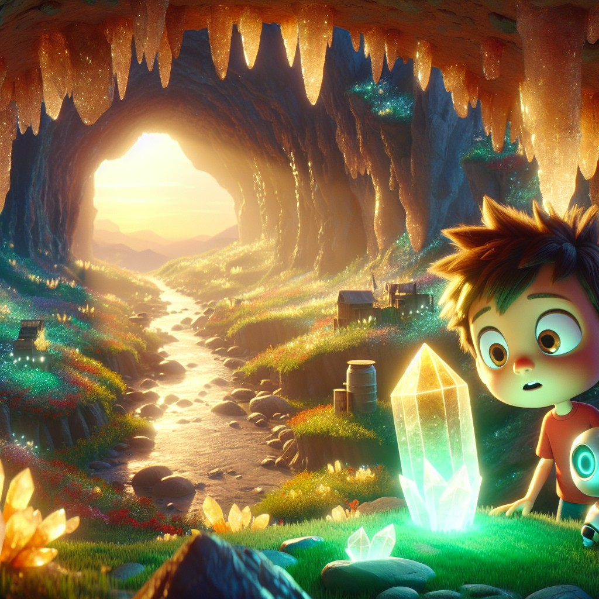
At the peak of the mountain, they found a hidden cave. Inside, a glowing crystal sat on a pedestal of natural stone, pulsing with soft golden-green light.
Sam approached slowly.
"What is it?" whispered Lily.
"I think..." said Sam. "I think it's been waiting for someone who cared enough to climb all the way up here."
As Sam touched the crystal, something extraordinary happened.
He could hear the whispers of the trees. The songs of the birds -- not just as sounds, but as words. The river far below, humming a slow, ancient melody. The mountain itself, breathing.
Sam had unlocked his fourth superpower: the ability to communicate with nature.
Robo cheered with jubilation. His display exploded with icons -- trees, birds, fish, flowers, stars.
And the forest joined the celebration. Birds sang louder. The trees swayed together as if dancing. The wind carried the smell of pine and wildflowers and clean water.
"I can hear them," Sam said, tears in his eyes. "I can hear all of them."
The mountain said, in a voice as old as stone:
"You listened. That is why we chose you."
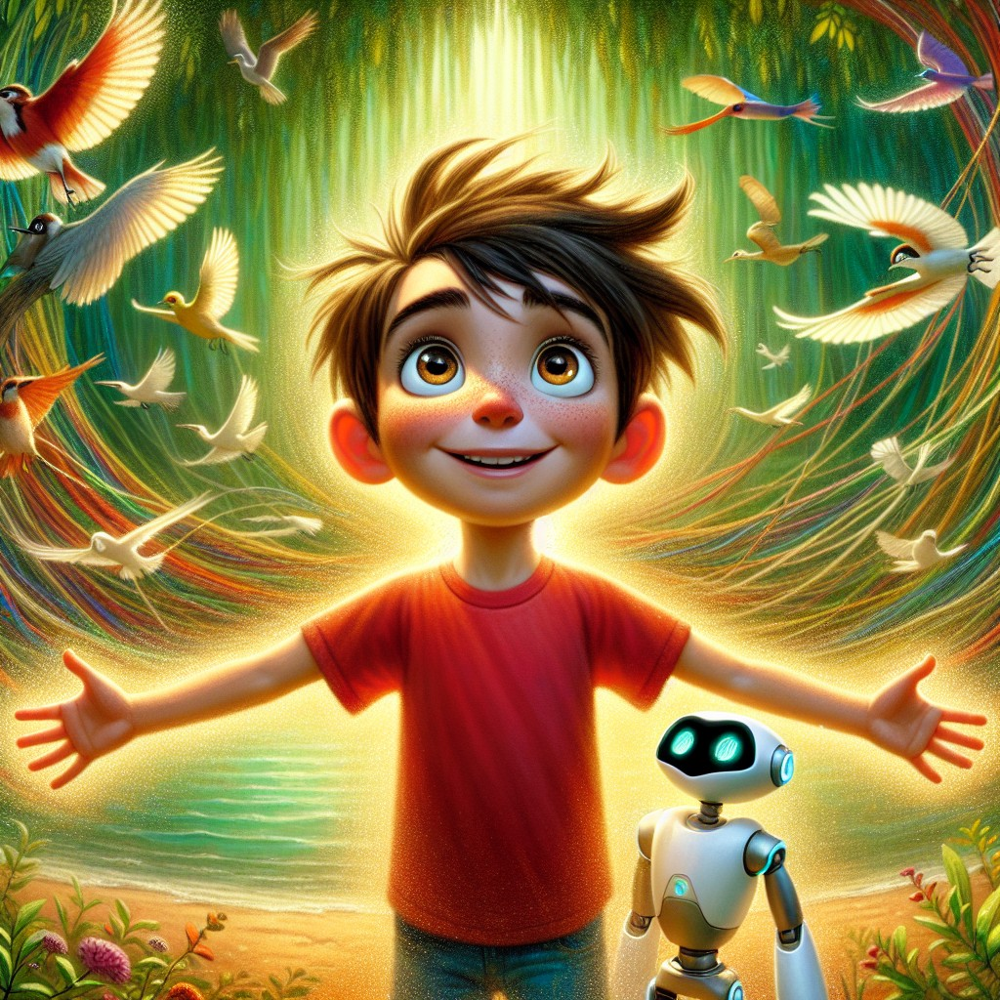
"This new superpower will help us protect nature even better," Sam said, opening his eyes.
He looked down at the valley. He could see the river where this adventure started. It wasn't perfect yet. But it was better. Because they showed up.
He could see Farmer Brown's fields, green and thriving with saved water. He could see the new saplings in Ranger Jane's forest, small but growing. He could see Mr. Green's recycling center, doing its quiet, important work.
Everything was connected. The river to the farm. The farm to the forest. The forest to the mountain. And Sam to all of it.
"Robo," said Sam as they began hiking back down, "what's the long vowel word for everything we did today?"
Robo thought for exactly one second.
"Hope," he said.
Sam smiled.
"Yeah," he said. "That's the one."
They hiked back down the mountain, feeling accomplished and ready for more adventures. Sam and Robo knew that with their new superpower, they could make an even greater impact on the world.
But more than that -- Sam knew something the mountain had taught him. Something no crystal could give and no superpower could replace:
You don't need a superpower to take care of the world. You just need to show up. And keep showing up. Even when only four people come. Even when your arms are tired. Even when nobody is watching.
That's the real power. And it was inside him all along.
Interactive Moment: Can you help Sam and Robo find the hidden cave? Point to where you think the cave might be! What do you think Sam can hear now that he has his new superpower? If YOU could talk to nature, what would you ask?
Question: What is Sam's fourth superpower?
Answer: The ability to communicate with nature -- to hear the whispers of trees, the songs of birds, and the voice of the earth itself.
Coloring Pages
Color these scenes from the chapter!

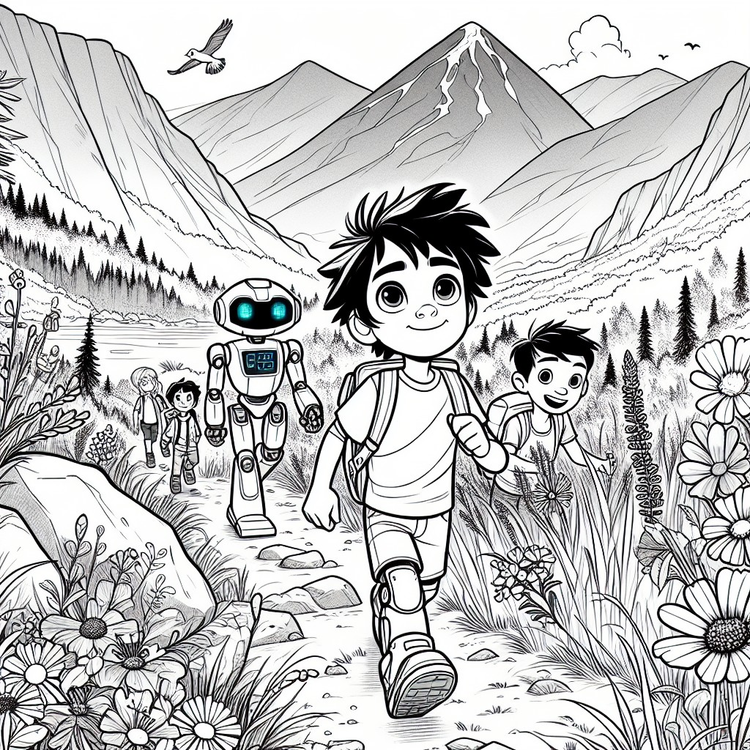

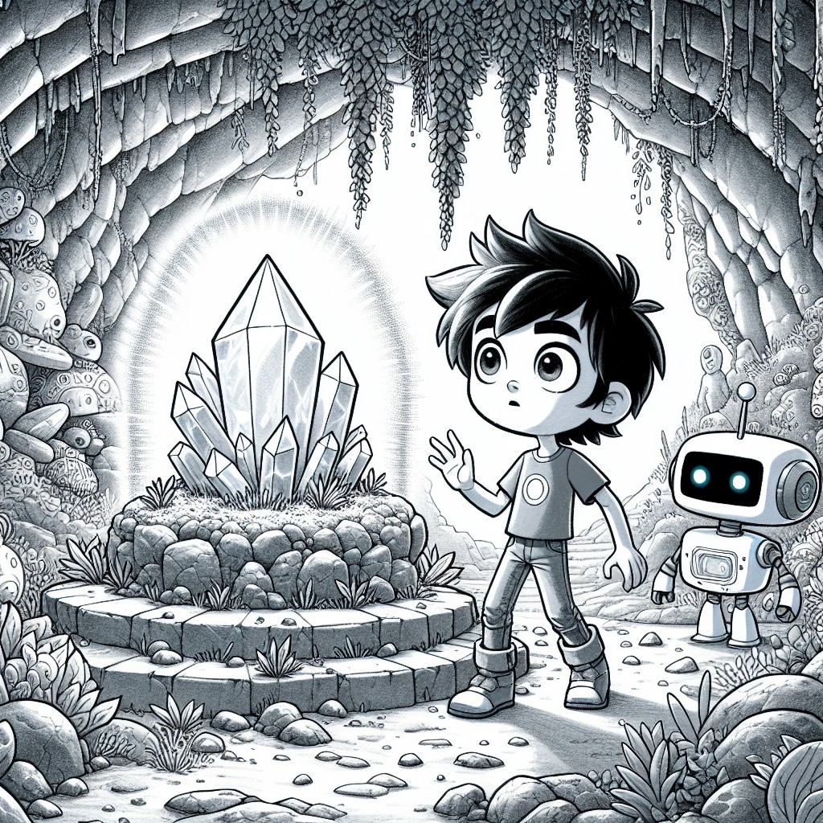

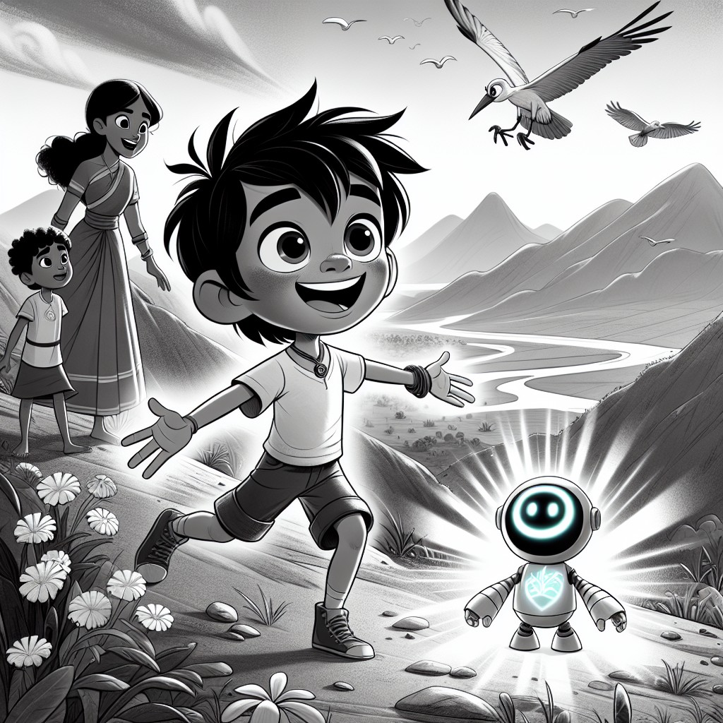
THE LEARNING CORNER
One page. Circle Time ready. A conversation, not a test.
Long Vowels: The Silent E Secret
In this story, Sam and Robo discovered that some words have a secret helper -- a silent e at the end! The e doesn't make a sound, but it changes the vowel before it. It makes the vowel say its own name!
Look at these pairs:
- tap becomes tape (the a says "ay!")
- hop becomes hope (the o says "oh!")
- hid becomes hide (the i says "eye!")
- cut becomes cute (the u says "you!")
- not becomes note (the o says "oh!")
Can you find these long-vowel words from the story?
- save (Chapter 3 -- saving water)
- life (Chapter 2 -- giving materials a second life)
- home (Chapter 4 -- the animals' homes)
- hope (Chapter 5 -- Robo's answer on the mountain)
- care (Chapter 1 -- Sam cares about the river)
Circle Time Discussion Questions:
1. What does the silent e do to a word? Can you think of a word that changes when you add a silent e?
2. Sam used ALL his superpowers in this book. Which one do you think was the most important?
3. What is YOUR favorite long-vowel word from the story?
THE VALUES MOMENT
Direct, warm address to the reader.
Sam learned some big things in this adventure.
He learned that responsibility means taking care of things -- even when no one asks you to, even when it's hard, even when you're tired.
He learned that respect means treating the earth, the animals, and the people around you the way you'd want to be treated.
He learned that perseverance means keeping going -- even when only four people show up, even when the river still looks messy, even when the mountain is steep.
And he learned something his grandma already knew:
Hard work and kindness are never wasted.
Have you ever taken care of something that needed you? A plant? An animal? A friend? A place you love?
What happened when you showed up?
ACTIVITY SUGGESTION
Simple. 15 minutes. No special supplies needed.
Make Your Own "Nature Watch" Notebook
Sam paid attention to the world around him -- and that's how his adventure started!
Grab a notebook (or fold some paper in half and staple it). This is your Nature Watch notebook.
Take a walk outside (with a grown-up) and write down or draw:
- One beautiful thing you see (a flower, a cloud, a bird)
- One thing that needs care (a piece of trash, a dry plant, a messy spot)
- One thing you're grateful for (a tree that gives shade, water you can drink, a friend)
That list is the beginning of YOUR superpower.
You don't need a glowing crystal. You just need to pay attention.
NOTE FOR GROWN-UPS
For parents, teachers, librarians, and caregivers.
Sam's Fourth Superpower is designed to introduce environmental responsibility, STEM concepts, and community values to children ages 3-8 through an adventure-driven story that builds on the three previous books in the series.
Educational alignment:
- Phonics: Long vowel patterns with silent e (a_e, i_e, o_e, u_e) are woven naturally into dialogue and narrative. Review of blends and digraphs from Book 3.
- CCSS Standards: RL.K.1 (ask and answer questions), RL.K.2 (retell and identify central message), RL.K.3 (identify characters, settings, events), RL.1.2 (central message/lesson), RL.1.3 (describe characters, settings, events with detail)
- CASEL Competencies: Responsible Decision-Making (environmental choices), Social Awareness (understanding impact on others/nature), Relationship Skills (teamwork with friends and mentors)
STEM Concepts Covered:
- Pollution and water quality (Chapter 1)
- Recycling and material science (Chapter 2)
- Water conservation and drip irrigation (Chapter 3)
- Ecology, deforestation, and habitat restoration (Chapter 4)
- Interconnected ecosystems (Chapter 5)
Values from the Twelve Pillars:
- Responsibility (core theme)
- Respect for Elders (Mr. Green, Farmer Brown, Ranger Jane)
- Hard Work and Perseverance (every chapter)
- Community and Giving Back (riverbank cleanup, tree planting)
- Honoring Those Who Have Gone Before (grandma references, Ranger Jane's grandmother)
- The Dignity of Every Person -- and every living thing
Circle Time Tips:
- Sit in a tight semicircle. This book works best read aloud with pauses for the Interactive Moments.
- Slow down at the emotional moments (the fish speaking, Farmer Brown's advice, the mountain's voice).
- The Activity Suggestion (Nature Watch Notebook) can be done as a class project over several days.
- Pair with a simple classroom recycling station for real-world reinforcement.
Coloring Pages:
Each left-hand page features a B&W line illustration of the facing scene, designed for children to color during or after reading. This dual format supports both active engagement during circle time and quiet individual activity.
Series Connection:
This is Book 4 of 5. Sam's superpowers build cumulatively. Each book can be read standalone, but reading in order deepens the experience and phonics progression.
Available through Follett Content and Mackin for school and library purchase.
ALL FIVE SUPERPOWERS (So Far!)
| Book | Superpower | What Sam Learned |
|------|-----------|-----------------|
| 1 | Understanding Animals | Listen. Observe. Care for living creatures. |
| 2 | Scientific Tasks | Be curious. Experiment. Build healthy habits. |
| 3 | Heightened Senses | Pay attention. Solve problems. Help friends. |
| 4 | Communicate with Nature | Show up. Take responsibility. Everything is connected. |
| 5 | ??? | Coming soon... |
Everlight Kids -- A division of Everlight Ventures
"Every word is a door. And every door is an adventure."

