Sam's Fifth Superpower
Adventures with Sam and Robo -- Book 5
Everlight Kids | Everlight Ventures

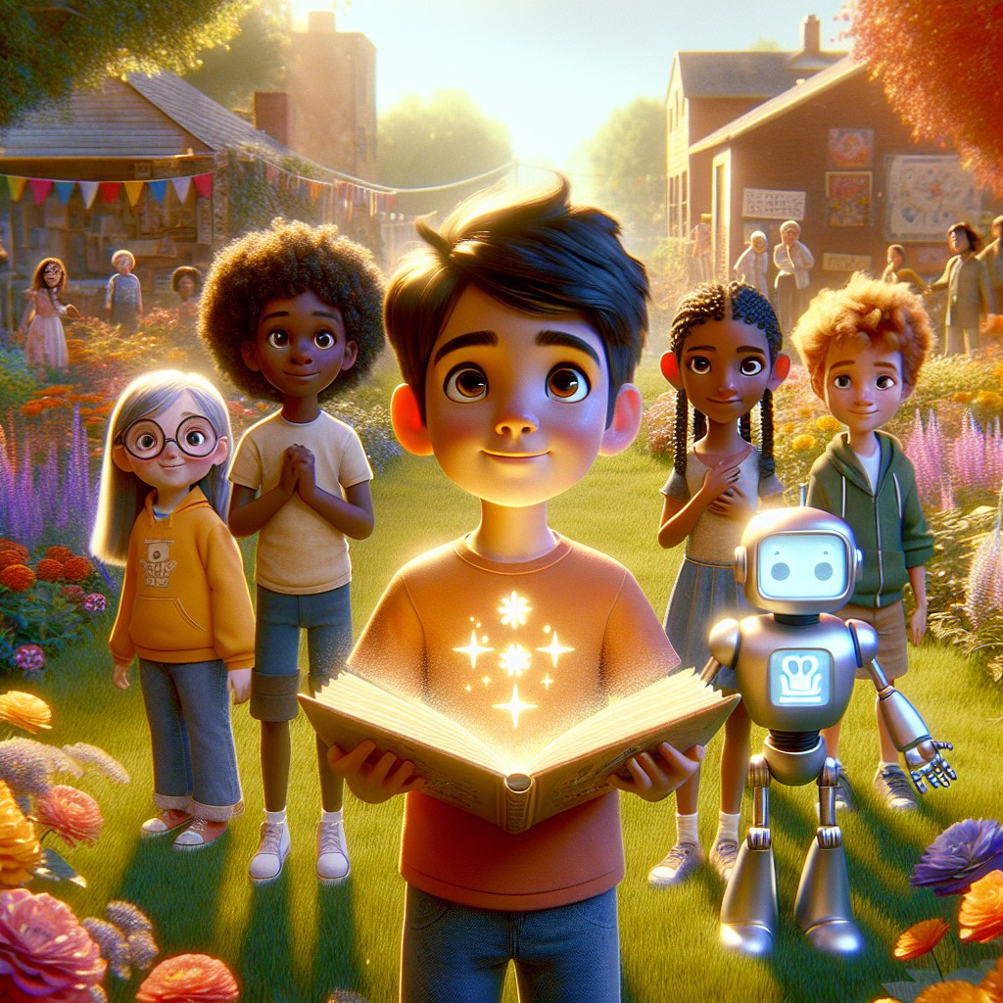

Adventures with Sam and Robo -- Book 5
SERIES RECAP (inside front cover)
Sam's Superpowers So Far:
In Book 1, Sam found a magical book under an old oak tree -- and out popped Robo, his robot best friend! Together they rescued a cat, fed a hungry rabbit, comforted a sad puppy, and calmed an angry bird. Sam learned the sounds at, an, and it, and earned his first superpower: understanding animals.
In Book 2, Sam and Robo visited a science lab with Dr. Spark, built a volcano, grew a sunflower with their friend Lily, and discovered the magic of compound words like backpack, sunset, and rainbow. Sam earned his second superpower: scientific tasks.
In Book 3, Sam and Robo followed a mysterious note on a scavenger hunt. Using blends and digraphs like ch, sh, th, cr, and str, they solved puzzles, helped friends, and earned Sam's third superpower: heightened senses.
In Book 4, Sam and Robo cleaned a polluted river, learned about recycling and conservation, planted trees with Ranger Jane, and climbed a mountain where a glowing crystal waited. Sam discovered long vowels with silent e -- words like hope, life, save, and home -- and earned his fourth superpower: communicating with nature.
Now, in Book 5, Sam has grown from a curious boy into someone who truly makes the world better. But there is one more adventure waiting -- the greatest one of all. And it begins with a question Sam has never been asked before:
"Can you teach ME?"

CHAPTER 1: The New Adventures
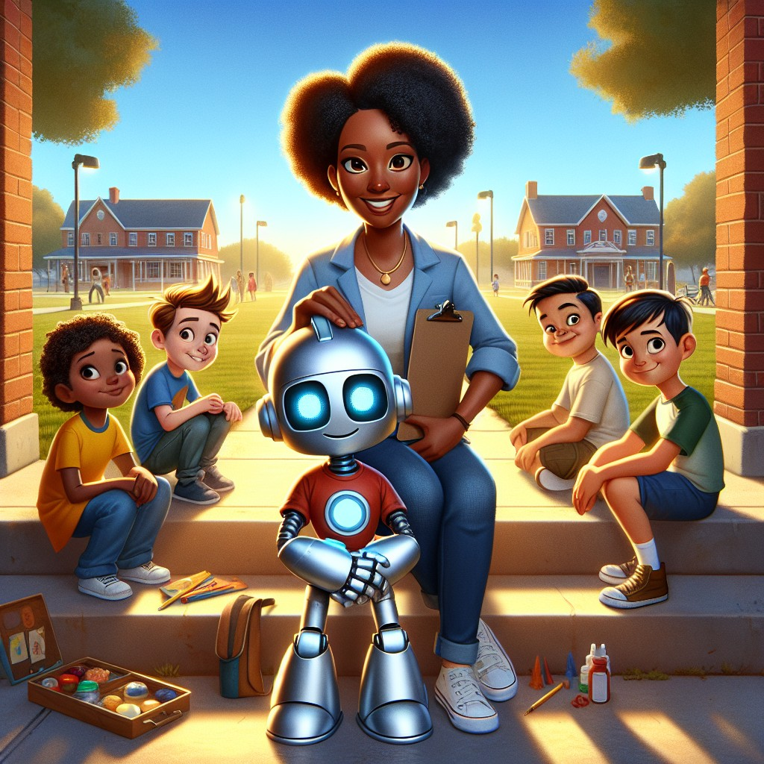
It was a warm Saturday morning, and Sam was sitting on the front steps of the community center with Robo beside him.
The community center was a big brick building in the middle of town. It had a wide lawn with picnic tables, a basketball court with faded lines, and a bulletin board covered in flyers. Sam had been coming here since he was little -- back when he didn't know any superpowers, back when he was just a curious boy who loved climbing trees.
Today, Sam was different. He was older now. Stronger. He'd rescued animals, built volcanoes, solved mysteries, planted forests, and talked to mountains.
But he still wore the same backpack. And he still asked questions about everything.
"Robo," said Sam, "do you remember our very first adventure?"
Robo's display flickered. A small image appeared -- a glowing book under an old oak tree.
"I remember every detail," said Robo. "You were nervous. You asked me if the book was real."
Sam laughed. "I asked if you were real."
"Also true," said Robo. "You poked my arm three times."
"I had to make sure!"
They sat together, enjoying the morning, when the door of the community center swung open and Ms. Reyes stepped out. She was the director -- a tall woman with kind eyes, a clipboard, and a voice that could carry across any room without shouting.
"Sam! Just the person I was looking for."
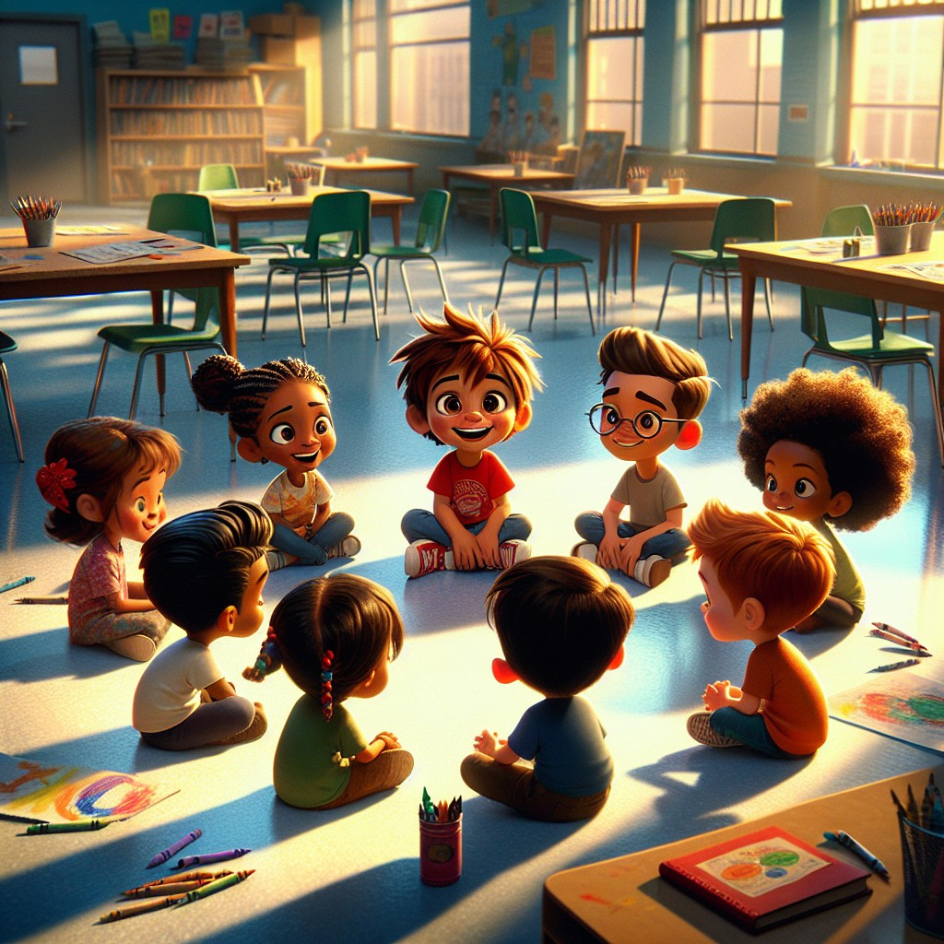
"We have a group of younger kids who come here every Saturday," said Ms. Reyes. "They're... struggling. Some of them are having a hard time with reading. Some don't like school. A few of them say things like 'I'm not smart enough' or 'I can't do it.'"
Sam's smile faded. He knew that feeling. He remembered it.
"I was like that once," Sam said quietly.
"I know you were," said Ms. Reyes. "That's why I'm asking you. Would you spend some time with them? Not as a teacher, exactly. Just as someone who's been where they are."
Sam looked at Robo. Robo's display showed a small question mark -- your call.
"Yes," said Sam. "I'd like that."
Ms. Reyes led them inside to a bright room with tables, chairs, crayons, and books scattered everywhere. Five kids sat in a loose circle. They looked up when Sam walked in. Their faces were a mix of curious, bored, and nervous.
"Everyone," said Ms. Reyes, "this is Sam. And this is his friend Robo."
Robo waved. His display showed a smiley face.
A girl with two braids and paint on her fingers spoke first. "Are you a teacher?"
"No," said Sam. "I'm just a kid. Like you."
"You don't look like a kid," said a boy with glasses, sitting in the back. "You look... bigger."
Sam sat down on the floor, cross-legged, so he was eye-level with everyone.
"I'm Sam," he said. "And not that long ago, I couldn't read very well either."
The room went quiet.
"Really?" said the girl with braids. Her name was Mia.
"Really," said Sam. "I remember sitting in class and the letters didn't make sense. They were just shapes. I thought something was wrong with me."
The boy in the back -- his name was Oliver -- pushed his glasses up. "That's how I feel," he said. Almost a whisper.
"Me too," said a small boy named Danny, hugging his knees.
"And me," said a girl named Priya, looking at the floor.
The fifth kid, a boy named Jax, just shrugged. "Reading is boring," he said. But Sam could hear something underneath the words. Something that sounded a lot like scared.
"Can I tell you a secret?" said Sam.
All five kids leaned forward.
"Words are just sounds. And sounds are like building blocks. Once you learn the blocks, you can build anything."
Robo's display lit up. It showed three letters: C - A - T.
"Let's start with something easy," said Sam. "Repeat after me: cat."
"Cat," said the kids.
"Now: hat."
"Hat."
"Now: bat. Sat. Mat."
The kids repeated each one. Mia started smiling. Oliver uncrossed his arms.
"Did you hear it?" said Sam. "They all end with the same sound -- at. That's a pattern. And once you hear the pattern, you can read ANY word in that family."
"Flat!" said Danny suddenly. "That ends in at too!"
"Yes!" said Sam. He high-fived Danny. "You just read a word!"
Danny's eyes went wide. "I... I did?"
"You did," said Sam.
Robo's display showed a tiny firework.
Sam continued. "Can, man, ran -- those end in an. And sit, bit, fit -- those end in it. Every word family works the same way."
"It's like a code," said Oliver, adjusting his glasses. "You just have to crack it."
"Exactly like a code," said Sam.
Jax hadn't said anything. But he was listening. Sam could tell.
"We'll come back tomorrow," said Sam. "And I'll show you more."
As they left, Mia ran up and tugged Sam's sleeve.
"Sam? Do you really think I can learn to read?"
Sam knelt down.
"Mia, I know you can."
Interactive Moment: Sam taught the kids the -at, -an, and -it word families! Can you help? Say three words that end in -at. Now three that end in -an. Now three that end in -it. Which word family is YOUR favorite?
Question: Why did Sam agree to help the younger kids at the community center?
Answer: Because Sam remembered being just like them -- struggling, unsure, and thinking he wasn't smart enough. He knew that if someone had shown him how to crack the code of reading, it would have changed everything. And now he could be that someone.
Coloring Pages
Color these scenes from the chapter!

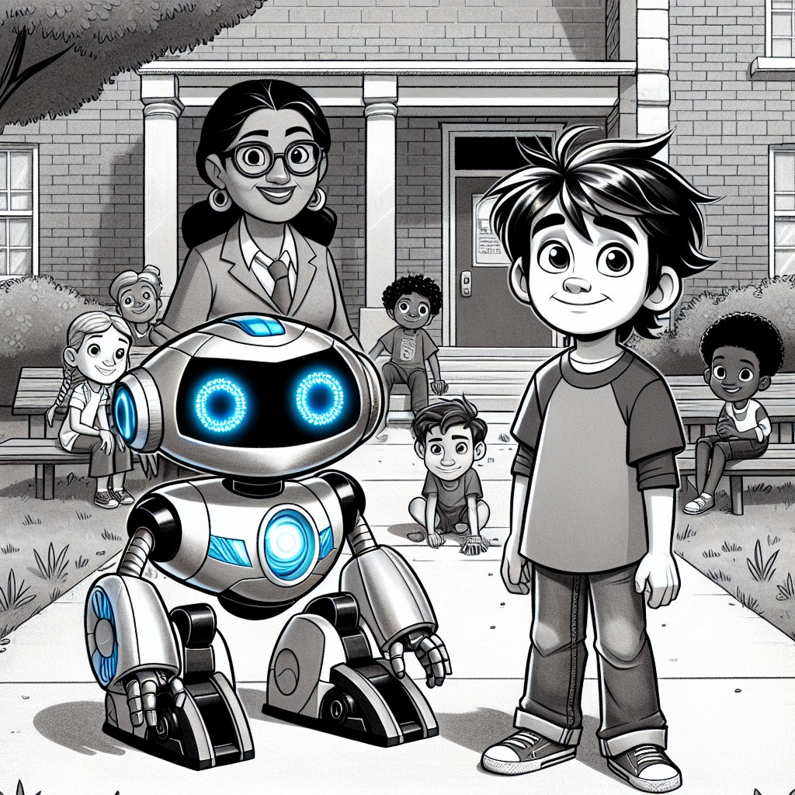

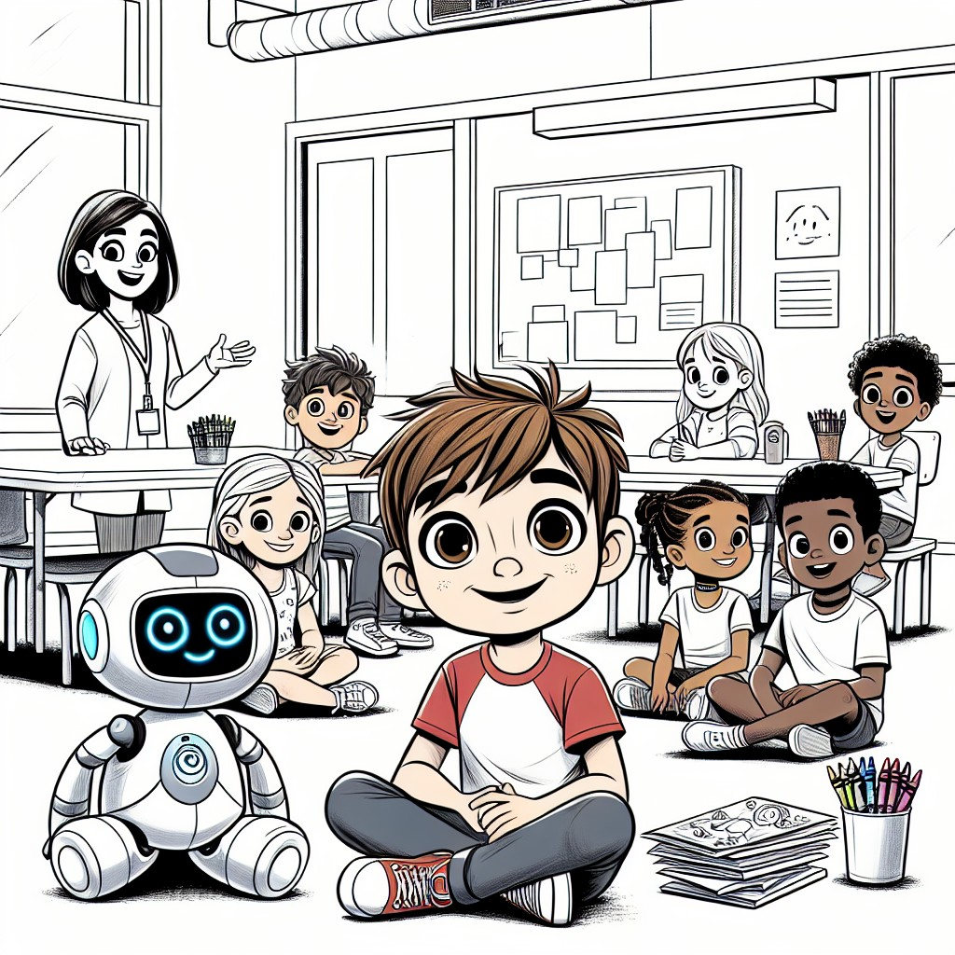

CHAPTER 2: Teaching Teamwork
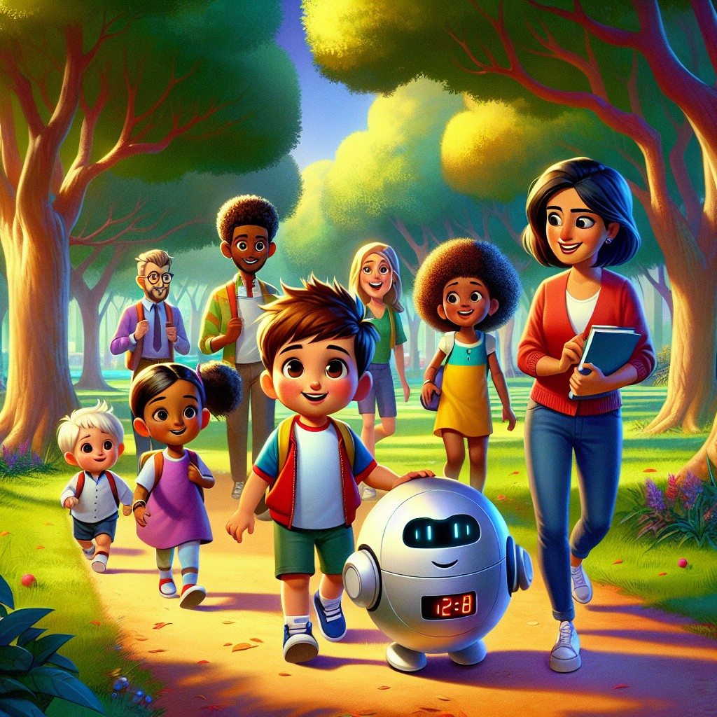
The next Saturday, Sam showed up early. The five kids were already there, sitting in the same room -- but this time, they looked different. They were waiting. They were ready.
"Today," said Sam, "we're going outside."
The kids grabbed their things. Danny grabbed his backpack. Priya pulled on her raincoat -- the sky looked a little grey. Oliver tucked a notebook into his lunchbox.
Robo beeped. "Sam -- did you hear all those compound words?"
Sam grinned. "I did. But let's see if the kids can spot them."
They walked to the big park behind the community center, where old trees lined a path and birds called from every direction. Sam stopped the group near a clearing.
"Okay, everyone. I want you to look around and find something. A word that's actually TWO words stuck together."
The kids looked confused for a second.
"Like... backpack?" said Danny, holding up his bag.
"That's one!" said Sam. "Back plus pack. What else?"
"Sunlight!" said Mia, pointing up at a beam cutting through the clouds. "Sun plus light!"
"Raincoat!" said Priya, tugging her sleeve.
"Butterfly!" said Oliver, watching one drift past.
Even Jax looked up. "The path goes past a playground," he said. "Play plus ground."
"FIVE compound words in two minutes," said Sam. "See what happens when you pay attention?"
Robo's display showed a running total. It climbed as the kids kept finding more: treetop, birdsong, hilltop, doorstep, footprint.
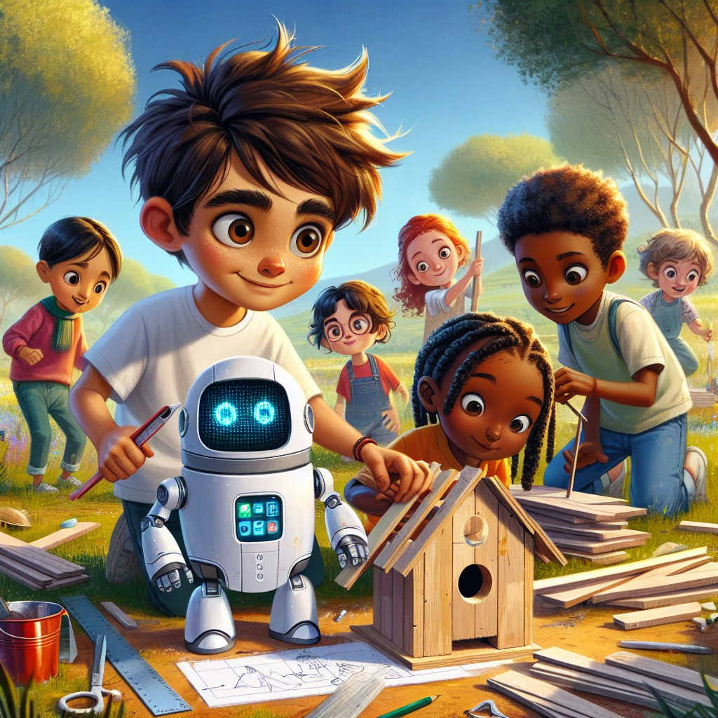
Sam led them deeper into the park, to a spot where three tall oak trees stood in a triangle with an open meadow between them.
"Today," said Sam, "we're going to build something. Together."
He reached into his backpack and pulled out supplies -- small boards, screws, a bag of birdseed, twine, and a simple plan drawn on paper.
"We're building a birdhouse," said Sam. "But here's the rule: nobody does it alone. Every step takes teamwork."
Robo projected the blueprint onto a flat rock. The kids gathered around.
"First," said Sam, "we need to measure and cut the pieces. Oliver, you're great at numbers -- can you measure?"
Oliver's face lit up. "I can do that!"
"Mia, you have the best eye for color and shape. Can you figure out how the pieces fit together?"
Mia studied the blueprint. "The sides go here... and the roof tilts like this..."
"Danny, you're strong. Can you hold the pieces steady while we attach them?"
Danny flexed his small arms. "I'm ready!"
"Priya, you know more about birds than anyone here. What kind of opening do we need?"
Priya thought. "Small birds need a small hole. About this big." She made a circle with her thumb and finger.
"Perfect," said Sam. He turned to Jax. "And Jax -- I need someone to double-check everything. Someone who notices when something isn't right. That's you."
Jax blinked. Nobody had ever given him a job like that before. "Okay," he said. And he meant it.
They worked together for an hour. Measuring, cutting, holding, checking, fitting. Robo helped with the tricky screws, but the kids did the real work.
When it was done, they stepped back and looked at it.
It was small. A little crooked. The roof tilted slightly more than the plan showed. But it was theirs.
"We built that," said Danny, amazement in his voice.
"Together," said Sam. "None of us could have done it alone. That's what teamwork means. Everybody brings something different, and together you make something none of you could make by yourself."
"Sam," said Robo quietly, "I believe this is a good time for blends."
Sam smiled. "Right. Okay, everyone -- listen to these words: strong, tree, bring, step, plan, trust. Can you hear the sounds at the beginning?"
"They smoosh together!" said Mia. "Str-ong. Tr-ee. Br-ing."
"Those are called blends," said Sam. "Two consonants that work together, just like you guys worked together. Str, tr, br, st, pl, cr -- they blend their sounds into one smooth start."
"Cr-aft!" said Oliver. "We did a craft project!"
"Pl-an!" said Priya. "We followed a plan!"
"Fr-iend," said Danny softly. "Friends."
Sam felt something warm in his chest.
"Yeah," he said. "Friends."
They hung the birdhouse in the tallest oak tree. Within ten minutes, a small chickadee landed on the perch and looked inside.
"She likes it," whispered Priya.
Nobody moved. They all just watched, together, as the tiny bird hopped inside their crooked little house and began to sing.
Interactive Moment: Sam and the kids built a birdhouse using teamwork! If YOU were building a birdhouse, what job would you want? Measuring? Drawing? Holding? Checking? Can you find three words that start with a blend? (Hint: tree, strong, plan.)
Question: Why did Sam give each kid a different job when building the birdhouse?
Answer: Because everyone has different strengths! Oliver was good at numbers, Mia had an eye for shapes, Danny was strong, Priya knew about birds, and Jax was great at noticing details. When everyone contributed what they were best at, they built something amazing together.
Coloring Pages
Color these scenes from the chapter!

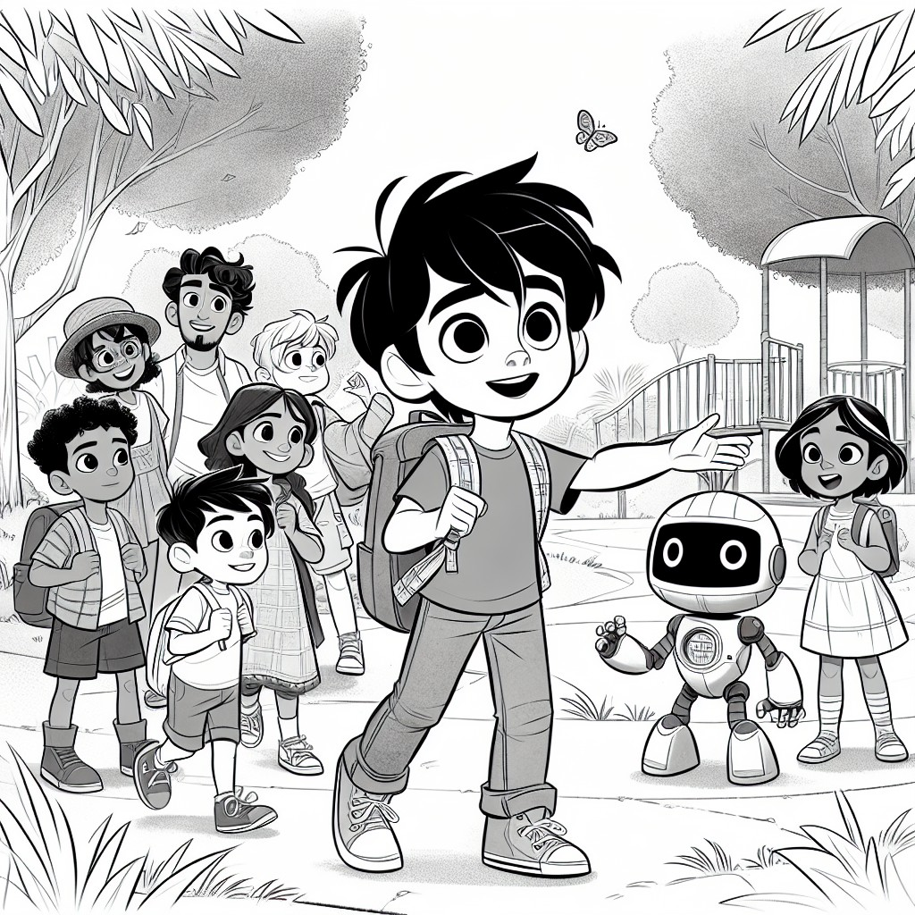

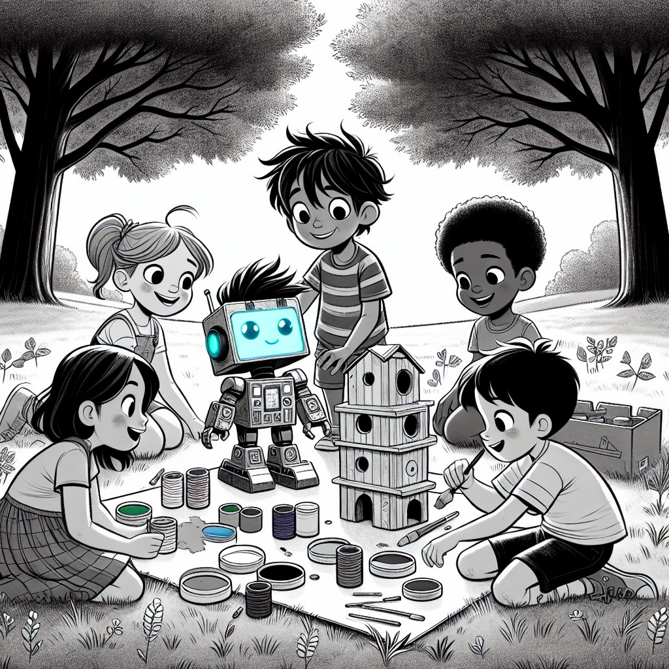

CHAPTER 3: The Big Challenge
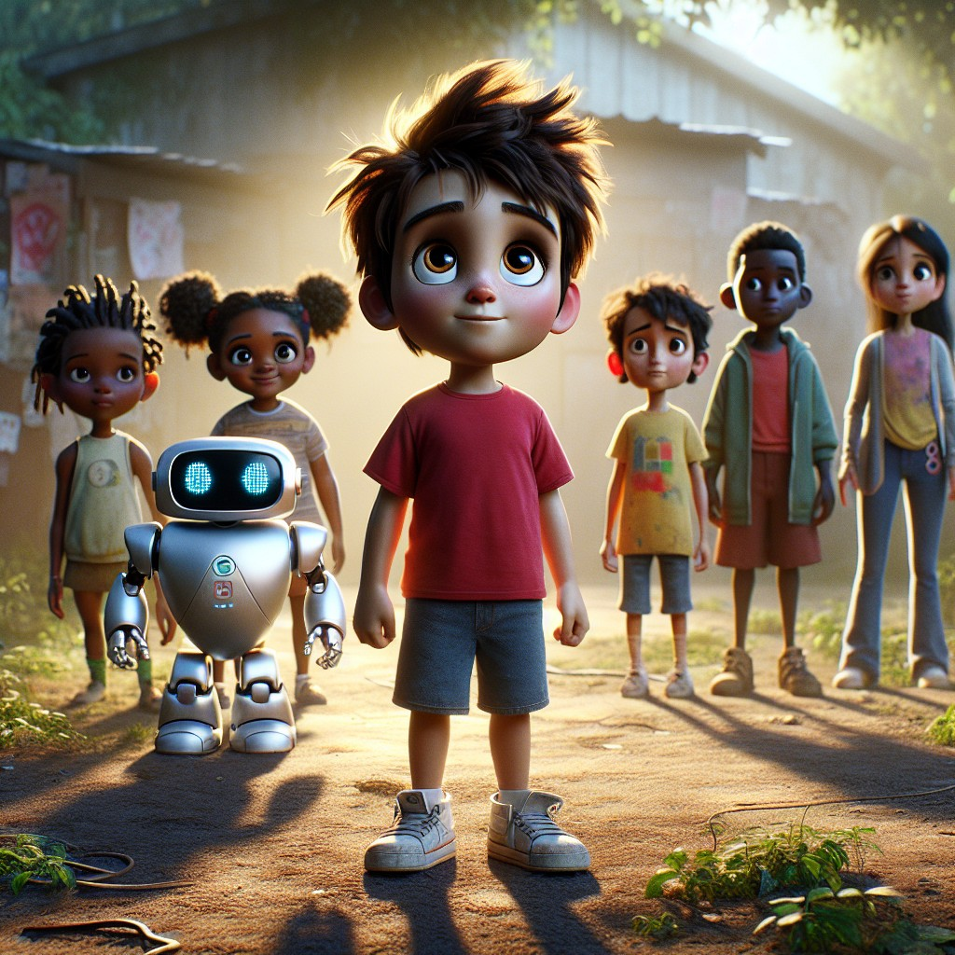
Two weeks had passed. Sam came to the community center every Saturday now, and sometimes on Wednesdays too. The five kids were growing. They were reading more, laughing more, and saying "I can't" a lot less.
But this Wednesday, something was different.
Ms. Reyes met Sam at the door. Her face was serious.
"The community garden behind the center," she said. "It's in bad shape. The raised beds are falling apart. Weeds have taken over. The fence has holes where rabbits keep getting in and eating the seedlings. And the city says if we don't fix it up by next Saturday, they're going to tear it out and put in a parking lot."
Sam looked at the garden through the back window. It was a mess. But underneath the weeds and broken boards, he could see what it used to be -- what it still could be.
"We can fix this," Sam said.
"In one week?" said Ms. Reyes, raising an eyebrow.
"I know some good helpers," said Sam.
He gathered the five kids, plus Lily (who had become a close friend since the sunflower days), and they all stood at the edge of the overgrown garden.
"This looks... huge," said Oliver.
"Impossible," said Jax.
"No," said Sam firmly. "It looks like a problem. And problems are just questions nobody has answered yet."
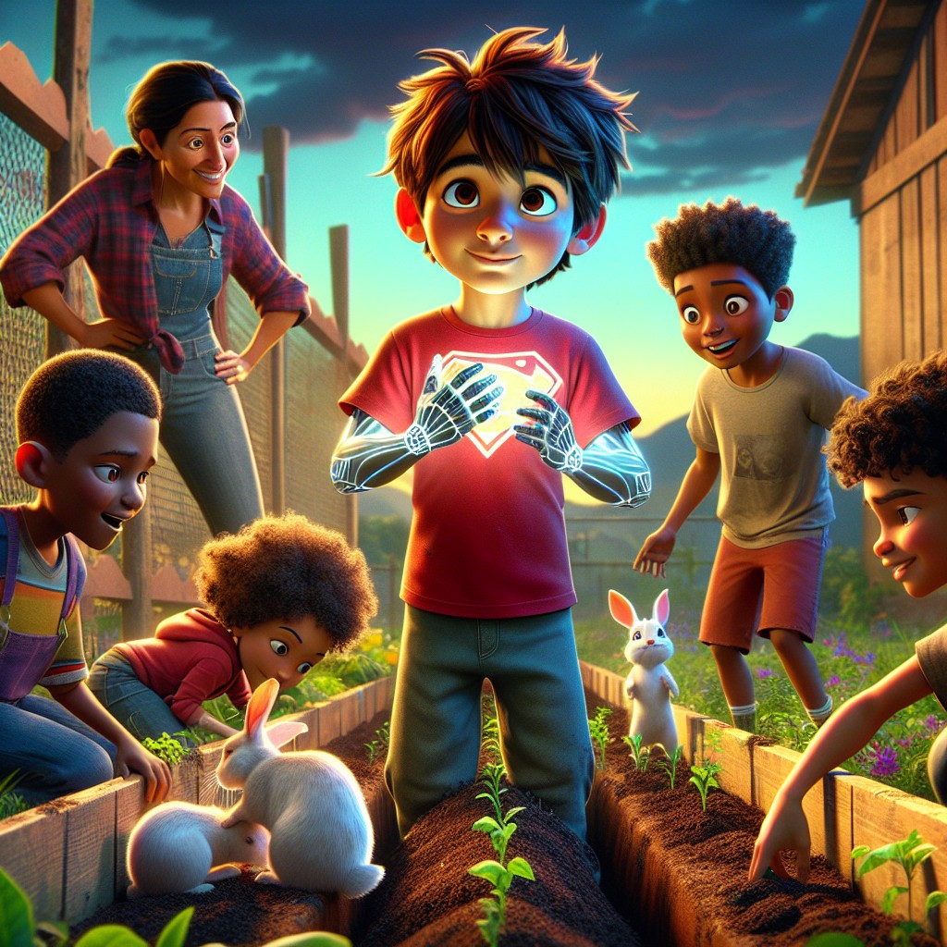
Sam used everything he had.
His first superpower -- understanding animals -- helped him talk to the rabbits. He didn't chase them away. Instead, he asked them, gently, "Where do you usually find food?"
The rabbits twitched their noses. "The fields past the creek," said the largest one. "But the path is blocked by thorns."
"If we clear the path to the field," said Sam, "will you stop eating the garden?"
The rabbit considered. "That seems fair."
Sam turned to the kids. "Oliver, Jax -- there's a thorn bush blocking the rabbits' path to the field. If we clear it, they'll leave the garden alone. Can you handle it?"
Oliver and Jax looked at each other. Then Oliver said, "We'll need thick gloves."
"And shears," said Jax. "Sharp ones."
They grabbed tools from the supply shed and went to work. They were careful. They were thorough. And they worked side by side without arguing once.
Sam used his second superpower -- scientific thinking -- to analyze the soil. He scooped up a handful and studied it.
"The soil is too dry and thin," he said. "The plants can't grow strong in this. We need compost -- that's decomposed organic material that adds nutrients back into the dirt."
"Where do we get compost?" asked Danny.
"We make it," said Sam. "Lily, remember the sunflower experiment? Remember what Dr. Spark said about giving plants what they need?"
Lily smiled. "Soil, water, and sunlight. And patience."
They built a simple compost bin from old wooden pallets. Sam taught the kids how to layer brown materials (dried leaves, cardboard) with green materials (vegetable scraps, grass clippings).
"This won't be ready for weeks," said Sam. "But Mr. Green at the recycling center has some finished compost we can use right now. Priya, Danny -- can you go ask him?"
Priya and Danny ran off. Twenty minutes later, they came back in Mr. Green's truck, with five big bags of rich, dark compost in the back.
"Mr. Green says hi," said Danny, beaming. "And he says he's proud of us."
Sam used his third superpower -- heightened senses -- to check every inch of the fence. He found three holes hidden by weeds, a loose post that wobbled when touched, and a section where the wire mesh had rusted through.
"I can hear the fence creak when the wind pushes it," Sam said, pressing his ear to the post. "This one is about to fall."
Sam used his fourth superpower -- communicating with nature -- to listen to the garden itself. He knelt down, pressed his palms to the earth, and closed his eyes.
The soil whispered. It was tired. It had been neglected. But underneath -- deep down -- it still wanted to grow.
"The garden isn't dead," Sam told the kids. "It's just been waiting for someone to care again."
"Then let's care," said Mia.
All week, they worked. They pulled weeds. They fixed the fence. They spread compost. They rebuilt the raised beds with new boards. They planted seeds -- tomatoes, peppers, sunflowers, herbs, and lettuce.
Robo helped calculate spacing and watering schedules. Lily painted cheerful signs for each bed. Mia drew a mural on the back wall of the center -- a garden with every kind of flower, and in the middle, a group of kids with their hands in the soil.
By Friday night, they were exhausted. Dirt under every fingernail. Sunburned noses. Sore arms.
But the garden was alive again.
"Sam," said Robo, as the sun went down, "I want to check our reading progress."
Sam sat the kids in a circle in the middle of the garden.
"Okay," said Sam. "We've been learning sounds all month. Let's put them all together. I'm going to say some words, and I want you to tell me what you hear."
"Shade," said Sam.
"Long a!" said Danny. "The silent e makes it say its name!"
"Vine."
"Long i!" said Priya. "V-i-ne. Like the vines on the fence!"
"Stone."
"Long o!" said Oliver. "Like the stones around the garden bed!"
"Huge."
"Long u!" said Mia. "This garden is huge now!"
"Now a digraph," said Sam. "Thrive."
"Th at the beginning!" said Jax. "And a long i with silent e. The garden is going to thrive."
Sam looked at Robo. Robo's display showed a single word: proud.
"You're all doing it," Sam said. "CVC words, compound words, blends, digraphs, long vowels -- you're reading. For real."
Nobody said "I can't" anymore.
Interactive Moment: Sam and the kids fixed the whole garden! Can you find the long vowel words? Shade, vine, stone, huge, thrive -- what does the silent e do in each one? Now try a digraph: what sound does th make in thrive? What about sh in shade?
Question: How did Sam use ALL FOUR of his superpowers to save the community garden?
Answer: He used understanding animals to negotiate with the rabbits, scientific thinking to fix the soil, heightened senses to find hidden damage in the fence, and communicating with nature to listen to what the garden needed. But the most important thing he did was believe the kids could help -- and let them.
Coloring Pages
Color these scenes from the chapter!

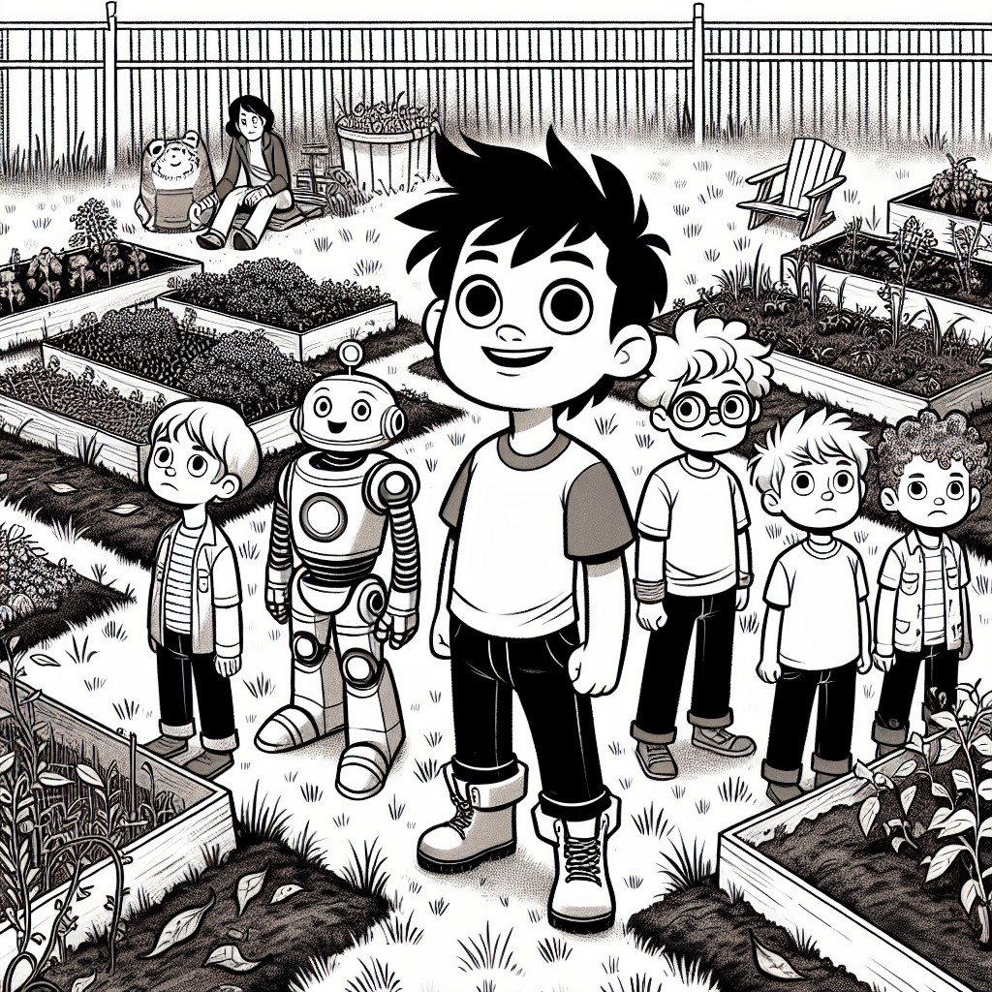

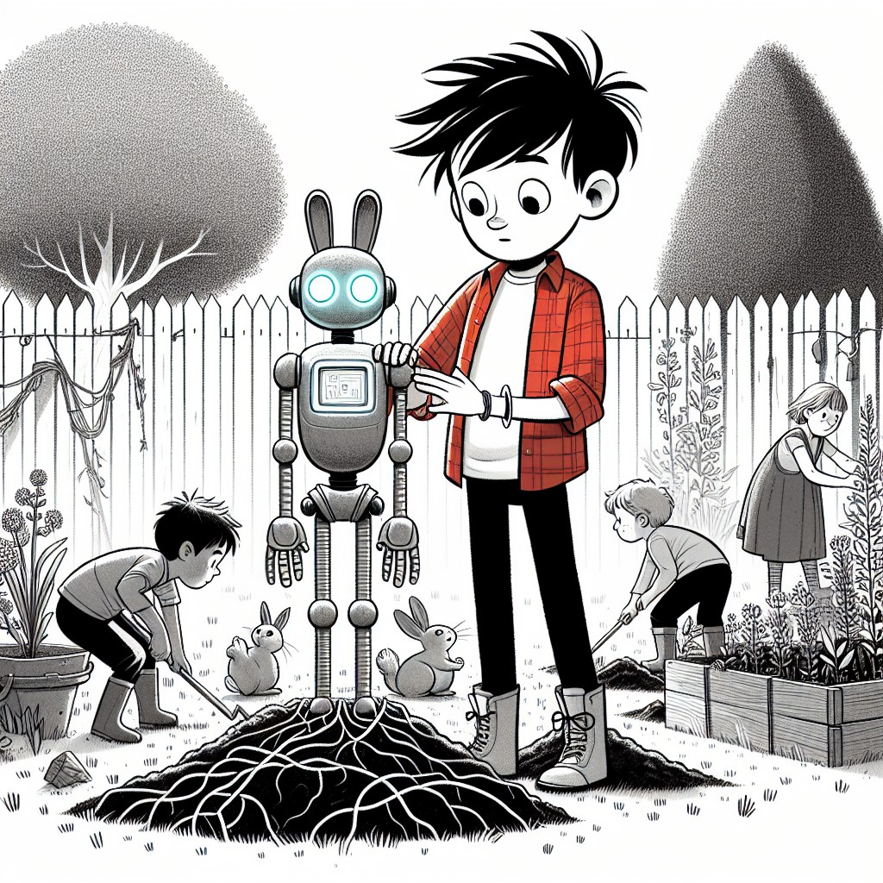

CHAPTER 4: Finding Your Own Power
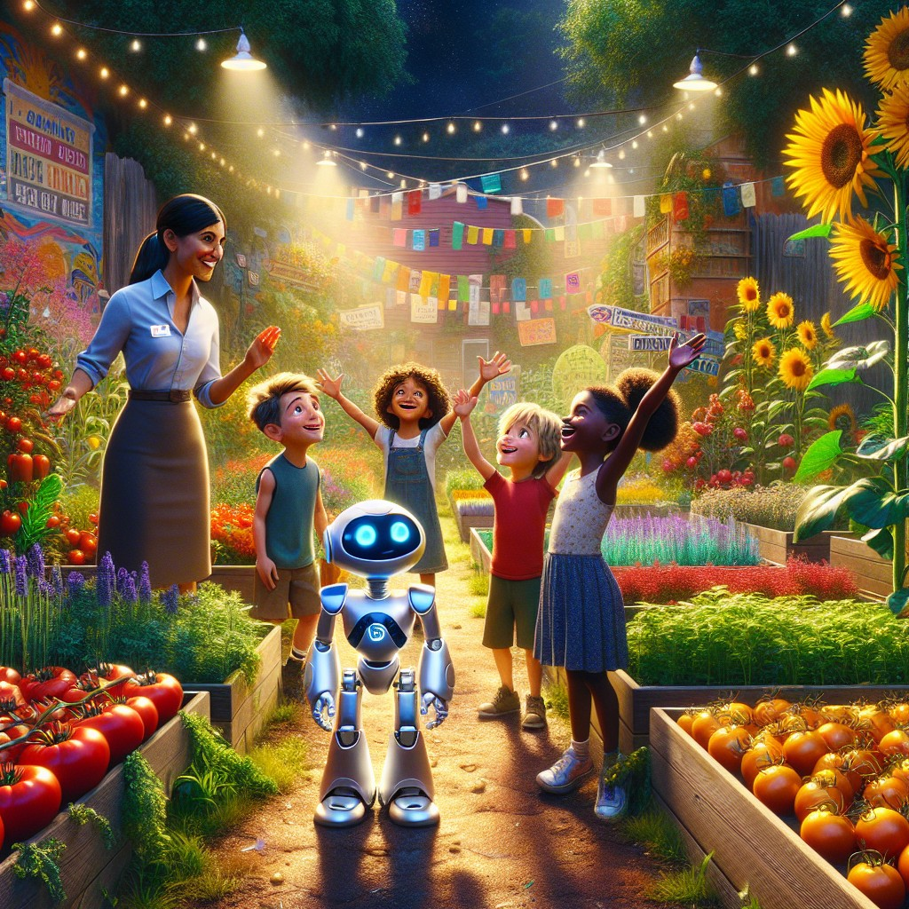
Saturday morning. The city inspector came.
She walked through the garden slowly. She checked the fence. She tested the raised beds. She looked at the compost bin, the irrigation lines, the newly planted rows. She read Mia's mural on the wall.
Then she turned to Ms. Reyes and said, "This stays."
The kids cheered so loud the birds flew out of the oak trees.
But Sam noticed something as the excitement settled. Each kid had changed. Not just in reading. In everything.
Mia was painting more than ever. She had turned the plain wooden signs into works of art -- bright colors, detailed drawings of each plant, labels in careful handwriting. Other kids in the neighborhood had started asking her to draw things for them.
"Mia," Sam said, sitting next to her while she painted a new sign for the herb section. "You're really talented."
Mia shrugged. "I just like drawing."
"No," said Sam. "It's more than that. You see things -- colors, shapes, patterns -- that other people walk right past. That's a superpower, Mia."
Mia looked at her paintbrush. Then at Sam.
"You really think so?"
"I know so."
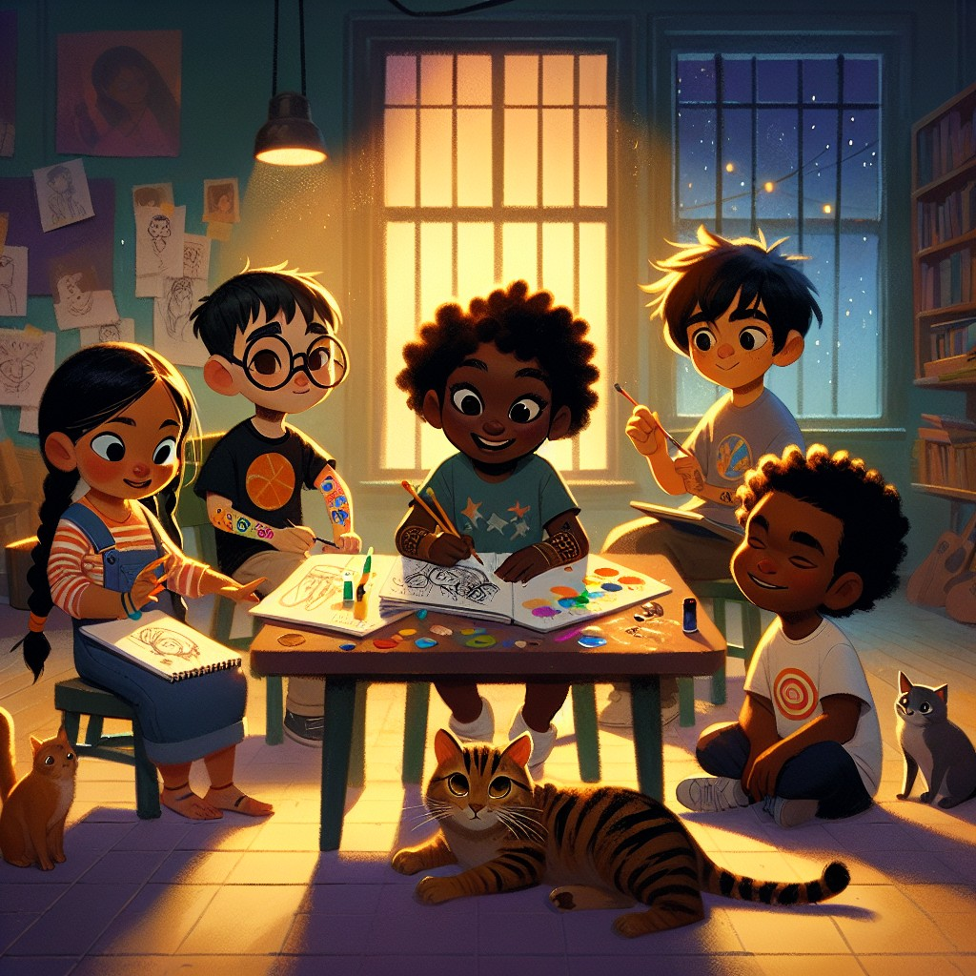
Oliver had become the group's engineer. He was the one who figured out how to angle the raised beds for maximum sunlight. He designed a rain collection system using old gutters and buckets. He kept a notebook full of measurements, sketches, and calculations.
"Oliver," said Sam, "you built a working rain collection system. Out of junk. Do you know what that's called?"
Oliver pushed his glasses up. "Recycling?"
"Engineering," said Sam. "You're an engineer, Oliver. You solve problems by building things."
Oliver was quiet for a long time. Then he said, "Nobody ever told me I was good at anything before."
Sam put a hand on his shoulder. "Then they weren't paying attention."
Danny, the smallest and quietest of the group, had found his place too -- but not where anyone expected. Danny was the one the animals trusted. When a stray cat wandered into the garden, Danny was the one who sat still and let it come to him. When a baby bird fell from a nest, Danny was the one who gently carried it back.
"Danny," said Sam, "do you know what my first superpower was?"
"Understanding animals," said Danny.
"And you have the same gift. The animals trust you because you're gentle and patient. You don't rush. You listen."
Danny smiled -- a real, full smile that reached his eyes.
Priya had become the group's scientist. She tested the soil every week, tracked the growth of each plant in a journal, and could tell you the exact pH level of the compost. She asked more questions than anyone Sam had ever met.
"Priya," said Sam, "you remind me of Dr. Spark."
"The scientist from your stories?" said Priya, eyes wide.
"The real scientist," said Sam. "He told me once that every great discovery starts with someone asking why. And you never stop asking."
Priya hugged her journal. "I want to be a real scientist one day."
"You already are one," said Sam.
And then there was Jax.
Jax had been the hardest to reach. The kid who sat in the back. The one who said "Reading is boring" when what he really meant was "Reading makes me feel stupid."
But over the weeks, something had shifted. Jax was the one who checked everything twice. He caught mistakes. He spotted problems before they happened. He was the one who noticed when the fence post was about to fall, when the irrigation line had a kink, when the compost pile was too wet.
And on this Saturday, Jax did something he had never done before.
He picked up a book.
It was a simple book -- one of the readers from the shelf in the community center room. A story about a dog and a boy. CVC words. Short sentences.
Jax sat in the corner and opened it.
Sam watched from across the room. He didn't say anything. He didn't interrupt. He just watched.
Jax's lips moved as he sounded out each word. Slowly. Carefully.
"The... dog... sat... on... the... mat. The... boy... ran... to... the... dog."
Jax looked up. His eyes were shining.
"Sam," he said. "I just read a whole page."
Sam's throat tightened.
"Yeah, Jax," he said. "You did."
Jax read three more pages that afternoon. Then five. Then the whole book.
When he finished, he closed it and held it against his chest.
"Can I take this home?" he whispered.
"It's yours," said Sam.
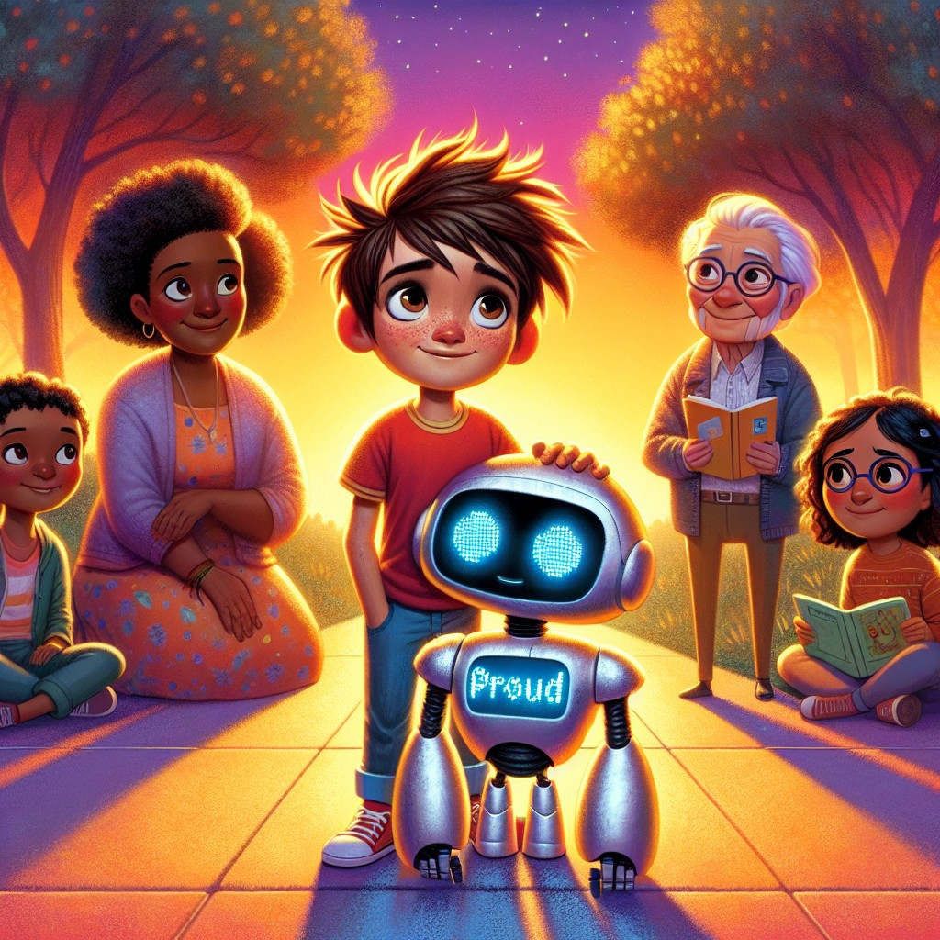
That evening, Sam and Robo walked home through the park.
"Robo," said Sam, "something is happening."
"What do you mean?" asked Robo.
"The kids. Mia is an artist. Oliver is an engineer. Danny understands animals. Priya is a scientist. Jax just read his first book. They don't need me anymore."
Robo was quiet for a moment.
"Sam -- that is not a failure. That is the goal."
Sam stopped walking. "What?"
"A true leader does not create followers," said Robo. "A true leader creates other leaders. You did not give them your superpowers. You helped them find their own."
Sam stood in the fading light of the park and felt something he had never felt before. It wasn't the tingling of a new superpower. It wasn't the excitement of a new adventure.
It was deeper than that.
It was the feeling of watching someone else succeed -- and knowing that you helped make it possible.
"Is that what teaching is?" Sam asked.
"That," said Robo, "is what teaching always was."
Interactive Moment: Each kid found their own special strength! Mia is an artist. Oliver is an engineer. Danny cares for animals. Priya is a scientist. Jax is a reader. What is YOUR special strength? Tell a friend or grown-up one thing you're really good at. Remember: everybody has a superpower!
Question: What did Sam realize about the kids he was teaching?
Answer: He realized that each kid had found their OWN special power. Mia was an artist, Oliver an engineer, Danny understood animals, Priya was a scientist, and Jax became a reader. Sam didn't give them his superpowers -- he helped them discover their own.
Coloring Pages
Color these scenes from the chapter!

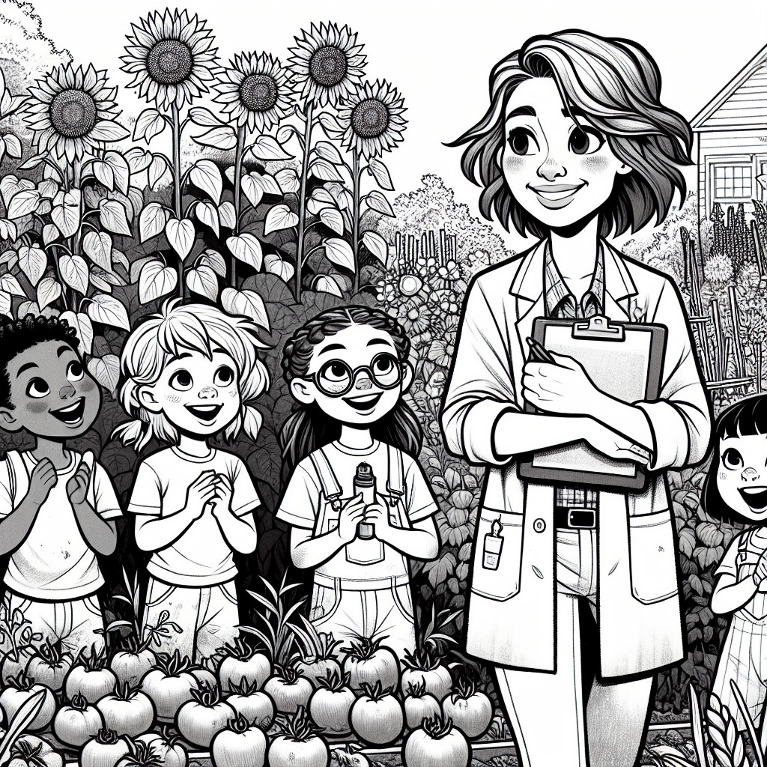

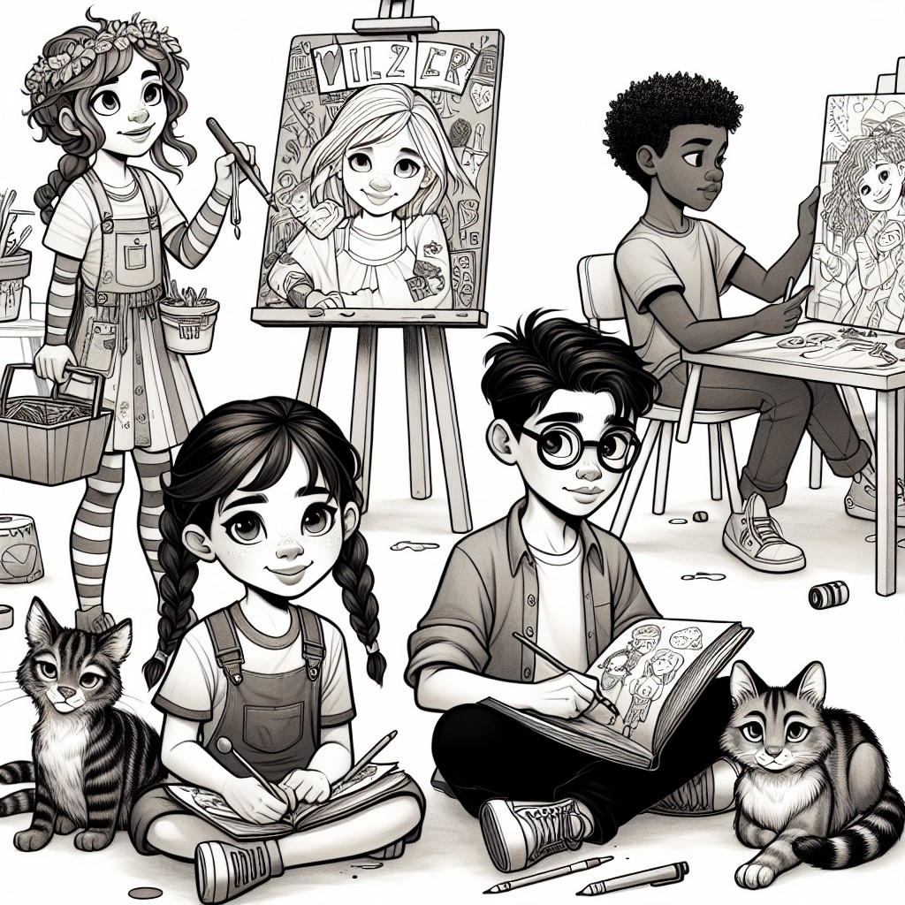

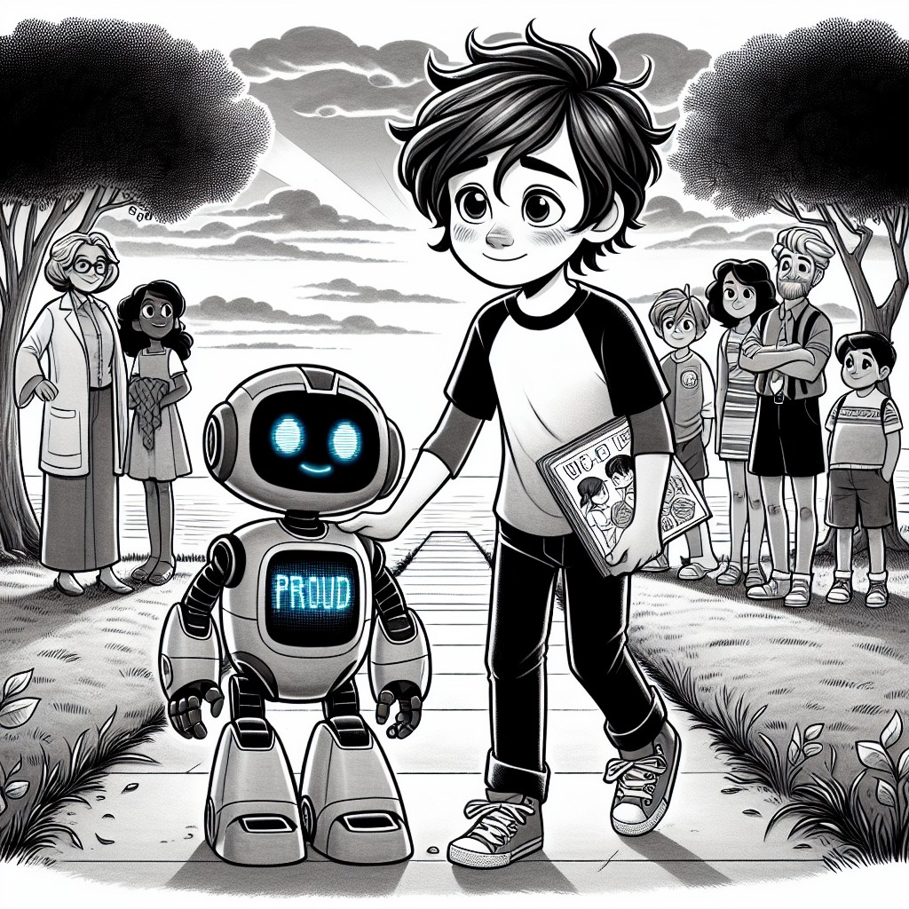

CHAPTER 5: The Greatest Superpower
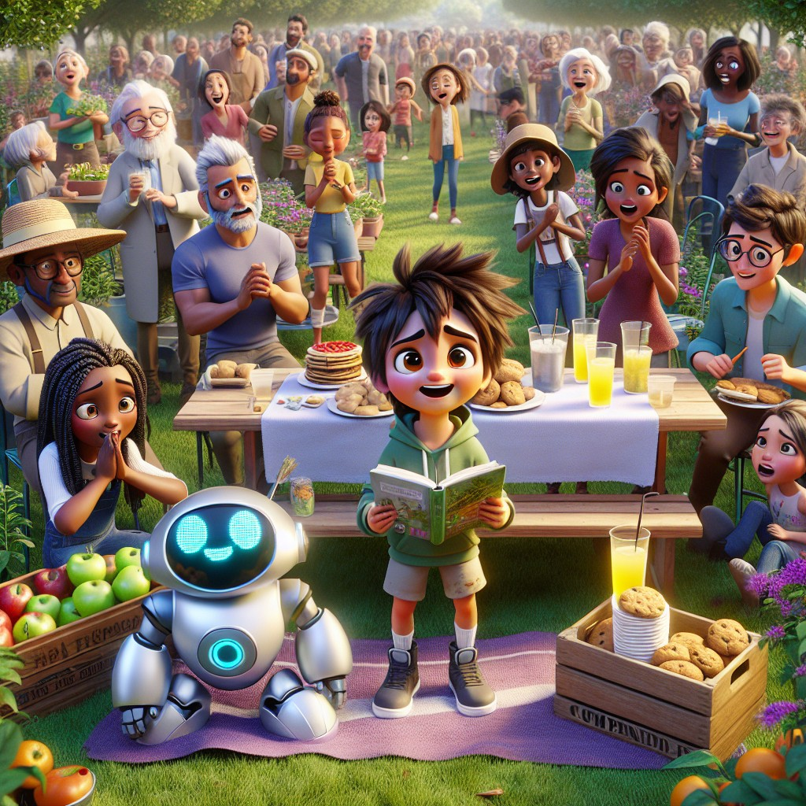
The community center held a celebration on the last Saturday of the month.
The garden was in full bloom. The tomatoes were turning red. The sunflowers -- Lily's contribution -- stood tall and golden against the fence. The herbs smelled so good you could catch their scent from the basketball court.
Ms. Reyes had set up tables with lemonade and cookies. Families came. Neighbors came. Mr. Green came, wearing his recycling center cap. Farmer Brown showed up with a crate of fresh apples. Ranger Jane drove in from the forest with a bundle of young saplings as gifts.
Dr. Spark arrived last, his lab coat stained as always, his eyes bright with pride.
"Sam," said Dr. Spark, shaking his hand. "I hear you've been busy."
"Just doing what you taught me," said Sam. "Using what I know to help people."
"No," said Dr. Spark. "You went further than that. You taught others to teach themselves. That's something no textbook can teach. That comes from the heart."
The five kids ran around the garden, showing their families everything they had built. Mia walked her mother through each sign she had painted. Oliver demonstrated the rain collection system to his father, who kept shaking his head in amazement. Danny sat in the corner of the garden with two stray cats curled up beside him. Priya presented her growth journal to Dr. Spark, who read every page with serious scientific attention.
And Jax stood at the front of the garden with his book -- his first book, the one about the dog and the boy -- and read it out loud.
To everyone.
His voice shook at first. His hands trembled. But he kept going. Word by word. Page by page.
When he finished, the whole garden was quiet.
Then everyone clapped.
Jax's mother was crying. The good kind of tears.
Jax looked at Sam across the garden and mouthed two words: Thank you.
Sam mouthed back: You did it.
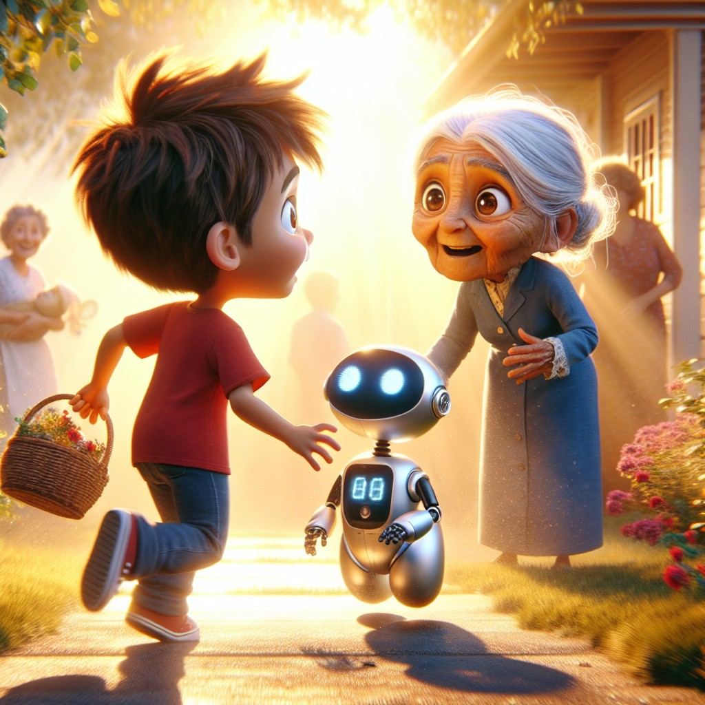
And then a voice came from behind Sam. A voice he knew from a thousand bedtime stories, a hundred life lessons, and a lifetime of love.
"Well, look at what my grandson has done."
Sam turned around.
Grandma.
She was shorter than he remembered. Her hair was silver-white, pulled back in a braid. Her eyes were dark and warm and bright -- the same eyes Sam had. She wore a simple blue dress and carried a basket covered with a cloth.
"Grandma!" Sam ran to her and threw his arms around her.
She held him tight. "I've been hearing about your adventures for a long time, Sam. The animals. The science lab. The scavenger hunt. The mountain."
"You know about all of that?"
Grandma smiled. "Who do you think left the book under the oak tree?"
Sam's mouth fell open.
"I... what?"
Grandma sat down on the garden bench and patted the spot beside her. Sam sat. Robo stood nearby, his display completely still -- something Sam had never seen before.
"A long time ago," said Grandma, "when I was about your age, I found a book too. A glowing book, under a very old tree. And it taught me that the world is full of magic -- but only if you're willing to learn, and to share what you learn with others."
"You had a magical book?" Sam whispered.
"Everyone does," said Grandma. "Some people find it under a tree. Some people find it in a library. Some people find it in the eyes of someone who believes in them. The magic isn't in the book, Sam. The magic is in what you DO with what it teaches you."
She reached into her basket and pulled back the cloth.
There it was.
The Book of Superpowers.
Glowing. Warm. Humming with life. The golden stars on its cover sparkled in the afternoon sun.
But this time, it looked different. It looked... complete. All five star slots on the cover were filled with light -- four steady and bright, one pulsing, waiting.
"Open it," said Grandma.
Sam's hands were shaking. He set the book on his lap and opened it.
The pages turned by themselves. Past the first chapter -- understanding animals. Past the second -- scientific tasks. Past the third -- heightened senses. Past the fourth -- communicating with nature. All the way to the fifth and final page.
The page was blank.
No -- not blank. As Sam watched, words began to appear. Golden letters, writing themselves across the page in a hand that looked like sunlight:
THE FIFTH SUPERPOWER
The ability to inspire and teach others.
This power cannot be given. It cannot be found in a crystal or earned from a book. It can only be grown -- in the heart of someone who cares enough to share what they know, patient enough to believe in someone who doesn't yet believe in themselves, and brave enough to let others shine brighter than they do.
Sam, you have all five superpowers now. But this one -- this one was always yours. Before the book. Before Robo. Before any adventure.
You got it from someone who loved you very much.
Sam looked at Grandma through blurry eyes.
"From you," he whispered.
Grandma touched his cheek.
"From love," she said. "It always starts with love."
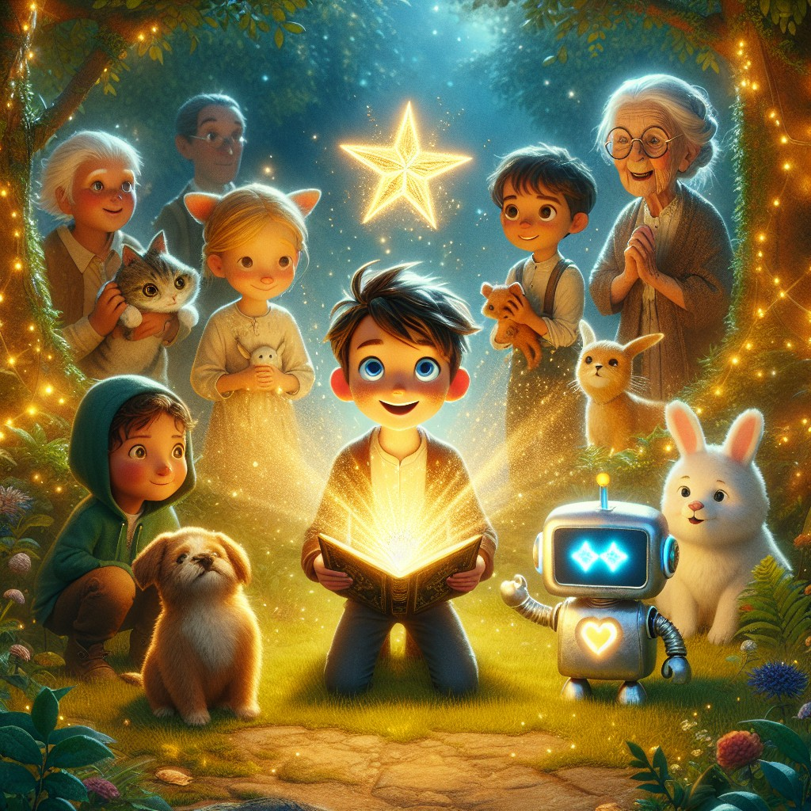
The book pulsed once more -- brighter than it had ever been. Every star on the cover blazed with golden light. Sam felt it flow through him. Not like electricity. Not like a rush. Like a deep, steady warmth that started in his chest and spread to his fingers and toes.
The animals came first. A cat. A rabbit. A small puppy -- older now, bigger, but still the same puppy he had sat with on that very first day. The bird landed on his shoulder.
Then the trees whispered his name. The wind carried the sound of the river. The garden itself seemed to hum.
And then the kids gathered around him. Mia. Oliver. Danny. Priya. Jax. And behind them, Lily, who had been there since Book 2. And behind her, more faces -- kids Sam had helped, people he had inspired, a whole community that was better because a curious boy once opened a glowing book.
Sam stood in the middle of it all and understood.
His first four superpowers were amazing. Understanding animals. Performing scientific tasks. Heightened senses. Communicating with nature.
But the fifth one -- the ability to inspire and teach others -- was the greatest of them all. Because it was the only one that multiplied. Every person Sam taught could teach someone else. And that person could teach another. On and on and on, like ripples in a pond, like sunlight through a window, like a seed that becomes a forest.
"Robo," said Sam.
"Yes, Sam?"
"Thank you. For everything. From the very first day under the oak tree."
Robo's display showed something Sam had never seen before. Not a smiley face. Not fireworks. Not a lightbulb or a star.
A single word: family.
"You are welcome, Sam," said Robo. "It has been the greatest adventure of my operational existence."
"Don't get all mushy on me," said Sam, grinning through tears.
"I am a robot," said Robo. "I do not get mushy. My display is simply malfunctioning due to... environmental moisture."
"You're crying, Robo."
"I am not crying. Robots do not cry. There is condensation on my optical sensors."
"Uh-huh."
"...Fine. I am crying. Marginally."
Everyone laughed. Even Grandma.
The book began to close. Slowly. Gently. The pages settled. The golden stars dimmed to a soft, steady glow.
Grandma placed her hand on the cover.
"The book has one more journey left in it," she said. "One day, somewhere, someone else will find it. Maybe under a tree. Maybe in a library. Maybe on a shelf in a community center."
She looked at Sam.
"And when they do, they'll start their own adventure. Just like you did."
Sam touched the cover one last time. It was warm.
"Goodbye," he said softly.
The book pulsed once -- a gentle farewell -- and its light faded to a quiet glow.
Sam placed it carefully back in Grandma's basket.
"Take care of it," he said.
"Always," said Grandma. "That's what family does."
The celebration went on until the fireflies came out. Sam sat with his friends -- old and new -- in the garden they had all built together. The birdhouse in the oak tree was full. The sunflowers nodded in the evening breeze. The tomatoes were almost ready.
Mia was drawing the fireflies. Oliver was calculating their blink patterns. Danny had a cat in his lap. Priya was writing everything down. Jax was reading -- a new book this time, a longer one, all by himself.
And Sam was watching them all. Quiet. Happy. Proud.
Not because of what he had done.
Because of what they would do next.
"Robo?" said Sam.
"Yes?"
"What's the multi-syllable word for everything that happened?"
Robo thought for exactly one second.
"Extraordinary," he said.
Sam smiled.
"Yeah," he said. "That's the one."
Far away, in a different town, in a different neighborhood, a little girl with curly hair and bright, curious eyes was playing in her backyard. She was climbing a tree -- her favorite tree -- when she noticed something strange.
Something was glowing beneath the roots.
She crouched down and reached carefully into the gap.
"What's this?" she whispered.
It was a book.
Interactive Moment: Sam earned his FIFTH and greatest superpower -- the ability to inspire and teach others! Think about someone who has inspired YOU. A parent? A teacher? A grandparent? A friend? Now think: who could YOU inspire? Can you teach someone one thing you learned from Sam's adventures? Try it today!
Question: What is Sam's fifth and greatest superpower, and why is it the most powerful of all?
Answer: The ability to inspire and teach others. It's the most powerful because it's the only superpower that multiplies -- every person Sam teaches can teach someone else, and on and on forever, like ripples in a pond. Sam learned it from his grandma, and now the kids he helped will pass it on too.
Coloring Pages
Color these scenes from the chapter!

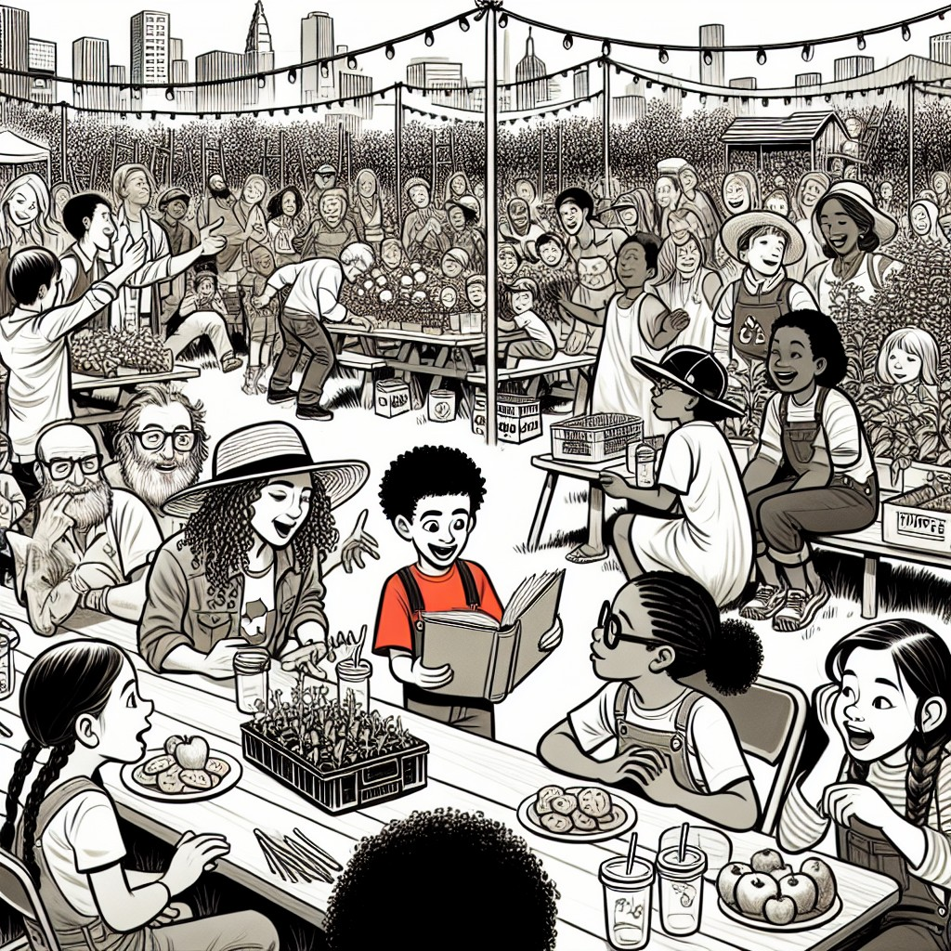

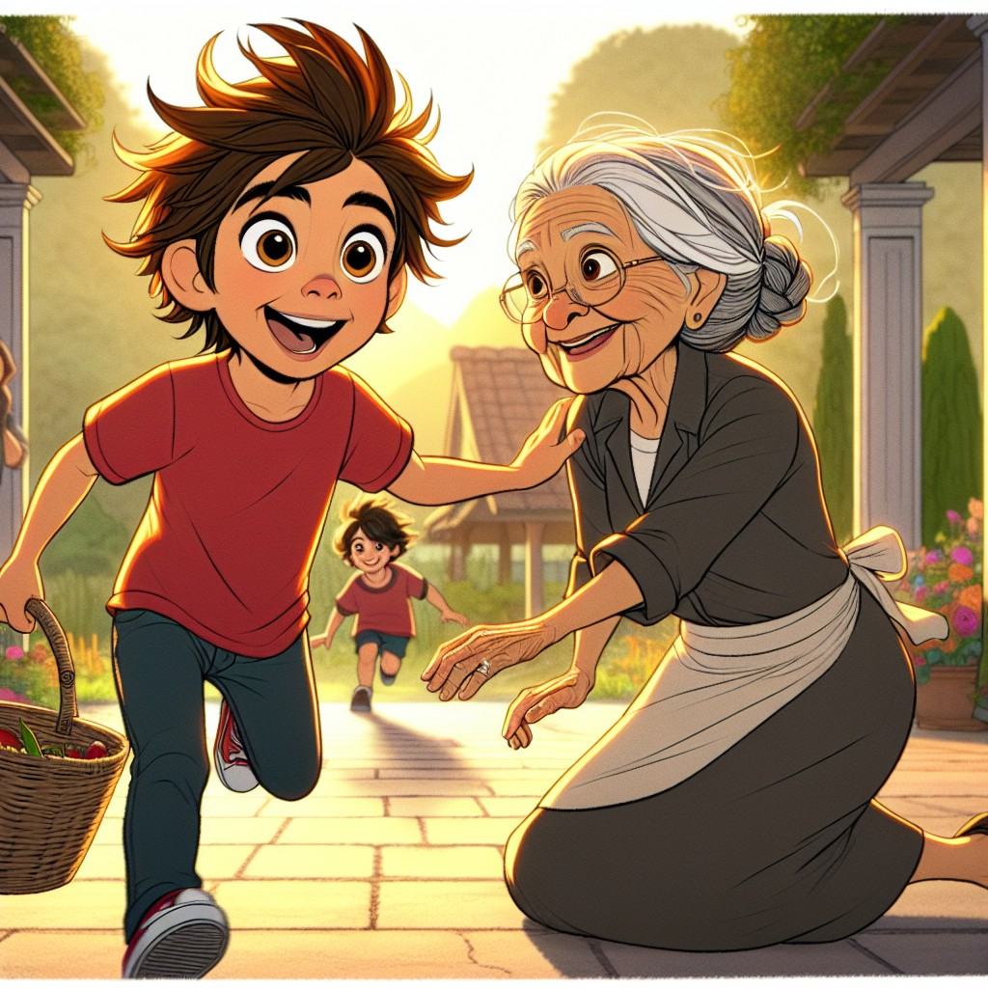

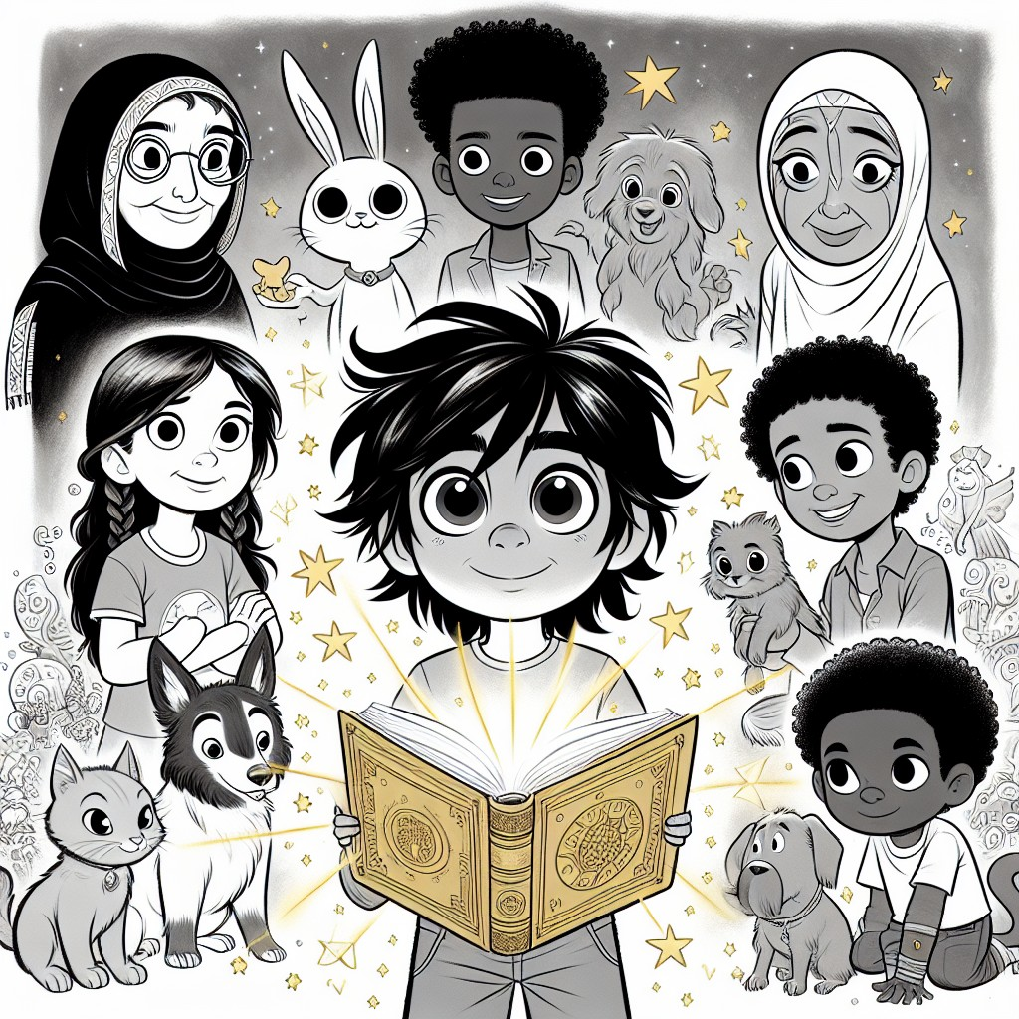
THE LEARNING CORNER
One page. Circle Time ready. A conversation, not a test.
The Grand Phonics Review: Everything Sam Learned
Over five adventures, Sam and Robo learned the building blocks of reading. Now it's time to put them ALL together -- just like Sam taught the kids at the community center!
Book 1 -- CVC Word Families (Consonant-Vowel-Consonant):
- The -at family: cat, hat, bat, sat, mat, flat
- The -an family: can, man, ran, fan, plan
- The -it family: sit, bit, fit, hit, kit
- The -og family: dog, log, fog, jog
- The -ub family: tub, rub, cub, club
Book 2 -- Compound Words (Two words become one!):
- backpack (back + pack), sunset (sun + set)
- sunflower (sun + flower), rainbow (rain + bow)
- raincoat (rain + coat), starfish (star + fish)
- playground (play + ground), butterfly (butter + fly)
- treetop (tree + top), sunlight (sun + light)
Book 3 -- Blends and Digraphs (Sounds that work together!):
- Blends: str-ong, tr-ee, br-ing, cr-aft, pl-an, st-ep, fr-iend
- Digraphs: ch-eck, sh-ade, th-rive, wh-isper
Book 4 -- Long Vowels with Silent E (The secret helper!):
- a_e: shade, save, place, made, safe, waste, name
- i_e: vine, life, thrive, hide, time, shine, pride
- o_e: stone, hope, home, bone, those, chose, wrote
- u_e: huge, cute, fuse, muse
Book 5 -- Multi-Syllable Words (The big ones!):
- ex-tra-or-di-na-ry (extraordinary!)
- com-mu-ni-ty (community)
- to-ge-ther (together)
- in-spi-ra-tion (inspiration)
- ad-ven-ture (adventure)
- su-per-pow-er (superpower!)
The Grand Challenge: Can you read this sentence that uses ALL the patterns?
"The brave cat sat on a flat stone in the sunshine, watching a butterfly thrive in the extraordinary community garden."
CVC (cat, sat, flat) + Compound (sunshine, butterfly) + Blend (brave, thrive) + Digraph (the) + Long vowel (stone, thrive) + Multi-syllable (extraordinary, community, butterfly, garden)
If you can read that sentence, you have learned EVERYTHING Sam learned in five books. And that is a real superpower.
Circle Time Discussion Questions:
1. What is your favorite word from the whole series? Can you tell us which book it came from?
2. Sam taught the younger kids to read. Can YOU teach someone a word family? Try teaching a friend the -at family right now!
3. What is the longest word you can read? Try extraordinary! (Clap each syllable: ex-tra-or-di-na-ry -- six claps!)
THE VALUES MOMENT
Direct, warm address to the reader.
Sam has come a very long way.
In Book 1, he was a curious boy who found a magical book under a tree. He didn't know any superpowers. He didn't know any big words. He was just... Sam. A kid who wanted to learn.
Now, five adventures later, Sam can understand animals, think like a scientist, notice things nobody else sees, talk to nature itself, and -- most importantly -- inspire other people to find their own strengths.
But here is the secret Sam learned in this last adventure:
He didn't need any of those superpowers to make a difference.
What made Sam special was never the magic. It was the choices. He chose to be curious. He chose to be kind. He chose to work hard. He chose to help others. He chose to believe in kids who didn't believe in themselves yet.
And those choices? You can make them too. Right now. Today.
Leadership doesn't mean being the loudest or the strongest. It means seeing what needs to be done and doing it -- even when nobody asks.
Generosity doesn't mean giving away your things. It means giving away your time, your attention, and your knowledge.
Courage doesn't mean not being scared. It means being scared and doing it anyway -- like Jax, picking up that book.
Community means that nobody has to do it alone. Not the garden. Not reading. Not growing up. We do it together.
And legacy -- that big, beautiful, multi-syllable word -- means that what you do today matters tomorrow. The garden Sam planted will grow for years. The kids Sam taught will teach other kids. And the love his grandma gave him will keep going, and going, and going.
So here is what we want to say to you:
You have superpowers inside you. Real ones. Maybe you're an artist like Mia. Maybe you're a builder like Oliver. Maybe you're gentle like Danny, or curious like Priya, or braver than you know, like Jax.
You don't need a magical book to find them.
You just need someone who believes in you.
And if nobody has told you yet -- we believe in you.
Now go find your superpower.
ACTIVITY SUGGESTION
Simple. 15 minutes. No special supplies needed.
The "Pass It On" Teaching Challenge
Sam learned that the greatest superpower is teaching others. Now it's YOUR turn!
Step 1: Pick ONE thing you learned from the Sam and Robo books. It can be:
- A word family (-at, -an, -it)
- A compound word (backpack, sunflower, rainbow)
- A blend (strong, tree, craft)
- A long vowel word (hope, life, shade)
- A science fact (vinegar + baking soda = eruption!)
- A value (kindness, patience, teamwork)
Step 2: Find someone to teach it to. A younger sibling. A friend. A stuffed animal. A pet. (Danny would approve.)
Step 3: Teach them! Use Sam's method:
- Start simple.
- Be patient.
- Celebrate every small win.
- Never say "that's wrong" -- say "try again, you're close!"
Step 4: When they get it, give them a high-five and say: "Now YOU teach someone else!"
That's how superpowers spread. One person at a time.
Bonus: Make a "Superpower Certificate" for the person you taught! Write their name, what they learned, and the date. Decorate it however you like. Sam would be proud.
NOTE FOR GROWN-UPS
For parents, teachers, librarians, and caregivers.
Sam's Fifth Superpower is the series finale of Adventures with Sam and Robo, designed to bring together all phonics patterns, STEM concepts, and character values from the five-book series while introducing the themes of leadership, mentorship, and legacy.
Educational alignment:
- Phonics: This book serves as a comprehensive review of ALL phonics patterns from the series: CVC word families (-at, -an, -it, -og, -ub) from Book 1; compound words (backpack, sunflower, playground, butterfly, treetop) from Book 2; consonant blends (str, tr, br, cr, pl, st, fr) and digraphs (ch, sh, th, wh) from Book 3; long vowels with silent e (shade, vine, stone, huge, thrive, hope) from Book 4; and introduction of multi-syllable words (extraordinary, community, together, inspiration, adventure, superpower) for fluency building. Words are woven naturally into dialogue and narrative, modeled through Sam's teaching interactions.
- CCSS Standards: RL.K.1 (ask and answer questions), RL.K.2 (retell and identify central message), RL.K.3 (identify characters, settings, events), RL.1.2 (central message/lesson), RL.1.3 (describe characters, settings, events with detail), RF.K.3 (phonics and word recognition), RF.1.3 (decoding -- including all patterns), RF.1.4 (read with sufficient accuracy and fluency to support comprehension)
- CASEL Competencies: Self-Management (Sam organizing projects and managing his own emotions), Relationship Skills (teamwork, mentoring younger children, building trust), Social Awareness (recognizing what others need, empathy for struggling learners)
STEM Concepts Covered:
- Engineering and design (birdhouse construction, raised bed rebuilding, rain collection system)
- Applied problem-solving (garden restoration, fence repair, soil analysis)
- Collaborative project management (organizing a team, assigning roles based on strengths)
- Ecology and botany (composting, garden planning, animal habitat negotiation)
- Scientific method review (observation, hypothesis, testing, recording -- modeled through Priya's journal)
Values from the Twelve Pillars:
- Leadership and Mentorship (core theme -- Sam teaching the next generation)
- Generosity (sharing knowledge freely, giving time and patience)
- Courage (Jax reading aloud, Sam stepping into a leadership role)
- Community and Belonging (the garden as shared space, the celebration)
- Respect for Elders (Grandma's wisdom, the reveal of her role in Sam's journey)
- Legacy (passing on what you've learned, the book continuing to a new reader)
- Hard Work (garden restoration, consistent effort over weeks)
- Empathy (understanding struggling learners, meeting each child where they are)
Circle Time Tips:
- This book is the longest and most emotionally complex in the series. Consider reading it over two sessions (Chapters 1-3, then 4-5) for younger listeners.
- Pause at the moment Jax reads his first book aloud. Ask children: "How do you think Jax feels right now?" This is a powerful CASEL conversation starter.
- The Grandma reveal is designed to surprise and move both children and adults. Let it land -- give it a full pause before continuing.
- The final scene (the girl finding the book) is a deliberate open door. Ask children: "What do you think happens next? What superpowers do you think SHE will find?"
- The "Pass It On" activity works beautifully as a week-long classroom project where each child teaches one thing to one person.
Coloring Pages:
Each left-hand page features a B&W line illustration of the facing scene, designed for children to color during or after reading. This dual format supports both active engagement during circle time and quiet individual activity. This book contains 12 illustration pairs (B&W + color).
Series Connection:
This is Book 5 of 5 -- the series finale. All four previous superpowers are actively used and referenced. The final scene seeds a potential new series featuring a new protagonist discovering the same magical book. The phonics progression is complete: CVC (Book 1) -> Compound Words (Book 2) -> Blends/Digraphs (Book 3) -> Long Vowels (Book 4) -> Full Review + Multi-Syllable (Book 5).
Available through Follett Content and Mackin for school and library purchase.
ALL FIVE SUPERPOWERS
| Book | Superpower | What Sam Learned |
|------|-----------|-----------------|
| 1 | Understanding Animals | Listen. Be kind. Show up for others. |
| 2 | Scientific Tasks | Be curious. Be patient. Ask "why?" |
| 3 | Heightened Senses | Pay attention. Solve problems. Help friends. |
| 4 | Communicate with Nature | Show up. Take responsibility. Everything is connected. |
| 5 | Inspire and Teach Others | Share what you know. Believe in people. The greatest power multiplies. |
Everlight Kids -- A division of Everlight Ventures
"Every word is a door. And every door is an adventure."

