Everlight_Logistics Strategic Investor Proposal

Executive Summary
Everlight_Logistics is actively building a decentralized wealth engine through Zilliqa accumulation, off-grid infrastructure, and AI-powered business operations. The founder, 1m_Rich_Gee, works full-time in a classified infrastructure security role, investing $1,000 per month to scale the operation until it reaches self-sufficiency or a major ROI milestone.

Projected ZIL Value Scenarios
Below is a projection of 1 million ZIL at various target prices:
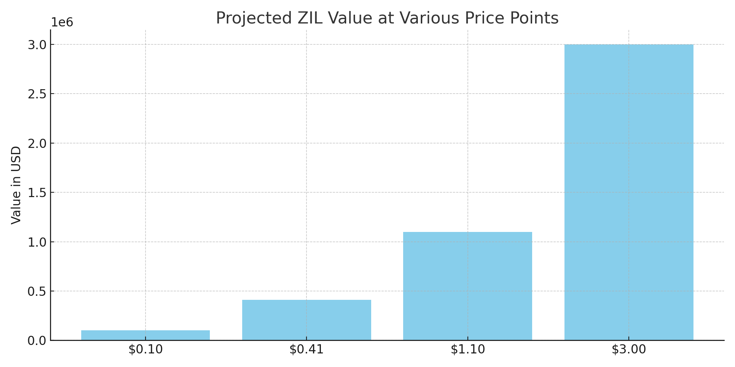

Hardware Investment Strategy
The business will be equipped with a state-of-the-art hardware stack, fully deductible as business capital expenditure under IRS Section 179.
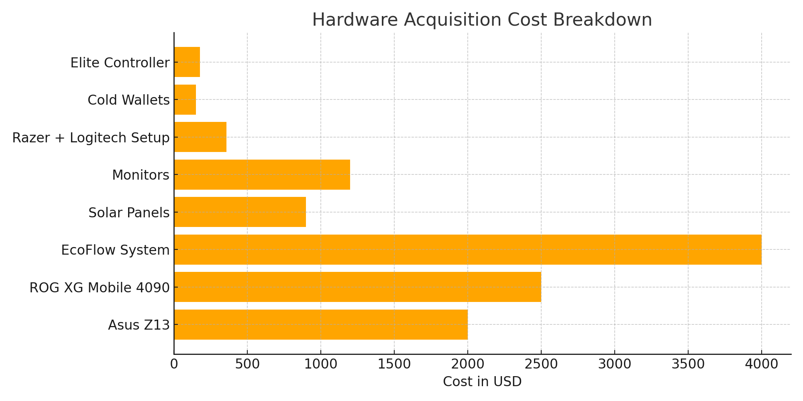

Income & Funding Plan
The founder earns $25/hour working 40-hour weeks at a CIF facility. Monthly injections of $1,000 into the business fund crypto acquisitions, gear, and infrastructure. This ensures scalability and cash flow even before ZIL hits its targets.

Execution Timeline
Q2 2025:
• Purchase hardware & complete setup
• Automate Slack & n8n ops
Q3 2025:
• Start land acquisition process
• Deploy automated crypto trader
Q4 2025:
• Begin family trust & whole life insurance setup
• Expand operational capacity

Closing Statement
Everlight_Logistics is the foundation. Zilliqa is the ignition. You are the catalyst.
This proposal is backed by discipline, security expertise, and consistent execution.

